*Note*

Because of size limitations, the full field wind file for turbulent wind conditions cannot be uploaded on GitHub. Therefore, you may encounter a problem when trying to manage the simulation. Therefore, please run TurbSim to generate the wind field data based on the input in directory “5MW_Baseline\Wind\” by simply dragging an ".inp" file on TurbSim.exe, or following the syntax in a CMD promote window below:

1. Launch cmd promote window
<Win>+R, or click “Start”, then type “cmd” and press <Enter>
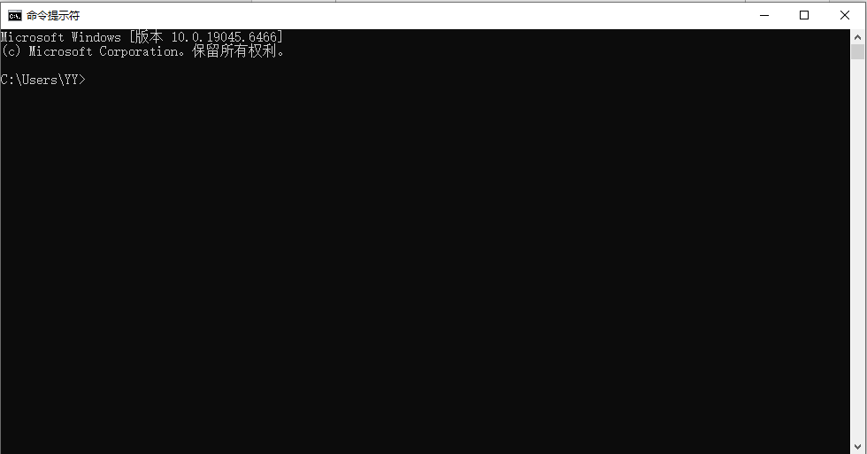

2. Change drive
Type your drive ID followed by “:”, like F: as follows:
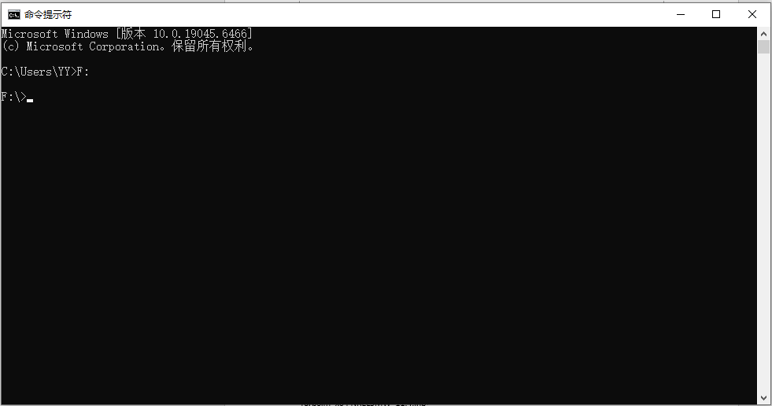
3. change directory to the TurbSim’s path using the command of “cd”, like:
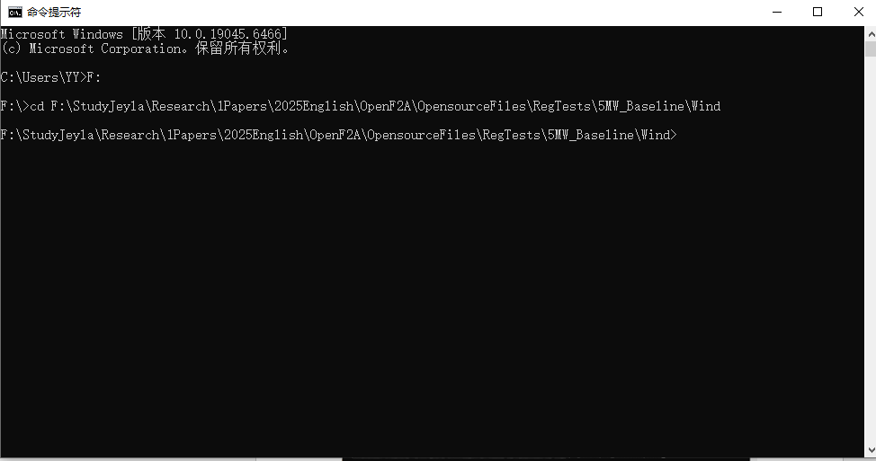
4. Run TurbSim

Type executable file name followed by a space and full name of TurbSim input file, like:
TurbSim_x64.exe NREL5MW_11.4.inp
