Tze-Yang Chen

Txc172930

CS4348 Project 3 summary

**Implementation**

Initially, I was consider using List of lists to save different objects, however I later on find out that it is easier to write objects as a separate class. Which changed my method of implementing them all the similar compare to FCFS. All the scheduler should have empty schedule handler with *Null* printed to indicate no process processing. This project is developed in a long period of time which could cause a lot of unnecessary memory usage. In addition, the memory usage in the project could be minimized if different variable. This project is implemented in Java, and there are a total of two classes, all in schedule.java.

All the methods are independently implemented from the class slide. Below I have attached the results from the provided txt file. The results are also ensured from slide.

**Learned**

It would be easier to implement if more output can be provided, which the idel CPU situation is also provided. Below are the end results. ALL command is not provide since it’s the same results of FCFS, RR, SPN, SRT, HRRN, and FB.

**Screenshot**

First-Come-First-Serve

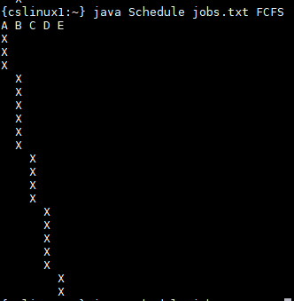

Round-Robin

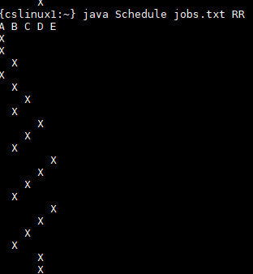

Shortest Process Next

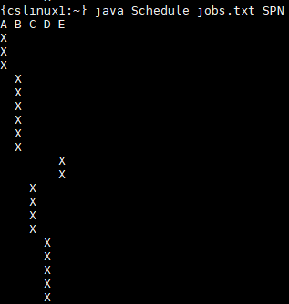

Shortest Remain Time

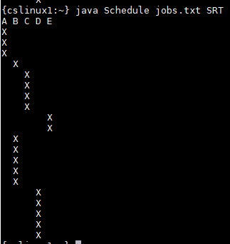

Highest Response Ratio Next

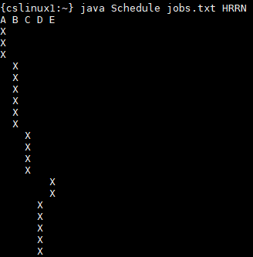

FeedBack

