**Data Sources:** HTML, Challenge Point: 8

**\***[***Estee Lauder***](https://www.esteelauder.com/)*: crawling and scraping multiple pages (haven’t used before), Score: 8*

**Screenshot for Cache:**

1. Screenshot for general cache files

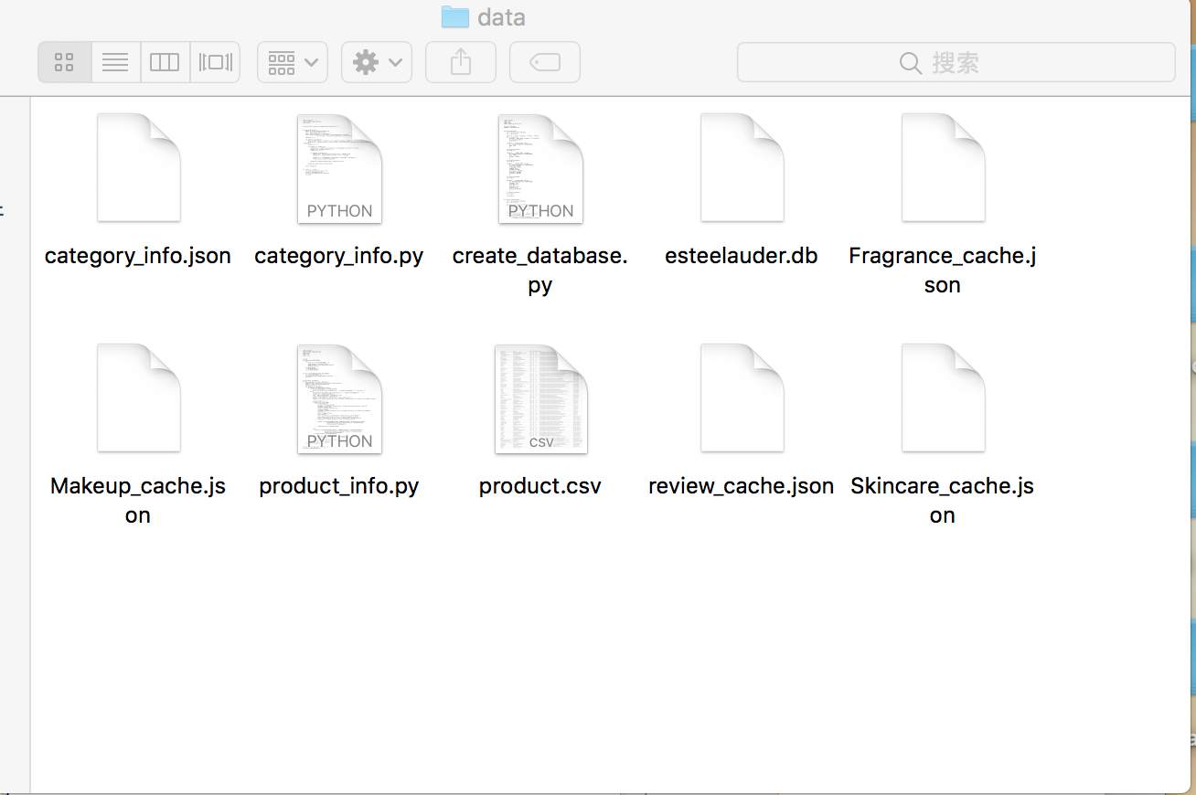

1. Screenshot for one of product cache file

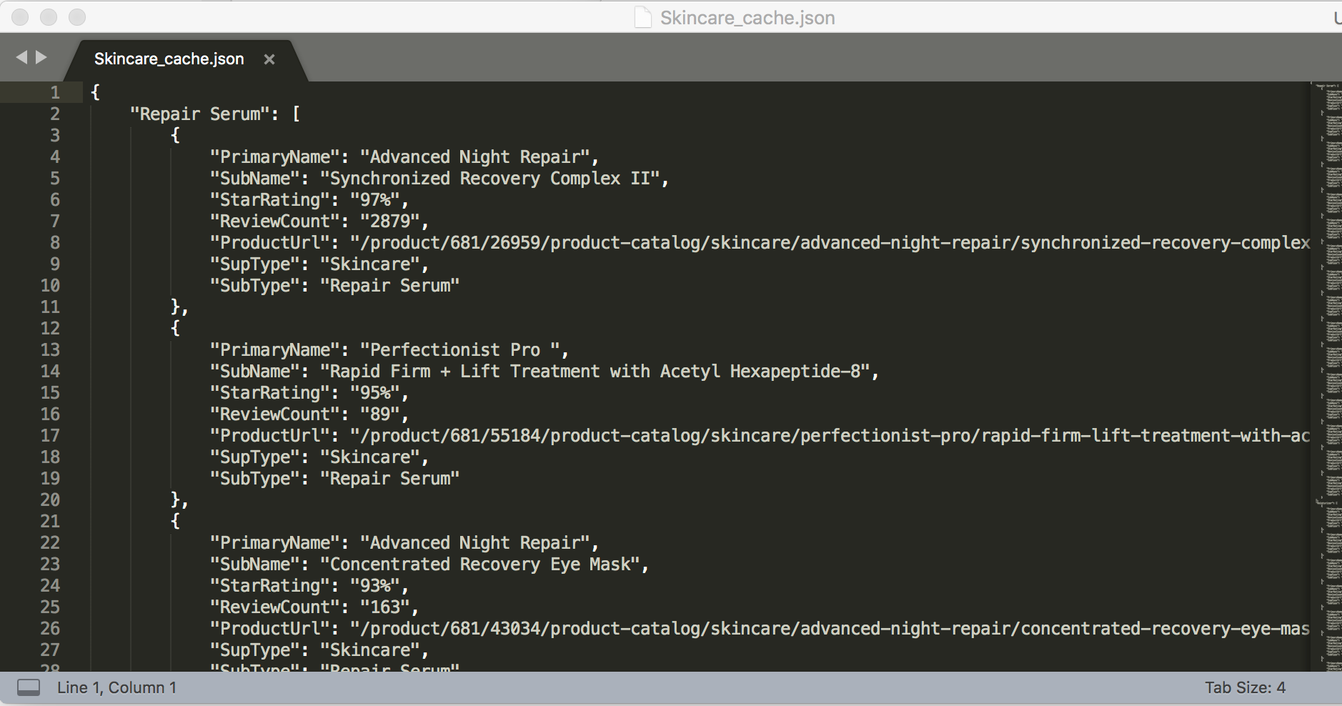

1. Screenshot for review cache file

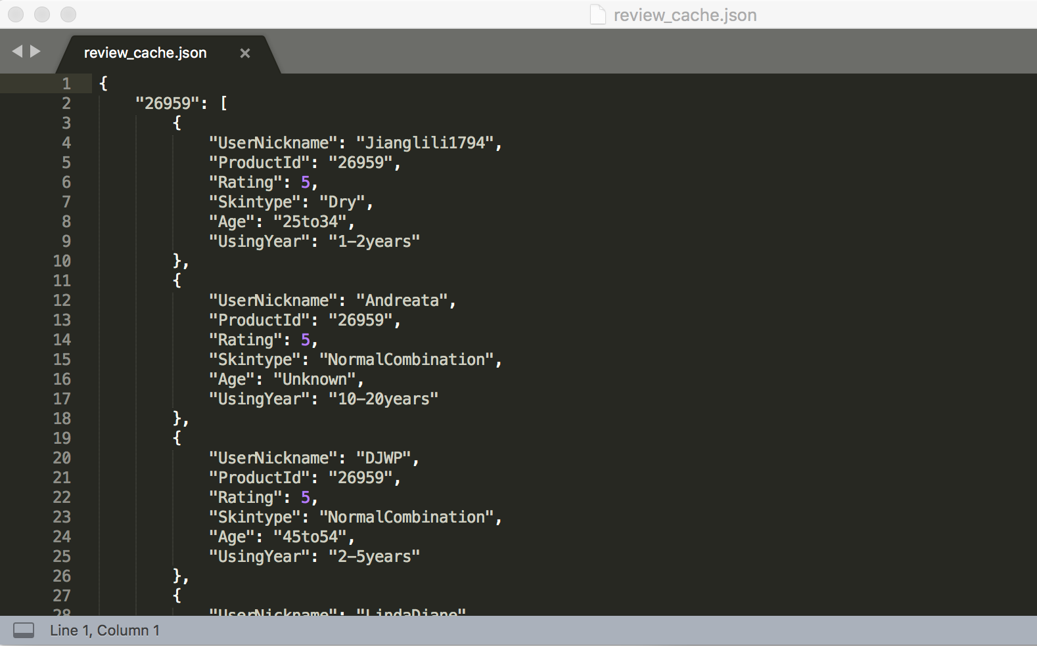

**Screenshot for Database:**

1. Screenshot for general database file

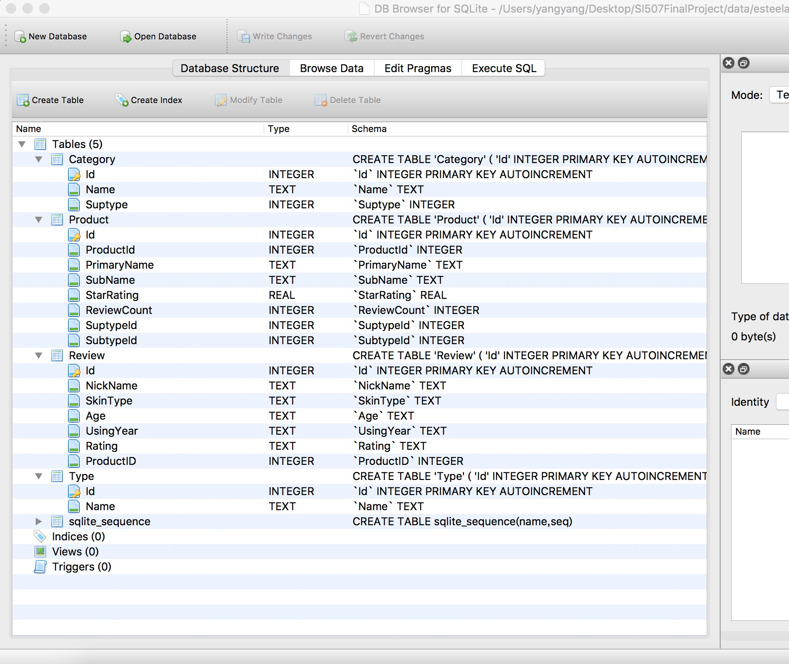

1. Screenshot for table Product

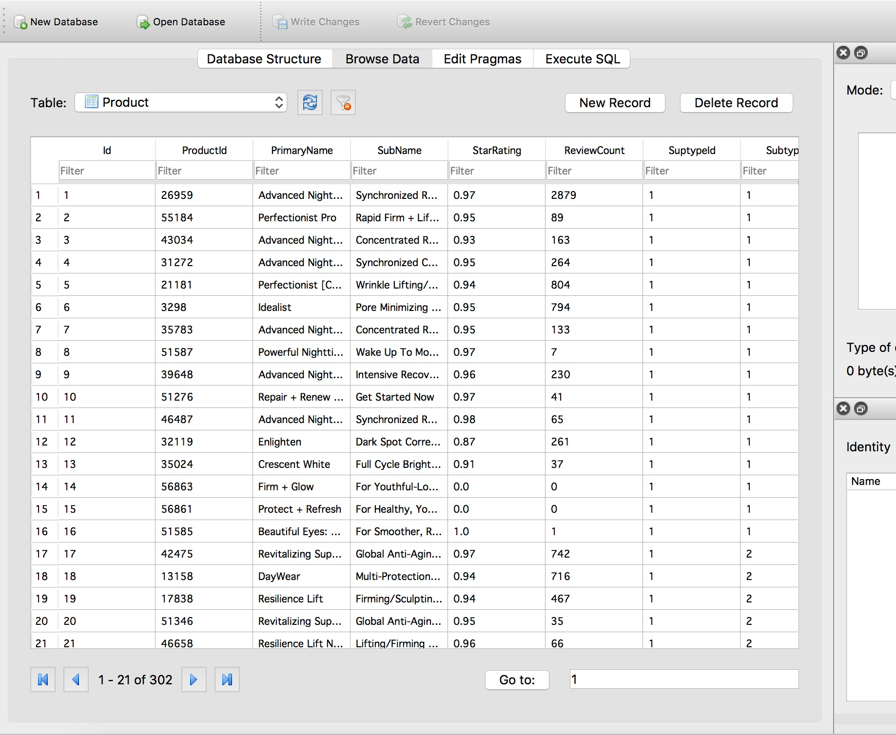

1. Screenshot for table Review

