🎨 PPTX Modern Design Styles Skill
English | 한국어 | Design Preview 🖼️ | 유튜브 영상 가이드
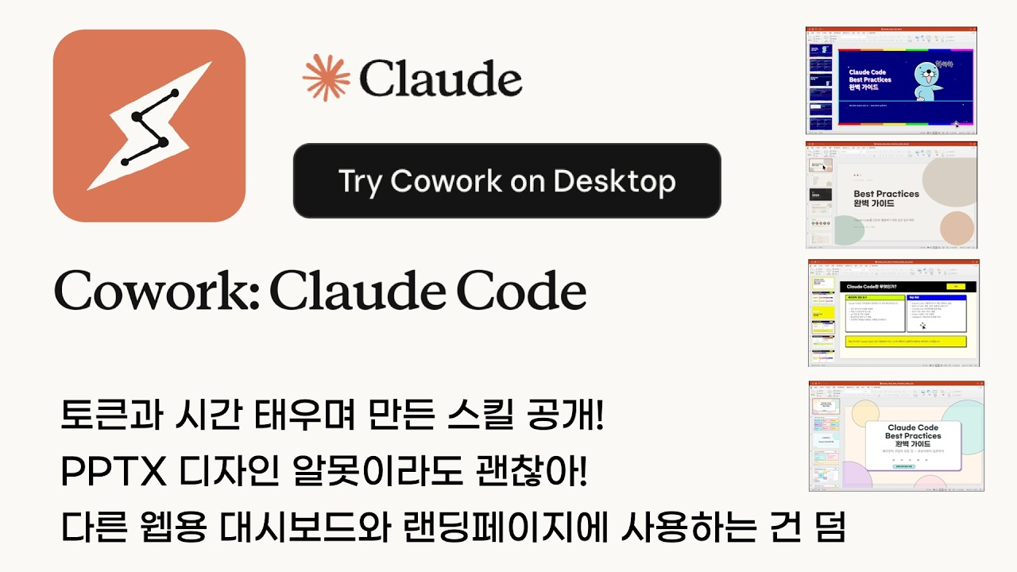
A Claude.ai skill for creating visually stunning presentations — 30 modern design styles included

Overview
This skill enables Claude.ai to apply 30 curated modern design styles when generating PPTX presentations. Each style includes precise HEX color values, font pairings, layout rules, and signature elements so every deck looks intentionally designed.

🚀 How to Use
This section guides you on how to set up and use this design skill across different AI platforms.

1. Claude.ai (Projects)
Turn Claude into your personal presentation design expert using the Projects feature.

- Setup:
  - Create a new Project in Claude.ai.
  - Upload SKILL.md and references/styles.md to the Project Knowledge.
- Usage: Ask in the project chat, e.g., "Create an outline for a PPTX deck". Claude will reference the knowledge base to apply the most optimal design from the 30 themes.

2. Gemini Antigravity (Local Skill)
Register this repository in the Antigravity agent's local skill system.

- Setup:
  - Clone or symlink this repository to your local skills directory (~/.gemini/antigravity/skills/).

ln -s $(pwd) ~/.gemini/antigravity/skills/pptx-design-styles

- Usage: Antigravity automatically detects the skill. When prompt with a request like "Make a modern presentation deck," the design process is triggered based on the conditions defined in SKILL.md.

3. Codex (Agent Skill)
Integrate these design guidelines within the Codex agent environment.

- Setup:
  - Add this project to the skills folder in your Codex workspace (e.g., .codex/skills/ or a designated path).
- Usage: When the agent detects presentation-related context during coding or drafting, it generates slide structures and styling codes following the 30 style specifications outlined in SKILL.md.

Visual Gallery
Explore a few of the 30 distinct styles available in this collection.

✨ Highlights

30 Design Styles
# | Style | Mood | Best For
01 | Glassmorphism | Premium · Tech | SaaS, AI
02 | Neo-Brutalism | Bold · Startup | Pitch decks
03 | Bento Grid | Modular · Structured | Product features
04 | Dark Academia | Scholarly · Refined | Education, research
05 | Gradient Mesh | Artistic · Vibrant | Brand launches
06 | Claymorphism | Friendly · 3D | Apps, education
07 | Swiss International | Functional · Corporate | Consulting, finance
08 | Aurora Neon Glow | Futuristic · AI | AI, cybersecurity
09 | Retro Y2K | Nostalgic · Pop | Events, marketing
10 | Nordic Minimalism | Calm · Natural | Wellness, non-profit
11 | Typographic Bold | Editorial · Impact | Brand statements
12 | Duotone Color Split | Dramatic · Contrast | Strategy decks
13 | Monochrome Minimal | Restrained · Luxury | Luxury brands
14 | Cyberpunk Outline | HUD · Sci-Fi | Gaming, infra
15 | Editorial Magazine | Magazine · Story | Annual reviews
16 | Pastel Soft UI | Soft · App-like | Healthcare, beauty
17 | Dark Neon Miami | Synthwave · 80s | Entertainment
18 | Hand-crafted Organic | Natural · Eco | Eco brands
19 | Isometric 3D Flat | Technical · Structured | IT architecture
20 | Vaporwave | Dreamy · Subculture | Creative agencies
21 | Art Deco Luxe | Gold · Geometric | Luxury, gala events
22 | Brutalist Newspaper | Editorial · Raw | Media, research
23 | Stained Glass Mosaic | Colorful · Artistic | Culture, museums
24 | Liquid Blob Morphing | Fluid · Organic Tech | Biotech, innovation
25 | Memphis Pop Pattern | 80s · Geometric | Fashion, lifestyle
26 | Dark Forest Nature | Mysterious · Atmospheric | Eco premium
27 | Architectural Blueprint | Technical · Precise | Architecture
28 | Maximalist Collage | Energetic · Layered | Advertising, fashion
29 | SciFi Holographic Data | Hologram · HUD | AI, quantum
30 | Risograph Print | CMYK · Indie | Publishing, art

File Structure
pptx-design-styles/

├── SKILL.md # Skill trigger + recommendation matrix

├── README.md # This file

├── preview/

│ └── modern-pptx-designs-30.html

└── references/

└── styles.md # Full specs: HEX, fonts, layout, signature elements

Style Selection Guide
Goal | Recommended
Tech / AI / Startup | Glassmorphism, Aurora Neon, Cyberpunk, SciFi Holographic
Corporate / Finance | Swiss International, Monochrome, Editorial Magazine
Brand / Marketing | Gradient Mesh, Typographic Bold, Duotone Split
Product / App / UX | Bento Grid, Claymorphism, Pastel Soft UI
Entertainment / Gaming | Retro Y2K, Dark Neon Miami, Vaporwave, Memphis Pop
Eco / Wellness | Hand-crafted Organic, Nordic Minimalism, Dark Forest
Luxury / Premium | Art Deco Luxe, Monochrome Minimal, Dark Academia
Science / Biotech | Liquid Blob, SciFi Holographic, Aurora Neon

📱 Full Collection Preview

Created By
TodayCode (오늘코드) — YouTube · Python & AI education in Korean

License
MIT License — free to use, modify, and distribute.

