7上英语期末综合复习卷三
（时间：60分钟 满分：100分）
第一部分 选择题（三大题；共56分）
一、单项填空（共10小题，每小题1分；满分10分）
从A、B、C、D中选出可以填入空白处的最佳选项。
1. We had__________ unusual school trip last week. I will never forget it.
A. a B. an C. the D. /
2. ---Jerry, is that boy__________ new classmate?
---Yes. Let's say hello to__________ .
A. our; he B. us; him C. ours; his D. our; him
3. The Pudong New Area, just__________ the Huangpu River, has many modern buildings.
A. over B. outside C. across D. in the centre of
4. Jim is going to join the Art Club because he likes__________ .
A. cooking B. drawing C. running D. reading
5. Tina__________ drives to work. But today she drives because of the rain.
A. always B. often C. sometimes D. hardly
6. Look! There__________ a computer and some books on the teacher's desk.
A. is B. are C. was D. were
7. If you take this train, you__________ in Shanghai tomorrow morning.
A. arrive B. will arrive C. arrives D. arrived
8. ---__________ did it take them to get to the Space Museum?
---Half an hour.
A. How many B. How much C. How long D. How often
9. Tom wore his glasses__________ he could see clearly.
A. so that B. if C. as soon as D. when
10. ---I dropped my cup onto the ground and broke it.
---Oh,__________ .
A. I'm sorry to hear that B. that's all right
C. of course you can D. it sounds interesting
二、完形填空（共15小题，每小题2分；满分30分）
阅读短文，掌握其大意，然后从A、B、C、D中选出可以填入空白处的最佳选项。
Jane is a kind girl. She is only ten years old, _____11_____ she has big ideas of helping other kids.
Jane _____12_____ a winter camp at the age of eight. During her stay in the camp, she went to _____13_____ some kids in poor areas. She was _____14_____ that the kids there didn't have new clothes to wear and toys to _____15_____ with. After she returned home, she _____16_____ thinking about what to do to help those kids.
One morning Jane _____17_____ some elder kids selling lemon（柠檬）juice by the street. They wanted to make _____18_____ to help their friends. Then she thought of an _____19_____ .
With the help of her father, Jane had _____20_____ own lemonade stand（摊档）. In a week's _____21_____ ,the stand made $52. It was _____22_____ a little money, but she helped 12 kids with it! She became very excited when she saw smiles _____23_____ their faces.
After that, her father helped her _____24_____ a program（活动）called Jane's Lemonade for Love. Until now, she has made more than $17000! She is going to _____25_____ the money on clothes, toys and books for the poor kids.
11. A. but B. so C. for D. and
12. A. travelled around B. joined in C. learnt about D. walked along
13. A. teach B. know C. protect D. visit
14. A. nervous B. sad C. bored D. excited
15. A. study B. make C. play D. tie
16. A. kept B. enjoyed C. completed D. practiced
17. A. stopped B. heard C. thought D. saw
18. A. clothes B. toys C. money D. juice
19. A. idea B. interview C. way D. plan
20. A. her B. his C. my D. your
21. A. holiday B. time C. energy D. trip
22. A. also B. never C. only D. hardly
23. A. in B. for C. like D. on
24. A. follow B. start C. learn D. attend
25. A. put B. provide C. give D. spend
三、阅读理解（共8小题，每小题2分；满分16分）
阅读短文，然后根据其内容从A、B、C、D中选出最佳选项。
A
Dear Liu Yang,
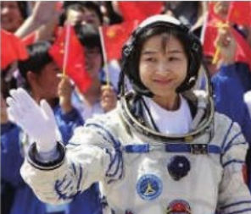
I'm Angela Liu, a junior high school student in Beijing. My classmates and I were really excited to learn that you were not only the first Chinese woman in space but also the youngest astronaut from China. That makes me admire（钦佩）you very much.
Life at school is busy, but as soon as I get home, I like reading books. My favourite books are about space. When I read them, I imagine（想象）that I'm an astronaut and I'm in a spaceship. I want to be an astronaut in the future, too.
It must be very exciting to live in space. I want to know what your life was like there. What did it feel like to be in space? What did you see? What did you eat? How did you sleep? What did the stars look like from space?
My classmates and I admire you very much. All of my classmates will work harder and do our best to realize（实现）our dreams, just like you.
I hope to hear from you.
Yours,
Angela Liu
26. What is Angela Liu doing in Beijing?
A. Studying. B. Teaching. C. Travelling. D. Working.
27. Angela wants to learn about Liu Yang's__________ .
A. family life B. school life C. space life D. daily life
28. What must Liu Yang write in her letter to Angela?
A. Why she became an astronaut. B. What food she ate in space.
C. How she realized her dream. D. Which book she likes best.
29. From the letter, we know Angela's dream is__________ .
A. to be an astronaut B. to read her favourite books
C. to write to Liu Yang D. to work hard and do her best
B
What is your club type（类型）? Read the following questions. Which answer describes（描述）you best? Circle it. Then add up your score and find out your club type!
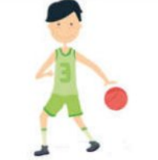
1. Do you get enough exercise?
a. Always! I love playing sports.
b. Not really. I like to listen to music and relax.
c. Not really. I usually draw and paint in my free time.
d. Never. I like to read books and exercise my mind.
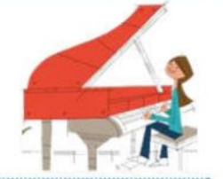
2. What is your favourite school subject?
a. P. E. I like to be active.
b. Music. I like to play an instrument.
c. Art. I love to draw and paint.
d. English and Chinese. I enjoy reading and writing.

3. What do you do on a cold and snowy day?
a. I can't sit quietly. I must do something active inside.
b. I stay in my room and listen to music or play an instrument.
c. I paint or draw a picture.
d. I read a book or write a story.
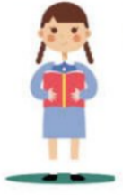
4. You are going on a trip. But you can only take one thing with you. What do you take?
a. Running shoes. I can't go anywhere without them.
b. A music player. I can't live without music.
c. Some paper and a pencil. I can draw a picture on the way.
d. A good book. I will be bored without a book.

Now look at your answers!
3 or more “a” → Sports
3 or more “b” → Music
3 or more “c” → Art
3 or more “d” → Reading
Or maybe you are in the middle!
For example: 2 “a” + 2 “b” → Sports and Music
30. The underlined word “active” may mean“__________ ”.
A. 文艺的 B. 安静的 C. 活跃的 D. 轻松的
31. What does “them” in Question 4 refer to（指的是）?
A. running shoes B. good books C. music players D. paper and pencils
32. Now Jack is a member of the Music Club, so his answers to the four questions may be__________ .
A. b-b-c-d B. b-a-b-b C. a-c-d-c D. d-a-d-a
33. What's the best title for the text?
A. What club do you have? B. What club is the best?
C. What club are you in? D. What club is right for you?
第二部分 非选择题（四大题；共44分）
四、单词拼写（共5小题，每小题1分；满分5分）
根据汉语提示，写出单词的正确形式。
34. The little boy is good at making __________ ships. （模型）
35. I don't like this camera. Show me __________ please. （另一个）
36. The snow will soon __________ when the warm weather comes. （消失）
37. If we stop __________ for a few minutes, we will die. （呼吸）
38. I'll never forget the __________ of the West Lake. （美丽）
五、阅读问答（共5小题，每小题2分；满分10分）
阅读短文，然后根据内容回答所提问题。
The Space Hotel
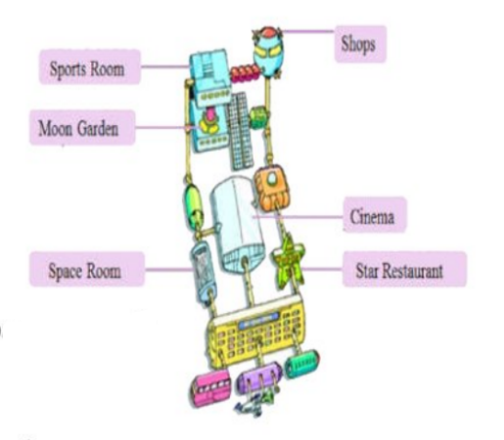
Cinema
Tomorrow: an exciting film about space.
Times: 3 p. m. and 8 p. m.
Moon Garden
Grows food for our restaurant.
Open from 2 p. m. to 5 p. m.
Shops
Buy great things such as Moon rocks and space postcards.
Open from 11 a. m. to 6 p. m.
Space Room
The best place to watch space and see the Earth.
Open all day.
Tomorrow: fly over China at 9 a. m.
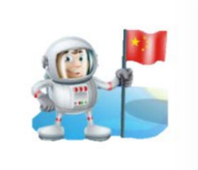
Sports Room
Good exercise machines and fun games for children.
Open from 10 a. m. to 3 p. m.
Star Restaurant
The best restaurant in space. Come for a big meal.
Open from 7 a. m. to 11 p. m.
39. Which places can you visit at 8 o'clock in the morning?
_______________________________________________________________________________
40. How many films can you see tomorrow afternoon?
_______________________________________________________________________________
41. What does Moon Garden grow food for?
_______________________________________________________________________________
42. When do the shops close?
_______________________________________________________________________________
43. Will a 7-year-old boy have a good time in the Sports Room?
_______________________________________________________________________________
六、阅读填空（共9小题，每小题1分；满分9分）
阅读短文，然后用短文括号中所给词的适当形式填空。
In the afternoon, I had a dream.
In the dream, it was 2050. Every morning, our family's robot woke（叫醒）me up. He brushed my 44. __________ （tooth）and washed my face. Then he 45. __________ （make）breakfast for me. After breakfast, he played table tennis with me. He did so 46. __________ （good）in it. This made me more and more 47. __________ （interest）in sports. We played and played and enjoyed 48. __________ （us）. When I wanted 49. __________ （watch）TV, the robot turned the TV on for me. Staying with the robot made me 50 __________ （real）happy. Then 51. __________（first）day, the robot said to me, “I'm cleverer than you. Why should I work for you? ” Then the robot left. I 52. __________ （feel）very sad. I cried and cried.
Then my mother woke me up and I knew it was only a dream.
七、综合阅读（共10小题，每小题2分；满分20分）
阅读短文，然后按要求完成第53—62小题。
A
Sam and Helen's grandparents have unusual collections. They collect almost everything. There are eight doorbells on their front door!
“This silver doorbell is my favourite,” said Helen. She pushed it（A）__________ soon Grandpa opened the door.
“Come in, my dear（B）grandson and granddaughter! ”he said.
“Who started collecting doorbells, Grandpa? ”asked Sam.
“Your grandma,” he answered. “She loves doorbells. ”
“What do you like collecting, Grandpa? ”asked Helen.
“I like collecting newspapers. ”
They went inside and saw newspapers（C）here and there.
“Hello children! ”called Grandma. “（D）让我们喝些茶吧。 ”
The children followed her into the living room and saw lots of toys there. There was hardly any space for the children to sit down.
“（E）__________ toys are these? ”asked Helen.
“They're ours,” said Grandma. “We both like collecting toys. ”
“But remember,” said Grandpa, “we have a lot of free time! （F）You have your school work to do, so you shouldn't spend too much time collecting things! ”
53. 在文中（A）和（E）的空白处分别填入一个适当的单词：__________ __________
54. 写出文中画线部分（B）和（C）的同义词或近义词：__________ __________
55. 将文中画线部分（D）译成英语：________________________________________
56. 将文中画线部分（F）改写为：__________ spend too much time collecting things __________ you have your school work to do.
57. 从文中找出能够说明本文主旨大意的中心短语：____________________
B
Last month we asked a hundred students about their free time activities. Our questions were about exercise, use of the computer and watching TV. Here are the results（结果）.
We found that only fifteen students exercise every day. Forty-five exercise four to six times a week. Twenty exercise only one to three times a week. ①
We all know that many students often use computers,（A）but we were surprised that ninety of them use the computer every day. The other ten use it three or four times a week. ② Most students use it for fun and not for homework.
The answers（B）__________ our questions about watching TV were also interesting. Only two of the students watch TV one to three times a week. Thirteen watch TV four to six times a week. And eighty-five watch TV every day! ③ Many students like to watch sports,（C）__________ more students like to watch game shows.
It's all right to use computers or watch TV, but we hope our students can exercise more（D）因为这对他们有好处. So start exercising before it's too late!
58. 将文中画线部分（A）改写为：..., but we were __________ that ninety of them use the computer __________ .
59. 在文中（B）和（C）的空白处分别填入一个适当的单词：__________ __________
60. 将文中画线部分（D）译成英语：________________________________________
61. 在文中①②③选出能够填入“And twenty students never do it! ”的位置：__________
62. 从文中找出两个学生喜爱的电视节目：__________ _______

