**沈阳市第一二六中学教育集团2023—2024学年度下学期**

**八年级英语学科 3月作业检查**

**检查时长：120分钟 作业满分：120分**

**听力试题 满分：20分**

**一、短对话理解（共8小题；每小题1分，共8分）**

**听下面8段短对话。每段对话后有一道小题，从每题所给的A、B、C三个选项中选出最佳选项。听完每段对话后，你将有10秒钟的时间来回答有关小题和阅读下一小题。每段对话仅读一遍。**

1．What did Lucy think of her summer holiday?

A．Tiring. B．Boring. C．Great.

2．Who are the speakers talking about?

A．Albert Einstein. B．Isaac Newton. C．William Shakespeare.

3．What do the woman’s family usually do together?

A．Cook dinner. B．Take trips. C．Take walks.

4．How long did the man sleep?

A．For 6 hours. B．For 5 hours. C．For 3 hours.

5．What does the woman advise the man to eat every day?

A．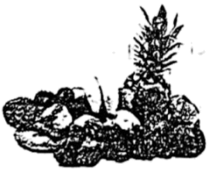 B．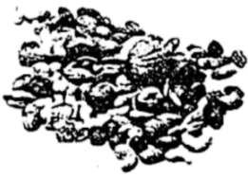 C．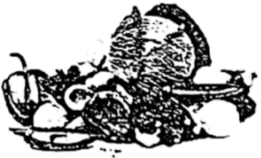

6．How does Jack go to school?

A．On foot. B．By bus. C．By bike.

7．What is the man?

A．An engineer. B．A teacher. C．A doctor.

8．Where did Tom go yesterday?

A．To the museum. B．To the bookstore. C．To the park.

**二、长对话理解（共12小题；每小题1分，共12分）**

**听下面4段长对话。每段对话后有三道小题，从每题所给的A、B、C三个选项中选出最佳选项。听完每段对话后，你将有 10秒钟的时间来回答有关小题和阅读下一小题。每段对话读两遍。**

听第9段材料，回答第9至11题。

9．Whose best friend is Ben?

A．The man’s. B．The woman’s. C．The man and the woman’s.

10．How long will Ben stay?

A．For two weeks. B．For three weeks. C．For two months.

11．What is Ben good at?

A．Playing volleyball. B．Playing basketball. C．Playing football.

听第10段材料，回答第12至14题。

12．What is James looking at?

A．An ad. B．A map. C．A poster.

13．What is the picture show about?

A．Asian culture. B．African culture. C．European culture.

14．Where does this conversation probably take place?

A．At the museum. B．At home. C．At school.

听第11段材料，回答第15至17题。

15．Why don’t many people talk to friends or parents about their problems sometimes?

A．Because the problems are easy

B．Because they have no chance to do so.

C．Because they feel ashamed.

16．How do people usually feel after getting Aunt Alice’s advice?

A．Happy. B．Sad. C．Surprised.

17．Who is the woman worried about?

A．Her elder brother. B．Her elder sister. C．Her younger sister.

听第12段材料，回答第18至20题。

18．Where is the story about white elephants from?

A．Ancient Thailand. B．Ancient China. C．Ancient Egypt.

19．Who might the king give a white elephant to?

A．A person who made him happy.

B．A person who made him angry.

C．A person who made great achievements.

20．Which of the following can be called a white elephant?

A．Something interesting but cheap.

B．Something expensive but useless.

C．Something cheap but useful.

**笔试试题 满分：100分**

**一、选择填空（共10小题，每小题1分：满分10分）**

1. They didn’t watch the movie together. They went to the cinema ______.

A. happily B. actually C. separately D. properly

2. He wanted to enter the university and at last he ______ it.

A. made B. had C. took D. got

3. We ______ help the homeless children so that they can live better.

A. needn’t to B. don’t need C. need to D. needn’t

4. He did everything he could ________ the old man.

A. save B. saving C. saved D. to save

5. —Mr. Li asked me to ______ you about the meeting this afternoon. Don’t forget it!

—OK. I won’t.

A. warn B. teach C. ask D. remind

6. Our school basketball team is excellent. They often play ________ other teams and win.

A. to B. for C. against D. on

7. Wang Damin is a fisherman. _______ he is over 65, he is very fit and still enjoys working.

A. Unless B. If C. After D. Though

8. The painting is really interesting. The people in it look real. They ______ to be alive.

A. sound B. appear C. look D. feel

9. The fish ______ in the market tomorrow.

A. will sell B. will sold C. will be sold D. will been sold

10. The shirt matches your trousers well. Their colours really ______.

A. go together B. go ahead C. go over D. go out

**二、阅读理解（共20小题，每小题2分；满分40分）**

**第一节 阅读下面语言材料，从每题所给的四个选项中选出最佳选项**

**（A）**

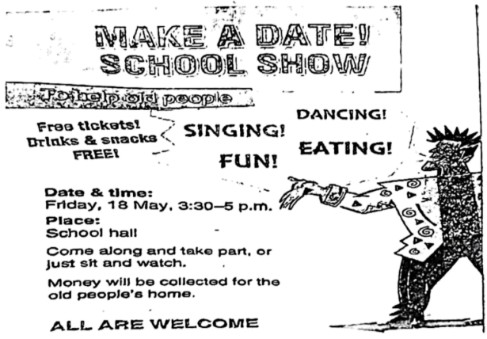

11. Why will the school show be held?

A. To make friends. B. To help old people.

C. To have fun. D. To make money.

12. What things are free according to the poster?

①tickets ②books ③snacks ④drinks ⑤toys

A. ①②④ B. ②④⑤ C. ②③⑤ D. ①③④

13. How long will the school show last?

A. For 30 minutes. B. For 60 minutes. C. For 90 minutes. D. For 120 minutes.

14. Who can take part in the school show?

A. Only students. B. Only parents. C. No one. D. Everyone.

**（B）**

①Besides the famous Great Wall and Tian’ anmen Square, what other places do you want to visit in Beijing? How about going to some interesting museums? You can learn a lot while having fun!

**China Bee Museum**

②Bees are tiny insects, but China Bee Museum is quite big. There are about 600 bee specimens (标本) in the museum. There is also a great bee-keeping exhibition. Do you want to learn more about where honey comes from and how it is made? Then you can go there to watch! Please remember to taste many different types of honey if you go there.

**China Watermelon Museum**

③If you love watermelon, you will feel at home in China Watermelon Museum. Most of the exhibits are about how people grow and develop different kinds of watermelons. Visitors can also see many paintings and other art pieces about this summer fruit in the museum. Great statues (雕塑) at the entrance are a must-see attraction.

**Beijing Diabolo Museum**

④Playing diabolo (空竹) is one of the most popular outdoor activities in Beijing. A diabolo looks like a dumbbell (哑铃). You can throw it up and catch it with a string tied between two bamboo sticks. Beijing Diabolo Museum has about 450 diabolos. It also teaches many diabolo skills. You can learn how to play diabolo yourself!

15. The underlined word “tiny” in Paragraph 2 probably means ______.

A. funny B. beautiful C. small D. quiet

16. We can see some art pieces in ______.

A. Tian’ anmen Square B. China Watermelon Museum

C. China Bee Museum D. Beijing Diabolo Museum

17. How many diabolos are there in Beijing Diabolo Museum?

A. About 600. B. About 500. C. About 350. D. About 450.

18. Which of the following best shows the structure of the passage?

A. 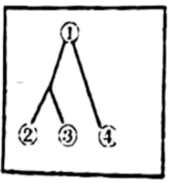 B. 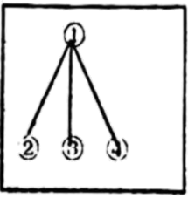 C. 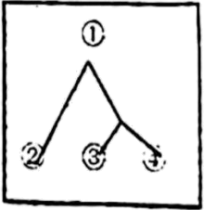 D. 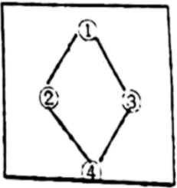

**（C）**

Confucianism (儒家思想) has been followed by Chinese people for more than two thousand years.

To help people understand how to behave towards others, Confucianism teaches the Five Constants (五常). These are *ren, yi, li, zhi* and *xin*. They are general virtues (美德) around the world. The most important two are *ren* and *li.*

*Ren* is the feeling of care and love we should have for others. Confucius explained ren could best be understood as loving others. He is famous for teaching people “What you do not want done to yourself, do not do to others”. It is quite similar to what is known in the West as the Golden Rule (treat others as you wish to be treated).

While the meaning of *ren* is easy to understand, *li* is a little harder to express. It can be thought of as duty or even respect. Generally, *li* is the way we should connect with people in our everyday life. In Confucian writings. discussions about *li* include the proper way to drink tea and how to remember ancestors (祖先). While *ren* is mostly about our opinions and feelings, *li* is about how we express our opinions and feelings towards others and towards the world around us.

Perhaps the most well-known Confucian virtue is *xiao*. This is the duty children have to their parents. *Xiao* means loving, respecting, obeying and taking care of one’s parents in their old age. In Confucianism, *xiao* is important for a harmonious (和谐的) society: Without it, the whole world would fall into a mess.

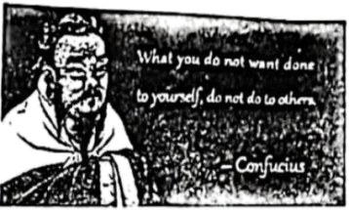

19. Which are the most important of the Five Constants?

A. *Ren* and *yi*. B. *Li* and *xin*. C. *Ren* and *li*. D. *Yi* and *zhi*.

20. What is the best Chinese for the underlined sentence in Paragraph 3?

A. 己所不欲，勿施于人。 B. 学而不思则罔，思而不学则殆。

C. 博学于文，约之以礼。 D. 君子和而不同，小人同而不和。

21. Which of the following is an example of *li*?

A. Building a peaceful society. B. Taking care of one’s children.

C. Learning all through one’s life. D. Following the rules for drinking tea.

22. What does the text mainly tell us about Confucianism?

A. Its long history. B. Its general virtues. C. Its new challenges. D. Its golden rules.

**（D）**

On August 4th, two men and two women were hit by lightning while visiting Washington’s Lafayette Square, just north of White House. All four people were taken to hospital quickly. Three of them later died.

Take lightning storms seriously. If you’re outdoors, it is important to know how to keep away from lightning.

**When thunder roars, go indoors**. Quickly go into a room such as a shopping center, home, or office.

**Are you in an open area?** Make sure that you’re not at the highest point. especially when you’re in an open area. Look for buildings not in high places, at the same time, be careful not to get caught in water.

**Are you in a car?** If you’re in your car during a lightning storm, close your windows and keep an eye out. Stop the car when you can’t see the road.

**Are you around water?** Keep away from water and don’t swim or row a boat if a storm is nearby. If you’re on the water, leave it quickly.

________ Don’t take shelter (庇护处) under a tree that is the only one or the tallest nearby.

**Keep away from flash floods (骤发洪水).**

Lightning storms can be followed by heavy rain that could lead to flash floods. Be careful when you’re looking for a shelter in a low place.

**Don’t touch metal items and other special things.** These things, such as bikes, power lines. and golf clubs, can conduct electricity (导电).

23. The writer starts the passage by ______.

A giving a reason B. giving an opinion C. giving a number D. giving an example

24. Which of the following can be put in “______” in Paragraph7?

A. Stay away from buildings. B. Stay away from shelters.

C. Do you feel good? D. Are you in a forest?

25. What can you infer from the text?

A. Two men were hit by lightning while visiting Washington’s Lafayette Square.

B. You should go to lower places when you’re in an open area during a lightning storm.

C. You can open the windows with eyes closed if you’re in a car during a lightning storm.

D. The metal things such as bikes, power lines, and golf clubs are safe in a lightning storm.

26. Which is the best title of the passage?

A. Problems of lightning B. News about lightning

C. How to stay safe in a lightning storm D. How a lightning storm forms

**第二节**

阅读短文，从所给的选项中选出可以填入空白处的最佳选项，其中有一个多余的选项。

If you have planned a trip during summer holiday, certainly you will want to share some photos on WeChat. ___27___ Don’t worry! Here are some tips you can follow to take wonderful photos.

**Turn back and smile.**

While on the road, the moment you turn back with a smile is the most impressive. Just walk away from the camera and do a turn-back for the most natural effect. You can also pretend to hear your name called, turn back, and run your fingers through long hair. ___28___

**Look away from the camera.**

There are many ways for you to avoid looking at the camera. ___29___ Looking down into the distance or looking out of the window is a good option. If there is nothing to see, you can also choose to close your eyes and enjoy this moment of quietness.

**Take a back view photo.**

Are you a little shy when facing the camera? Taking a back view photo is a good choice, which can leave room for imagination and bring a different feeling as well.

**Take a seat.**

___30___ If there are good places to sit down, please do it! You can pose in a variety positions with your arms and legs.

Taking the perfect photo takes time and practice. If you follow these simple tricks above your photos will start coming out beautifully! Do not hesitate to go out with your friends and take more photos.

A. Not every photo needs to have you stand.

B. This is a fantastic way to increase your beauty.

C. But what if the photos are not as pretty as you expected?

D. But how do you choose and share your photographs properly?

E. For example, you can look into the sky and let the camera catch your side face.

**三、完形填空（共10 小题，每小题1分：满分10分）**

**阅读短文，理解其大意，从所给的四个选项中选出可以填入空白处的最佳选项**

Ma Li is a dessert shop owner in Yinchuan, Ningxia. On a cold morning, she received an online ___31___, but it took an hour for her to wait for the deliveryman (外卖送餐员).

When the deliveryman came. Ma was a little ___32___. “It is too cold outside and my motorbike didn’t work.” explained the deliveryman. After she heard his words, her anger was ___33___. She invited him to sit for a while and offered him a cup of hot water.

At that moment, Ma noticed the deliveryman’s face and hands were dark purple because he was working outside for too long. She felt ___34___ for him. While they were talking, Ma knew that the deliveryman ___35___ wanted to buy his daughter a birthday cake, but he thought it was a little expensive.

After the deliveryman left, Ma ___36___ what happened just now on her WeChat Moments (微信朋友圈) with two photos of the deliveryman.

Heartwarming comments (评论) poured in, such as “Life is not easy but none of us ___37___!” “Thumbs up for hard-working people!” and “Showing understanding to deliverymen.” Some even offered money for a ___38___.

The next day, Ma got in touch with the deliveryman and invited him to her shop. When they met, Ma expressed people’s ___39___ to him and gave him a cake for his daughter’s birthday. The deliveryman was ___40___.

Ma received more than 600 *yuan* in donations from her friends and customers. She said she would use the money to offer some help to people in need.

31.

A. bill B. order C. ticket D. reply

32.

A. excited B. nervous C. happy D. angry

33.

A. gone B. stopped C. lost D. broken

34.

A. lucky B. sorry C. relaxed D. tired

35.

A. widely B. nearly C. really D. hardly

36

A. found B. checked C. shared D. heard

37.

A. give up B. grow up C. take up D. keep up

38.

A. bag B. cake C. coat D. bike

39.

A. sadness B. suggestions C. expectation D. kindness

40.

A. helpful B. careful C. thankful D. wonderful

**四、语篇填空（共10小题，每小题1分；满分10分）**

阅读短文，在空白处填入一个适当的单词或用括号内所给词的正确形式填空，使短文通顺，连贯。

Hanfu has become popular again in recent years. A growing number of young people in China are starting to wear the ___41___ (tradition) Han Chinese clothing. The style has even attracted some foreigners. One of them is Rian, a young man from Brazil.

Rian lives in Xi’an. Two years ago, he came to the beautiful city and became ___42___ English teacher at a kindergarten. After seeing many people wearing Hanfu in the streets, Rian had a strong ___43___ (interesting) in it and wanted ___44___(try) it on himself. “My ___45___ (one) taste of Hanfu was the Tang style. It is fun to wear it.” said the young man. “Today, it is still my favorite Hanfu style.” Every time he puts it ___46___, he feels as if he has travelled back to ancient times.

Since then, Hanfu has helped Rian learn more about China. In the past, the only thing he knew about the country was that it had a long history and a rich culture. But now Hanfu has shown ___47___ (he) more details about Chinese culture.

Rian wants to share his feelings with friends both in China ___48___ abroad, so he begins to make videos of himself trying on Hanfu and the videos ___49___ (post) up on Western social media platforms. It has ____50____ (quick) become a hot hit on the Internet. He spreads Chinese culture in his own way.

**五、阅读与表达（共4小题，71-73小题，每小题2分，74小题4分：满分10分）**

阅读短文，然后根据内容回答问题

Look at the diary from Tom and answer the following questions.

|  |
| --- |
| Friday, 8 July  Tomorrow I’m going to take part in an exchange programme in London. I’ll be there for two weeks. Over the two weeks, I hope to learn about British culture and practice my English. I’ll be an exchange student at a famous school in London. I’m already a little nervous now because I don’t know anyone there. However, the British students are the same age as me, so I think we’ll become good friends. They’ll introduce me to many new things. I also plan to tour around London. The next two weeks should be a good experience for me. |

51 What is the text above?

_______________________________________

52. When is the text written?

_______________________________________

53. Why is Tom already a little nervous now?

_______________________________________

54. What do you think of being an exchange student? Why?

_______________________________________

**六、书面表达（满分20分）**

55. 假设你制作了一部卡通短片*A Lovely Dog*，并获得了“国际卡通片制作大赛(International Cartoon-making Competition)的金奖。英国*Times*的记者准备对你进行采访请你写一篇英语短文，谈谈制作这部卡通片的过程。

要点如下：

1．参赛原因；

2．制作过程；

3．比赛感受或收获。

注意：

（1）词数为80-100：短文开头已给出，不计入总词数；

（2）可适当增加细节，以使行文连贯；

（3）文中不能出现真实姓名及学校名称等。

I’m so lucky to win the prize.

___________________________________________________________________________________________________________________________________________________________________________________________________________________________________________________________________________________________________________________________________________________

**沈阳市第一二六中学教育集团2023—2024学年度下学期**

**八年级英语学科 3月作业检查**

**检查时长：120分钟 作业满分：120分**

**听力试题 满分：20分**

**一、短对话理解（共8小题；每小题1分，共8分）**

**听下面8段短对话。每段对话后有一道小题，从每题所给的A、B、C三个选项中选出最佳选项。听完每段对话后，你将有10秒钟的时间来回答有关小题和阅读下一小题。每段对话仅读一遍。**

1．What did Lucy think of her summer holiday?

A．Tiring. B．Boring. C．Great.

2．Who are the speakers talking about?

A．Albert Einstein. B．Isaac Newton. C．William Shakespeare.

3．What do the woman’s family usually do together?

A．Cook dinner. B．Take trips. C．Take walks.

4．How long did the man sleep?

A．For 6 hours. B．For 5 hours. C．For 3 hours.

5．What does the woman advise the man to eat every day?

A． B． C．

6．How does Jack go to school?

A．On foot. B．By bus. C．By bike.

7．What is the man?

A．An engineer. B．A teacher. C．A doctor.

8．Where did Tom go yesterday?

A．To the museum. B．To the bookstore. C．To the park.

**二、长对话理解（共12小题；每小题1分，共12分）**

**听下面4段长对话。每段对话后有三道小题，从每题所给的A、B、C三个选项中选出最佳选项。听完每段对话后，你将有 10秒钟的时间来回答有关小题和阅读下一小题。每段对话读两遍。**

听第9段材料，回答第9至11题。

9．Whose best friend is Ben?

A．The man’s. B．The woman’s. C．The man and the woman’s.

10．How long will Ben stay?

A．For two weeks. B．For three weeks. C．For two months.

11．What is Ben good at?

A．Playing volleyball. B．Playing basketball. C．Playing football.

听第10段材料，回答第12至14题。

12．What is James looking at?

A．An ad. B．A map. C．A poster.

13．What is the picture show about?

A．Asian culture. B．African culture. C．European culture.

14．Where does this conversation probably take place?

A．At the museum. B．At home. C．At school.

听第11段材料，回答第15至17题。

15．Why don’t many people talk to friends or parents about their problems sometimes?

A．Because the problems are easy.

B．Because they have no chance to do so.

C．Because they feel ashamed.

16．How do people usually feel after getting Aunt Alice’s advice?

A．Happy. B．Sad. C．Surprised.

17．Who is the woman worried about?

A．Her elder brother. B．Her elder sister. C．Her younger sister.

听第12段材料，回答第18至20题。

18．Where is the story about white elephants from?

A．Ancient Thailand. B．Ancient China. C．Ancient Egypt.

19．Who might the king give a white elephant to?

A．A person who made him happy.

B．A person who made him angry.

C．A person who made great achievements.

20．Which of the following can be called a white elephant?

A．Something interesting but cheap.

B．Something expensive but useless.

C．Something cheap but useful.

**笔试试题 满分：100分**

**一、选择填空（共10小题，每小题1分：满分10分）**

【1题答案】

【答案】C

【2题答案】

【答案】A

【3题答案】

【答案】C

【4题答案】

【答案】D

【5题答案】

【答案】D

【6题答案】

【答案】C

【7题答案】

【答案】D

【8题答案】

【答案】B

【9题答案】

【答案】C

【10题答案】

【答案】A

**二、阅读理解（共20小题，每小题2分；满分40分）**

**第一节 阅读下面语言材料，从每题所给的四个选项中选出最佳选项**

**（A）**

【11~14题答案】

【答案】11. B 12. D 13. C 14. D

**（B）**

【15~18题答案】

【答案】15. C 16. B 17. D 18. B

**（C）**

【19~22题答案】

【答案】19. C 20. A 21. D 22. B

**（D）**

【23~26题答案】

【答案】23. D 24. D 25. B 26. C

**第二节**

【27~30题答案】

【答案】27. C 28. B 29. E 30. A

**三、完形填空（共10 小题，每小题1分：满分10分）**

**阅读短文，理解其大意，从所给的四个选项中选出可以填入空白处的最佳选项**

【31~40题答案】

【答案】31. B 32. D 33. A 34. B 35. C 36. C 37. A 38. B 39. D 40. C

**四、语篇填空（共10小题，每小题1分；满分10分）**

【41~50题答案】

【答案】41. traditional

42. an 43. interest

44. to try 45. first

46. on 47. him

48. and 49. are posted

50. quickly

**五、阅读与表达（共4小题，71-73小题，每小题2分，74小题4分：满分10分）**

【51~54题答案】

【答案】51. A diary.

52. On Friday, 8 July.

53. Because he doesn’t know anyone there.

54. I think being an exchange student is perfect because I can learn a foreign language and different cultures. I can go to many places of interest and make more friends too.

**六、书面表达（满分20分）**

【55题答案】

【答案】例文

I’m so lucky to win the prize. I enjoy drawing and I have some computer skills, so I decided on making a cartoon named *A Lovely Dog*. Firstly, I used a computer to draw a few pictures of a lovely dog. The pictures are a little different from each other. I made the dog wear glasses and a red hat so that it looked lovely and funny. Secondly, I added colour to the pictures and used a computer program to put the pictures together as a film. Thirdly, I did the voice of the dog according to the pictures.

Honestly speaking, making cartoons is challenging, but I feel happy to know more about pandas. More importantly, I feel proud of myself because I finished my work well and developed my drawing and computer skills as well. Thank you.