1引入JS包
<script type="text/javascript" src="proj4js-2.4.3/dist/proj4.js"></script>
2计算查找相关参数
2.1 打开ESPG.txt 搜索 “xian”
2.2 已知当地参数
如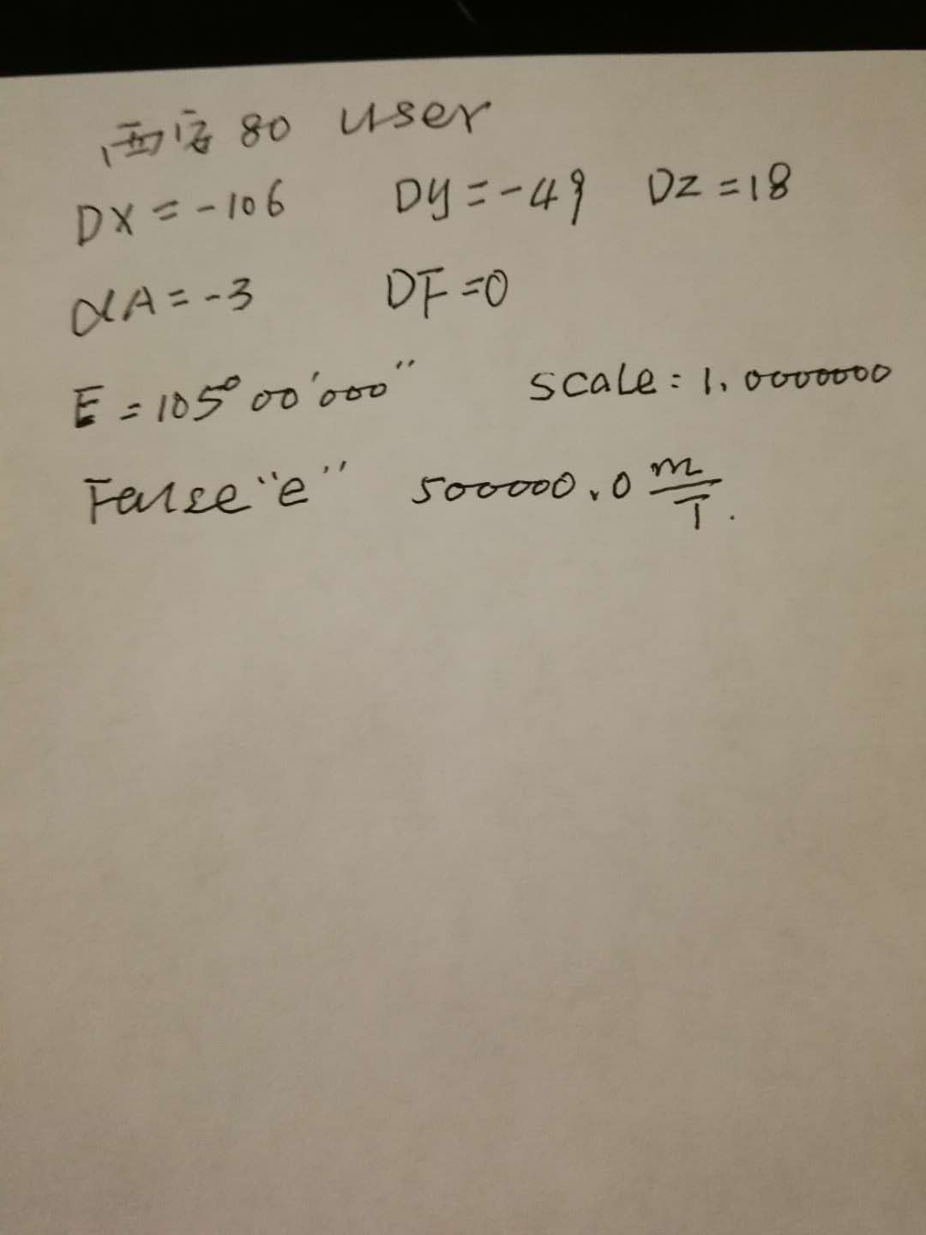
找到经线为105°的
+proj=tmerc +lat_0=0 +lon_0=105 +k=1 +x_0=18500000 +y_0=0 +a=6378140 +b=6356755.288157528 +units=m +no_defs

3替换等好后面参数
m +towgs84=-106.0,-94,-18,0,0,0,0 +no_defs

4 转换api
var point = view.toMap({x: event.x, y: event.y});

var firstProjection ='+proj=tmerc +lat_0=0 +lon_0=129 +k=1 +x_0=500000 +y_0=0 +a=6378140 +b=6356755.288157528 +units=m +towgs84=-98.0,-64,-5,0,0,0,0 +no_defs';
var mm=proj4(firstProjection,[point.x,point.y]);

$("#Potioninfo").html("<strong>经度：" + point.x.toFixed(6) + "<br> 纬度：" +point.y.toFixed(6)+"<br>X坐标：" + mm[0].toFixed(3) + "<br> Y坐标：" +mm[1].toFixed(3)+"</strong>");

