Microsoft Windows [版本 10.0.17134.285]

(c) 2018 Microsoft Corporation。保留所有权利。

C:\WINDOWS\system32>mysql -u root -p

Enter password: ******

Welcome to the MySQL monitor. Commands end with ; or \g.

Your MySQL connection id is 15

Server version: 8.0.12 MySQL Community Server - GPL

Copyright (c) 2000, 2018, Oracle and/or its affiliates. All rights reserved.

Oracle is a registered trademark of Oracle Corporation and/or its

affiliates. Other names may be trademarks of their respective

owners.

Type 'help;' or '\h' for help. Type '\c' to clear the current input statement.

mysql> use tianbao;

Database changed

mysql> create table movie(id int(10) auto_increment primary key,name varchar(30) not null,year int(4) ,director varchar(30) not null,grade int(3));

Query OK, 0 rows affected (0.13 sec)

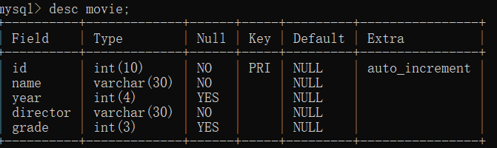

mysql> insert into movie (id,name,year,director,grade) values(1,'wobushiyaoshen','2018','wenmuye','9.6'),(2,'xihongshishoufu','2018','yanfei',"6.6"),(3,'Twilight','2009','foreigner','7.3');

Query OK, 3 rows affected (0.11 sec)

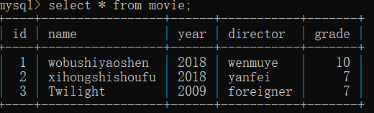

mysql> select director from movie where director like"yan%";

