Microsoft Windows [版本 10.0.16299.611]

(c) 2017 Microsoft Corporation。保留所有权利。

C:\Users\dell>mysql -u root -p

Enter password: ******

Welcome to the MySQL monitor. Commands end with ; or \g.

Your MySQL connection id is 47

Server version: 8.0.12 MySQL Community Server - GPL

Copyright (c) 2000, 2018, Oracle and/or its affiliates. All rights reserved.

Oracle is a registered trademark of Oracle Corporation and/or its

affiliates. Other names may be trademarks of their respective

owners.

Type 'help;' or '\h' for help. Type '\c' to clear the current input statement.

mysql> use tianbao;

Database changed

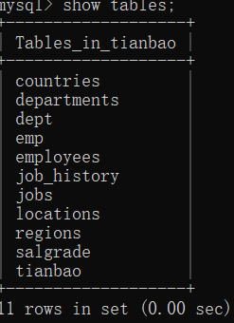

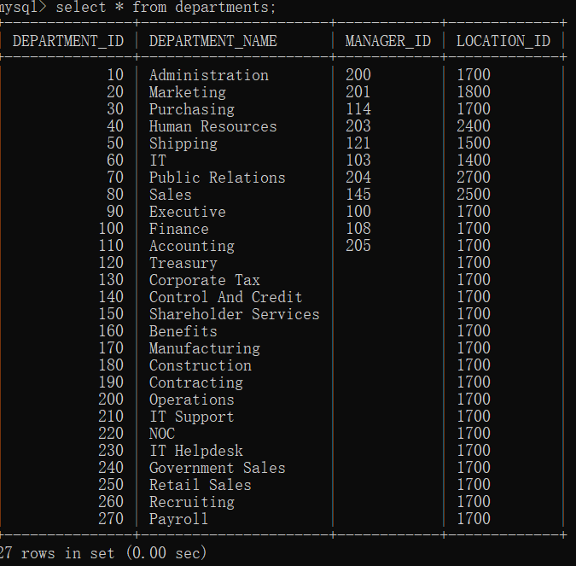

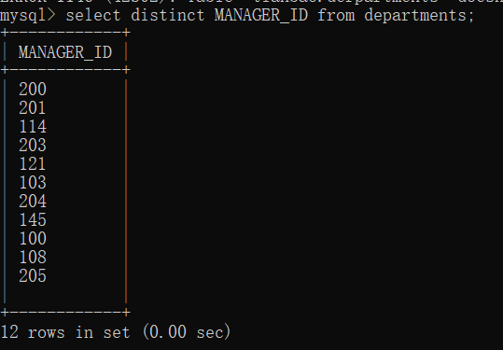

mysql> select MANAGER_ID from departments order by MANAGER_ID;

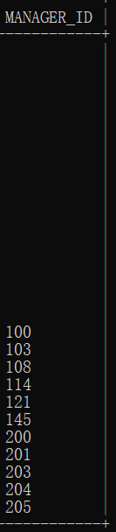

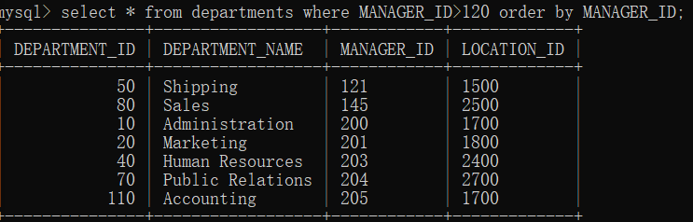

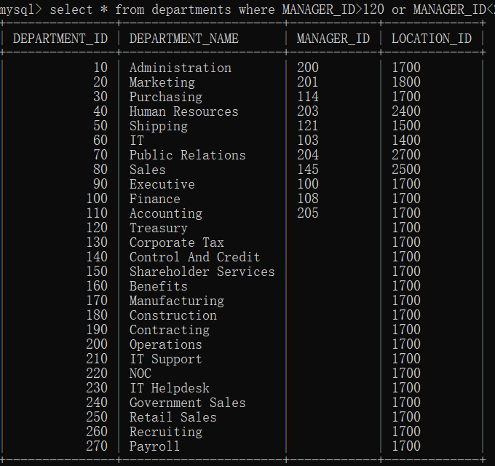

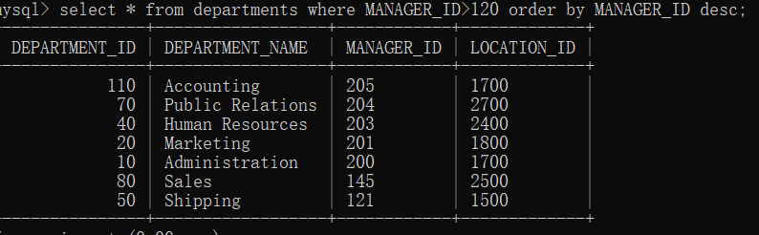

mysql> select * from departments where MANAGER_ID>120 order by MANAGER_ID desc limit 3,2;

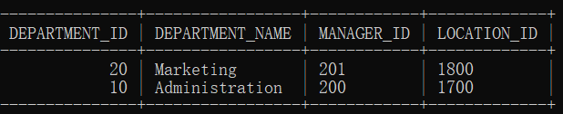

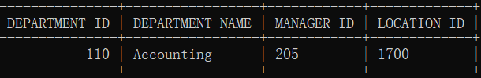

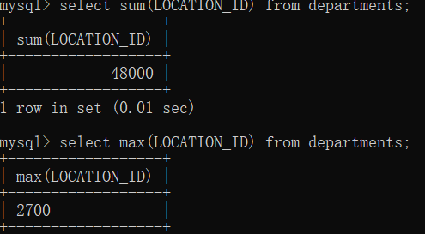

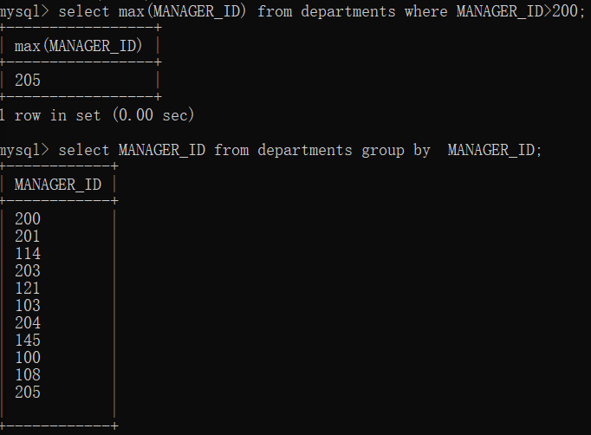

mysql> select MANAGER_ID, sum(MANAGER_ID) from departments group by MANAGER_ID;

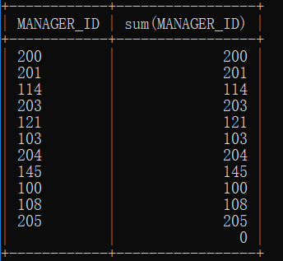

mysql> select sum(MANAGER_ID),sum(LOCATION_ID) from departments;

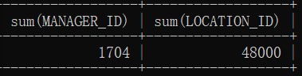

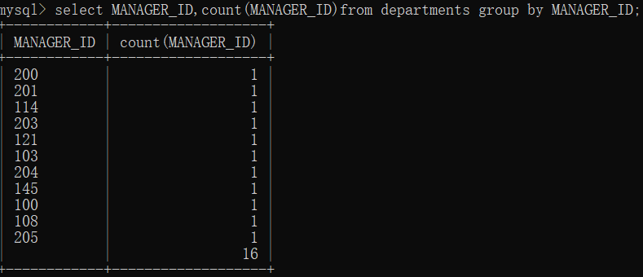

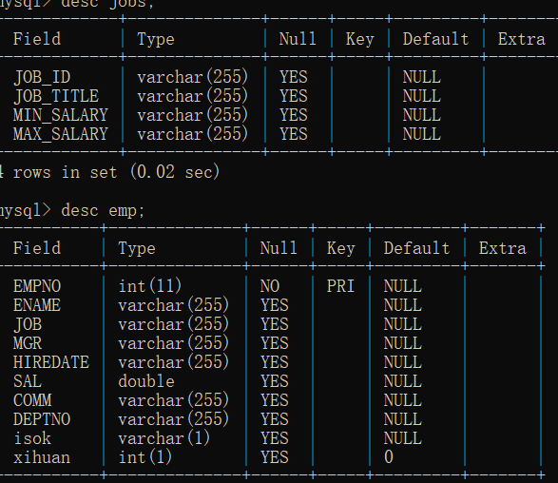

mysql> alter table jobs add xihuan int(1);

Query OK, 0 rows affected (0.06 sec)

Records: 0 Duplicates: 0 Warnings: 0

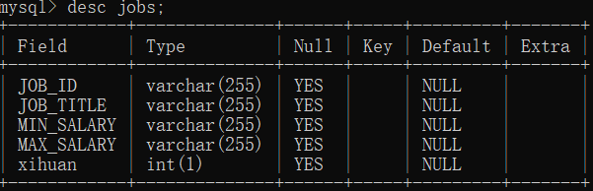

mysql> select * from jobs left join emp on jobs.xihuan=emp.xihuan;

