**UML :**

|  |
| --- |
| **MainWindow : public QMainWindow, public b2ContactListener** |
| + Q_OBJECT  - ui : Ui::MainWindow *  - scene : QGraphicsScene *  - world : b2World *  - itemList QList<GameItem *>  - timer : QTimer  - bird[5] : Bird *  - currentBird : Bird *  - slingshot : Slingshot *  - mousePress : bool  - birdAttacking : bool  - destroying : bool  - theEnd : bool  - mouseX : float  - mouseY : float  - mouseToReady : float  - birdCount : int  - score : int  - numOfPig : int |
| + MainWindow(QWidget *)  + ~MainWindow()  + *showEvent*(QShowEvent *) : void  + *eventFilter*(QObject *,QEvent *) : bool  + *closeEvent*(QCloseEvent *) : void  + restart() : void  s quitGame() : void  - tick() : void  - QUITSLOT() : void  - xPixToMet(int) : float  - yPixToMet(int) : float  - distance(float,float,float,float) : float  - velocity(b2Vec2) : float  - *BeginContact*(b2Contact *) : void  - *EndContact*(b2Contact *) : void |

|  |
| --- |
| **GameItem : public QObject** |
| + Q_OBJECT  + canDie : bool  # g_body : b2Body *  # g_pixmap : QGraphicsPixmapItem;  # g_size : QSizeF;  # g_world : b2World *  # g_worldsize : static QSizeF  # g_windowsize : static QSizeF  # hitPoint : float  # name : QString |
| + GameItem(b2World *)  + ~*GameItem*()  + setGlobalSize(QSizeF, QSizeF) : static void  + setHitPoint(float) : void  + getBody() : b2Body *  + getHitPoint() : float  + getName() : QString  + paint() : void  + *collide*(float) : virtual void |

|  |
| --- |
| **Bird : public GameItem** |
| - type : int  - skillValid : bool |
| + Bird(float, float, float, int, QTimer *, QPixmap,  b2World *, QGraphicsScene *)  + setLinearVelocity(b2Vec2) : void  + setTransform(b2Vec2, float) : void  + getX() : float  + getY() : float  + getType() : int  + getSkillValid() : bool  + getLinearVelocity() : b2Vec2  + useSkill() : void  + *collide*(float velocity) : void |

|  |
| --- |
| **Block : public GameItem** |
|  |
| + Block(float, float, float, float, QTimer *,  QPixmap, b2World *, QGraphicsScene *)  + SetTransform(b2Vec2, float) : void  + *collide*(float) : void |

|  |
| --- |
| **Land : public GameItem** |
|  |
| + Land(float, float, float, float, QPixmap, b2World *,  QGraphicsScene *)  + *collide*(float) : void |

|  |
| --- |
| **Pig : public GameItem** |
|  |
| + Pig(float, float, float, QTimer *, QPixmap, b2World *,  QGraphicsScene *)  + setLinearVelocity(b2Vec2) : void  + setTransform(b2Vec2, float) : void  + getX() : float  + getY() : float  + *collide*(float velocity) : void |

|  |
| --- |
| **Slingshot : public GameItem** |
|  |
| + Land(float, float, float, float, QPixmap, b2World *,  QGraphicsScene *)  + *collide*(float) : void |

**Screen Shot :** 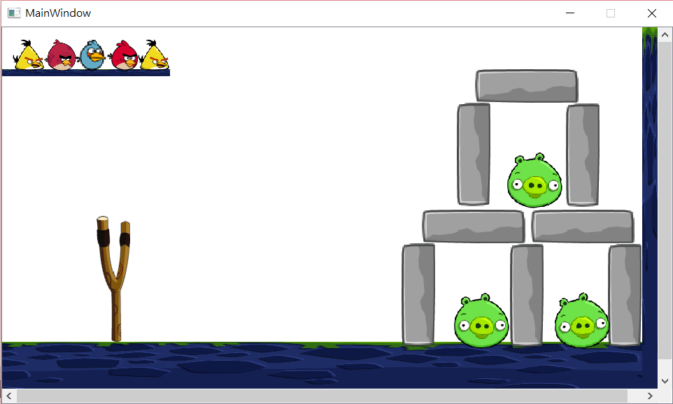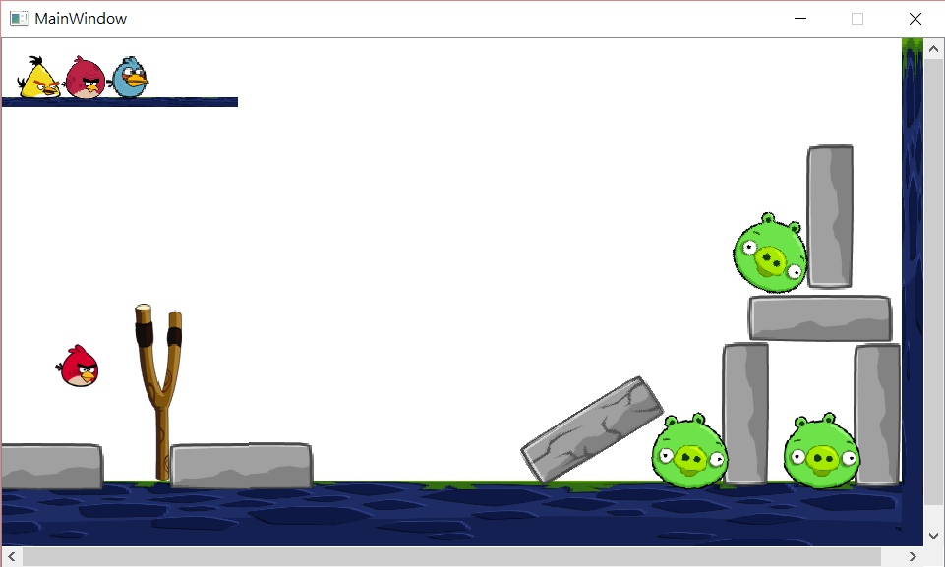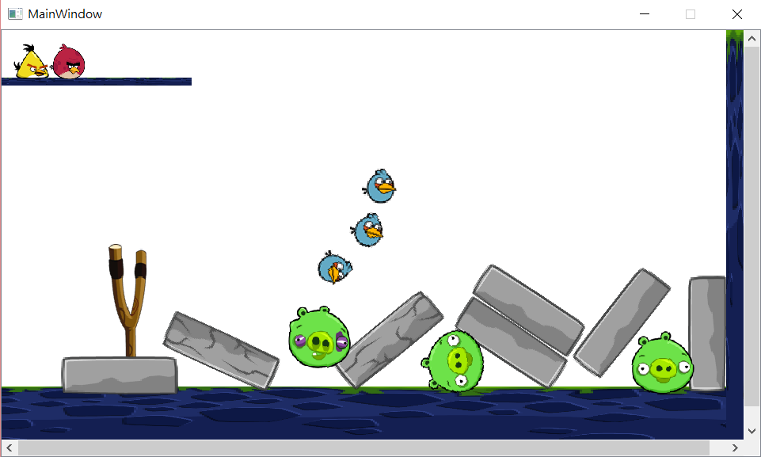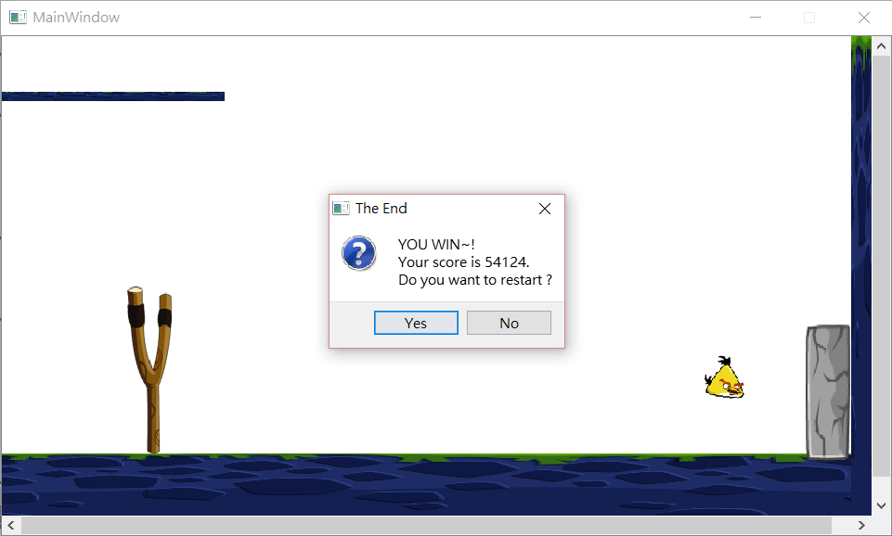

**How To Play :**

**1. Use birds and the slingshot to attack pigs.**

**2. Press to use the bird's skill during the bird attacking.**

**3. Yellow birds can dash and biue bird's can use split body technique.**

**4. Old birds are heavier then the other birds.**

**5. Break a rock will get 3000 points.**

**6. Kill a pig will get 8000 points.**

**7. One more remainder bird get 10000 points.**

**8. Kill all the pigs to win the game.**

**Program Architecture :**

**利用BOX2D 作為物理引擎，以一個virtual的class GameItem 作為遊戲物件的base，然後建立Bird, Block, Land, Pig, Slingshot，並override GameItem中 virtual的 collide()，做為不同物體碰撞的反應。**

**於 MainWindow中建立一個world，並架設好關卡，以一個QList itemList紀錄 world中的物件，方便移除時使用。MainWindow 繼承b2ContactListener，接收碰撞的訊號，並做出相對應的反應。**

**Pig跟Block都有一個hitPoint，在碰撞中會逐漸減少，歸零時，MainWindow會將此物件移出world。**

**遊戲結束時，跳出MessageBox。**

**離開遊戲時，傳送quitGame()訊號。**