**UML :**

|  |
| --- |
| **MainWindow** |
| **- ui : Ui::MainWindow\***  **- game : Game**  **- game2 : Game2** |
| **+ MainWindow(QWidget *)**  **+ ~MainWindow()**  **- on_Start_clicked() : void**  **- on_Exit_clicked() : void**  **- on_Start_2_clicked() : void** |

|  |
| --- |
| **Game** |
| **+ timer : QTimer\***  **- ui : Ui::Game\***  **- drum[10] : QLabel\***  **- comboLabel[3] : QLabel\***  **- countPath : QString**  **- recentDrum : QLabel\***  **- x, y : int**  **- score : int**  **- speed : int**  **- speed_up_count : int**  **- speed_stage[4] : bool**  **- autoPress : bool**  **- gameTime : int**  **- combo : int**  **- max_combo : int**  **- player : int** |
| **+ Game(QWidget *)**  **+ ~Game()**  **+ void startGame()**  **- keyPressEvent(QKeyEvent *) : void**  **- keyReleaseEvent(QKeyEvent *) : void**  **- countDown() : void**  **- setGame() : void**  **- mainGame() : void**  **- auto_play() : void**  **- on_Auto_clicked() : void**  **- on_restart_clicked() : void**  **- on_exit_clicked() : void** |

|  |
| --- |
| ***Game2*** |
| **+ timer : QTimer\***  **- ui : Ui::Game2\***  **- drum[10] : QLabel\***  **- comboLabel[3] : QLabel\***  **- countPath : QString**  **- recentDrum : QLabel\***  **- x, y : int**  **- score : int**  **- speed : int**  **- speed_up_count : int**  **- speed_stage[4] : bool**  **- gameTime : int**  **- combo : int**  **- max_combo : int**  **- player : int** |
| **+ Game2(QWidget *)**  **+ ~Game2()**  **+ void startGame()**  **- keyPressEvent(QKeyEvent *) : void**  **- keyReleaseEvent(QKeyEvent *) : void**  **- countDown() : void**  **- setGame() : void**  **- mainGame() : void**  **- setTarget(int, int) : void**  **- on_restart_clicked() : void**  **- on_exit_clicked() : void** |

**Screen Shot :**

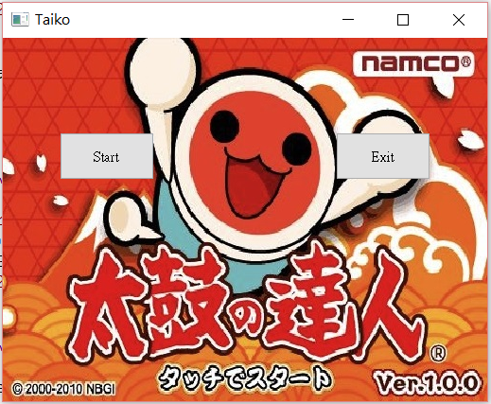

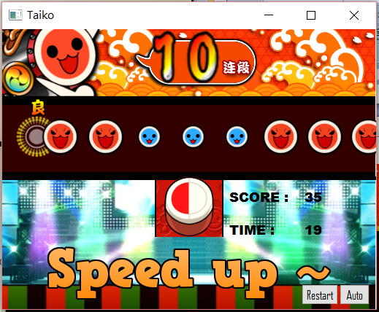

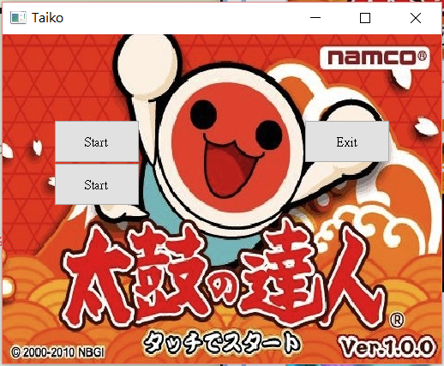

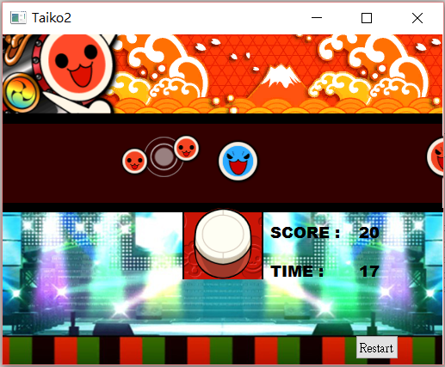

**How To Play :**

**game1:**

**1. Press Start to start game1.**

**2. Use F & J to hit red drums.**

**3. Use D & K to hit blue drums.**

**4. Speed up when player get more then 10,30,60,100 combos.**

**game2:**

**1. Press another Start to start game2.**

**2. Use F to hit red drums.**

**3. Use D to hit blue drums.**

**4. Use I, K, J & L as up, down, left & right to control the**

**position of target icon.**

**5. Speed up when player get more then 5,10,20,40 combos.**

**Program Architecture :**

**game1:**

**Start按鈕呼叫game.show(),並進行初始化,主要利用Qpixmap和QLabel來控制圖形。首先使用timer connect countDown()做倒數,呼叫遊戲開始的數值(與初始化值有些微不同),接著connect timer跟mainGame(),開始主要遊戲部分。**

**mainGame()每次將gameTime - 10, 30秒後, gameTime即會歸0,則跳出messagebox,顯示分數及最大連擊數。**

**每次將drums.x - speed，若label超出畫面,則將其接回最尾端,如此便可一直產生drums。產生drums時,紀錄target附近的recentDrum以及drums的類型在whatsThis,方便消除時做判斷。**

**利用keyPressEvent()和keyReleaseEvent(),來接收鍵盤的訊號,並與recentDrum做比對,做消除,加分和combo。**

**game2:**

**與game1大致相同, keyPressEvent()多了控制target位置的訊號。 判斷消除時,需多判斷y座標位置。**