CID-101044

**Three biggest questions that need additional modelling efforts:**

1. **Sensitivity analysis around incubation period:**

With the current approach, each outbreak is assigned a random incubation period between 3 and 7. The R0 estimated from them is forming these new distributions. There’s a really great systematic review out of NUS stating there’s actually not good evidence on how long exactly is incubation period, so now I am assuming a uniform distribution between 3 and 7 days. <https://journals.lww.com/pidj/fulltext/2016/10000/the_epidemiology_of_hand,_foot_and_mouth_disease.3.aspx>

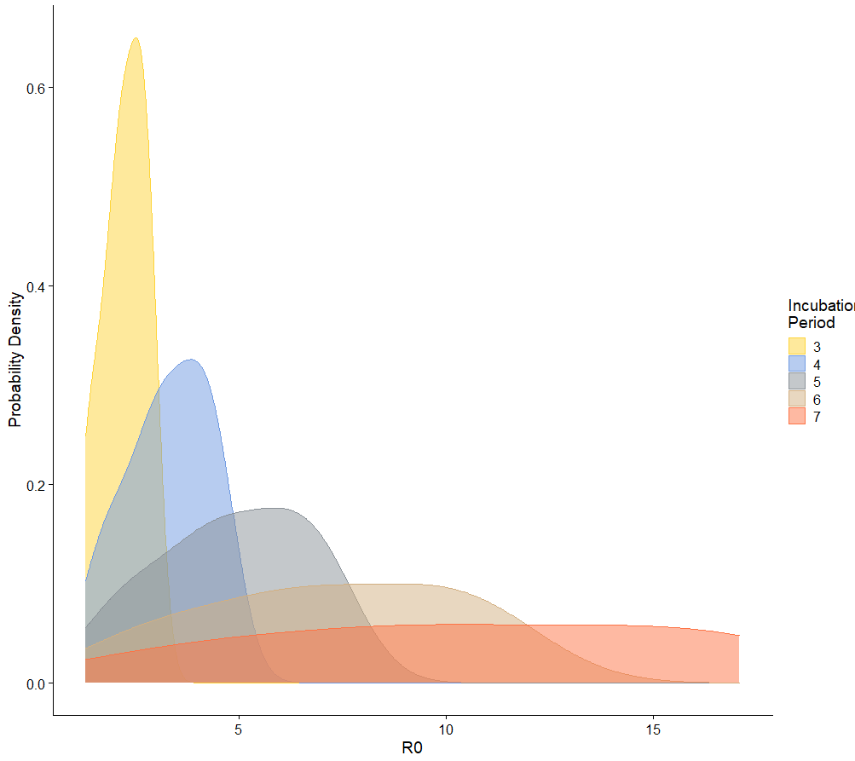

1. **Effective Reproduction Number using EpiEstim**

I am using a simplified version published with the data earlyR. It is essentially the same method used in EpiEstim but using a slightly simpler version. I used the serial interval with mean of 3.7 days, and standard deviation of 2.6 days, assuming normal distribution. We are seeing the serial interval based etsimates tend to be smaller compared to the arithmetic sequence based estimate, previously used for estimating the reproduction number for SARS.

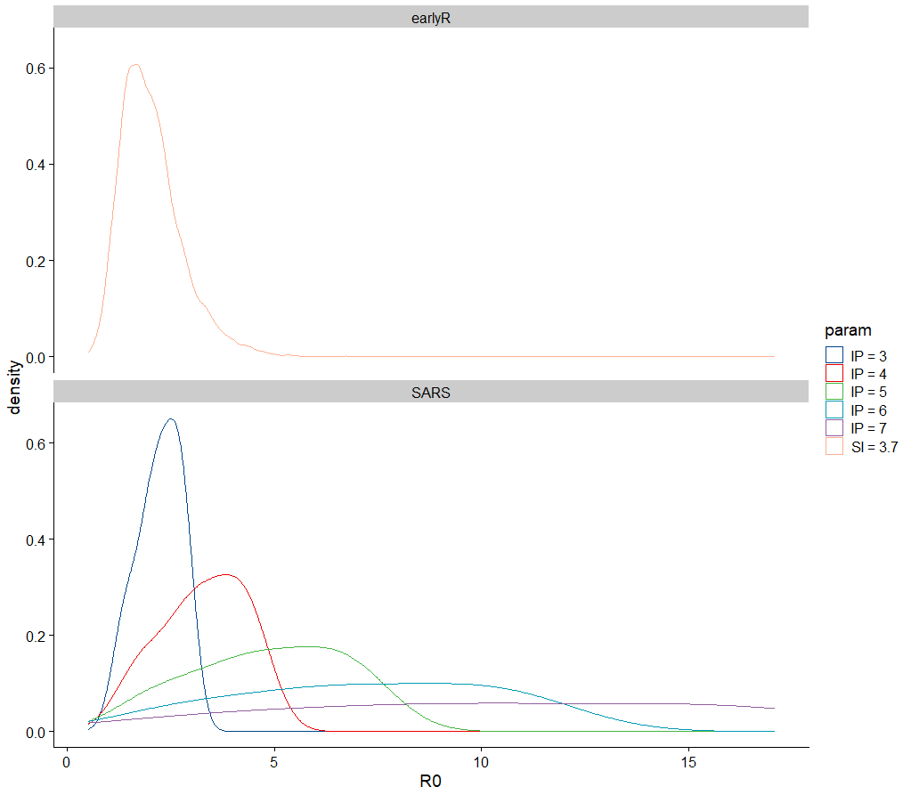

1. **Right Censoring of Outbreaks**

Reviewer 2 raised the problem of right-censoring of data. This is when cases that should have been included in the cumulative incidence counts but were left out because we are drawing a line using the definition of the initial growth phase. With right censoring, we would expect the bias to be towards the null hypothesis. To examine the magnitude of this bias, I did a sensitivity analysis that extend the length of the IGP by 1-3 days. In general, including more days only shift R0 estimates further to the left, this means we are generally stopping at places where overall infectivity starts going down. If the bias is significant, we would expect the R0 estimates factoring delays to appear on the right hand side. Bias in estimates caused by right-censoring of data, in this case, may not be severe.

