**Full title:** Basic reproduction number of Enterovirus 71, Coxsackievirus A16 and A6: evidence from outbreaks of hand, foot and mouth disease in China between 2011 and 2018

Zhong Zhang1,2, Yang Liu3, Fengfeng Liu4, Minrui Ren4, Taoran Nie4, Jinzhao Cui4, Zhaorui Chang4, Zhongjie Li4

1Nanjing Municipal Center for Disease Control and Prevention, Nanjing, 210003, China

2Chinese Field Epidemiology Training Program (CFETP), Beijing, 100050, China

3Centre for Mathematical Modelling of Infectious Diseases, Department of Infectious Disease Epidemiology, Faculty of Epidemiology and Population Health, London School of Hygiene & Tropical Medicine

4 Division of Infectious disease, Key Laboratory of Surveillance and Early Warning on Infectious Disease，Chinese Center for Disease Control and Prevention，Beijing 102206，China

Senior author: Zhongjie Li

Corresponding author: Zhaorui Chang, Division of Infectious disease, Key Laboratory of Surveillance and Early Warning on Infectious Disease, Chinese Center for Disease Control and Prevention; No.155 Changbai Road, Changping District, Beijing, People's Republic of China, 102206; Phone: 86-010-58100510; Fax: 86-010-58100576; Email: [changzr@chinacdc.cn](mailto:changzr@chinacdc.cn)

**Key Words**:

Enterovirus; transmission dynamics; basic reproduction number; vaccine; hand, foot, and mouth disease

**Running title:** Transmission of Hand, Foot, and Mouth Disease

**Alternate contact information:**

Zhong Zhang, Nanjing Municipal Center for Disease Control and Prevention, No.2 Zizhulin, Gulou District, Nanjing, Jiangsu, People's Republic of China, 210003. Phone: 86-025-83538333; Email: [nanjingzhangz@qq.com](mailto:nanjingzhangz@qq.com)

Article Type: Major Articles

Summary of Main Points: This study estimates the pathogen-specific basic reproduction number based on laboratory-confirmed hand, foot, and mouth disease outbreaks in China between 2011 and 2018. It is the first to compare the changes of R0s before and after the EV-A71 vaccines licensure.

**Abstract (250 words):**

**Background**: Enterovirus 71 (EV-A71), Coxsackievirus A16 (CV-A16) and Coxsackievirus A6 (CV-A6) are common serotypes causing hand, foot, and mouth disease (HFMD). Analyses on the basic reproduction number (R0) of common pathogens causing HFMD are limited and there are no related studies using field data from outbreaks in mainland China.

**Methods**: We estimated the pathogen-specific basic reproduction number based on information related to laboratory-confirmed HFMD outbreaks (clusters of ≥10 HFMD cases) reported to the national surveillance system between 2011 and 2018. The reproduction numbers were calculated based on the cumulative number of cases during the initial growth periods using a mathematical model.

**Results**: This study included 539 outbreaks, of which 198 were caused by EV-A71, 316 by CV-A16, and 25 by CV-A6. All 10417 cases involved were children. Assuming the outbreak to have occurred in closed systems and the incubation period of 5 days, the median R0s of EV-A71 and CV-A16 were 5.46 and 5.11 between 2011 and 2016. Taking considerable levels of sero-prevalence into consideration, R0s of EV-A71, CV-A16 and CV-A6could be larger than 10. The R0 of EV-A71 declined from the pre-vaccine period level of 5.46 (2011-2016) to post-vaccine period level of 3.81 (2017-2018) (*p*-value=0.042).

**Conclusions**: The R0 of EV-71 is comparable to that of CV-A16. The R0 of CV-A6 seems the highest among all three. The statistically significant decline of the R0 of EV-A71 may be associated with the licensure of vaccines. This study provides insights into the transmission dynamics of HFMD-related enterovirus among children in China.

**Key Words**:

Enterovirus; transmission dynamics; basic reproduction number; vaccine; hand, foot, and mouth disease

**Introduction**

Hand, Foot, and Mouth Disease (HFMD) is an infectious disease most commonly observed among children under five years and in Asia-Pacific regions, including Singapore, Taiwan, Hong Kong, Japan and mainland China [1-2]. In mainland China specifically, more than one million cases involving hundreds of outbreaks have been reported every year since 2008, leading to a substantial burden, especially among pediatric healthcare providers [3]. Various serotypes of the *Enterovirus* genus of the family *Picornaviridae* can cause HFMD, such asEV-A71, CV-A16, and CV-A6 [1,3-4]. The main clinical manifestations include fever and a rash or blisters on the hands, feet, mouth, and buttocks, and a small number of patients, especially those infected with EV-A71, may develop severe complications [5]. Inactivated monovalent EV-A71 vaccines, which showed high efficacy in the prevention of EV-A71 related HFMD, were licensed in mainland China in 2016[3].

The transmission dynamics of an infectious disease is crucial to support public health decision-making. The basic reproduction number (R0), one of the most fundamental parameters that govern the transmission patterns of infectious diseases, measures the average number of secondary cases infected by a typical primary case in a susceptible population. The R0 is determined by the duration of infectiousness and the effective contact rate [6].

However, studies on the R0 of HFMD-related enterovirus are limited. Previous studies have drastically different results, ranging from 1.1 to 27[7-8], and these results were not pathogen-specific. Such uncertainty hinders the use of these estimates for further analyses [2]. In mainland China, HFMD outbreaks primarily occur in relatively closed units such as kindergartens (usually for 3 to 6 year olds) and primary schools (usually for 6 to 12 year olds) [9-10]. Thus, one of the foci of HFMD prevention and control is to timely intervene at these key locations. Other studies have provided estimates of R0 of EV-A71 and CV-A16 for Hong Kong using data between 2004 and 2009[11] and for Singapore between 2007 and 2012[12]. However, only a small number of outbreaks were identified (34 and 33, respectively) [11-12]. R0s of HFMD-related enteroviruses have not been accurately estimated using outbreaks in mainland China, where the largest number of cases is observed in the world [13]. In this study, we estimated the R0 of EV-A71, CV-A16 and CV-A6, and assessed the change of R0 after the licensure of EV-A71 vaccines.

**Materials and methods**

**Key Terminologies**

In mainland China, a public health emergency event (PHEE) of HFMD is defined as an outbreak involving10 or more cases in a unit such as a kindergarten and primary school or involving 5 or more cases in a village or a community during a seven-day window. In this study, we selected PHEE outbreaks using the ten-case threshold to reduce numeric noises.

The initial growing phase (IGPs) refers to the period from the onset of the primary case to the date when the number of newly affected cases have peaked or plateaued or the date when public health measures were put in action, whichever occurred first.

**Surveillance Systems**

HFMD has been classified as a “notifiable infectious disease” in mainland China since 2008. There are currently two systems for HFMD surveillance: (1) the National Notifiable Infectious Diseases Surveillance System (NNIDSS), a subsystem of the China Disease Prevention and Control Information System (CDPCIS), which keeps track of patient information (e.g., clinical categorisation); and (2) the National Public Health Emergency Event Surveillance System (PHEESS), another subsystem of CDPCIS, which focuses on outbreak investigation (e.g., subtype, number of total exposed individuals). We rely on outbreak-specific data from PHEESS in this study as it includes information on the underlying outbreak characteristics. This is consistent with XXXX and XXXX.

**Data collection**

A retrospective review was conducted on HFMD outbreaks reported to PHEESS from 2011/01/01 to 2018/12/31. Outbreaks reported by the local Centers for Disease Prevention and Control (CDCs) to the web-based PHEESS through a structured database that include items including but not limited to the timing of first and last cases, location, number of the exposed and infected, and the death toll. Additional information could be found in the unstructured narratives attached to the PHEESS reports, including the detailed epidemic curve (by symptoms onset), laboratory test results (i.e., EV-A71，CV-A16 and CV-A6), age (based on outbreak settings, e.g., first year kindergarteners are assumed to be three year olds), and control measures including but not limited to suspending classes and enhanced disinfection. The completeness and quality of these narratives may vary by municipalities. Note that PHEESS cannot capture asymptomatic indidividuals during outbreaks.

For this analysis, both structured data and non-structured narratives of all HFMD outbreaks between 2011/01/01 and2018/12/31 were downloaded from PHEESS and analyzed. Note that surveillance lab did not start testing for CV-A6 nation-wide in China until 2017[3]. Outbreaks need to meet the following four criteria to be included in calculating the corresponding R0: (1) there was a single index case (having multiple cases at the beginning of the time-series indicate the true primary case was never identified); (2) there was an identifiable IGP (e.g., reports of 1 case daily for a week was not included; (3) during the outbreak, there was no consecutive periods of longer than 10 days where no cases occur; and (4) all cases involved can be attributed to the same pathogen.

**Estimating the Basic Reproduction Number**

We applied a previously method [11-12] to estimate the R0s of EV-A71, CV-A16 and CV-A6 in China. The method was originally introduced by Choi and Pak to study the 2003 SARS-COV outbreak [14]. Each unit was assumed to be a closed system during an outbreak. All outbreaks were assumed to be seeded by a single case (i.e., the primary case). It was also assumed that at the early stage of the outbreak all in the unit were susceptible. The value of R0 is estimated using the following formula:

=1+R0+R02+R03+…+R0*t*=(R0*t+1*-1) /(R0-1)

Where, *i* refers to the incubation period of HFMD-related enteroviruses and *t* the number of transmission generation. The total time elapsed, thus, is *t*i*. The notion represents the expected cumulative number of cases on day *t*i* of the initial growing phase. We assumed the incubation period to be 5 days, consistent with previous studies [11-12]. We also show results using incubation periods of 3 to 7 days in the Supplemental Material, as this parameter is currently not well understood. Kruskal-Wallis test was used to compare the estimated R0s of all three HFMD related enterovirus serotypes. We validate this method via simulations based on an SEIR model (see Supplementary Material Section 1).

Besides raw estimates, adjusted R0s based on subtype specific seroprevalence are also provided:

where represents the age- and subtype-specific seroprevalence. All reproduction number estimates are further validated by comparing against effective reproduction numbers based on methods described in Wallinga & Lipsith (2007), White & Pagano (2009), and Cori et al. (2013).

We further investigated the association between the estimated R0s and other outbreak characteristics (outbreak duration, number of children exposed, and number of total cases). The analyses were truncated at the end of 2015/ beginning of 2016 when the EV-A71 monovalent HFMD vaccines were licensed [3]. There is currently no vaccine for CV-A6 and CV-A16. Mann-Whitney U test was used to examine for statisticaldifferencebetweenestimatedR0s before and after the licensure of the EV-A71 vaccines.

**Data Management and Analysis**

Information provided by unstructured narratives was abstracted for temporal, spatial and demographic parameters indicators before summarized and analyzed. Software R (4.0.0) and Microsoft Excel were used for data cleaning, analysis, and visualisation. Code used can be found at.

**Ethics Statement**

This project involved a retrospective analysis of data on outbreaks reported to PHEESS by local CDCs in China between 2011 and 2018. No identifiable information was included as part of this project.

**Results**

Between 2011 and 2018, 2178 outbreaks of HFMD were reported to PHEESS in China, of which 1743 were laboratory confirmed. The three HFMD-related pathogens (i.e., EV-A71, CV-A16, and CV-A6) caused 1653 (94.8%) of these outbreaks. We identified 539 outbreaks with identifiable IGPs (Figure 1).

Among the 539 HFMD outbreaks that met the inclusion criteria, 198 (36.7%) were associated with EV-A71, 316 (58.6%) with CV-A16, and 25 (4.6%) with CV-A6. Inter-annual variability in the number of outbreaks was observed - a relatively larger number of outbreaks occurred every other year (Figure 2, a and c). In years with a larger number of outbreaks, CV-A16 tended to be the dominating serotype; in years with a smaller number of outbreaks, EV-A71 tended to be the dominating serotype (Figure 2, a and c). Within year analyses revealed two peaks within a year (Figure 2, b and d), which was consistent with the surveillance results of all HFMD cases in China. The April-June peaks, however, was much more evident than the September-October peaks.

The 539 outbreaks that met the inclusion criteria occurred in 27 provinces (Figure 3) – those with the largest number of outbreaks were Guangdong (88), Chongqing (81), Guangxi (53), Anhui (51), Jiangsu (36), Yunnan (36) and Shandong (35). These six provinces were also among the provinces with the highest incidence of HFMD cases in China.

There were 479 (88.9%) outbreaks that occurred in kindergartens, affecting 9202 children; 33(6.1%) outbreaks in primary schools, affecting 635 students; 18 (3.3%) in villages, affecting 400 preschool children; 6 (1.1%) in childcare centers, affecting 121 cases; and 3 (0.6%) in junior middle schools, affecting 59 cases.

Outbreaks caused by EV-A71, CV-A16 and CV-A6 were similar in terms of the number of children infected and duration of outbreaks. However, in CV-A6 outbreaks, more children were exposed on average, leading to overall lower attack rates (Table 1).

Before the EV-A71 mono-valent vaccines were licensed in mainland China, the R0 of EV-A71 and CV-A16 were comparable (5.46 and 5.11, respectively). After vaccine licensure, the R0 of EV-A71 quickly declined from 5.46 to 3.81 with statistical significance (Z=-2.032，P=0.042). Although the R0 estimate for EV-A71 in 2018 appeared to be higher when expressed as a box plot, the number of outbreaks were so small (see Figure 2, a and c) that they do not affect the overall decreasing trend. The R0 of CV-A16 declined from 5.11 to 4.00, but the decline was not statistically significant (Z=-1.095，P=0.057) (Figure 4, panels (a), (d), and (g)). The estimated R0 of CV-A6 was 6.50. The difference between these three types was not statistically significant(*χ2*=3.387，*P*=0.184) in 2017 and 2018. Age stratified probability distributions of raw R0 estimates did not reveal meaningful variations as the overwhelming majority of the outbreaks under consideration are among 3-5 year olds (Figure SX).

In figure 4, panels (b-c), (e-f), and (h-i), we showed that after adjusting for seroprevalence, the R0 estimates become substantially higher. We then compare both raw and adjusted R0 estimates against effective reproduction numbers, for comparison. We found that compared to compared R0 estimates, raw R0 estimates are consistently more consistent with effective reproduction numbers estimated using other methods (Supplemental Figure X).

Further statistical analyses showed that the estimated R0s were independent of the number of children exposed and infected in the outbreak. Nevertheless, there is a negative and statistically significant association between R0s and outbreak duration (Figure 5).

**Discussion**

The most HFMD-outbreak-affected provinces in this study also reported the most HFMD cases in China [15]. Among the three serotypes studied here, CV-A6 has emerged as one of the predominant causative agents since 2013[16], later than EV-A71 and CV-A16 in mainland China. As mentioned before, R0 is not an intrinsic value of a given pathogen, but rather describes the transmissibility of that pathogen within the specific populations and settings [6]. R0 depends not only on the biology of the infectious agent but also the natural environment and socio-demographically dependent factors.

This study estimated the R0 among children in China in outbreak settings. To our best knowledge, this is the first study that estimates the pathogen-specific R0s based on the outbreaks of HFMD across mainland China and the largest study of its kind in the world. In addition, this study is the first to compare the changes of R0s after the licensure of the EV-A71 mono-valent vaccines. A wide geographical coverage and a large time span of this study ensure representativeness.

The overwhelming majority of the HFMD outbreaks we identified (88.9%) were in kindergartens, implying that the impacts were predominantly on those between 3 and 6 years of age. The HFMD Prevention and Control Handbook includes specific individual and environmental measures designed to protect children within this age group, including the promotion of hand hygiene, daily sanitation of toys and classrooms, and school suspension in response to confirmed HFMD cases.

Althoug HFMD is an endemic disease in China. Our results show that the raw R0 estimates assuming complete susceptibliy in the underlying population is more consistent with effective reproduction numbers. The R0 estimates adjusted for seroprevalence are consistently larger than effective reproduction numbers. This imply that in the underlying population of the outbreaks considered, the seroprevlanece may be significantly lower than existing literature. A potential explanation is that HFMD subtype positivity may be highly clustered by educational setting – within a classroom, either most children are infected or no child is. However, this hypothesis needs to be validated in future research.

This study revealed that between 2017 and 2018 the median R0 of CV-A6 was the highest among three serotypes, but the differences by serotype identified here were not statistically significant. It is possible that CV-A6 is more transmissible than other two serotypes. Local public health agencies need to continue to monitor the serotype distribution to draw further conclusions.

The median R0 of EV-A71 (5.46) between 2011 and 2016 in our study was similar to that in Hong Kong (5.48), but was larger than that in Singapore (3.50). The median R0 of CV-A16 (5.11) between 2011 and 2016 in our study was similar to EV-A71 and larger than that of both Hong Kong (2.50) and Singapore (2.42). Overall, current evidence in this study does not indicate differential transmissibility between EV-A71 and CV-A16 in mainland China.

Comparing to the wide range of uncertainty around R0 of EV-A71 (3.02 to 44.91) estimated by two studies using SIR/TSIR model conducted in Guangdong [8,17], the mathematical model used in this study are more consistent with existing literature.

After 2016, the R0s of EV-A71 and CV-A16 both decreased compared to 2011-2016. However, only the decreasing trend of EV-A71 was statistically significant. Measures taken to prevent and control outbreaks caused by EV-A71 and CV-A16 was identical except the use of EV-A71 vaccines, indicating a potential role played by these vaccines. Further researches are needed to establish causality.

Some limitations remain. Firstly, the primary case is hard to identify using the available outbreak surveillance system. When investigators failed to trace the true index case of an outbreak, they underestimate the IGPs, leading to an overestimation of R0s. This issue may have contributed to the association between larger R0s and shorter outbreak durations in Figure 5. Secondly, in this study, we only included outbreaks where the intervals between subsequent cases were shorter than 10 days to eliminate potentially overlapping outbreaks. We may have excluded exceptional cases or outbreaks where public health surveillance quality is suboptimal. Thirdly, our study design suffers from potential right-censoring of data, i.e., those who should have been included in the cumulative incidence were mistakenly excuded due to reporting. Based on simulation, we show that right censoring leads to a potential underestimation of R0. Such underestimation increases as true R0 increases. Last but not the least, we did not account for asymptomatic infections in this study as there is currently no infrastructure during outbreak investigation to identify these individuals in China.

**Contributors**

Zhaorui Chang and Zhongjie Li conceived, designed, and supervised the study. Zhong Zhang and Yang Liu conducted the analysis, visualized and interpreted the results, and wrote the manuscripts. Fengfeng Liu, MinruiRen, Taoran Nie, Jinzhao Cui participated in collection and management of data. All authors provided comments and approved the submitted version of the manuscript.

**Conflicts of interest**

All authors declare no conflicts of interest.

**Acknowledgments and funding**

We thank mentors of CFETP and HFMD outbreaks related staff of CDCs at all levels in China. This study was supported by National Science and Technology Major Project of China (2016ZX09101120-004) and Beijing Municipal Natural Science Foundation (L192014), the funding bodies had no role in study design, data collection and analysis, preparation of the manuscript, or the decision to publish. YL acknowledges the partial support by the National Institute for Health Research (NIHR) (GHRU-EPIC, 16/137/109) using UK aid from the UK Government to support global health research. The views expressed in this publication are those of the author(s) and not necessarily those of the NIHR or the UK Department of Health and Social Care. YL also acknowledges the funding support by the partial funding support by the Bill & Melinda Gates Foundation (INV-003174).

**References**

[1]Esposito S, Principi N. Hand, foot and mouth disease: current knowledge on clinical manifestations, epidemiology, aetiology and prevention[J]. European journal of clinical microbiology & infectious diseases : official publication of the European Society of Clinical Microbiology, 2018, 37(3): 391-398.

[2]Koh W M, Bogich T, Siegel K, et al. The Epidemiology of Hand, Foot and Mouth Disease in Asia: A Systematic Review and Analysis[J]. The Pediatric infectious disease journal, 2016, 35(10): e285-e300.

[3]Yang B, Liu F, Liao Q, et al. Epidemiology of hand, foot and mouth disease in China, 2008 to 2015 prior to the introduction of EV-A71 vaccine[J]. Euro surveillance : bulletin Europeen sur les maladies transmissibles = European communicable disease bulletin, 2017, 22(50).

[4]Zhao Q, Zhu J. [Prevalence and Analyses of the Changing Etiology of Hand, Foot and Mouth Disease in China][J]. Bing du xue bao = Chinese journal of virology, 2015, 31(5): 554-559.

[5]Lee K Y. Enterovirus 71 infection and neurological complications[J]. Korean journal of pediatrics, 2016, 59(10): 395-401.

[6]Guerra F M, Bolotin S, Lim G, et al. The basic reproduction number (R) of measles: a systematic review[J]. The Lancet. Infectious diseases, 2017, 17(12): e420-e428.

[7]Wang Y, Feng Z, Yang Y, et al. Hand, foot, and mouth disease in China: patterns of spread and transmissibility[J]. Epidemiology (Cambridge, Mass.), 2011, 22(6): 781-792.

[8]Takahashi S, Liao Q, Van Boeckel T P, et al. Hand, Foot, and Mouth Disease in China: Modeling Epidemic Dynamics of Enterovirus Serotypes and Implications for Vaccination[J]. PLoS medicine, 2016, 13(2): e1001958.

[9]Li D, Wu Y, Xing X, et al. Onychomadesis and potential association with HFMD outbreak in a kindergarten in Hubei province, China, 2017[J]. BMC infectious diseases, 2019, 19(1): 995.

[10]Li J, Zhu R, Huo D, et al. An outbreak of Coxsackievirus A6-associated hand, foot, and mouth disease in a kindergarten in Beijing in 2015[J]. BMC pediatrics, 2018, 18(1): 277.

[11]Ma E, Fung C, Yip S H L, et al. Estimation of the basic reproduction number of enterovirus 71 and coxsackievirus A16 in hand, foot, and mouth disease outbreaks[J]. The Pediatric infectious disease journal, 2011, 30(8): 675-679.

[12]Lim C T K, Jiang L, Ma S, et al. Basic reproduction number of coxsackievirus type A6 and A16 and enterovirus 71: estimates from outbreaks of hand, foot and mouth disease in Singapore, a tropical city-state[J]. Epidemiology and infection, 2016, 144(5): 1028-1034.

[13]Xing W, Liao Q, Viboud C, et al. Hand, foot, and mouth disease in China, 2008-12: an epidemiological study[J]. The Lancet. Infectious diseases, 2014, 14(4): 308-318.

[14]Choi B C K, Pak A W P. A simple approximate mathematical model to predict the number of severe acute respiratory syndrome cases and deaths[J]. Journal of epidemiology and community health, 2003, 57(10): 831-835.

[15]Wang C, Li X, Zhang Y, et al. Spatiotemporal Cluster Patterns of Hand, Foot, and Mouth Disease at the County Level in Mainland China, 2008-2012[J]. PloS one, 2016, 11(1): e0147532.

[16]Li Y, Chang Z, Wu P, et al. Emerging Enteroviruses Causing Hand, Foot and Mouth Disease, China, 2010-2016[J]. Emerging infectious diseases, 2018, 24(10): 1902-1906.

[17]Du Z, Zhang W, Zhang D, et al. Estimating the basic reproduction rate of HFMD using the time series SIR model in Guangdong, China[J]. PloS one, 2017, 12(7): e0179623.

[18]Yang B, Wu P, Wu J T, et al. Seroprevalence of Enterovirus 71 Antibody Among Children in China: A Systematic Review and Meta-analysis[J]. The Pediatric infectious disease journal, 2015, 34(12): 1399-1406.

[19]Wang J, Teng Z, Cui X, et al. Epidemiological and serological surveillance of hand-foot-and-mouth disease in Shanghai, China, 2012-2016[J]. Emerging microbes & infections, 2018, 7(1): 8.

[20]Gao F, Mao Q-Y, Chen P, et al. Seroepidemiology of Coxsackievirus A6, Coxsackievirus A16, and Enterovirus 71 infections in infants and children: A prospective cohort study in Jiangsu, China[J]. The Journal of infection, 2016, 73(5): 509-512.

**Tab.1** Characteristics of 539 identified HFMD outbreaks in China, 2011-2018.

|  |  |  |  |  |  |
| --- | --- | --- | --- | --- | --- |
| Serotype | Number of Outbreaks | Median #children exposed | Median #children infected | Median attack rate | Median outbreaks duration (days) |
| EV-A71 | 198 | 280(188-449) | 17(13-22) | 6.5%(4.0-10.1) | 15(11-22) |
| CV-A16 | 316 | 299(189-453) | 17(14-22) | 6.1%(4.3-10.0) | 16(11-22) |
| CV-A6 | 25 | 408(300-658) | 16(14-20) | 4.2%(3.2-5.2) | 14(10-17) |
| Overall | 539 | 297(191-451) | 17(13-22) | 6.1%(4.0-10.0) | 15(11-22) |

Values in parentheses are interquartile range. Outbreak duration is the time elapsed between the onset time of the first and last case identified.

**Figure legends:**

**Fig.1** Process used to identify HFMD outbreaks for R0 estimation in China, 2011-2018.

**Fig.2** Between- and within-year variability of HFMD outbreaks (measured by changes in the number of outbreaks and the number of infected children) by serotypes in China, 2011-2018.

**Fig.3** Spatial distribution of HFMD outbreaks in China, 2011-2018.

**Fig.4** Basic reproduction numbers of EV-A71, CV-A16 and CV-A6 in China, 2011-2018.

**Fig.5** Association between estimated R0s (Percentile = 0.025-0.975) and other outbreak characteristics in China, 2011-2018.

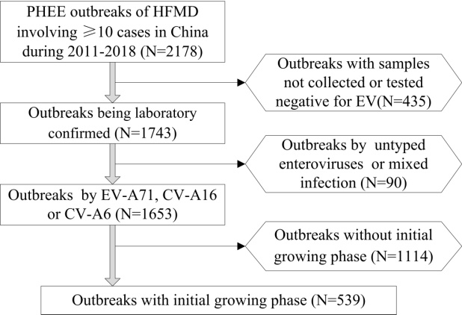

**Fig.1** Process used to identify HFMD outbreaks for R0 estimation in China, 2011-2018.

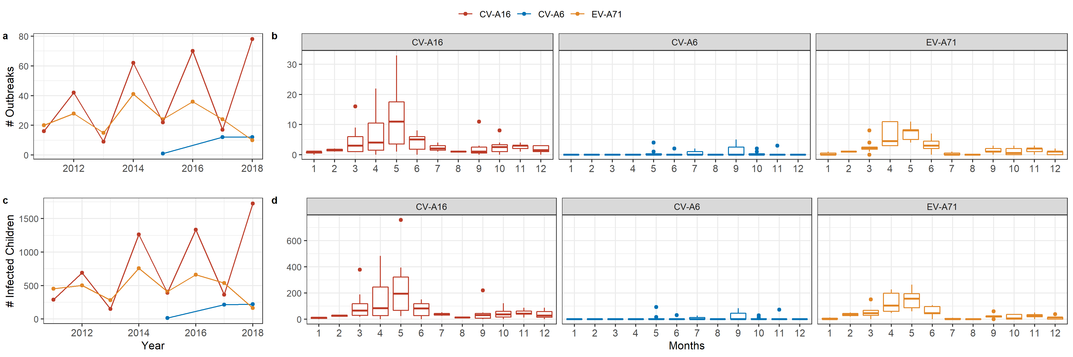

**Fig.2** Between- and within-year variability of HFMD outbreaks (measured by changes in the number of outbreaks and the number of infected children) by serotypes in China, 2011-2018. The corresponding month and year of outbreaks are attributed based on the timing of the first cases.

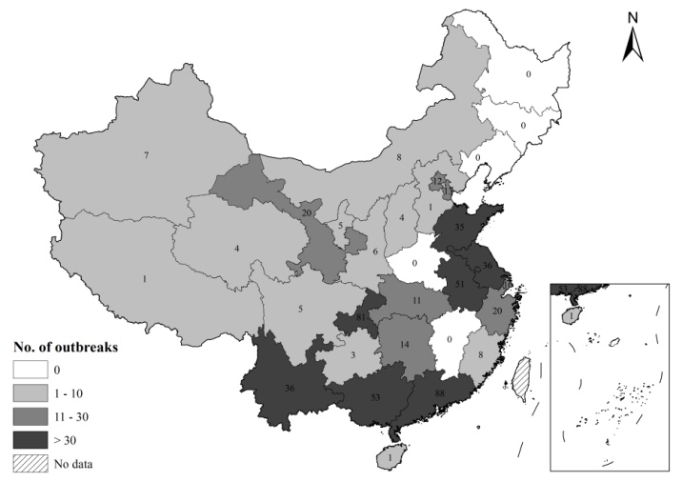

**Fig.3** Spatial distribution of HFMD outbreaks in China, 2011-2018.

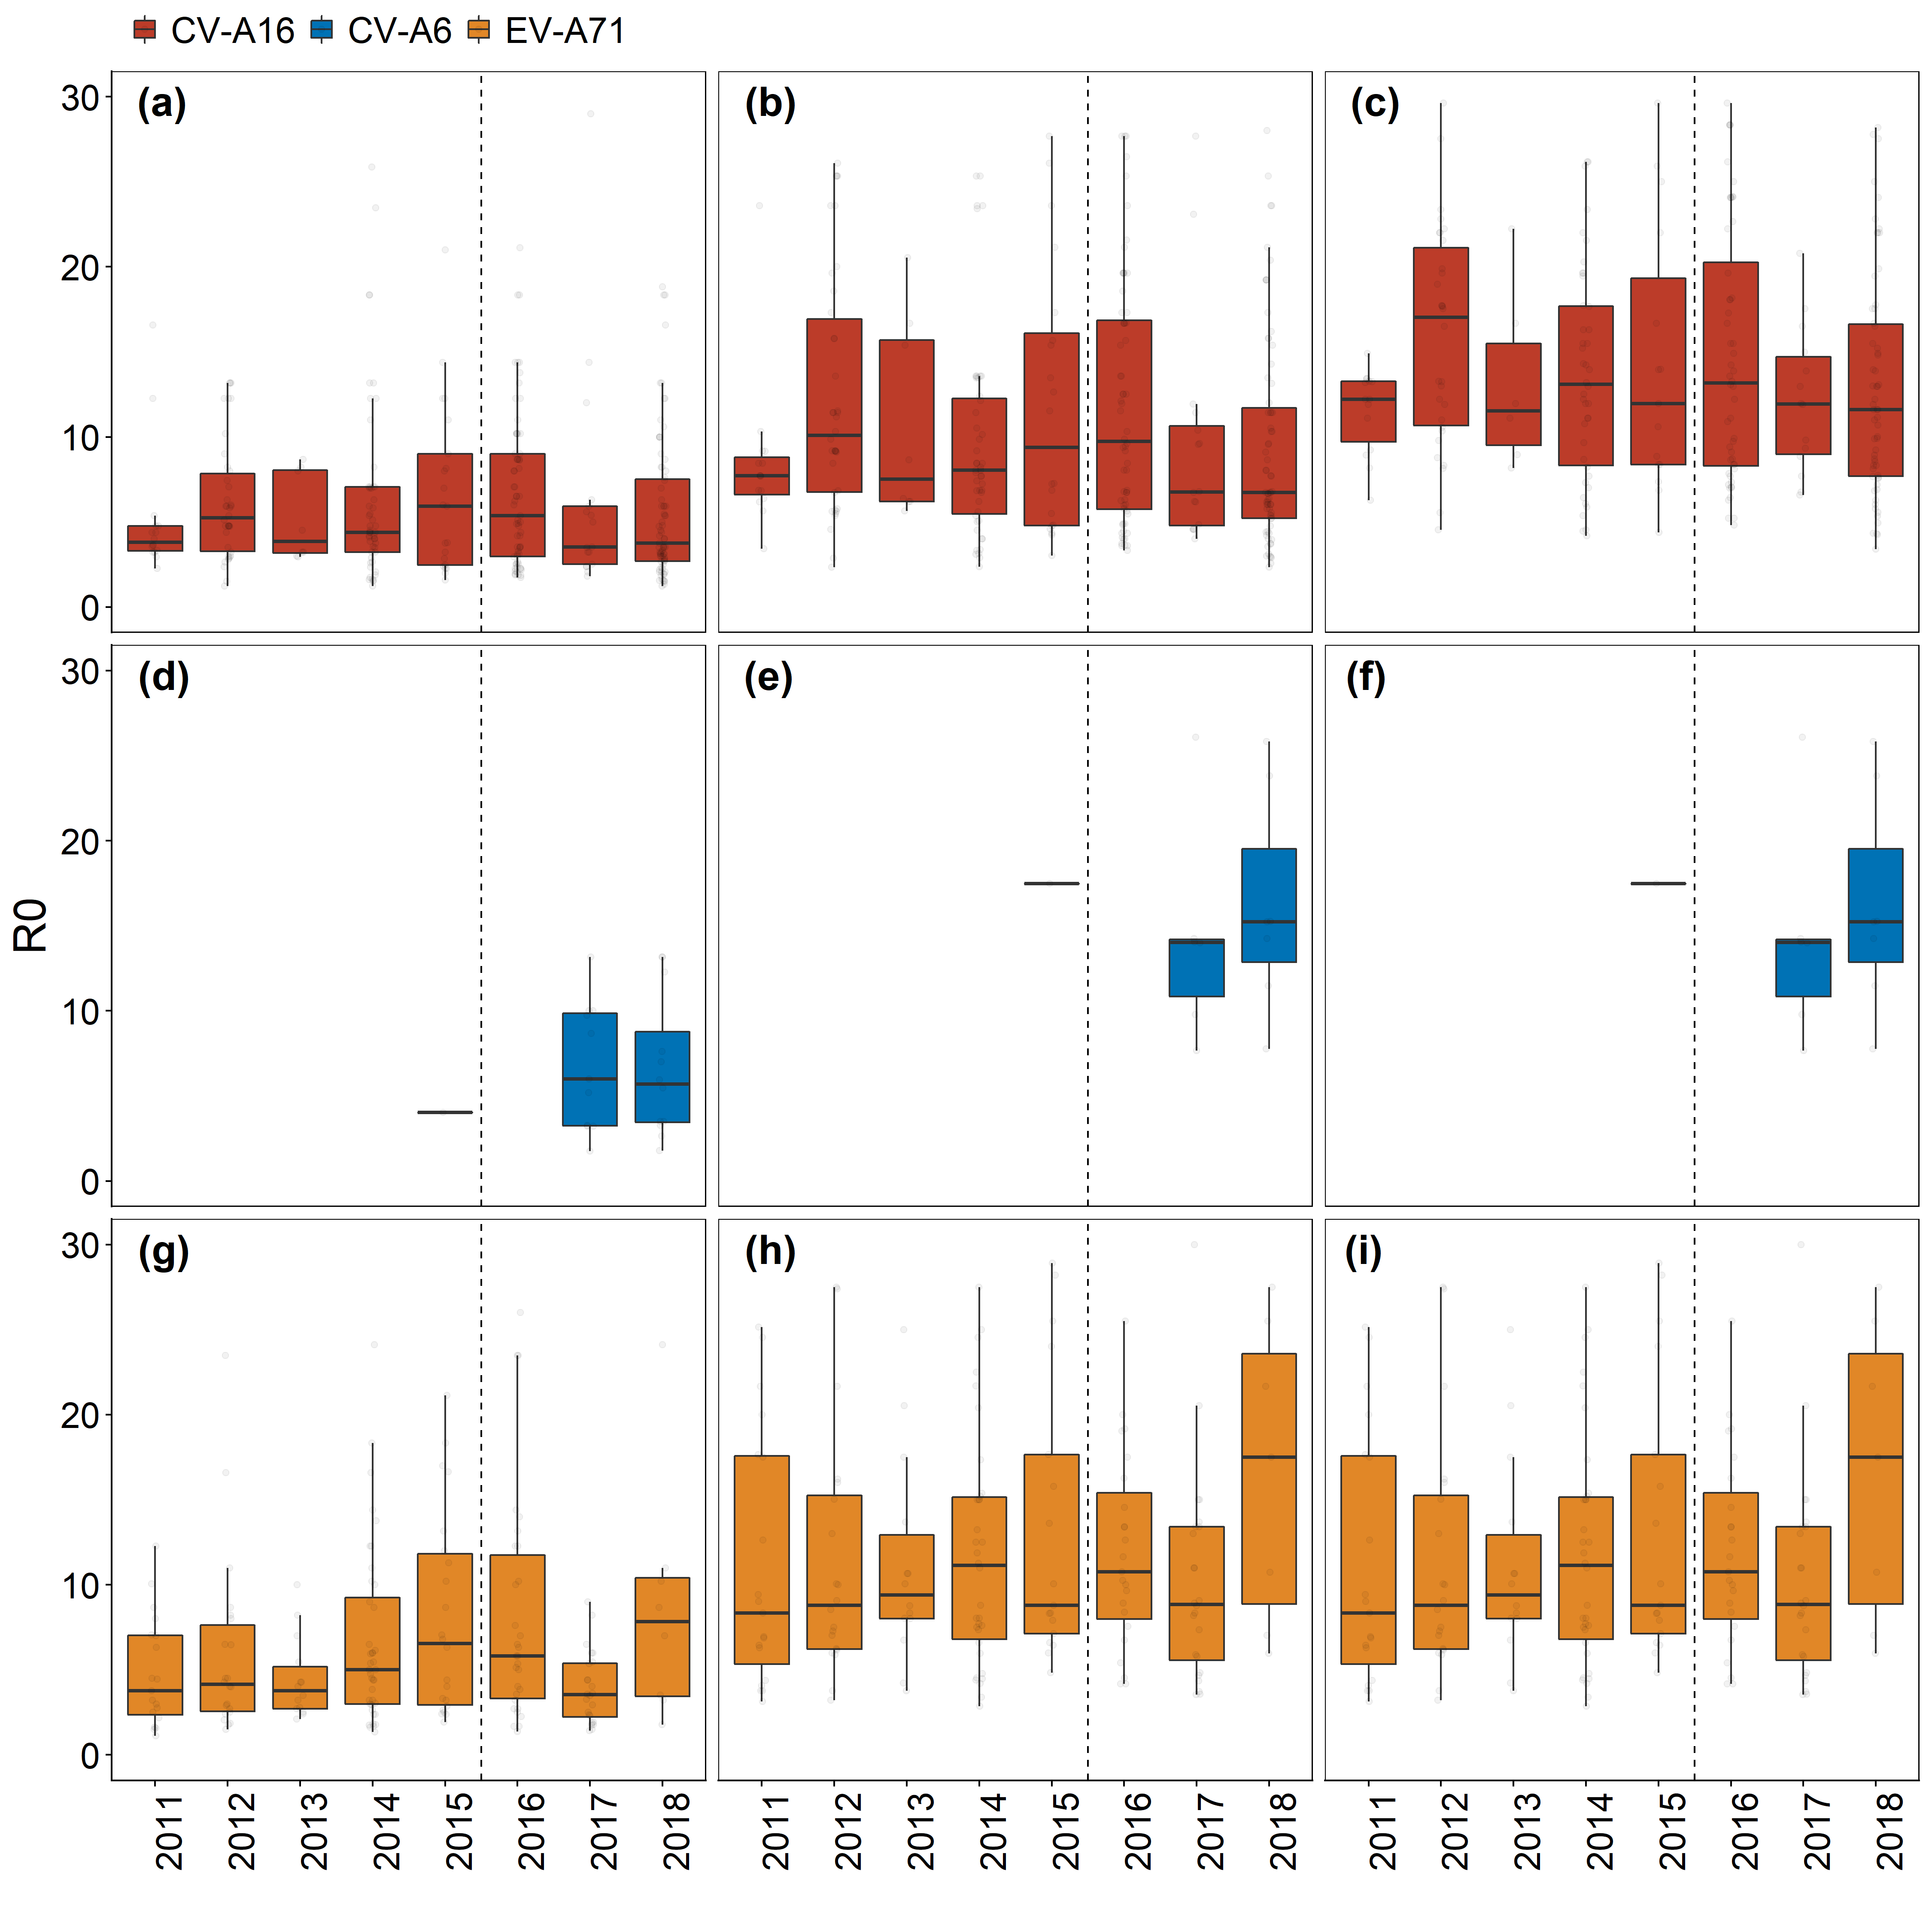

**Fig.4** Basic reproduction numbers of EV-A71, CV-A16 and CV-A6 in China, 2011-2018. The corresponding month and year of outbreaks are attributed based on the timing of the first cases. Adjusted R0 estimates are based on seroprevalence data among Chinese children identified through existing literature. The seroprevalence of EV-A71 is based on the estimated mean in a meta-analysis; the seroprevalence of CV-A6 is based on the estimated mean in the only study identified. We identified several studies on the seroprevalence of CV-A16, yet no meta-analysis – so we include both the conservative (i.e., the highest mean seroprevalence found) and the optimistic (i.e., the lowest mean seroprevalence found) scenarios. Numeric values used in this visualize can be found in Table SX.

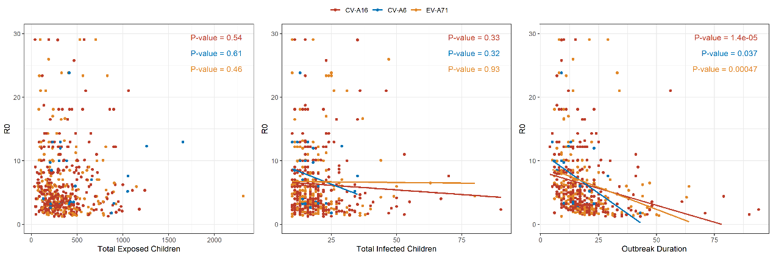

**Fig.5** Association between estimated R0s (Percentile = 0.025-0.975) and other outbreak characteristics in China, 2011-2018.

**Supplemental Material**

1. Method Validation

In order to validate the method used, we simulate HFMD outbreaks using a stochastic SEIR model using the following specifications:

|  |  |  |
| --- | --- | --- |
| Metric | Value | Source |
| Input R0 | 2 to 10 with 0.5 increments | Assumed |
| Recovery rate | 1/7 day-1 |  |
| Initial Seroprevalence | 0.3 to 0.7 with 0.1 increments | Assumed |
| Number of simulations ran | 5000 | Assumed |
| Population size | 1000 | Assumed |
| Initial infected individual | 1 | Assumed |

Simulated epicurves are then used to estimate the R0 using the method in this study and to assess the magnitude of potential bias caused by right censoring. Across a wide range of R0 and seroprevalence tested, we discovered that the method could well reproduce input (hypothetical) R0s. Bias caused by right censoring is towards the null hypotheses, i.e., estimated R0s tend to be smaller than true R0s. Bias seems to increase as true R0s increase.

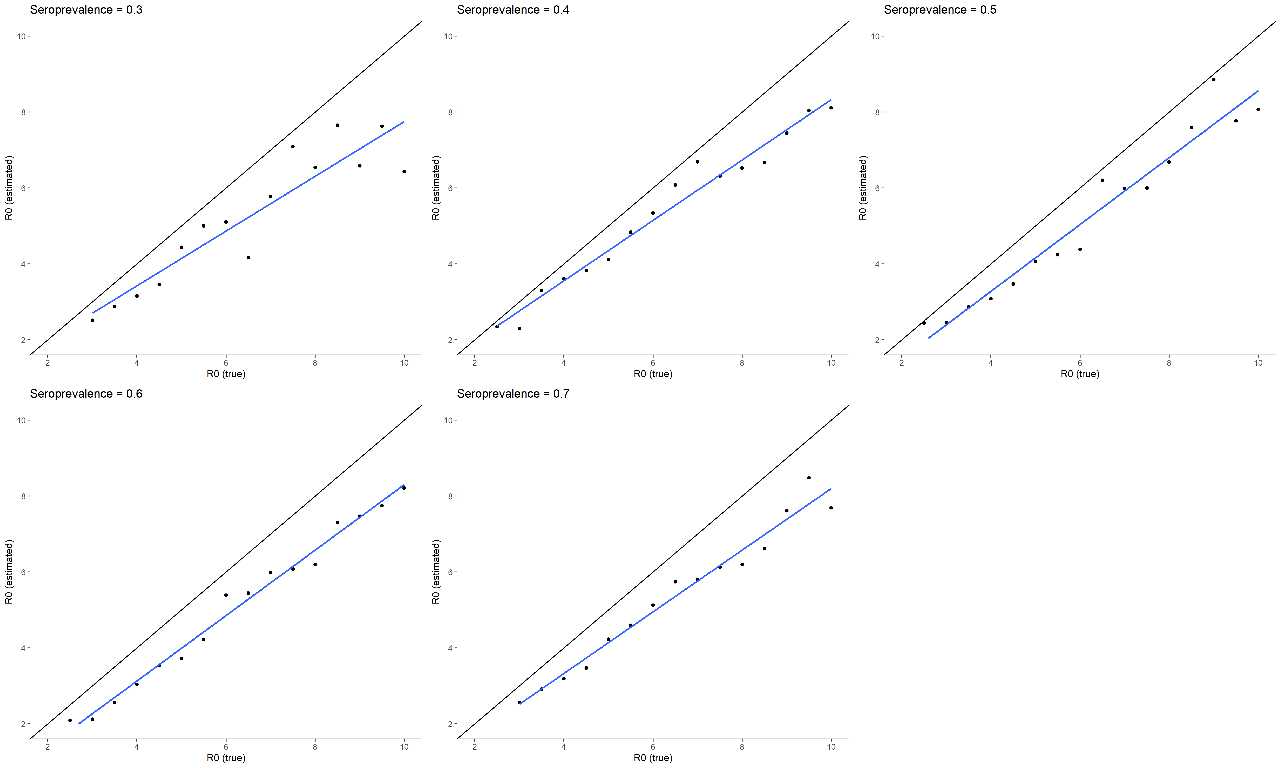

Figure S1. Method validation using different input R0s and intial seroprevalence.

1. Sensitivity Analysis by Incubation Period

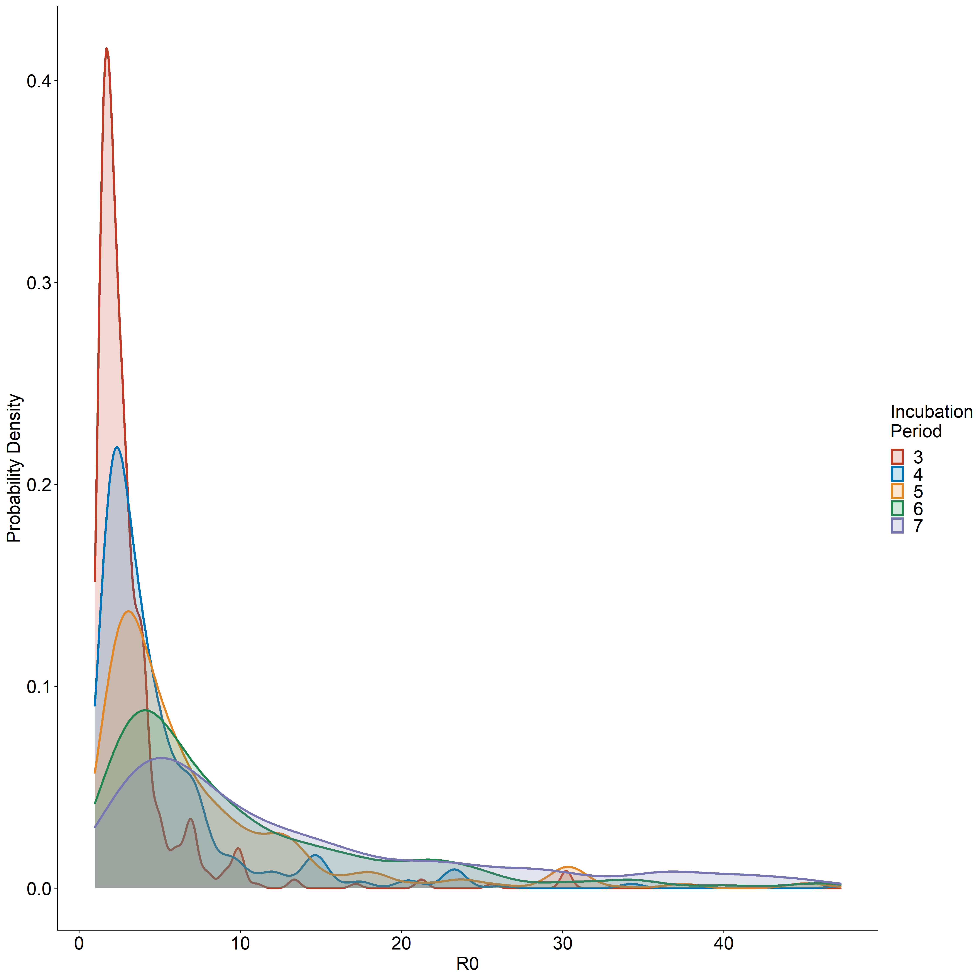

1. Age

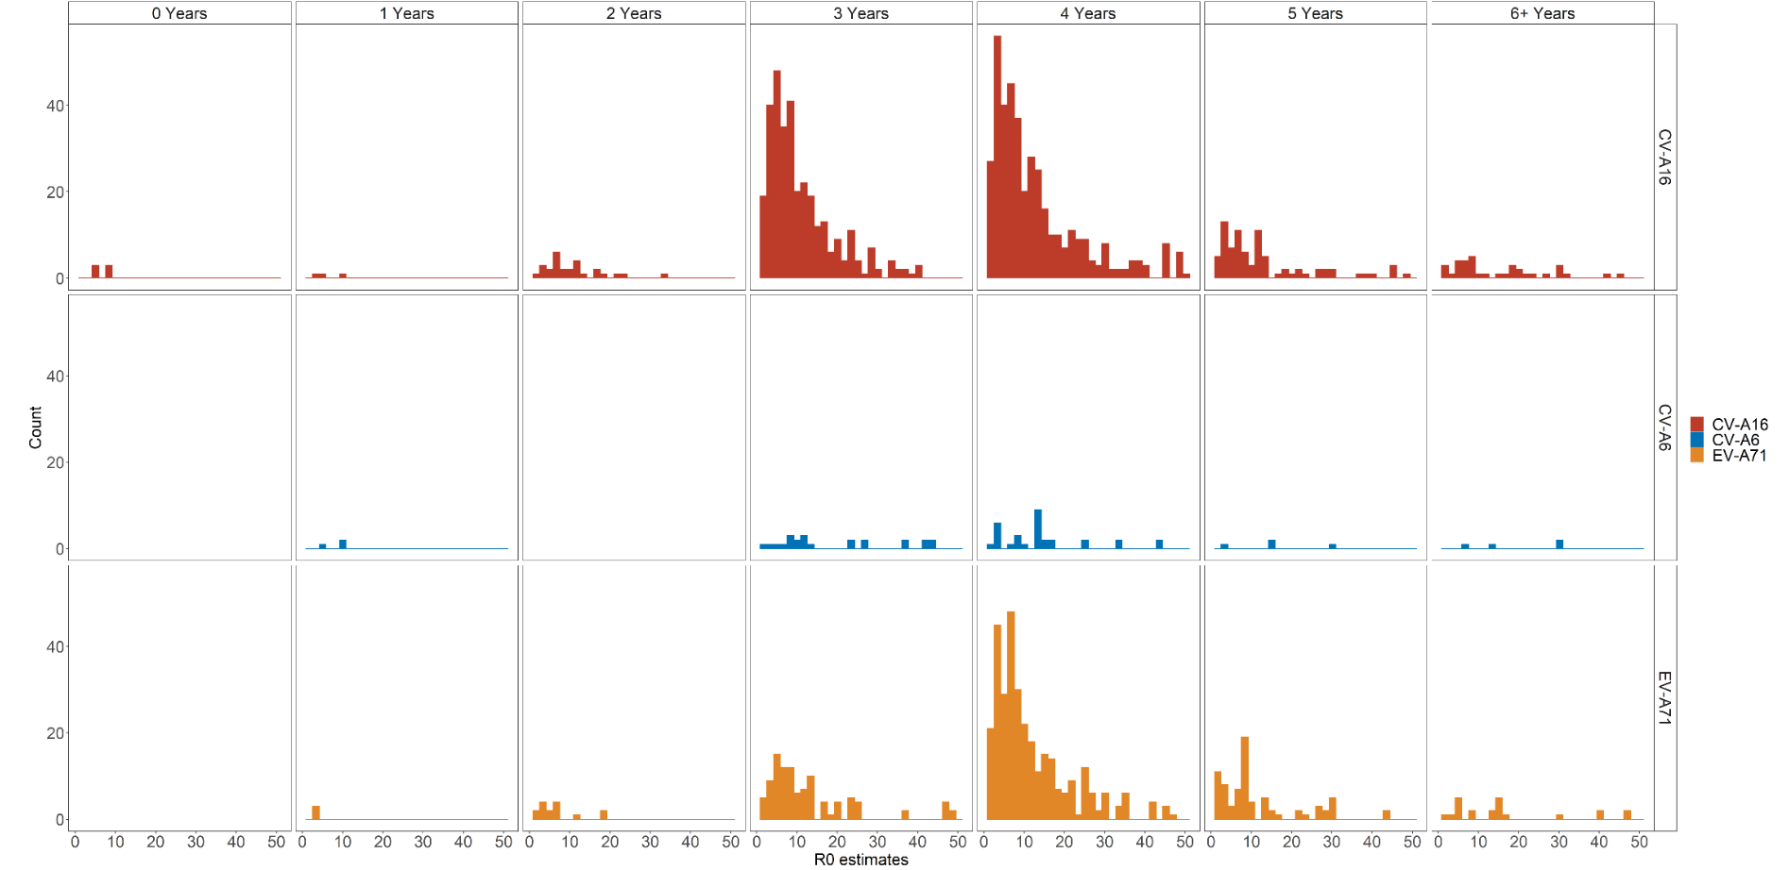

Figure S1. Histograms of R0 estimates (without adjusting for seroprevalence) by subtype and by age. Age is based on outbreak settings. For example, if an outbreak occurs at in the classroom of first year of kindergarten, we assigned the outbreak to age group of “3 Years”.

1. Comparison of R0s against Res

