* 5.2 (创建站点)
  + hugo new site [站名]
  + hugo new site myblog
* 6.1 (建立第一篇博客)
  + #切入到站点文件夹下
  + cd myblog
  + hugo new post\[文章标题].md
  + hugo new post\1.md
  + # 可以打开1.md进行编辑
* 7 (下载主题)
* 8 (建立本地站点 localhost:1313)
  + hugo server -t [主题文件夹名] --buildDrafts
  + hugo server -t m10c –buildDrafts
* 9 (登录github建立仓库)

[用户名].github.io

* 10 (在本地生成public文件夹)

hugo --theme=[主题文件夹名] --baseUrl=”[git仓库地址]” --buildDrafts

hugo --theme=m10c --baseUrl="https://yangcy26.github.io" --buildDrafts

cd public

git init ()

git add .

git commit -m “提交说明”

git remote add origin [远程仓库地址]

git push -u origin master

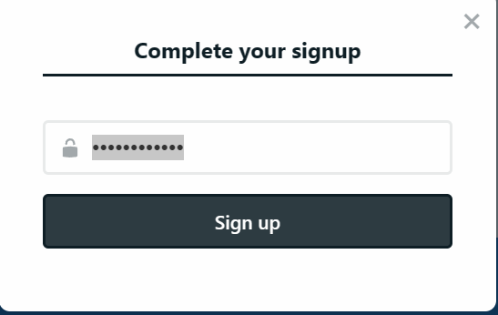yang19930326 [chaoyu0326@qq.com](mailto:chaoyu0326@qq.com)

git init

git remote add origin https://github.com/yangcy1993/starter-hugo-academic.git

git pull --rebase origin main

**…or create a new repository on the command line**

git init

git add README.md

git commit -m "first commit"

git branch -M main

git remote add origin <https://github.com/yangcy1993/starter-hugo-academic.git>

git remote add origin https://github.com/yangcy1993/new-academic.git

git push -u origin main

**…or push an existing repository from the command line**

git remote add origin https://github.com/yangcy1993/starter-hugo-academic.git

git branch -M main

git push -u origin main

link: uploads/resume.pdf

[🏷 Page Features | Wowchemy](https://wowchemy.com/docs/content/page-features/)

https://wowchemy.com/docs/content/page-features/

[📸 Page Elements: Writing content with Markdown, LaTeX, and Shortcodes | Wowchemy](https://wowchemy.com/docs/content/writing-markdown-latex/)

https://wowchemy.com/docs/content/writing-markdown-latex/

[Wowchemy website builder for Hugo themes](https://wowchemy.com/docs/getting-started/page-builder/) （主页）

<https://wowchemy.com/docs/getting-started/page-builder/>

正文之中加视频将视频文件加入至本publication中并在文中插入

{{< video src="2.mp4" controls="yes" >}}