logbus部署环境
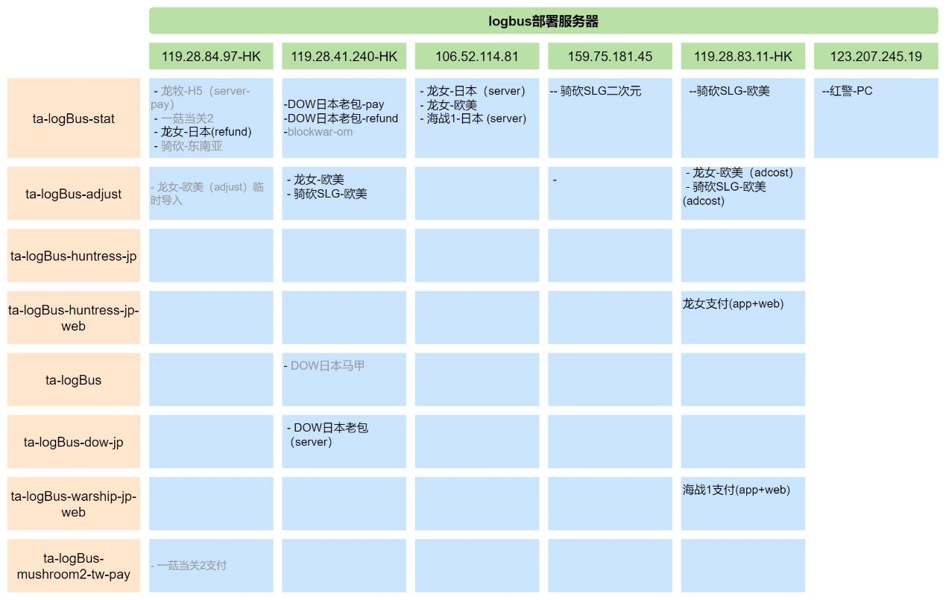

119.28.83.11

1.ta-logBus-stat
龙牧APPLovin广告：/data/web/statisticsgoogleadweb/lovinlog_longmu_tw_column1/*

2.ta-logBus-adjust
龙女-欧美-report-service：/data/web/statisticsgoogleadweb/reportlog_huntressusa/*
龙牧-台湾-report-service：/data/web/statisticsgoogleadweb/reportlog_longmu/*
方块-欧美-report-service：/data/web/statisticsgoogleadweb/reportlog_blockwar/*

3.ta-logBus-huntress-jp-web
龙女-网页-支付：/data1/sslog/huntress_jp_pay_new/*

119.28.84.97

1.ta-logBus-adjust
方块-adjust:/data/web/adjust_blockwar/logs/ajevent.*.log

119.28.41.240

1.ta-logBus
DOW马甲：/data/log/talogmj1/*

2.ta-logBus-dow-jp
DOW-日本：/data/log/talog1/*

3.ta-logBus-stat
DOW-日本-网页支付：/data1/sslog/dow_jp_pay/
DOW-日本-支付退款：/data2/zhanguo/jp/payment_refund/*
方块-欧美：/data1/sslog/blockwar_om/*

4.ta-logBus-adjust
龙女-欧洲：/data/web/adjust_huntress_europe/logs/*/*/ajevent.*.log
龙牧-台湾：/data/web/adjust_warship1_japan/logs/*/*/adjust_event_dragonteam_taiwan.*.log

106.52.114.81
龙女-日本：/data3/bigdata/huntresslog/ssjplog/*
龙女-欧美：/data3/bigdata/huntresslog/ssomlog/*
龙女-欧美-支付：/data3/bigdata/huntresslog/ssompay/*
海战1-日本：/data3/bigdata/warshiplog/ssjplog/*

