**WEBGIS服务编译及部署**

系统采用：ubuntu 16.04版本，

1. 更新系统

sudo apt-get update

sudo apt-get -y upgrade

1. 安装基础依赖工具

sudo apt-get -y install curl unzip gdal-bin tar wget bzip2 build-essential clang

1. 配置检擦系统swap

如果内存足够，已有swap，则略过。

1. 检查EnglishLocale

locale

export LANGUAGE=en_US.UTF-8

export LANG=en_US.UTF-8

export LC_ALL=en_US.UTF-8

1. 创建TileServer用户

sudo useradd -m tileserver

sudo passwd tileserver

1. 安装GIT  
   git --version # to verify whether git is already installed

sudo apt-get install -y git

1. 安装Mapnik库

sudo apt-get install -y git autoconf libtool libxml2-dev libbz2-dev \

libgeos-dev libgeos++-dev libproj-dev gdal-bin libgdal-dev g++ \

libmapnik-dev mapnik-utils python-mapnik

1. 验证mapnik安装

mapnik-config -v

python -c "import mapnik;print mapnik.__file__"

1. 安装Apache

sudo apt-get install -y apache2 apache2-dev

1. 安装Mod_tile

test -d ~/src || mkdir ~/src ; cd ~/src

git clone https://github.com/openstreetmap/mod_tile.git

cd mod_tile

./autogen.sh && ./configure && make && sudo make install && sudo make install-mod_tile && sudo ldconfig

cd ~/

1. 安装Yaml 和Package Manager for Python

系统需要安装好python

sudo apt-get install -y python-yaml

pip -V # to verify whether pip is already installed

sudo apt-get install -y python-pip

1. 安装Mapnik工具

sudo apt-get install -y mapnik-utils

1. 安装openstreetmap-carto

cd ~/src

git clone https://github.com/gravitystorm/openstreetmap-carto.git

cd openstreetmap-carto

1. 安装Fonts

sudo apt-get install -y fonts-noto-cjk fonts-noto-hinted fonts-noto-unhinted fonts-hanazono ttf-unifont

cd ~/src

git clone https://github.com/googlei18n/noto-emoji.git

git clone https://github.com/googlei18n/noto-fonts.git

sudo cp noto-emoji/fonts/NotoColorEmoji.ttf noto-emoji/fonts/NotoEmoji-Regular.ttf /usr/share/fonts/truetype/noto

（到此）

sudo cp noto-fonts/hinted/NotoSansArabicUI-Regular.ttf noto-fonts/hinted/NotoNaskhArabicUI-Regular.ttf noto-fonts/hinted/NotoSansArabicUI-Bold.ttf noto-fonts/hinted/NotoNaskhArabicUI-Bold.ttf /usr/share/fonts/truetype/noto

sudo fc-cache -fv

sudo apt install fontconfig

fc-list

fc-list | grep Emoji

cd openstreetmap-carto

1. 创建数据文件夹

cd ~/src

cd openstreetmap-carto

scripts/get-shapefiles.py

更新的数据，可以参考格式直接替换data文件夹下的数据即可。

1. 安装carto和Mapnik xml stylesheet

sudo apt install -y nodejs-legacy

sudo apt install -y npm

sudo npm install -g carto@0.18.0

确保version >= 0.18.0, using YAML

生成style.xml文件

cd ~/src

cd openstreetmap-carto

carto -a "3.0.0" project.mml > style.xml

ls -l style.xml

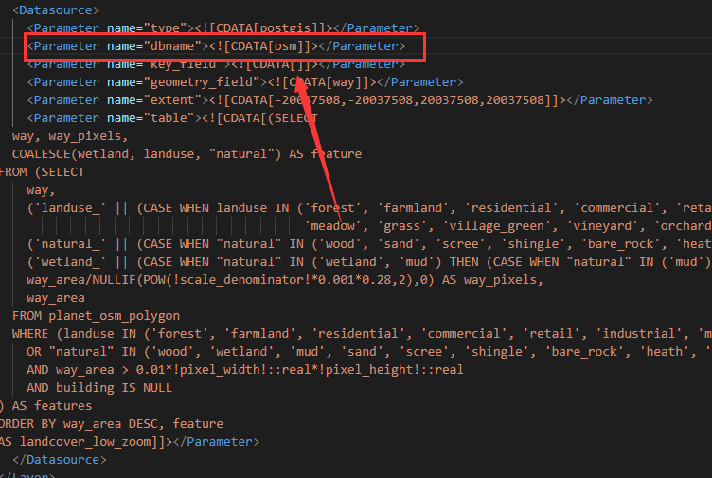

数据库名称

1. 安装PostgreSQL和PostGIS

sudo apt-get update

sudo apt-get install -y postgresql postgis pgadmin3 postgresql-contrib

sudo -u postgres psql postgres

2

设置好密码

创建osm数据库，并设置好postgis和hstore扩展。

添加用户tileserver，并设置好授权

1. 设置数据库配置

postgresql.conf 参考如下配置：

shared_buffers = 2GB

work_mem = 128MB

maintenance_work_mem = 1GB

wal_level = minimal

synchronous_commit = off

min_wal_size = 1GB

max_wal_size = 2GB

checkpoint_timeout = 15min

checkpoint_completion_target = 0.9

default_statistics_target = 1000

autovacuum = off

fsync = off

1. 安装Osm2pgsql

sudo apt-get install -y osm2pgsql

**sudo apt-get install libprotobuf-c0-dev protobuf-c-compiler**

1. 将数据导入PostGIS

参考指令：osm2pgsql -s -C 1000 -c -G --hstore --style /home/ydx/src/openstreetmap-carto/openstreetmap-carto.style --tag-transform-script /home/ydx/src/openstreetmap-carto/openstreetmap-carto.lua -d osm -H localhost -U postgres /home/ydx/src/openstreetmap-carto/data/china-latest.osm.pbf -W

创建索引：

HOSTNAME=localhost # set it to the actual ip address or host name

cd ~/src

cd openstreetmap-carto

scripts/indexes.py | psql -U postgres -h $HOSTNAME -d osm

1. 配置renderd

sudo vi /usr/local/etc/renderd.conf

In the [default] section, change the value of XML and HOST to the following.

XML=/home/ydx/src/openstreetmap-carto/style.xml

HOST=localhost

Also, substitute all ;** with ;xxx=** (e.g., with vi :1,$s/^;\*\* /;xxx=** /g).

We suppose in the above example that your home directory is */home/tileserver*. Change it to your actual home directory.

In [mapnik] section, change the value of plugins_dir.

plugins_dir=/usr/lib/mapnik/3.0/input/

Save the file.

Check this to be sure:

ls -l /home/ydx/src/openstreetmap-carto/style.xml

grep '^;xxx=\*\*' /usr/local/etc/renderd.conf

In case of error, verify user name and check again /usr/local/etc/renderd.conf.

Install *renderd* init script by copying the sample init script included in its package.

sudo cp ~/src/mod_tile/debian/renderd.init /etc/init.d/renderd

Grant execute permission.

sudo chmod a+x /etc/init.d/renderd

Edit the init script file

sudo vi /etc/init.d/renderd

Change the following variables:

DAEMON=/usr/local/bin/$NAME

DAEMON_ARGS="-c /usr/local/etc/renderd.conf"

RUNASUSER=tileserver

In RUNASUSER=tileserver we suppose that your user is *tileserver*. Change it to your actual user name.

Save the file.

Create the following file and set *tileserver* (your actual user) the owner.

sudo mkdir -p /var/lib/mod_tile

sudo chown tileserver:tileserver /var/lib/mod_tile

Again change it to your actual user name.

Then start renderd service

sudo systemctl daemon-reload

sudo systemctl start renderd

sudo systemctl enable renderd

需要检查renderd的日志：

sudo journalctl -eu renderd

确保renderd不会在日志中产生任何错误，否则将不会显示地图。

The following output is regular:

renderd.service is not a native service, redirecting to systemd-sysv-install

Executing /lib/systemd/systemd-sysv-install enable renderd

1. 配置Apache

Create a module load file.

sudo vi /etc/apache2/mods-available/mod_tile.load

Paste the following line into the file.

LoadModule tile_module /usr/lib/apache2/modules/mod_tile.so

Create a symlink.

sudo ln -s /etc/apache2/mods-available/mod_tile.load /etc/apache2/mods-enabled/

Then edit the default virtual host file.

sudo vi /etc/apache2/sites-enabled/000-default.conf

Past the following lines after the line <VirtualHost *:80>

# Load all the tilesets defined in the configuration file into this virtual host

LoadTileConfigFile /usr/local/etc/renderd.conf

# Socket where we connect to the rendering daemon

ModTileRenderdSocketName /var/run/renderd/renderd.sock

# Timeout before giving up for a tile to be rendered

ModTileRequestTimeout 3

# Timeout before giving up for a tile to be rendered that is otherwise missing

ModTileMissingRequestTimeout 60

Save and close the file. Restart Apache.

sudo systemctl restart apache2

1. 测试链接：

<http://yourip/osm_tiles/0/0/0.png>

<https://blog.csdn.net/u012241570/article/details/80283009>