CS767 Assignment 2 — Data Analysis Agent
Student: Dongqing Yang
ID: 291140653
GitHub: https://github.com/yangdongqing214/compsci767_assignment2

System design

Repository
https://github.com/yangdongqing214/compsci767_assignment2

Architecture
The agent follows a perceive → decide → act → reflect loop:
- Perceive: Load CSV; compute profile (columns, types, missing counts).
- Decide: Planner produces a JSON list of steps (LLM if OPENAI_API_KEY set, else heuristic rules).
- Act: Each step runs a builtin tool (statistics, plots, groupby) or sandboxed pandas code validated by safety.py.
- Reflect: Results stored in AgentMemory; final markdown report written to output/.
User goal + CSV
↓
[DataAnalysisAgent]
↓
profile → plan → execute steps → memory + report.md + PNG artifacts

Design choices
Tools vs. free-form code: Most steps use reliable builtins; optional code step for goal-specific metrics (e.g. revenue = units × price).
Safety: AST scan blocks os, subprocess, open, network imports before exec.
Reproducibility: Heuristic mode requires no API; graders can run python main.py immediately.

Screenshot 1,2 — CLI run, Generated artifacts
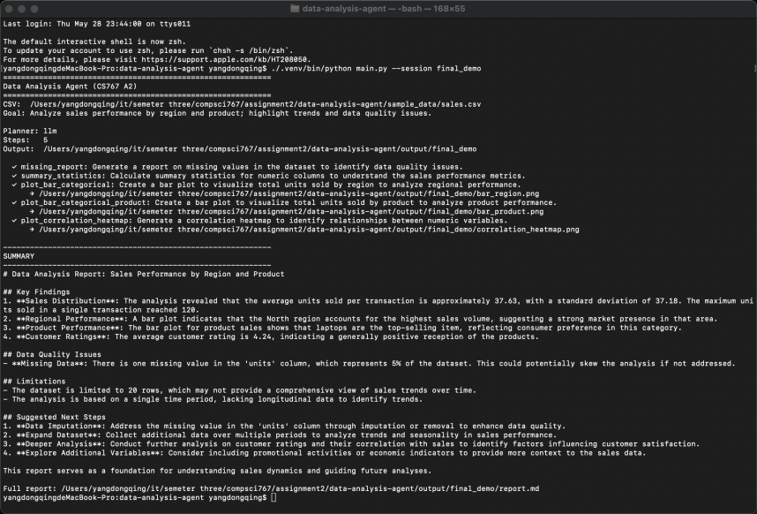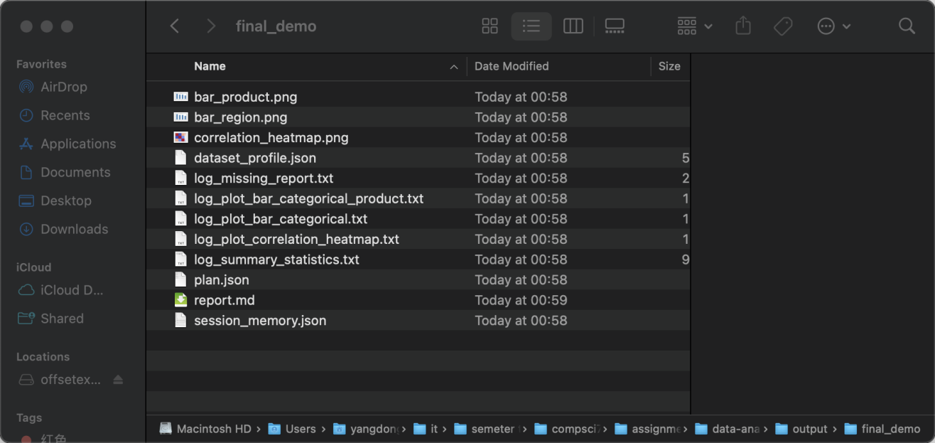
1.Completes 5–6 steps and prints a short summary.
2.Histogram, correlation heatmap, and bar charts produced automatically.

How it works (short)
The user supplies a goal and CSV. The agent does not hard-code one analysis pipeline—it selects steps from the dataset profile and user goal, executes them, and aggregates results. Failed steps are logged without stopping the whole run (robust act loop). For limitations, single-pass planning — no observe→replan if a step fails. Memory logs outcomes but does not feed back into replanning within one run. Trade-off: builtin tools improve reliability over fully LLM-generated code.

