NCS Visitor Management System

Modernising front-desk visitor control
Management Briefing September 2026

The problem we set out to solve
Our reception desks ran on paper visitor registers.
The issue | The cost
Handwritten entries | Illegible and inconsistent records
No central search | Returning visitors re-register every time
Manual numbering | Lost references and no audit trail
No live view | No way to know who is on site right now
Manual reporting | Hours spent counting entries by hand

Bottom line: the organisation could not answer basic security questions about who entered its facilities, when, and why.

What the system delivers
A digital visitor control platform covering the full reception workflow.
- Register visitors once, reuse them forever
- Identify returning visitors by phone, email or face
- Issue a unique reference and QR-coded slip per visit
- Track sign-in and sign-out in real time
- Report on any date range in seconds

How it works — the three-step workflow
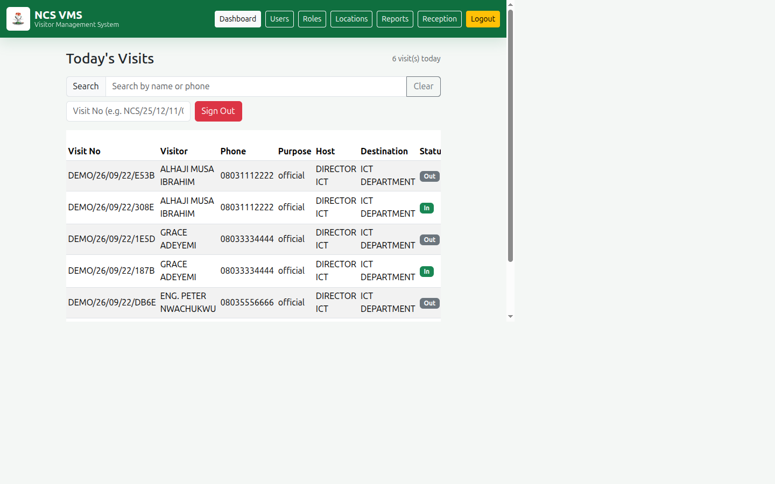
w:1000
1. Identify → search or register the visitor 2. Record → capture purpose, host, documents, group size 3. Close → sign the visitor out when they leave

The reception screen
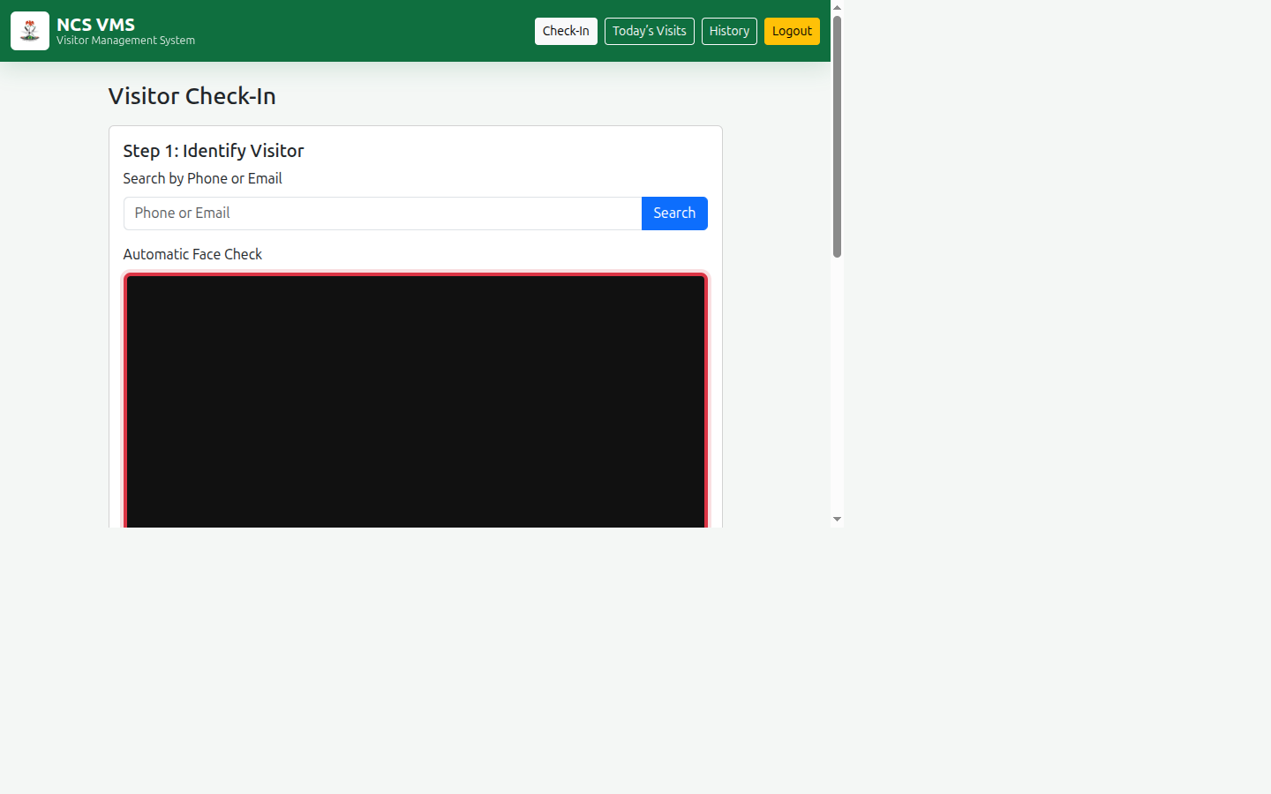
w:1050
One screen guides the officer. No training manual needed at the desk.

Key capability: instant visitor lookup
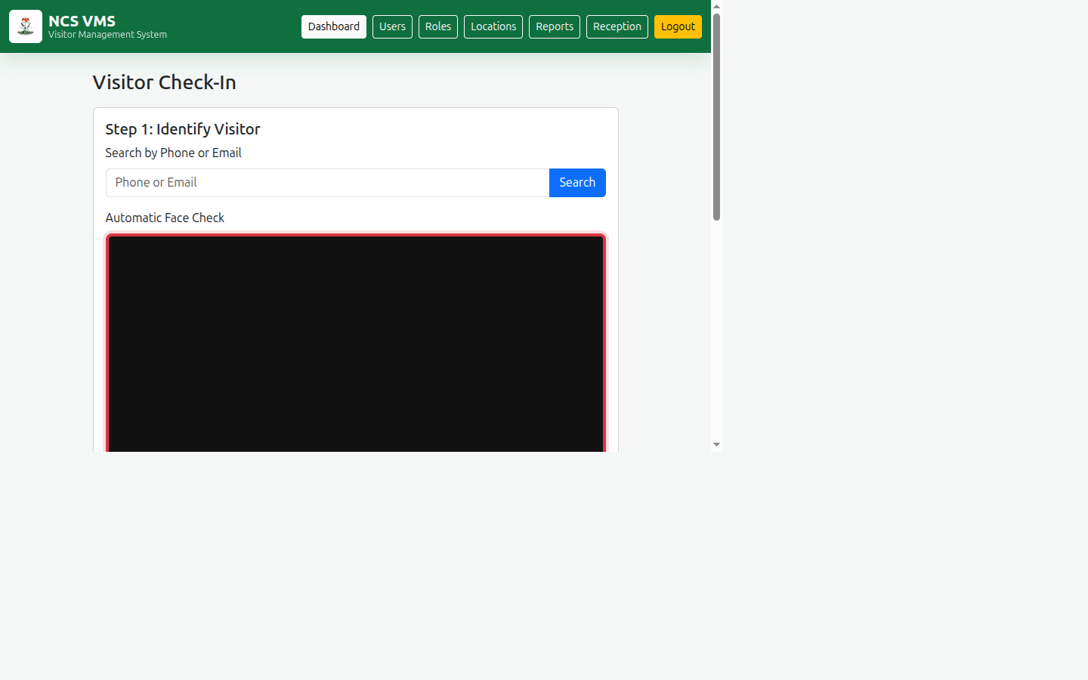
w:1000
- Search by phone or email — returning visitors found in one second
- Optional face check speeds up regular visitors
- Duplicate records are prevented automatically by phone number
- Visitor photographs are captured on a clean white background for identification

Key capability: complete visit history
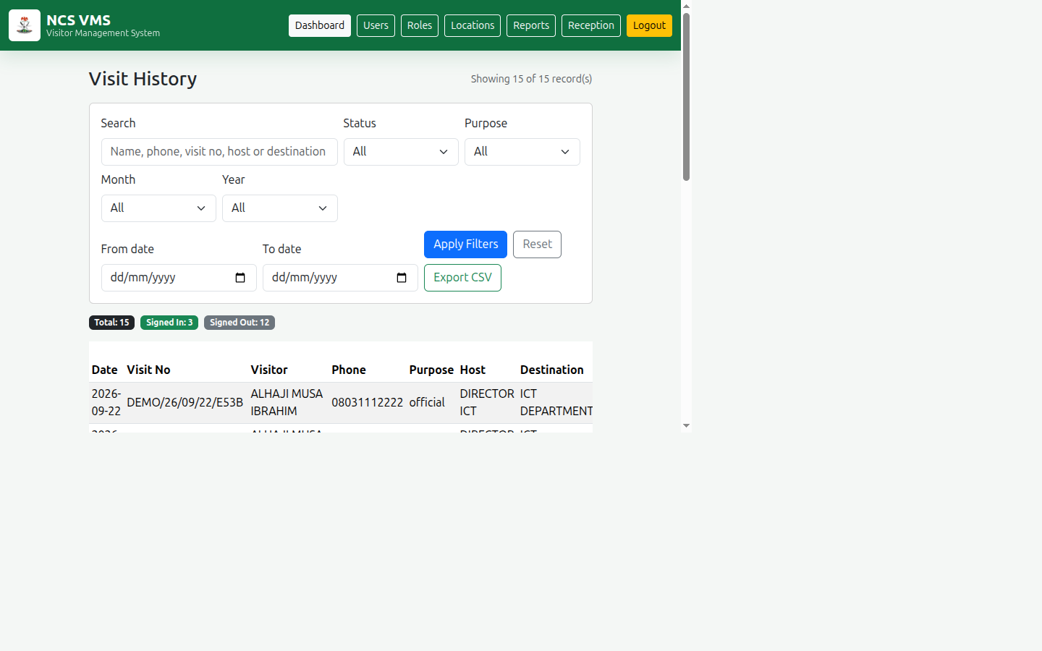
w:1050
- Search all visits by name, phone, visit number, host or destination
- Filter by status, purpose, month, year or exact date range
- Export to CSV for Excel or Google Sheets
What used to take hours of manual counting now takes seconds.

Key capability: live site presence
w:1050
The desk can see, at a glance, everyone currently on site, and sign them out with a single click — a directly measurable security improvement.

Security and accountability built in
Control | What it gives us
Individual accounts | Every action is traceable to a person, not a shared PIN
Hashed passwords | Credentials cannot be read from the database
Role-based access | Officers see only reception; admins see administration
Named audit trail | Each visit records who created it and who signed it out
One active visit per day | Blocks duplicate or unclosed entries
Protected admin actions | Administrators cannot lock themselves out

Two modules, two audiences
 | Reception | Admin
Users | Desk and security officers | System administrators
Focus | Check-in, sign-out, history | Users, roles, locations, reports
Lands on | Visitor Check-In | Admin Dashboard

The system decides automatically after login, based on the user's role.

Administration at a glance
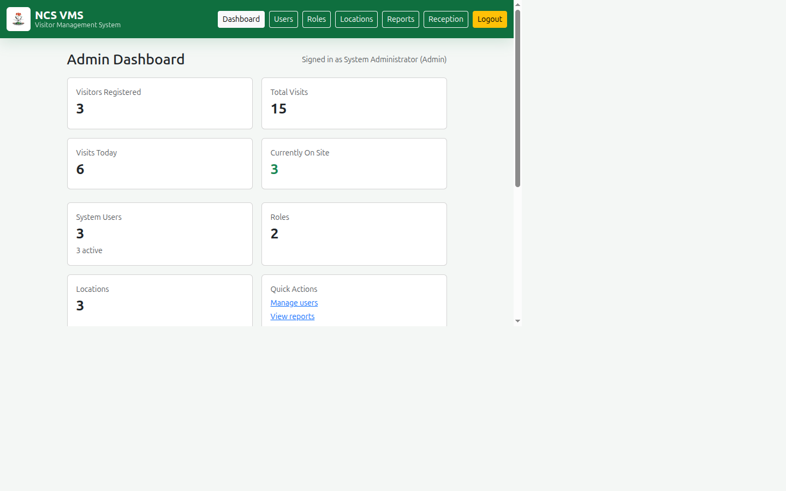
w:1050
Live counts of visitors, visits, site occupancy, users and locations — an operational picture for supervisors at any moment.

Managing people and permissions
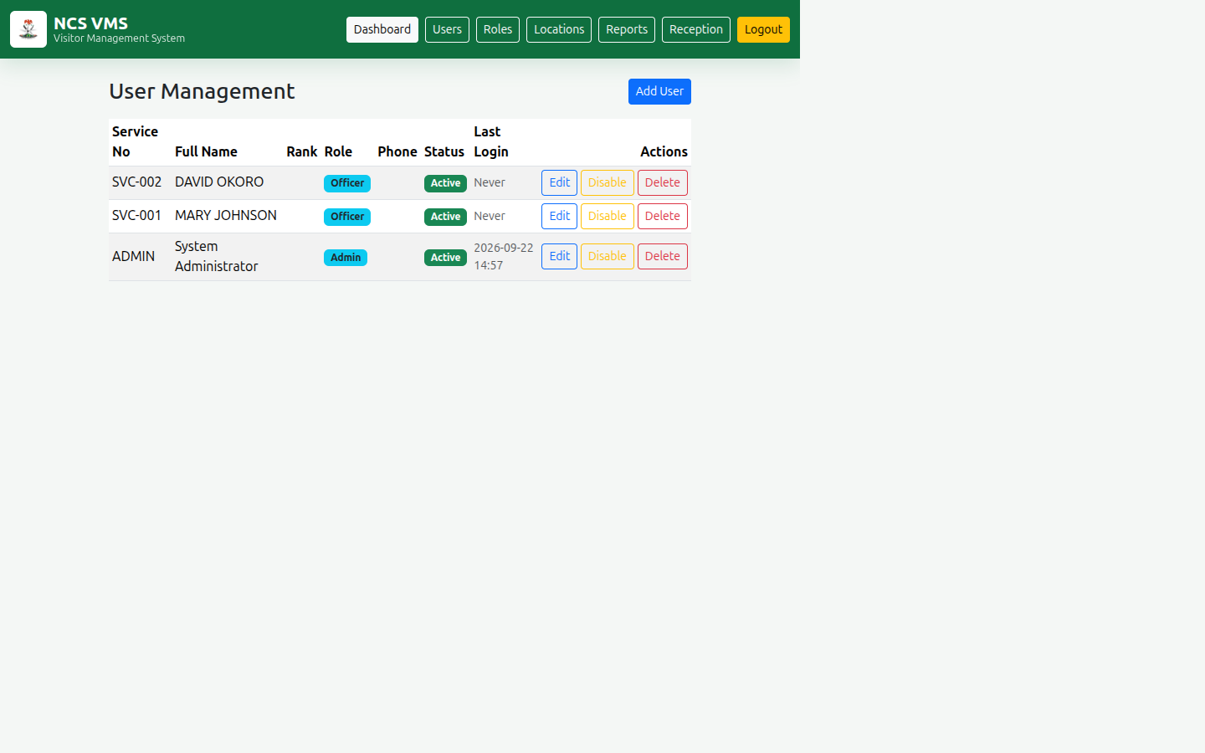
w:1000
- Create, edit, disable or delete user accounts
- Assign roles; change them without touching code
- Disable rather than delete to preserve audit history

Roles are configurable, not hard-coded
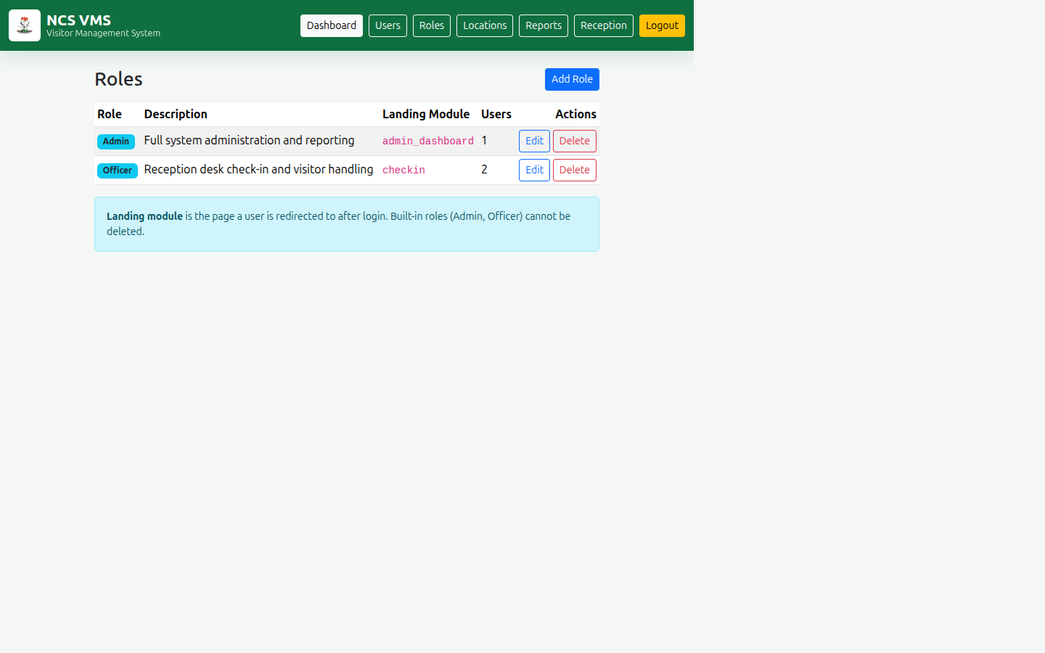
w:1000
New roles can be created by administrators and pointed at the appropriate module. The organisation is not locked into two fixed permission levels.

Reporting for management
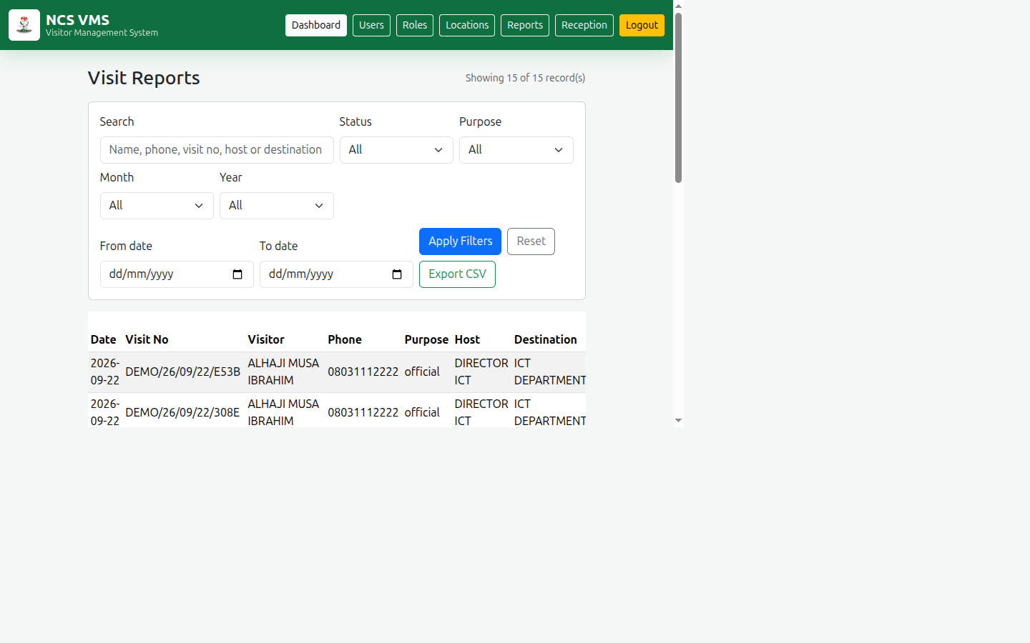
w:1050
Answers questions such as:
- How many official visitors did we host this month?
- Which departments receive the most visitors?
- Who was on site on the day of a specific incident?
- What are our peak visiting periods?
All exportable, all filterable by flexible date ranges.

Organisational structure supported
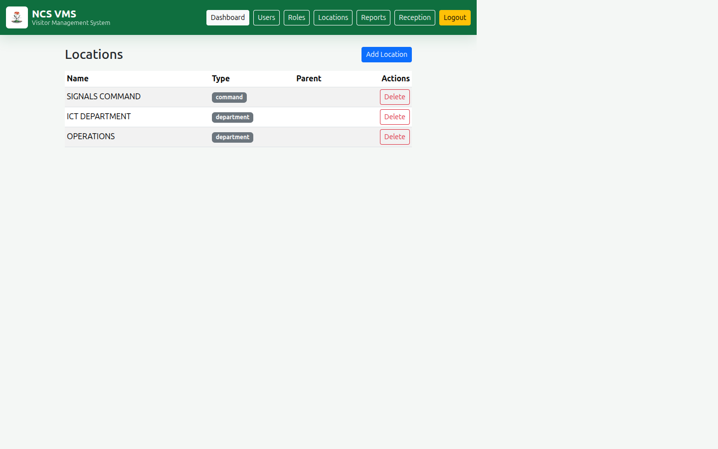
w:1000
Departments, commands and units are modelled with parent-child relationships, allowing destinations to reflect the real command structure.

Privacy and data protection
Visitor information is personal data and is treated accordingly.
- Visitor photographs are excluded from source control
- Databases and captured images are kept out of the repository
- Passwords are stored only as salted hashes
- Access requires authentication and a recognised role
Note: Before production deployment, add encryption at rest, a formal retention policy, scheduled secure backups and complete audit logging.

What has been delivered
Capability | Status
Visitor registration and lookup | ✅ Delivered
Photograph capture and portrait processing | ✅ Delivered
Visit creation with QR slips | ✅ Delivered
Sign-in / sign-out tracking | ✅ Delivered
Daily and historical reporting with export | ✅ Delivered
User accounts, roles and permissions | ✅ Delivered
Admin dashboard and user management | ✅ Delivered
Biometric fingerprint / voice capture | 🔜 Future (fields reserved)

Where this can go next
Phase 2 candidates
- Badge printing and QR scanning at gates
- SMS or email visitor notifications
- Photo-to-host alerts when a visitor arrives
- Cloud hosting with automatic backups
- Mobile app for security patrols
- Integration with access-control hardware

Recommended next steps
- Pilot at one reception desk for two weeks
- Gather officer feedback and refine the workflow
- Harden for production: backups, retention policy, HTTPS
- Train reception staff using the published User Guide
- Roll out to remaining facilities
The prototype is functional and demonstrated. The remaining work is operational hardening and rollout, not core development.

The value proposition
Before | After
Paper registers | Searchable digital records
Manual counting | Instant reports
No live occupancy view | Real-time site presence
Shared desk PIN | Named, auditable accounts
Re-typing returning visitors | One-second lookup
No management visibility | Dashboard and exports on demand

Thank you

NCS Visitor Management System
Questions and discussion
Author: Yange Henry Terzugwe Software Developer • AI & Robotics Practitioner

NCS Visitor Management System — Management Briefing, September 2026

