NCS Visitor Management System — User Guide
Audience: Reception officers, desk officers, security personnel and system administrators Version: 1.0 Last updated: 22 September 2026

Table of Contents
Right-click and choose "Update Field" to build the table of contents.
(In Word: right-click the line above → Update Field → Update entire table.)
- 4.1 Identifying a Visitor
- 4.2 Registering a New Visitor
- 4.3 Creating a Visit
- 4.4 The Visitor Slip and QR Code
- Today's Visits
- Visit History
- Visitor Verification (Department Stations)
- The Admin Module
- Troubleshooting
- Glossary

1. Introduction
The NCS Visitor Management System (VMS) replaces the paper visitor register with a digital workflow. It lets the reception desk:
- register visitors and keep a searchable record of them
- identify returning visitors instantly, so details are not re-typed
- issue each visit a unique reference number and a QR-coded visitor slip
- track who is currently on site and sign them out when they leave
- search and report on all past visits
The system has two modules, and which one you see depends on your role:
Module | Who uses it | What it does
Reception | Officers | Day-to-day visitor check-in, sign-out and history
Verification | Department staff | Camera-only check that a visitor is signed in
Admin | Administrators | Manage users, roles, locations and reports

2. Getting Started

What you need
- A computer with a modern web browser (Chrome, Edge or Firefox)
- Your Service Number and password, issued by the administrator
- A webcam (optional) — used for face check and visitor photographs

Opening the system
Enter the address provided by your administrator (for example http://localhost:5100) into your browser. You will see the landing page:
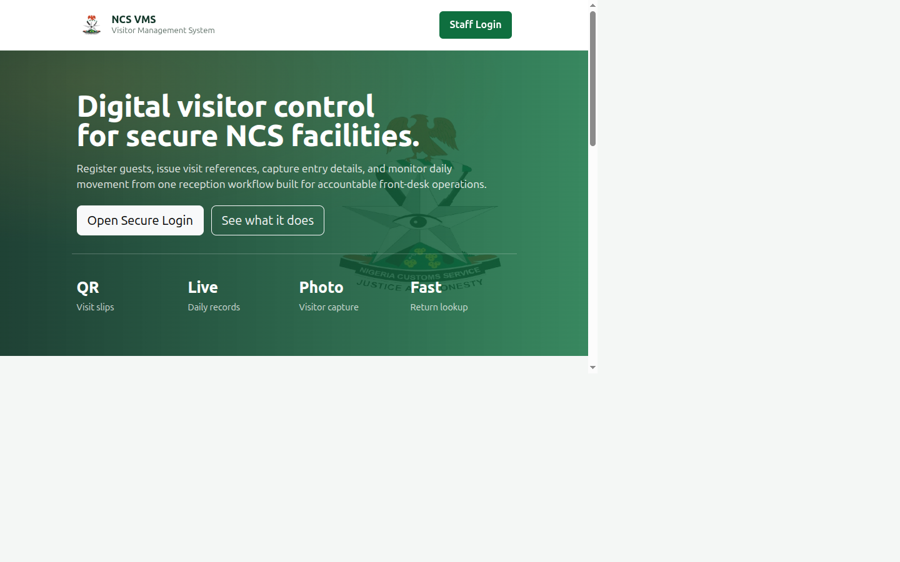
Landing page
The landing page describes what the system does. To continue, click Staff Login in the top-right corner, or the Open Secure Login button.

3. Signing In
Click Staff Login. The login window appears:
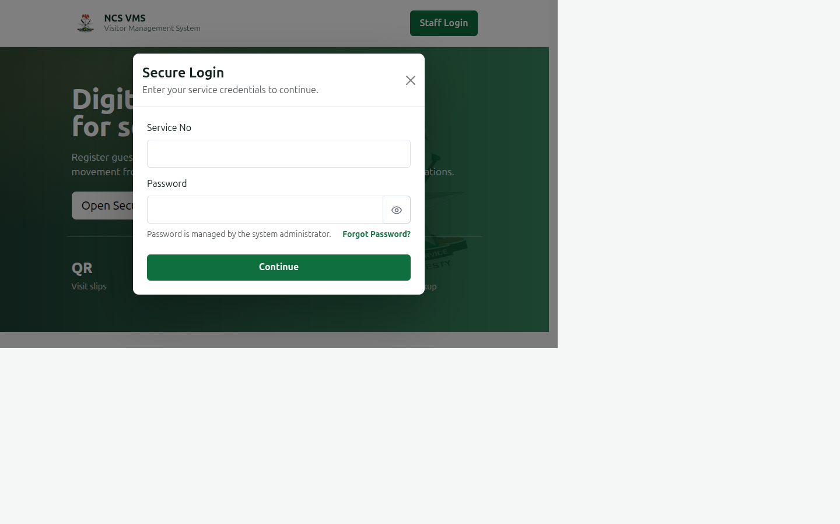
Login modal
- Enter your Service No (for example SVC-001).
- Enter your Password.
- Click the eye icon to show or hide the password.
- If Caps Lock is on, a warning appears below the field.
- Click Continue.
Where will I land? The system sends you to the module that matches your role automatically: - Officers go straight to Visitor Check-In. - Department staff go to the Visitor Verification screen. - Administrators go to the Admin Dashboard.
If your details are not recognised you will see "Invalid service number or password." If your account has been disabled you will see a message asking you to contact the administrator.

Signing out
Click Logout in the top-right corner when you finish your shift. Always sign out on a shared reception computer.

4. The Reception Module
After signing in as an officer, you arrive at the check-in screen:
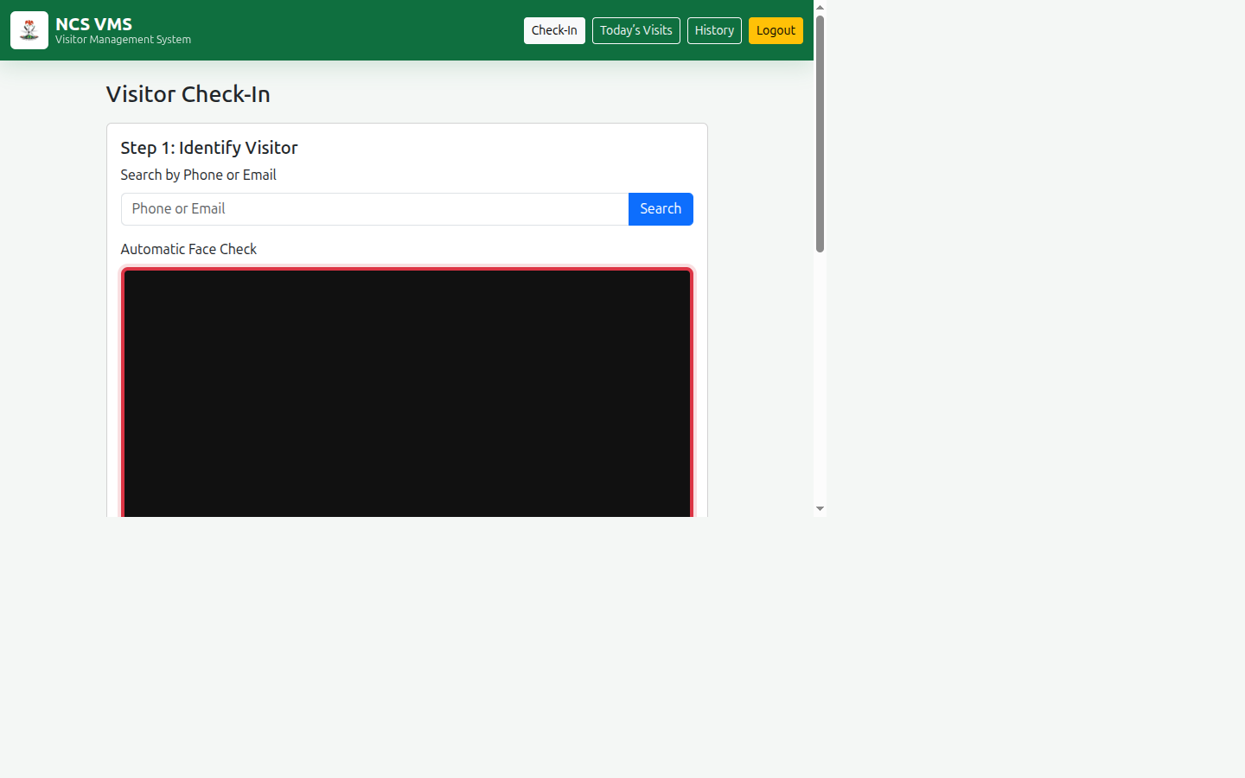
Officer check-in
The screen has three steps, which appear as you progress.

4.1 Identifying a Visitor
Before registering anyone, check whether they have visited before.
Method 1 — Search by phone or email
- Type the visitor's phone number or email address into the **Search by Phone or
Email** box.
- Click Search.
- If the visitor exists, their details and previous visit count appear in green.
Method 2 — Automatic face check
If a webcam is connected, the system watches the camera frame for a face.
- Ask the visitor to look at the camera — one person only.
- Wait for the message "Single face detected."
- Click Capture & Search.
The frame border tells you the result:
Border colour | Meaning
🟩 Green | A matching visitor was found
🟥 Red | No match — this is a new visitor
🟨 Yellow | More than one face is visible — ask others to step aside

Note: The face check is a convenience feature to speed up returning visitors. You can always fall back to searching by phone number.

4.2 Registering a New Visitor
If the search finds nobody, the New Visitor Registration form opens.
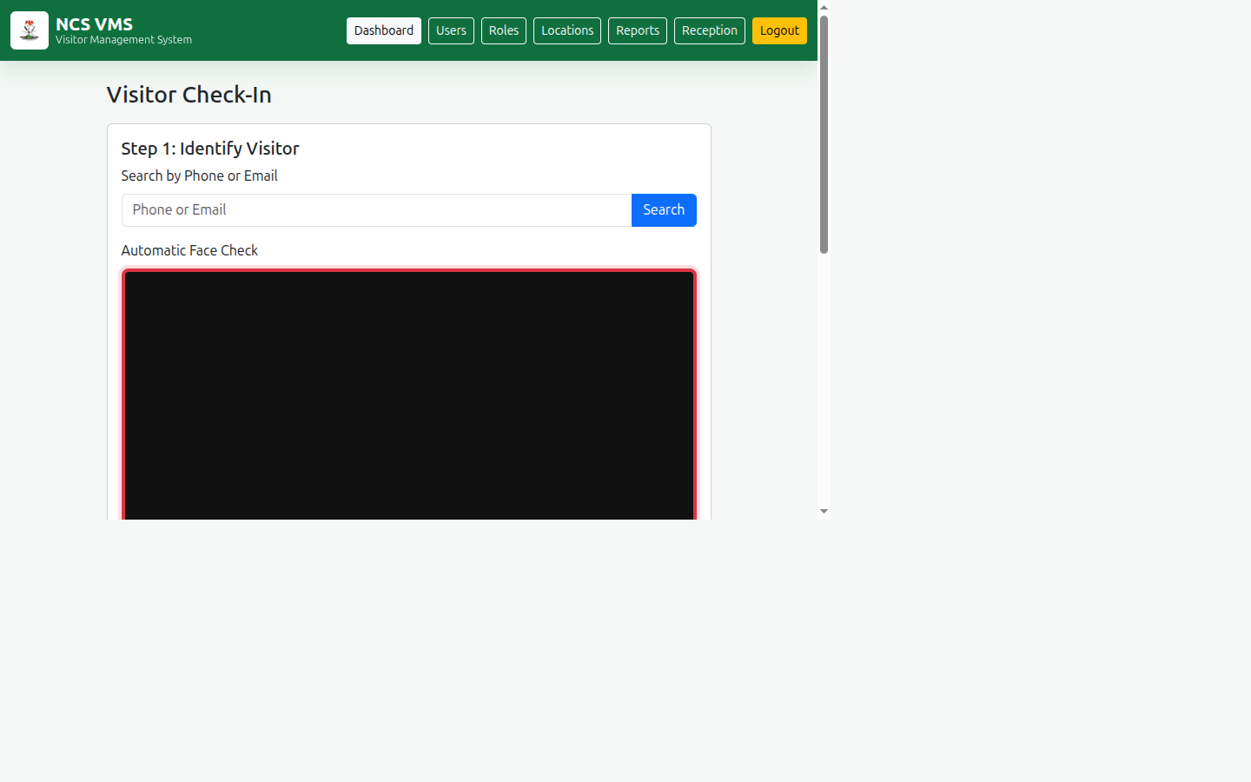
Check-in page
Fill in the details:
Field | Required | Notes
Full Name | Yes | Automatically converted to UPPERCASE
Phone | Yes | Exactly 11 digits; letters and symbols are rejected
Email | No | Used for future lookups
Gender | No
Address | No

The Professional Portrait panel shows the captured photograph. The system automatically crops the face and places it on a clean white background.
Click Save Visitor.
Duplicate protection: If the phone number or email already belongs to someone, the system will not create a second record. It shows you the existing visitor instead, and you continue straight to the visit details.

4.3 Creating a Visit
With the visitor identified (existing or newly saved), the Visit Details form becomes available.
- Purpose — select Official or Personal.
- Choosing Personal reveals two extra fields: Host / Officer to Visit and
Department / Destination. The host name is required.
- Group Visit? — select Yes if more than one person is entering, then enter
the Number of Persons.
- Documents Carried — record anything the visitor is bringing in.
- Click Generate Visit & QR.
One visit at a time: A visitor cannot hold two active visits on the same day. If they are already signed in, the system blocks the new visit and shows a warning with their existing visit number and a link to sign them out first.

4.4 The Visitor Slip and QR Code
On success, a Visitor Slip appears with:
- the unique Visit No (format NCS/YY/MM/DD/NNNN)
- a QR code encoding the visit
Check-in page
The page then returns to a fresh check-in screen, ready for the next visitor.

5. Today's Visits
Open Today's Visits from the menu to see everyone who has entered today.
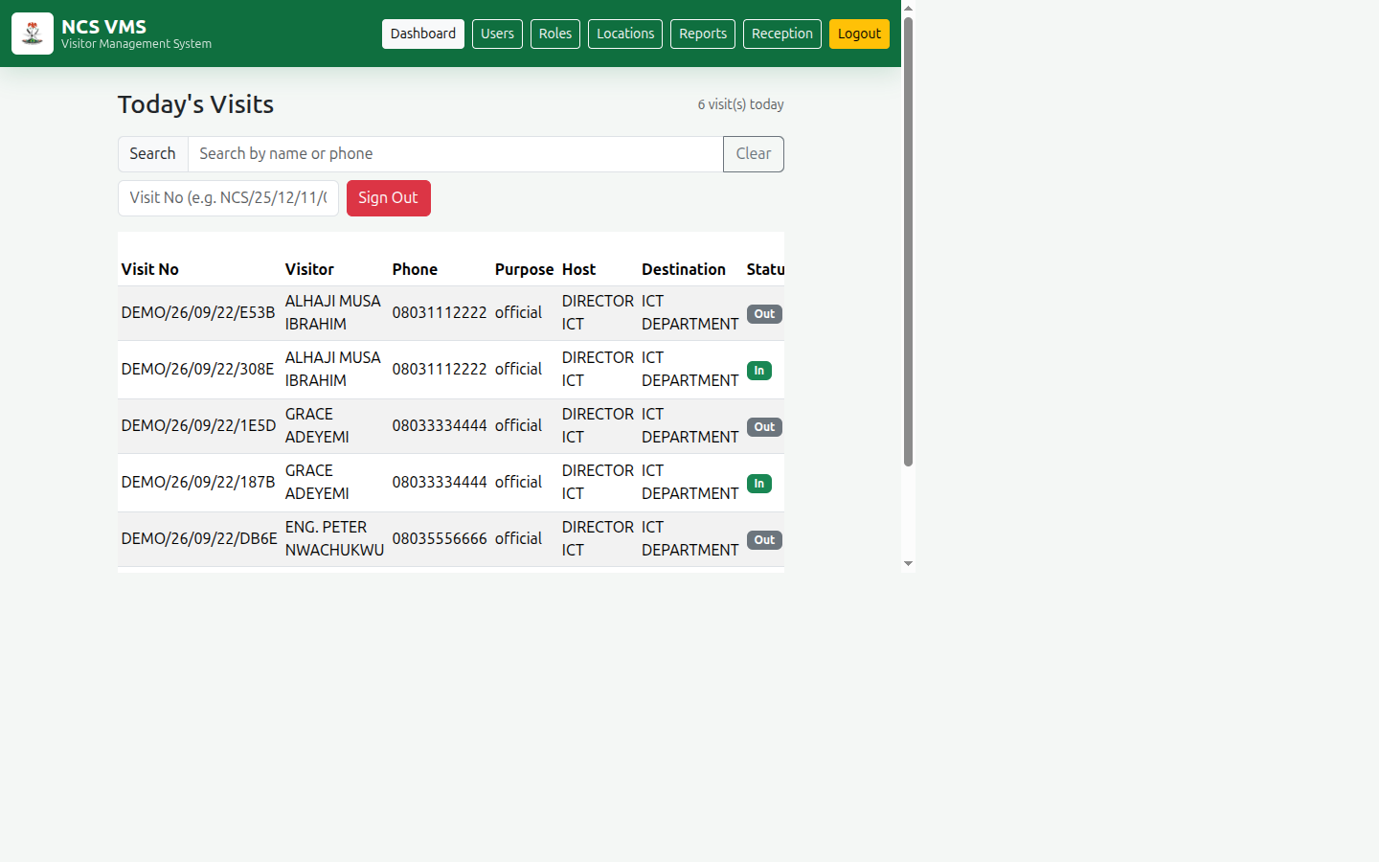
Today's visits
The table shows the visit number, visitor name, phone, purpose, host, destination, status, sign-in and sign-out times, and the officer who recorded it.

Searching the list
Use the Search box above the table to filter by name or phone number in real time. Click Clear to reset.

Signing a visitor out
There are two ways:
Option A — From the table
- Find the visitor's row. Their status shows a green In badge.
- Click the red Sign Out button at the right of that row.
- Confirm the prompt.
Option B — By visit number
- Type the visit number into the Visit No box (for example
NCS/26/09/22/0001).
- Click Sign Out.
The visitor's status changes to a grey Out badge and the sign-out time is recorded along with your service number.

6. Visit History
Open History from the menu to search all past visits, not just today's.
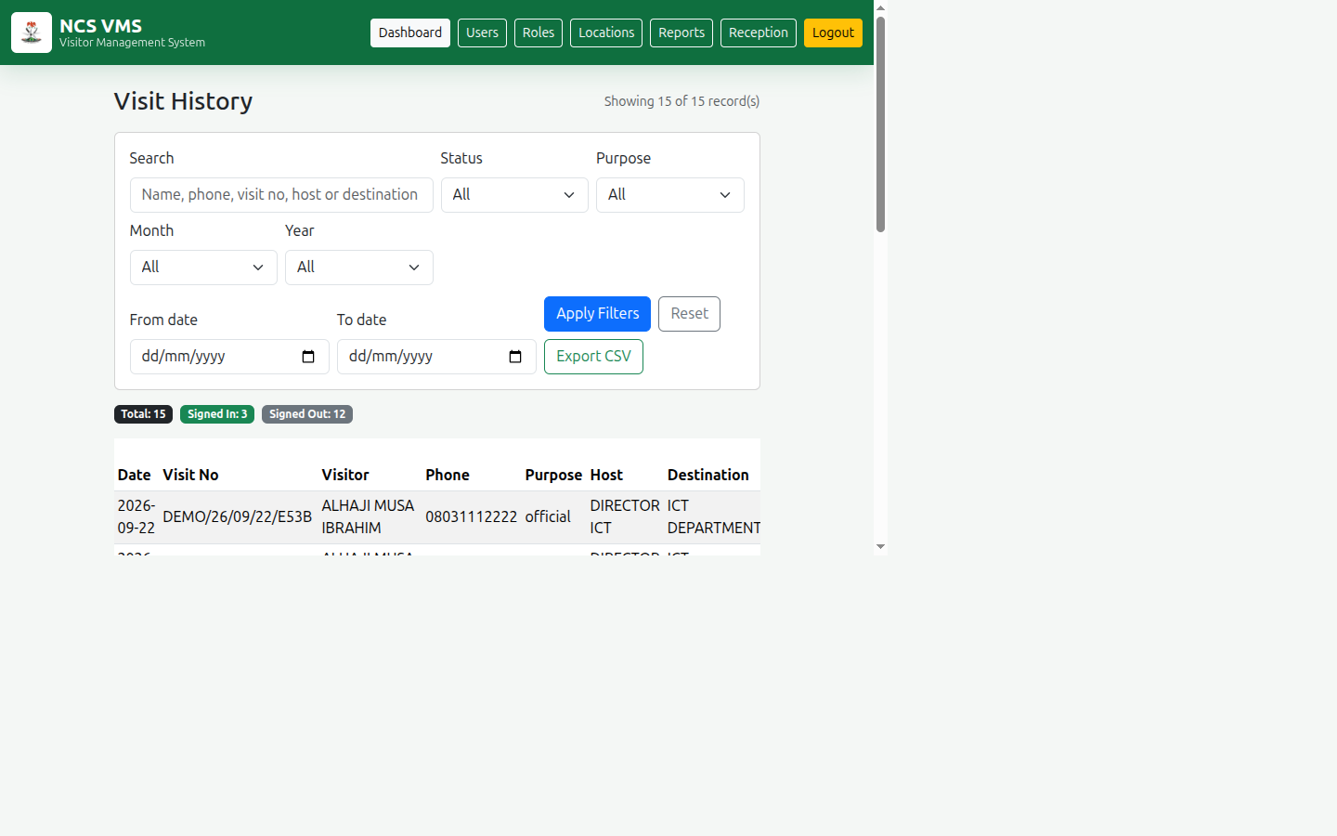
Visit history

Filtering
Filter | What it does
Search | Matches visitor name, phone, visit number, host or destination
Status | Signed In or Signed Out
Purpose | Official or Personal
Month | Any month, or all
Year | Only years that contain data
From date / To date | A specific date range

Filters can be combined. Click Apply Filters to run the search, or Reset to clear everything.
The badges above the table show the totals for your current filter.

Exporting
Click Export CSV to download the currently displayed results as a spreadsheet file, which opens in Excel or Google Sheets. This respects whatever filters are active.

7. Visitor Verification (Department Stations)
Some departments have a camera at the entrance so staff can confirm that a person arriving is a registered visitor who is signed in — without a reception officer being present.
If you sign in with a Department account, you go straight to the verification screen and you will see only two menu items: Verify Visitor and Logout.
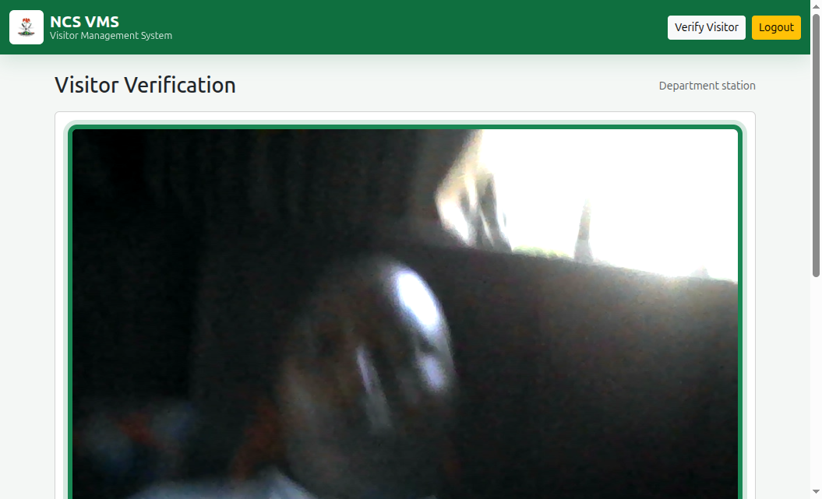
Department verification screen

How it works
- The camera starts automatically and the frame turns green when it detects a
single face.
- Verification runs automatically, or you can press Verify Now.
- The result appears in a large coloured banner:
Colour | Message | What it means | What to do
🟩 Green | VERIFIED — ON SITE | The visitor is recognised and currently signed in | Allow entry
🟨 Amber | VERIFIED — NOT SIGNED IN | The person is known but has no active visit today | Send them to reception to sign in
🟥 Red | NOT VERIFIED | No matching record found | Send them to reception to register
🟨 Amber | MULTIPLE FACES | More than one person in frame | Ask others to step aside

The banner also shows the visitor's name, their visit number and the time they signed in when there is an active visit.

The buttons
Button | Purpose
Verify Now | Runs a check immediately, whatever the automatic timer is doing
Pause Auto-Check | Stops automatic checking (useful during a crowd). Press again to resume

Good practice at the station
- Ask the visitor to look directly at the camera and remove sunglasses or a hat
- Keep one person in the frame at a time
- Wait for the frame to turn green before relying on the result
- If a regular visitor is not recognised, send them to reception — the camera is
a convenience, not proof of identity
Important: this screen is an aid, not a security guarantee. The photograph matching compares overall image structure and can occasionally be wrong. Treat a red result as "go to reception", and treat a green result as confirmation only when it agrees with what you expect.

Privacy
This screen deliberately shows status only. It does not display phone numbers, email addresses, home addresses, ID numbers or visit history — those remain at the reception desk. Only the visitor's name and visit reference are shown, so staff can confirm the right person is being admitted.

8. The Admin Module
Administrators see additional menu items. This section is for them.

8.1 Dashboard
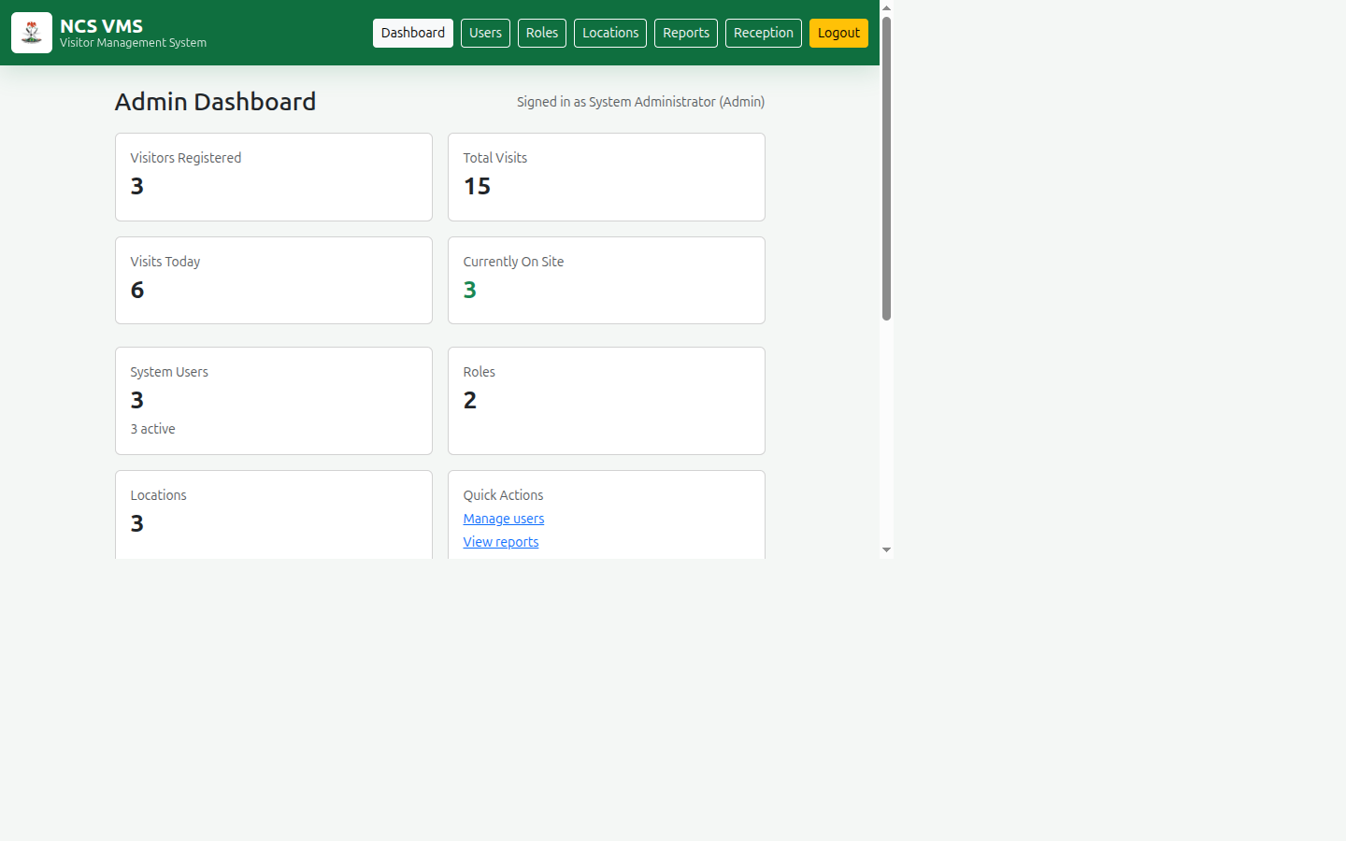
Admin dashboard
The dashboard summarises the whole system: visitors registered, total visits, visits today, who is currently on site, system users, roles and locations. The bottom table lists the most recent visits.

8.2 Users
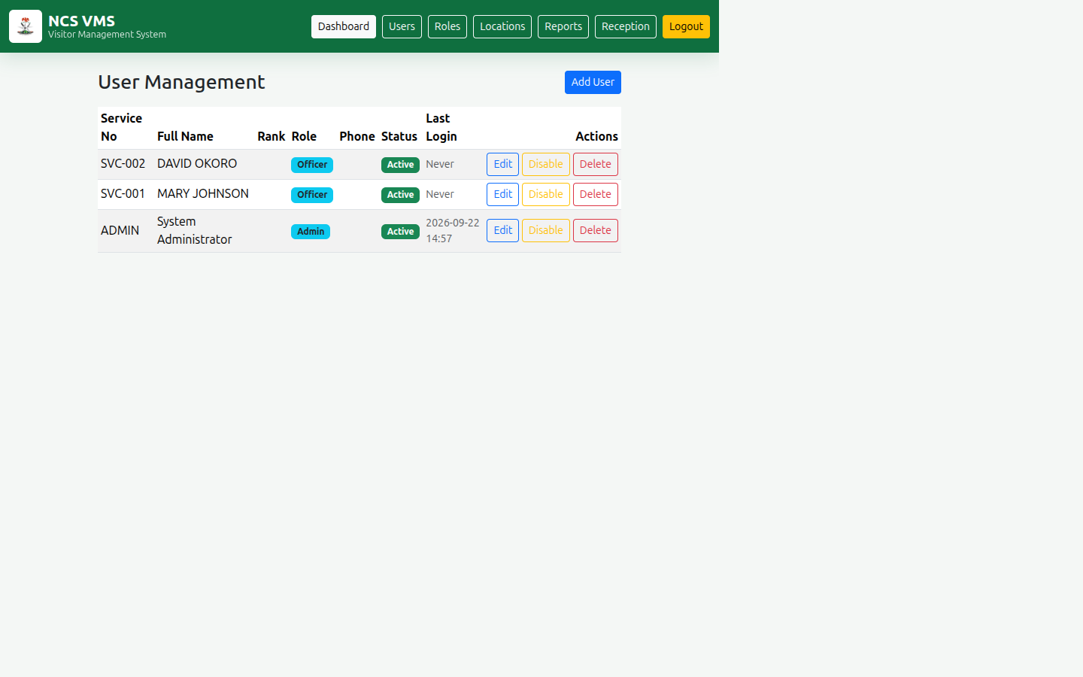
User management
Manage everyone who can sign in.
To add a user:
- Click Add User.
- Complete the form, including Service No, Full Name, Role and
Password (minimum 6 characters).
- Click Save User.
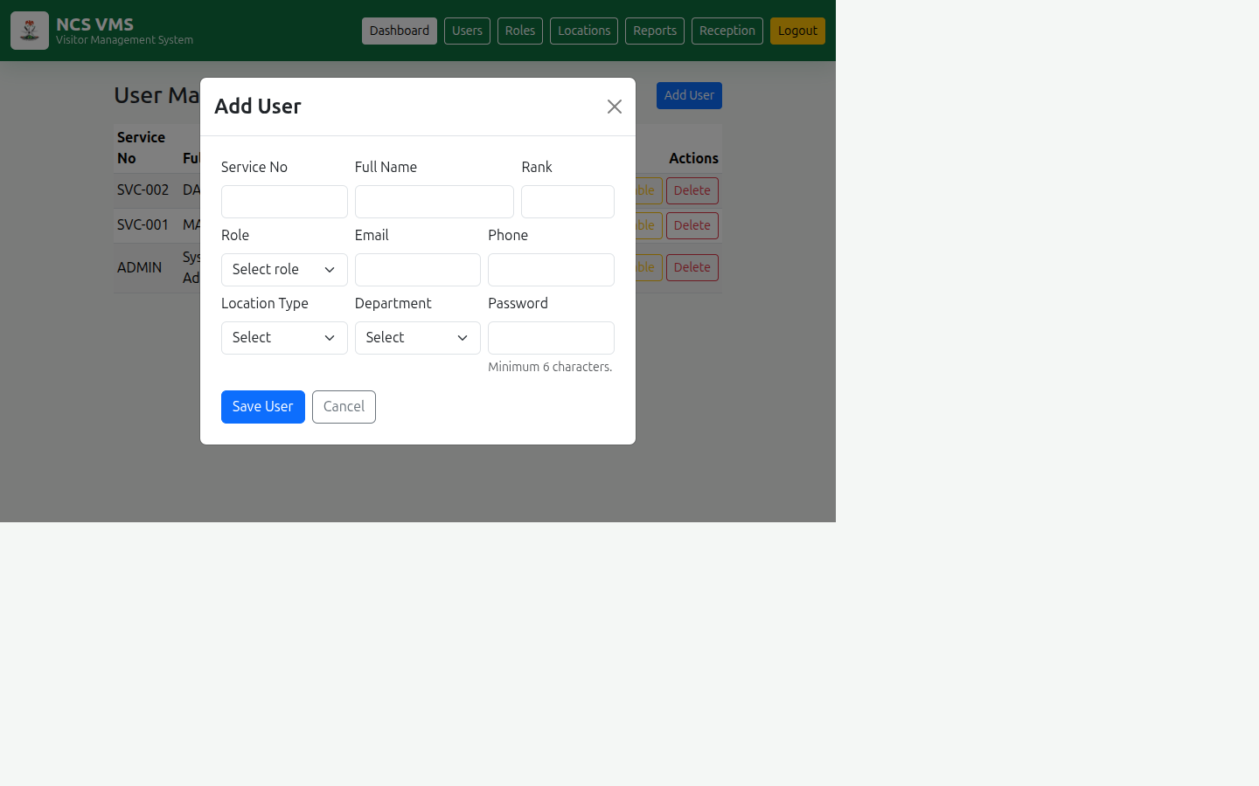
Add user modal
To edit: click Edit on the user's row. The Service No cannot be changed. Leave the password blank to keep the existing one.
To disable or enable: click Disable / Enable. A disabled user cannot sign in. Prefer disabling over deleting — it preserves the audit trail.
To delete: click Delete and confirm. This is permanent.
Safety rule: You cannot disable, delete or change your own role. This prevents locking everyone out of the admin module.

8.3 Roles
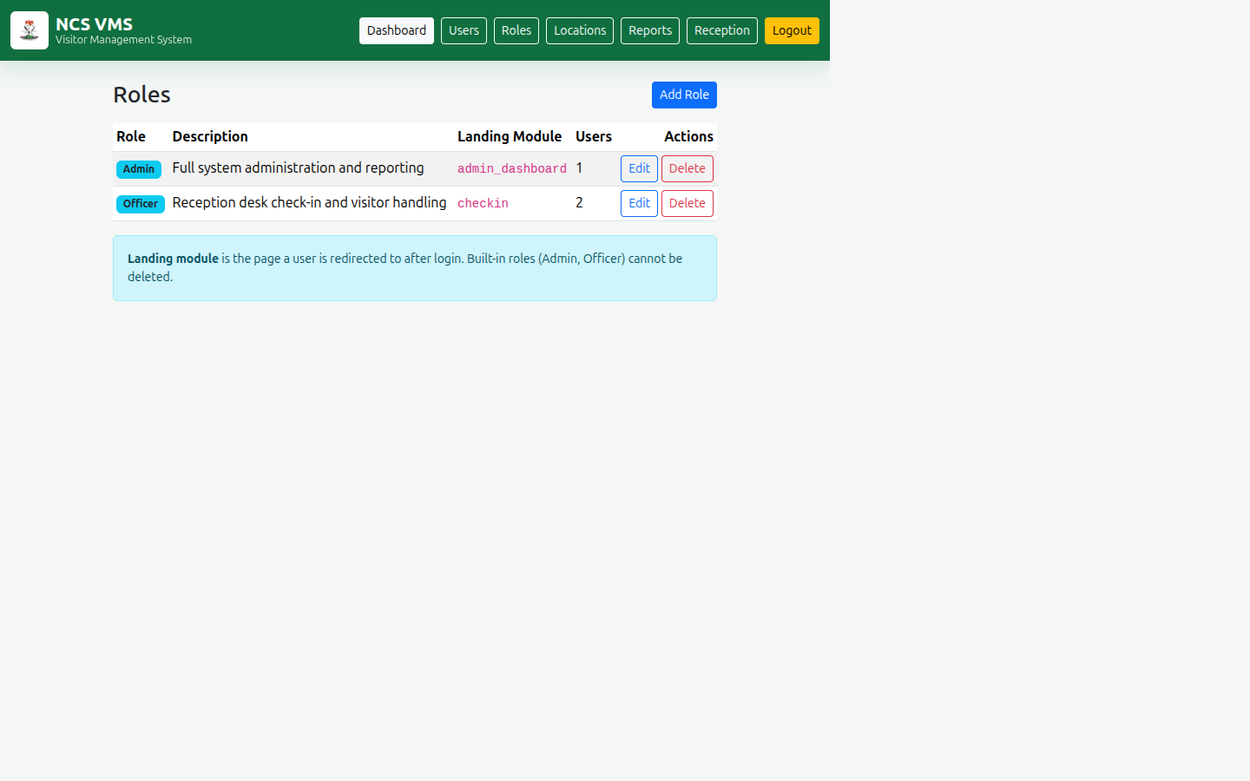
Roles
A role determines which module a user lands on after signing in. The system ships with two protected roles:
Role | Landing module
Admin | Admin Dashboard
Officer | Reception Check-In

You can create additional roles for your organisation. Each role needs a name, an optional description, and a Landing Module. Built-in roles cannot be deleted, and a role that still has users assigned cannot be deleted until they are reassigned.

8.4 Locations
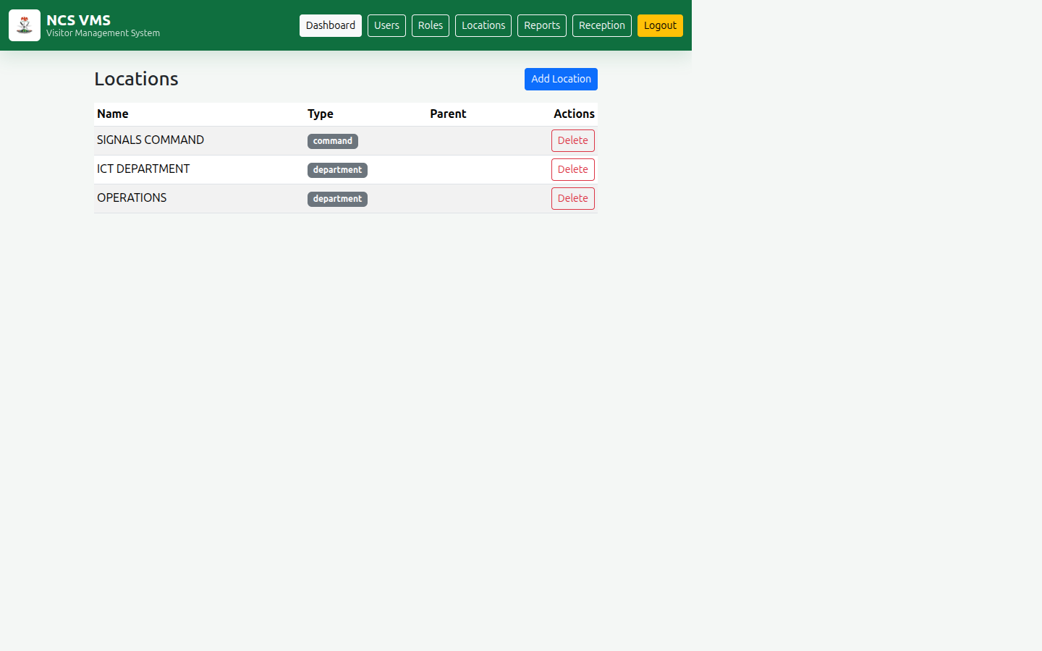
Locations
Define the organisational structure — Departments, Commands and Units. A location may have a parent, so you can build a hierarchy (for example a unit inside a command). A location with children cannot be deleted until its children are removed.

8.5 Reports
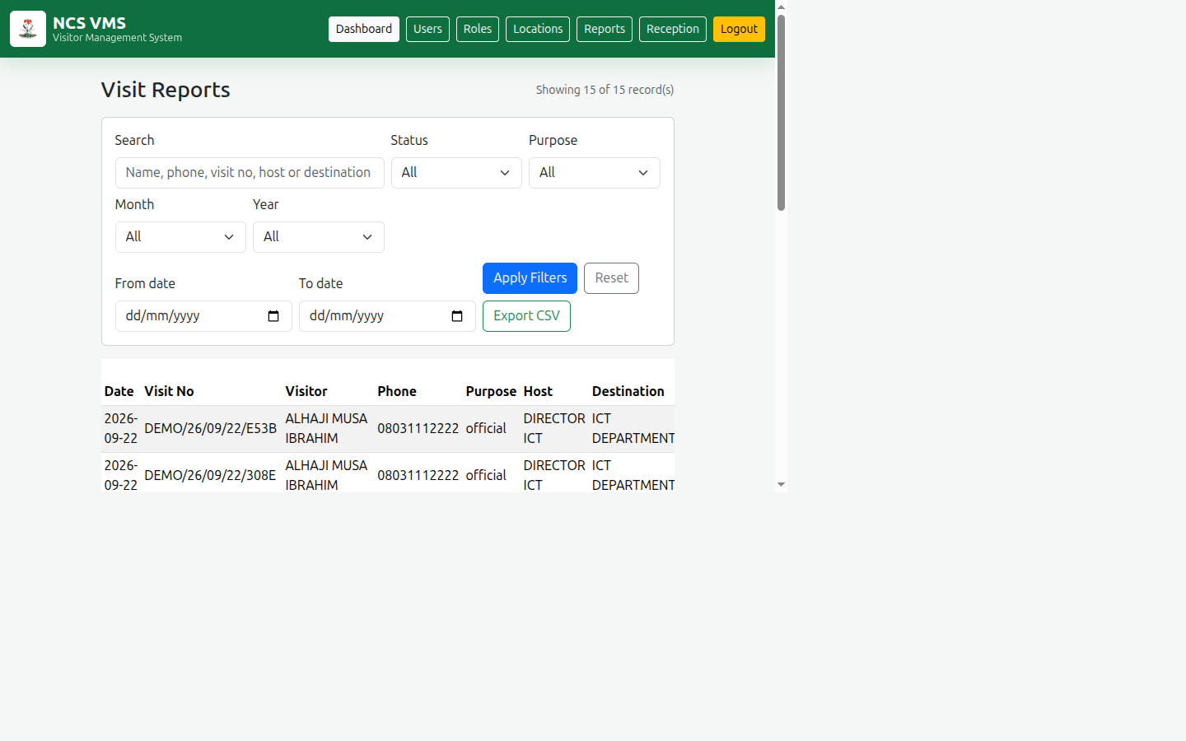
Reports
The reports page is the full-visit history with the same powerful filters — search, status, purpose, month, year and date range — plus Export CSV.
Use reports to answer management questions such as "How many official visitors did we host in September?" or "Who was on site on a particular date?"

9. Troubleshooting
Problem | Cause and solution
"Invalid service number or password." | Check spelling and Caps Lock. If it persists, ask the administrator to reset your password.
"This account has been disabled." | The administrator has deactivated your account. Contact them to restore access.
"Phone number must contain exactly 11 digits." | Re-enter the phone number using digits only.
Camera shows "Camera permission is required." | Allow camera access in your browser, or use phone/email search instead.
"Multiple faces detected." | Ask others to step out of frame, leaving only the visitor.
"Active visit already open." | The visitor never signed out. Use Today's Visits to sign them out, then create the new visit.
"Access Denied." | Your role does not permit that page. Ask the administrator.
Nothing matches in History. | Clear the filters and click Apply Filters, or widen the date range.

10. Glossary
Term | Meaning
Visitor | A person. Registered once and reused for every visit.
Visit | One entry event by a visitor, with its own reference and status.
Visit No | The unique reference, e.g. NCS/26/09/22/0001.
Sign In / Check In | Recording a visitor's arrival.
Sign Out | Recording a visitor's departure, closing the visit.
Status | In (on site) or Out (departed).
Role | A set of permissions that decides a user's landing module.
Officer | Reception staff role.
Admin | Administrator role with full access.
Landing Module | The page a user is taken to after signing in.
Portrait | The cropped, white-background photograph of a visitor.

NCS Visitor Management System — User Guide v1.0

