首战内存过高分析：

使用华为mate8联调收集首战内存收据如下表格：

联调时发现每次播放Cutscene都会有大量内存增加，而且播放完成后没有把资源完全卸载。

原因：

1. Cutscene特效在Cutscene播放完之后没有直接卸载而是返回给缓存池。
2. 角色模型的卸载会检测是否有角色需要使用，如果没有直接卸载，如果有则还给对象池
3. 角色的Animation没有卸载。

以下数据中无单位的默认为M，括号内代表数量

|  |  |  |  |  |  |  |
| --- | --- | --- | --- | --- | --- | --- |
|  | Before | Cutscene1 | After1 | Cutscene2 | After2 | Cutscene3 |
| Other | 139 | 154.8 | 152.9 | 207.5 | 191.1 | 221.5 |
| Assets | 74.8 | 99.1 | 96.9 | 146.6 | 134.2 | 169.8 |
| Scenememory | 45.9 | 48.1 | 46.6 | 59 | 50.5 | 74.7 |
| NotSaved | 10.7 | 11 | 11 | 11.7 | 11.6 | 12.3 |
| Totle | 270.4 | 313 | 307.4 | 424.8 | 387.4 | 478.3 |
| PSS | 482.8 | 531.9 | 543.1 | 631.9 | 630.9 | 736.3 |
| (Other) |  |  |  |  |  |  |
| SerializedFile | 11.2 | 13.9 | 13.8 | 21.3 | 20.8 |  |
| Objects | 33.8 | 44 | 42.2 | 89.2 | 73.4 |  |
| Managedheap.usedsize | 30.5 | 31.5 | 30.2 | 31.7 | 32.2 |  |
| Managedheap.Unusedsize | 4.0 | 3.1 | 4.4 | 2.9 | 2.3 |  |
| (Assets) |  |  |  |  |  |  |
| Texture | 45.5(204) | 60.3(240) | 60(239) | 70.7(315) | 70.4(314) |  |
| Mesh | 12(154) | 14.6(164) | 12.7(162) | 24.8(187) | 13.1(176) |  |
| AnimationClip | 6.2(136) | 12(189) | 12(188) | 32.4(238) | 32.2(237) |  |
| ParticleSystem | 2.7(208) | 3.6(274) | 3.6(276) | 8.8(671) | 8.8(671) |  |
| ParticleSystemRenderer | 232.8k(208) | 312.9k(274) | 314.7k(276) | 0.8M(671) | 0.8M(671) |  |
| SceneMemory |  |  |  |  |  |  |
| RenderTexture | 33(5) | 34.1(5) | 33(5) | 34.1(5) | 33(5) |  |
| Mesh | 5.4(27) | 5.4(27) | 5.4(27) | 5.4(31) | 5.4(31) |  |
| ParticleSystem | 3.5(256) | 4.4(322) | 4.1(291) | 14.2(914) | 7.7(499) |  |

Mono内存使用情况：

1. 首战峰值39M
2. 龟仙人灭火之前（前30分钟）峰值63M
3. 30分--50分钟峰值151M

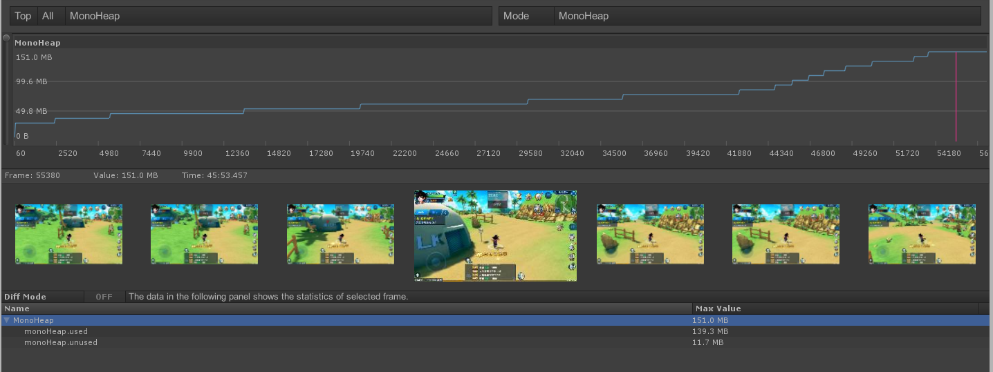

2017年12月9日 内存过高分析

Cutscene资源卸载优化，及assetbundle内存泄漏问题解决后，首战数据统计：

以下数据中无单位的默认为M，括号内代表数量

|  |  |  |  |  |  |  |
| --- | --- | --- | --- | --- | --- | --- |
| Profiler参数 | BeforeCS | CS1 | After CS1 | CS2 | After S2 | CS3 |
| Other | 126.3 | 142.1 | 138.4 | 196.5 | 166.4 | 203.5 |
| Assets | 74.9 | 99.2 | 84.2 | 143.6 | 100.7 | 140.8 |
| Scenememory | 45.9 | 48.2 | 47.2 | 55.2 | 49.7 | 76.8 |
| NotSaved | 10.7 | 11 | 10.9 | 11.7 | 11.5 | 12.2 |
| Totle | 257.8 | 300.5 | 280.7 | 407 | 287.3 | 433.3 |
| (Other) |  |  |  |  |  |  |
| SerializedFile | 11.2 | 13.9 | 13.6 | 21.1 | 20.3 | 27.1 |
| Objects | 33.9 | 44.1 | 40.7 | 83.1 | 53.8.4 | 84.1 |
| Managedheap.usedsize | 21.3 | 22.2 | 22.5 | 23.5 | 24.1 | 27.5 |
| Managedheap.Unusedsize | 2.6 | 1.6 | 1.3 | 8.4 | 7.7 | 4.3 |
| (Assets) |  |  |  |  |  |  |
| Texture | 45.6(205) | 60.3(241) | 49.4(238) | 70.0(315) | 55.8(307) | 74.8(343) |
| Mesh | 12(154) | 14.6(164) | 12.7(162) | 24.4(187) | 12.7(175) | 18.3(184) |
| AnimationClip | 6.2(136) | 12(189) | 10(186) | 30.4(238) | 13.9(232) | 19.8(292) |
| ParticleSystem | 2.7(208) | 3.6(274) | 3.6(274) | 8.8(671) | 8.8(671) | 15.9(1217) |
| ParticleSystemRenderer | 232.8k(208) | 312.9k(274) | 312.7k(276) | 0.8M(671) | 0.8M(671) | 1.4(1217) |
| SceneMemory |  |  |  |  |  |  |
| RenderTexture | 33(5) | 34.1(5) | 33(5) | 34.1(5) | 33(5) | 48.8(6) |
| Mesh | 5.4(27) | 5.4(27) | 5.4(27) | 5.4(31) | 5.4(31) | 5.4(31) |
| ParticleSystem | 3.5(256) | 4.4(322) | 4.6(319) | 10.6(705) | 6.9(499) | 17(1088) |

优化后与优化前对比：

优化前：单位：M

|  |  |  |  |  |  |  |
| --- | --- | --- | --- | --- | --- | --- |
|  | Before | Cutscene1 | After1 | Cutscene2 | After2 | Cutscene3 |
| Other(before) | 139 | 154.8 | 152.9 | 207.5 | 191.1 | 221.5 |
| Assets(before) | 74.8 | 99.1 | 96.9 | 146.6 | 134.2 | 169.8 |
| Scenememory(before) | 45.9 | 48.1 | 46.6 | 59 | 50.5 | 74.7 |
| NotSaved(before) | 10.7 | 11 | 11 | 11.7 | 11.6 | 12.3 |
| Totle(before) | 270.4 | 313 | 307.4 | 424.8 | 387.4 | 478.3 |
| PSS(before) | 482.8 | 531.9 | 543.1 | 631.9 | 630.9 | 736.3 |

优化后：单位：M

|  |  |  |  |  |  |  |
| --- | --- | --- | --- | --- | --- | --- |
|  | Before | Cutscene1 | After1 | Cutscene2 | After2 | Cutscene3 |
| Other(after) | 126.3 | 142.1 | 138.4 | 196.5 | 166.4 | 203.5 |
| Assets(after) | 74.9 | 99.2 | 84.2 | 143.6 | 100.7 | 140.8 |
| Scenememory(after) | 45.9 | 48.2 | 47.2 | 55.2 | 49.7 | 76.8 |
| NotSaved(after) | 10.7 | 11 | 10.9 | 11.7 | 11.5 | 12.2 |
| Totle(after) | 257.8 | 300.5 | 280.7 | 407 | 287.3 | 433.3 |
| PSS(after) | 445.3 | 485 | 483.5 | 598.2 | 568.4 | 625.7 |

用Androidstudio分析应用内存使用情况（高配和极简模式）：

高配模式：单位：M

|  |  |  |  |  |  |  |
| --- | --- | --- | --- | --- | --- | --- |
| PSS | BeforeS | CS1 | AfterCS1 | CS2 | AfterCS2 | CS3 |
| Java Heap | 20.1 | 13.4 | 13.2 | 13.2 | 13.6 | 13.9 |
| NativeHeap | 136.4 | 163 | 159.1 | 249.6 | 217.6 | 265.7 |
| Code | 24.7 | 24.9 | 25.4 | 25.1 | 28.1 | 29.7 |
| Stack | 0.7 | 0.67 | 0.67 | 0.67 | 0.67 | 0.68 |
| Graphics | 191.2 | 207.8 | 210.2 | 228.8 | 226.8 | 269.3 |
| PrivateOther | 60.1 | 61.3 | 61.5 | 63 | 63.1 | 67 |
| System | 10.3 | 10.5 | 10.5 | 10.5 | 10 | 9.4 |
| TOTAL | 443.5 | 481.5 | 480.7 | 590.8 | 559.9 | 655.6 |

极简模式：单位：M

|  |  |  |  |  |  |  |
| --- | --- | --- | --- | --- | --- | --- |
| PSS | BeforeS | CS1 | AfterCS1 | CS2 | AfterCS2 | CS3 |
| Java Heap | 22.7 | 16.1 | 16.1 | 16.1 | 16.1 | 16.3 |
| NativeHeap | 139.7 | 166.4 | 163.4 | 254.7 | 222.4 | 271.2 |
| Code | 31.6 | 31.7 | 31.8 | 31.9 | 32 | 31.9 |
| Stack | 0.67 | 0.68 | 0.67 | 0.67 | 0.63 | 0.69 |
| Graphics | 145 | 164.8 | 165 | 167.2 | 175 | 191.4 |
| PrivateOther | 60.4 | 61.3 | 61.6 | 65 | 65.3 | 65.4 |
| System | 6.2 | 6.3 | 6.3 | 6.3 | 6.3 | 6.3 |
| TOTAL | 406.2 | 447.3 | 444.9 | 542 | 517.8 | 583.2 |

导致内存过大的原因：

1. Cutscene的资源没有完全卸载（已解决）
2. Assetbundle管理器存在内存泄漏问题（已解决）
3. 使用Androidstudio分析内存情况发现Graphics 占用内存比重很大，而开极简模式有几十兆的减少，推测原因可能后处理效果存在占用内存过大的问题。
4. Cutscene角色贴图资源过大（有2048*2048和1024*1024的贴图），且有冗余资源存在，跟美术讨论过该问题，美术后面会修改角色的制作方案，可以修复此问题