## gulp教程之gulp-imagemin

Ooo_My_God发表于2015-02-24 分类：[构建工具](http://www.ydcss.com/archives/category/%E6%9E%84%E5%BB%BA%E5%B7%A5%E5%85%B7" \t "http://www.ydcss.com/archives/_blank) 阅读(16969) 评论([42](http://www.ydcss.com/archives/26" \l "comments))

### 简介：

使用gulp-imagemin压缩图片文件（包括PNG、JPEG、GIF和SVG图片），很多人安装gulp-imagemin都会出现错误，我也查了很多资料，也不知道所以然，我的做法是出错再重新安装，如果你知道问题所在，请一定告诉我！

### 1、安装nodejs/全局安装gulp/本地安装gulp/创建package.json和gulpfile.js文件

1.1、gulp基本使用还未掌握？请参看： [gulp详细入门教程](http://www.ydcss.com/archives/18" \o "gulp详细入门教程" \t "http://www.ydcss.com/archives/_blank)

1.2、本示例目录结构如下：

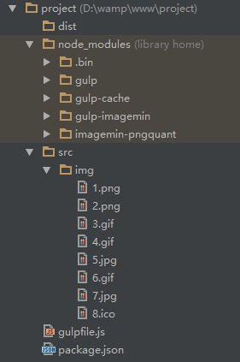

### 2、本地安装gulp-imagemin

2.1、github：[https://github.com/sindresorhus/gulp-imagemin](https://github.com/sindresorhus/gulp-imagemin" \t "http://www.ydcss.com/archives/_blank)

2.2、安装：命令提示符执行 **cnpm install gulp-imagemin --save-dev**

2.3、注意：没有安装**cnpm**请使用 **npm install gulp-imagemin --save-dev**[什么是cnpm，如何安装？](http://www.ydcss.com/archives/18" \l "lesson4" \o "什么是cnpm，如何安装？" \t "http://www.ydcss.com/archives/_blank)

2.4、说明：--save-dev 保存配置信息至 package.json 的 devDependencies 节点。[为什么要保存至package.json？](http://www.ydcss.com/archives/18" \l "why" \t "http://www.ydcss.com/archives/_blank)

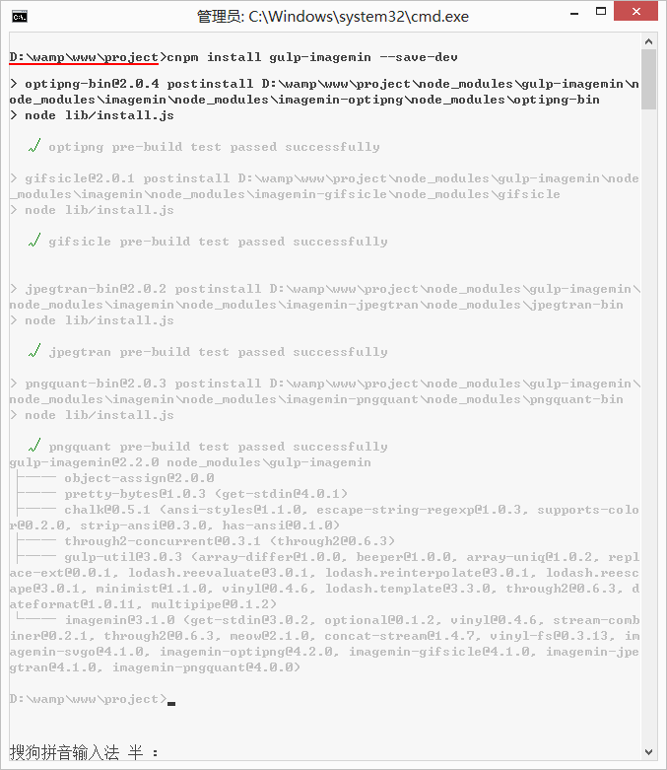

### 3、配置gulpfile.js

3.1、基本使用

JavaScript

|  |  |
| --- | --- |
| 1  2  3  4  5  6  7  8 | var gulp = require('gulp'),      imagemin = require('gulp-imagemin');    gulp.task('testImagemin', function () {      gulp.src('src/img/*.{png,jpg,gif,ico}')          .pipe(imagemin())          .pipe(gulp.dest('dist/img'));  }); |

3.2、gulp-imagemin其他参数 [具体参看](https://github.com/sindresorhus/gulp-imagemin" \l "user-content-options" \t "http://www.ydcss.com/archives/_blank)

JavaScript

|  |  |
| --- | --- |
| 1  2  3  4  5  6  7  8  9  10  11  12  13 | var gulp = require('gulp'),      imagemin = require('gulp-imagemin');    gulp.task('testImagemin', function () {      gulp.src('src/img/*.{png,jpg,gif,ico}')          .pipe(imagemin({              optimizationLevel: 5, //类型：Number  默认：3  取值范围：0-7（优化等级）              progressive: true, //类型：Boolean 默认：false 无损压缩jpg图片              interlaced: true, //类型：Boolean 默认：false 隔行扫描gif进行渲染              multipass: true //类型：Boolean 默认：false 多次优化svg直到完全优化          }))          .pipe(gulp.dest('dist/img'));  }); |

3.3、深度压缩图片

JavaScript

|  |  |
| --- | --- |
| 1  2  3  4  5  6  7  8  9  10  11  12  13  14 | var gulp = require('gulp'),      imagemin = require('gulp-imagemin'),      //确保本地已安装imagemin-pngquant [cnpm install imagemin-pngquant --save-dev]      pngquant = require('imagemin-pngquant');    gulp.task('testImagemin', function () {      gulp.src('src/img/*.{png,jpg,gif,ico}')          .pipe(imagemin({              progressive: true,              svgoPlugins: [{removeViewBox: false}],//不要移除svg的viewbox属性              use: [pngquant()] //使用pngquant深度压缩png图片的imagemin插件          }))          .pipe(gulp.dest('dist/img'));  }); |

3.3、只压缩修改的图片。压缩图片时比较耗时，在很多情况下我们只修改了某些图片，没有必要压缩所有图片，使用”gulp-cache”只压缩修改的图片，没有修改的图片直接从缓存文件读取（C:\Users\Administrator\AppData\Local\Temp\gulp-cache）。

JavaScript

|  |  |
| --- | --- |
| 1  2  3  4  5  6  7  8  9  10  11  12  13  14  15 | var gulp = require('gulp'),      imagemin = require('gulp-imagemin'),      pngquant = require('imagemin-pngquant'),      //确保本地已安装gulp-cache [cnpm install gulp-cache --save-dev]      cache = require('gulp-cache');    gulp.task('testImagemin', function () {      gulp.src('src/img/*.{png,jpg,gif,ico}')          .pipe(cache(imagemin({              progressive: true,              svgoPlugins: [{removeViewBox: false}],              use: [pngquant()]          })))          .pipe(gulp.dest('dist/img'));  }); |

### 4、执行任务

4.1、命令提示符执行：**gulp testImagemin**

### 5、结束语