基于 LangGraph 的 BIM 施工安全协同智能体
面向 BIM 场景下的施工安全风险分析与协同处置，本文基于 LangGraph 构建了一个由自然语言驱动、受工程规则与可验证证据约束的施工安全协同智能体，其总体框架如图 1 所示。该智能体集成六类面向工程业务的专业工具：BIM 与空间分析工具关联模型构件、楼层和检查区域，计算人员与标注边线的空间关系；活动协同工具结合施工时段与作业空间，识别需要协调的时空冲突；多模态巡检工具联合现场图片、文本记录和作业任务，利用 Qwen 提取观察候选，并保留人工确认的现场参数；规范检索工具提供带有来源、页码和有效版本的条款依据；风险与证据校核工具执行确定性检查，识别事实缺口、来源冲突及不受支持的判断；整改与复核工具围绕候选措施、责任主体和批准后的验收要求，对整改后证据进行核验。此外，分层记忆保存任务状态、历史场景配置与已审核案例，持久检查点支持长流程恢复。DeepSeek 大语言模型负责理解用户意图、规划受约束的工具调用并组织结果说明，整体过程由有向状态图协调执行。在结果生成阶段，规范知识、结构化规则与证据引用共同约束解释和建议，使模型输出与实际计算、现场观察及业务状态保持一致。
该智能体能够处理与 BIM 对象定位、临边防护及人员暴露分析、施工活动时空协调、多源证据一致性检查、整改措施制定、整改效果复核和安全检查报告生成相关的任务。为展示其在连续业务链路中的适用性，以 S1 项目 05 层板边检查为可控演示场景，将确定的模型范围、活动时段、现场资料、模拟观察和整改后证据作为连续输入，向智能体提出综合安全检查与整改建议请求。智能体依据任务语义组织几何计算、活动校核、规范检索与规则检查，并在需要解析新图片时调用多模态感知工具；系统据此识别模拟栏杆高度 1.0 m 低于 1.2 m 检查阈值的风险候选，形成待人工审核的控制建议，并在人工批准及提交新证据后，按已批准要求完成复核闭环。其结果表达围绕五个互补维度组织：关键结果与可验证证据、结论、推理与机制解释、工程级决策建议与下一步，以及总结报告。自然语言由此成为工程任务的控制入口，构件位置、活动条件、观察事实、规范条款、整改责任与复核结论被关联为可追溯的证据链，为安全管理人员提供可解释、可审计的决策支持。
该框架将专业计算与安全业务流程纳入统一的智能体执行体系，使风险发现、控制决策和整改验证围绕同一安全案例持续衔接。大模型承担语义理解、信息组织与候选建议生成，工程阈值、证据适用性和状态转换由确定性规则执行，措施批准与最终复核由人工完成。证据不足时，系统转入定向补证；复核未通过或现场条件变化时，保留既有记录并重新分析。由此，智能体在保持工程约束与责任边界的同时，支持具有上下文连续性、证据可验证性和执行可恢复性的 BIM 施工安全协同。

智能体总体框架
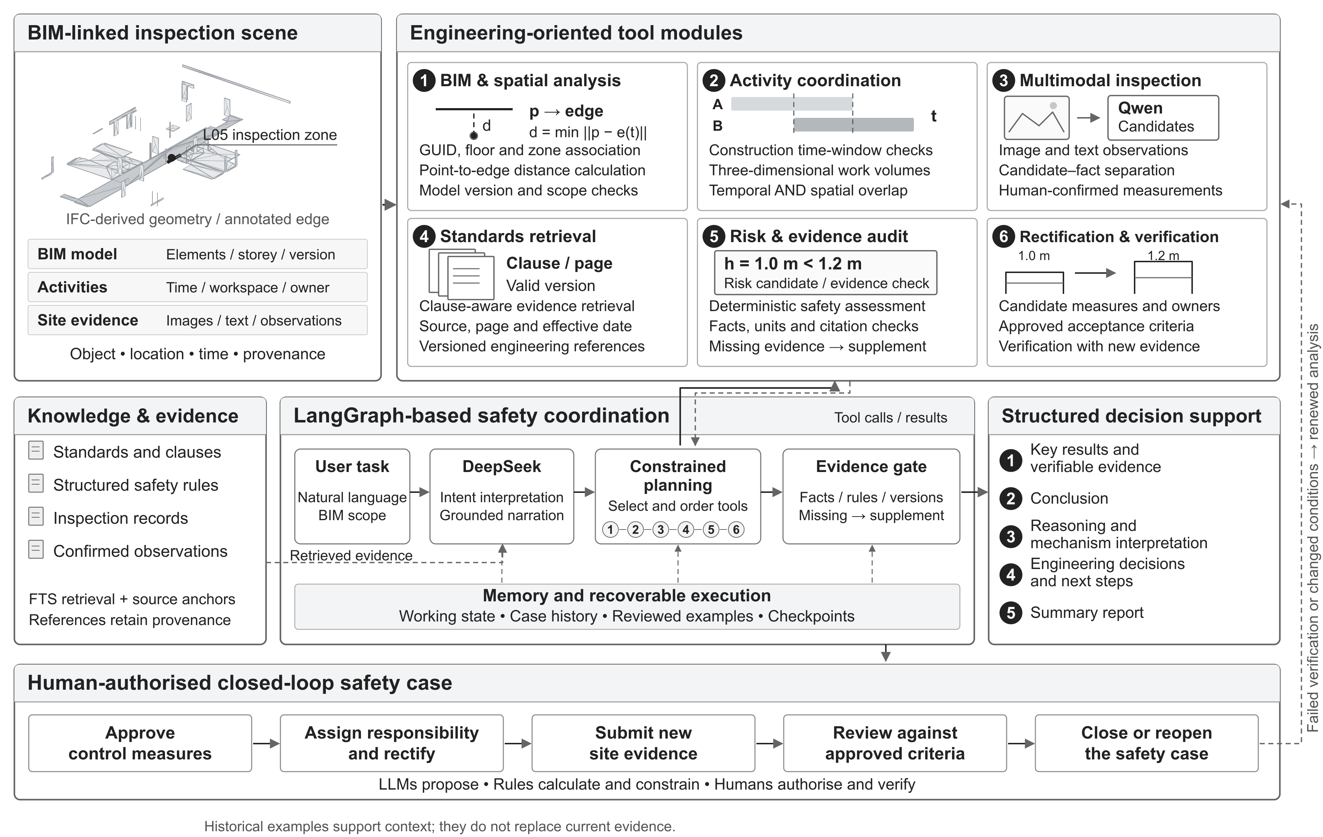
图 1 基于 LangGraph 的 BIM 施工安全协同智能体框架
Fig. 1. Framework of the LangGraph-based agent for BIM construction safety coordination.
图示组织参考文献 [1] 的 Fig. 13，按 BIM 施工安全业务重新设计；图中几何来自 IFC，现场参数为受控演示观察。

A LangGraph-based agent for BIM construction safety coordination
To support construction-safety risk analysis and coordinated intervention in building information modelling (BIM) environments, we develop a LangGraph-based agent with a natural-language-controlled execution flow constrained by engineering rules and verifiable evidence, as illustrated in Fig. 1. The agent integrates six engineering-oriented tool modules. BIM and spatial analysis tools link model elements, storeys and inspection zones and calculate the spatial relationship between workers and annotated edges. Activity coordination tools identify conflicts through construction time windows and workspaces. Multimodal inspection tools combine site images, textual records and task context, use Qwen to extract candidate observations and retain human-confirmed field parameters. Standards retrieval tools return governing clauses with their sources, page numbers and applicable versions. Risk and evidence-audit tools execute deterministic checks to identify missing facts, conflicting sources and unsupported judgments. Rectification and verification tools organise proposed controls and responsible parties and evaluate new evidence against approved acceptance criteria. Layered memory retains task states, historical scenario configurations and reviewed cases, while persistent checkpoints support recovery of long-running workflows. DeepSeek interprets user intent, plans constrained tool invocations and composes result explanations within a directed state graph. During reporting, regulatory knowledge, structured rules and evidence references jointly constrain interpretations and recommendations, maintaining consistency with executed calculations, observations and business states.
The agent addresses tasks involving BIM object localisation, edge-protection and worker-exposure analysis, spatiotemporal activity coordination, multisource evidence consistency, formulation of control measures, verification of rectification effectiveness and safety-report generation. To demonstrate its applicability across an integrated workflow, a controlled inspection scenario is constructed for the fifth-floor slab edge of the S1 project. A defined model scope, activity window, site records, simulated observations and post-rectification evidence are supplied sequentially to request a comprehensive safety inspection and control recommendations. Based on task semantics, the agent selects appropriate geometry, activity, standards-retrieval and rule-checking tools, invoking multimodal perception when new images require analysis. It identifies a risk candidate because the simulated guardrail height of 1.0 m falls below the 1.2 m inspection threshold, proposes controls for human review and, following approval and submission of new evidence, completes verification against the approved requirements. Results are organised across five complementary dimensions: key results and verifiable evidence; conclusion; reasoning and mechanism interpretation; engineering-level decision recommendations and next steps; and summary report. Natural language therefore serves as the entry point for engineering tasks, while element locations, activity conditions, observations, governing clauses, rectification responsibilities and verification outcomes form a traceable evidence chain for interpretable and auditable safety decision support.
The framework integrates specialist calculations and safety-management workflows within a unified agent execution system, linking risk identification, control decisions and rectification verification through a common Safety Case. The language model interprets task semantics, organises information and generates candidate recommendations; deterministic rules govern engineering thresholds, evidence applicability and state transitions; and human operators approve controls and confirm final verification. Insufficient evidence triggers targeted supplementation, whereas failed verification or changed site conditions lead to renewed analysis with prior records retained. The resulting framework supports BIM construction safety coordination with consistent context, verifiable evidence and recoverable execution while preserving engineering constraints and responsibility boundaries.
[1] Cui J, Zhai C, Wang Y, Li Y. Large language models and AI agents in disaster-resilient infrastructure: concepts, applications, pathways, and challenges. Reliability Engineering & System Safety, 2026, 272: 112497. https://doi.org/10.1016/j.ress.2026.112497.

