基于 LangGraph 的 BIM 施工安全协同智能体
面向 BIM 场景下的施工安全风险分析与协同处置，本文基于 LangGraph 构建了一个由自然语言驱动、受工程规则与可验证证据约束的施工安全协同智能体，其总体框架如图 1 所示。该框架以统一安全案例为载体，将项目场景与任务组织、多源风险发现、人工授权整改以及复核反馈贯穿为连续的业务流程。首先，系统关联 BIM 构件与检查范围、施工活动和现场资料，形成具有对象、位置、时间及来源约束的任务上下文。随后，大语言模型（LLM）理解用户意图并规划分析步骤，按需调用空间计算、活动校核、多模态感知、规范检索和规则检查等专业能力，汇集观察事实、计算结果与条款依据，形成风险候选及待审核的控制建议。经人工批准后，责任主体实施整改并提交新证据，系统按照批准后的验收要求开展复核，并根据结果关闭案例或重新进入分析。在执行层，LangGraph 通过有向状态图协调任务推进、证据补充与人工交互，规范知识与确定性规则共同约束推理和结果表达；分层记忆、版本记录及持久检查点则保持跨阶段的上下文一致性与执行连续性，从而将风险发现、处置决策和结果验证组织为可追溯的项目级协同过程。
该智能体能够处理与 BIM 对象定位、临边防护及人员暴露分析、施工活动时空协调、多源证据一致性检查、整改措施制定、整改效果复核和安全检查报告生成相关的任务。为展示其在连续业务链路中的适用性，以 S1 项目 05 层板边检查为可控演示场景，将确定的模型范围、活动时段、现场资料、模拟观察和整改后证据作为连续输入，向智能体提出综合安全检查与整改建议请求。智能体依据任务语义组织几何计算、活动校核、规范检索与规则检查，并在需要解析新图片时调用多模态感知工具；系统据此识别模拟栏杆高度 1.0 m 低于 1.2 m 检查阈值的风险候选，形成待人工审核的控制建议，并在人工批准及提交新证据后，按已批准要求完成复核闭环。其结果表达围绕五个互补维度组织：关键结果与可验证证据、结论、推理与机制解释、工程级决策建议与下一步，以及总结报告。自然语言由此成为工程任务的控制入口，构件位置、活动条件、观察事实、规范条款、整改责任与复核结论被关联为可追溯的证据链，为安全管理人员提供可解释、可审计的决策支持。
该框架将专业计算与安全业务流程纳入统一的智能体执行体系，使风险发现、控制决策和整改验证围绕同一安全案例持续衔接。大模型承担语义理解、信息组织与候选建议生成，工程阈值、证据适用性和状态转换由确定性规则执行，措施批准与最终复核由人工完成。证据不足时，系统转入定向补证；复核未通过或现场条件变化时，保留既有记录并重新分析。由此，智能体在保持工程约束与责任边界的同时，支持具有上下文连续性、证据可验证性和执行可恢复性的 BIM 施工安全协同。

智能体项目流程框架
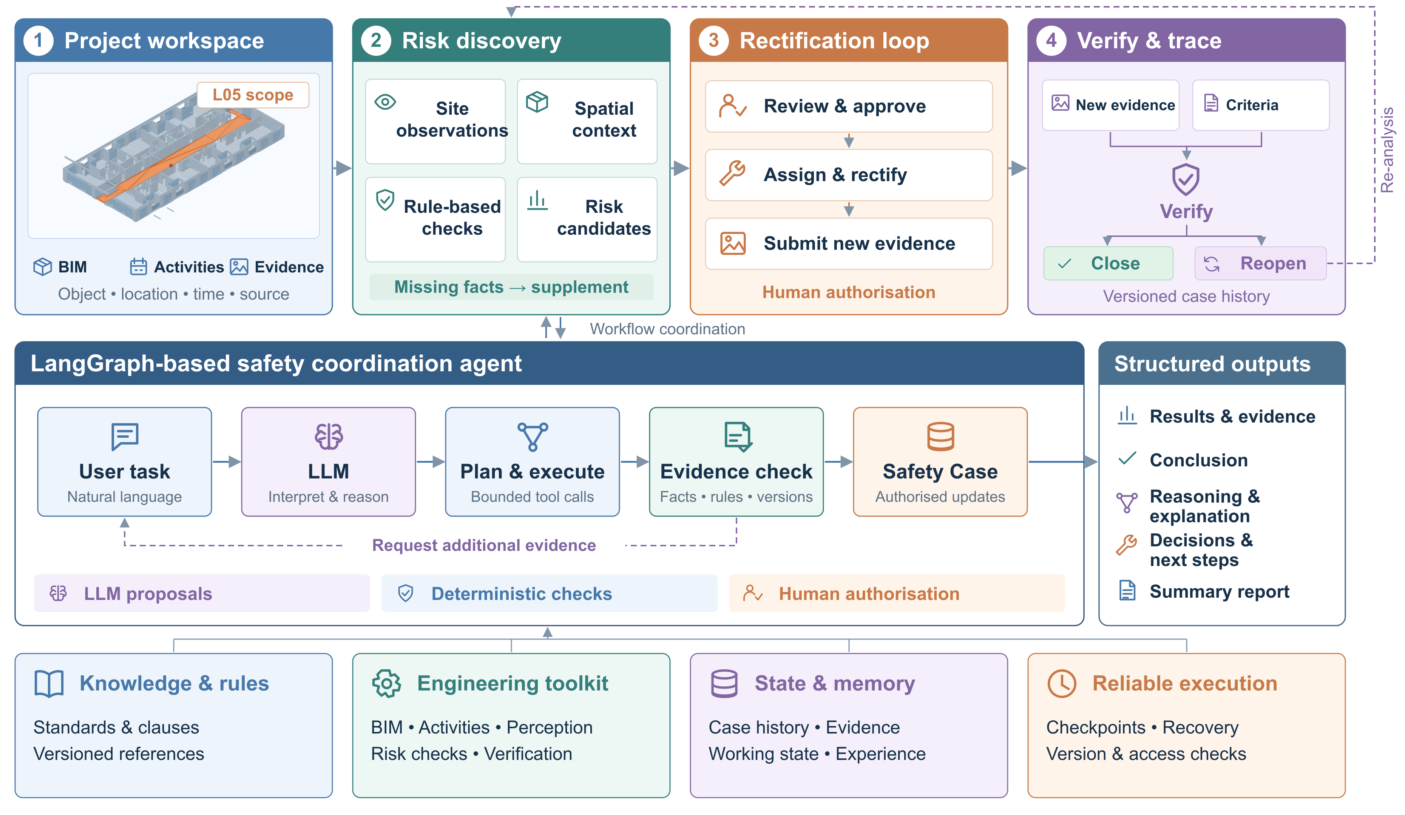
图 1 基于 LangGraph 的 BIM 施工安全协同智能体框架
Fig. 1. Framework of the LangGraph-based agent for BIM construction safety coordination.
图示突出项目业务流程及其执行与支撑层；05 层模型由 IFC 几何生成，现场观察为受控演示输入。框架表达参考文献 [1]。

A LangGraph-based agent for BIM construction safety coordination
To support construction-safety risk analysis and coordinated intervention in building information modelling (BIM) environments, we develop a LangGraph-based agent with a natural-language-controlled execution flow constrained by engineering rules and verifiable evidence, as illustrated in Fig. 1. A common Safety Case links four continuous business stages: project context and task organisation, multisource risk discovery, human-authorised rectification, and verification with feedback. The system first associates BIM elements and inspection scope with construction activities and site records, establishing task context anchored to objects, locations, time and provenance. A large language model (LLM) then interprets user intent and plans the analysis, invoking spatial computation, activity validation, multimodal perception, standards retrieval and deterministic checks as needed. Observations, computational results and governing clauses are assembled into risk candidates and proposed controls for human review. Following approval, responsible parties implement rectification and submit new evidence; verification against approved acceptance criteria leads to case closure or renewed analysis. Within the execution layer, a directed LangGraph state graph coordinates task progression, evidence supplementation and human interaction, while domain knowledge and deterministic rules constrain reasoning and reporting. Layered memory, versioned records and persistent checkpoints maintain contextual consistency and execution continuity across stages, connecting risk discovery, intervention decisions and outcome verification within a traceable project-level workflow.
The agent addresses tasks involving BIM object localisation, edge-protection and worker-exposure analysis, spatiotemporal activity coordination, multisource evidence consistency, formulation of control measures, verification of rectification effectiveness and safety-report generation. To demonstrate its applicability across an integrated workflow, a controlled inspection scenario is constructed for the fifth-floor slab edge of the S1 project. A defined model scope, activity window, site records, simulated observations and post-rectification evidence are supplied sequentially to request a comprehensive safety inspection and control recommendations. Based on task semantics, the agent selects appropriate geometry, activity, standards-retrieval and rule-checking tools, invoking multimodal perception when new images require analysis. It identifies a risk candidate because the simulated guardrail height of 1.0 m falls below the 1.2 m inspection threshold, proposes controls for human review and, following approval and submission of new evidence, completes verification against the approved requirements. Results are organised across five complementary dimensions: key results and verifiable evidence; conclusion; reasoning and mechanism interpretation; engineering-level decision recommendations and next steps; and summary report. Natural language therefore serves as the entry point for engineering tasks, while element locations, activity conditions, observations, governing clauses, rectification responsibilities and verification outcomes form a traceable evidence chain for interpretable and auditable safety decision support.
The framework integrates specialist calculations and safety-management workflows within a unified agent execution system, linking risk identification, control decisions and rectification verification through a common Safety Case. The language model interprets task semantics, organises information and generates candidate recommendations; deterministic rules govern engineering thresholds, evidence applicability and state transitions; and human operators approve controls and confirm final verification. Insufficient evidence triggers targeted supplementation, whereas failed verification or changed site conditions lead to renewed analysis with prior records retained. The resulting framework supports BIM construction safety coordination with consistent context, verifiable evidence and recoverable execution while preserving engineering constraints and responsibility boundaries.
[1] Cui J, Zhai C, Wang Y, Li Y. Large language models and AI agents in disaster-resilient infrastructure: concepts, applications, pathways, and challenges. Reliability Engineering & System Safety, 2026, 272: 112497. https://doi.org/10.1016/j.ress.2026.112497.

