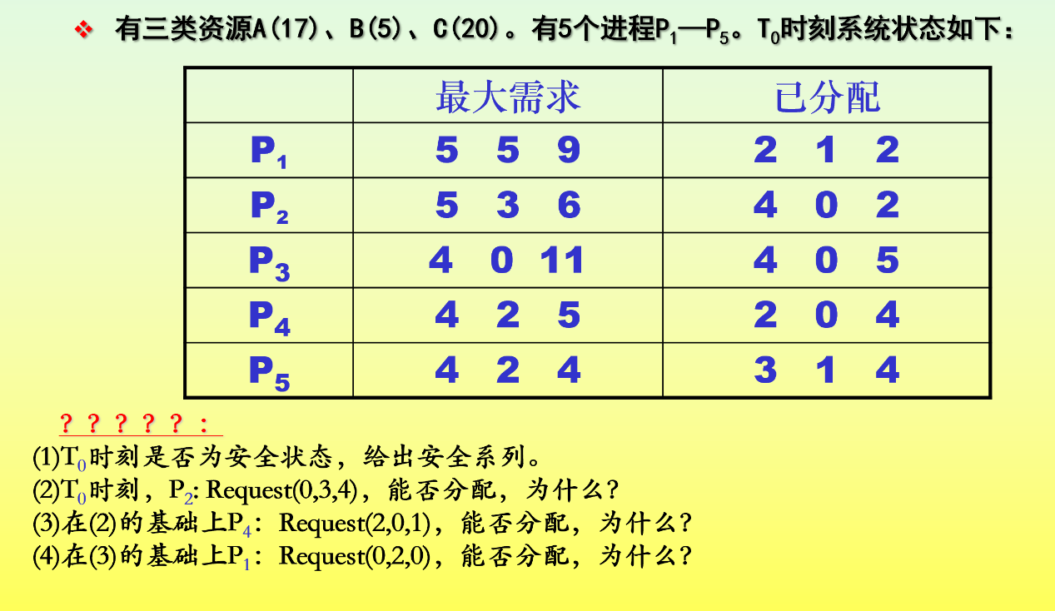

1.

|  |  |  |  |  |
| --- | --- | --- | --- | --- |
|  | Max  A B C | Allocated  A B C | Need  A B C | Available  A B C |
| P1 | 5 5 9 | 2 1 2 | 3 4 7 | 2 3 3 |
| P2 | 5 3 6 | 4 0 2 | 1 3 4 | 4 3 7(P4) |
| P3 | 4 0 11 | 4 0 5 | 0 0 6 | 7 4 11(P5) |
| P4 | 4 2 5 | 2 0 4 | 2 2 1 | 9 5 13(P1) |
| P5 | 4 2 4 | 3 1 4 | 1 1 0 | 13 5 15(P2) |
|  |  |  |  | 17 5 20(P3) |

安全序列为 P4, P5, P1, P2, P3

2.

因为Request(0, 3, 4) > Available(2, 3, 3)，所以不能分配

3.

能分配

Request(2, 0, 1) < Need(2, 2, 1)

Request(2, 0, 1) < Available(2, 3, 3)

|  |  |  |  |  |
| --- | --- | --- | --- | --- |
|  | Max  A B C | Allocated  A B C | Need  A B C | Available  A B C |
| P1 | 5 5 9 | 2 1 2 | 3 4 7 | 0 3 2 |
| P2 | 5 3 6 | 4 0 2 | 1 3 4 | 4 3 7(P4) |
| P3 | 4 0 11 | 4 0 5 | 0 0 6 | 7 4 11(P5) |
| P4 | 4 2 5 | 4 0 5 | 0 2 0 | 9 5 13(P1) |
| P5 | 4 2 4 | 3 1 4 | 1 1 0 | 13 5 15(P2) |
|  |  |  |  | 17 5 20(P3) |

存在安全序列: P4, P5, P1, P2, P3， 所以可以分配

4.

不能分配

Request(0, 2, 0) < Need(3, 4, 7)

Request(0, 2, 0) < Available(0, 3, 2)

|  |  |  |  |  |
| --- | --- | --- | --- | --- |
|  | Max  A B C | Allocated  A B C | Need  A B C | Available  A B C |
| P1 | 5 5 9 | 2 3 2 | 3 2 7 | 0 1 2 |
| P2 | 5 3 6 | 4 0 2 | 1 3 4 |  |
| P3 | 4 0 11 | 4 0 5 | 0 0 6 |  |
| P4 | 4 2 5 | 4 0 5 | 0 2 0 |  |
| P5 | 4 2 4 | 3 1 4 | 1 1 0 |  |
|  |  |  |  |  |

由表可知不存在Need向量小于等于Available向量，因此会进入不安全状态所以不能分配