一、安装检查及配置

1、检查软硬件

内存，swap(内存>32G,那么设置为32G)

安装软件的磁盘空间分配

/ 40960M

/boot 200M

/swap 32678M

/u01 40960M

/u02 存放数据库文件或者其他用途，实际大小根据具体情况划分

2、创建用户组及用户

groupadd -g 501 oinstall

groupadd -g 502 dba

groupadd -g 503 asmadmin

groupadd -g 504 asmdba

groupadd -g 505 asmoper

useradd -u 501 -g oinstall -G asmadmin,asmdba,asmoper grid

useradd -u 502 -g oinstall -G dba,asmdba oracle

# passwd oracle

Changing password for user oracle.

New UNIX password:

BAD PASSWORD: it is based on a dictionary word

Retype new UNIX password:

passwd: all authentication tokens updated successfully.

# passwd grid

Changing password for user grid.

New UNIX password:

BAD PASSWORD: it is based on a dictionary word

Retype new UNIX password:

passwd: all authentication tokens updated successfully.

[root@hxdb1 ~]#

3、网络

配置hostname

vi /etc/sysconfig/network

vi /etc/hosts配置主机名和IP（根据实际情况而定）：

10.0.86.105 hostname

4、双网卡绑定（根据实际情况修改相应ip，mac地址等参数）

hxdb1

vi /etc/sysconfig/network-scripts/ifcfg-bond0

DEVICE=bond0

BOOTPROTO=none

ONBOOT=yes

TYPE=Ethernet

BROADCAST=196.16.0.255

IPADDR=196.16.0.222

NETMASK=255.255.0.0

NETWORK=196.16.0.0

GATEWAY=196.16.0.254

USERCTL=no

PEERDNS=no

vi /etc/sysconfig/network-scripts/ifcfg-eth0 文件内容（HWADDR地址依据实际情况修改）

DEVICE=eth0

BOOTPROTO=none

MASTER=bond0

SLAVE=yes

TYPE=Ethernet

USERCTL=no

HWADDR=F0:92:1C:06:CD:EC

ONBOOT=yes

PEERDNS=no

vi /etc/sysconfig/network-scripts/ifcfg-eth2 文件内容（HWADDR地址依据实际情况修改）

DEVICE=eth2

BOOTPROTO=none

HWADDR=F0:92:1C:06:CD:EE

ONBOOT=yes

MASTER=bond0

SLAVE=yes

USERCTL=no

TYPE=Ethernet

PEERDNS=no

vi /etc/modeprobe.d/dist.conf

alias bond0 bonding

options bonding miimon=100 mode=1 max_bonds=1

重启服务器

检查绑定生效

cat /proc/net/bonding/bond0

----- 关闭服务，执行以下操作

chkconfig smartd off

chkconfig auditd off

chkconfig bluetooth off

chkconfig cups off

chkconfig avahi-daemon off

chkconfig hidd off

chkconfig ip6tables off

chkconfig iptables off

chkconfig irqbalance off

chkconfig iscsi off

chkconfig iscsid off

chkconfig mcstrans off

chkconfig nfslock off

chkconfig pcscd off

chkconfig rhnsd off

chkconfig sendmail off

chkconfig tog-pegasus off

chkconfig yum-updatesd off

--检查确认都已关闭

chkconfig --list smartd

chkconfig --list auditd

chkconfig --list bluetooth

chkconfig --list cups

chkconfig --list avahi-daemon

chkconfig --list hidd

chkconfig --list ip6tables

chkconfig --list iptables

chkconfig --list irqbalance

chkconfig --list iscsi

chkconfig --list iscsid

chkconfig --list mcstrans

chkconfig --list nfslock

chkconfig --list pcscd

chkconfig --list rhnsd

chkconfig --list sendmail

chkconfig --list tog-pegasus

chkconfig --list yum-updatesd

6、内核参数

root用户更改：/etc/sysctl.conf

kernel.shmmni = 4096

kernel.sem = 250 32000 100 128

fs.file-max = 6815744

fs.aio-max-nr = 1048576

net.ipv4.ip_local_port_range = 9000 65500

net.core.rmem_default = 262144

net.core.rmem_max = 4194304

net.core.wmem_default = 262144

net.core.wmem_max = 1048576

#/sbin/sysctl -p立即生效

7、限制参数

/etc/security/limits.conf

grid soft nproc 2047

grid hard nproc 16384

grid soft nofile 1024

grid hard nofile 65536

oracle soft nproc 2047

oracle hard nproc 16384

oracle soft nofile 1024

oracle hard nofile 65536

在 /etc/profile 中最后添加以下

if [ $USER = "oracle" ] || [ $USER = "grid" ]; then

if [ $SHELL = "/bin/ksh" ]; then

ulimit -p 16384

ulimit -n 65536

else

ulimit -u 16384 -n 65536

fi

umask 022

fi

8、创建目录

oracle Inventory Directory

mkdir -p /u01/app/oraInventory

chown -R oracle:oinstall /u01/app/oraInventory

chmod -R 775 /u01/app/oraInventory

Oracle Base Directory

mkdir -p /u01/app/oracle

chown -R oracle:oinstall /u01/app/oracle

chmod -R 775 /u01/app/oracle

Oracle RDBMS Home Directory

mkdir -p /u01/app/oracle/product/11.2.0/db_1

chown -R oracle:oinstall /u01/app/oracle/product/11.2.0/db_1

chmod -R 775 /u01/app/oracle/product/11.2.0/db_1

9、检查软件环境

以下是64位系统需要的包，确认都已安装

binutils-2.15.92.0.2

compat-libstdc++-33-3.2.3

compat-libstdc++-33-3.2.3 (32 bit)

elfutils-libelf-0.97

elfutils-libelf-devel-0.97

expat-1.95.7

gcc-3.4.6

gcc-c++-3.4.6

glibc-2.3.4-2.41

glibc-2.3.4-2.41 (32 bit)

glibc-common-2.3.4

glibc-devel-2.3.4

glibc-headers-2.3.4

libaio-0.3.105

libaio-0.3.105 (32 bit)

libaio-devel-0.3.105

libaio-devel-0.3.105 (32 bit)

libgcc-3.4.6

libgcc-3.4.6 (32-bit)

libstdc++-3.4.6

libstdc++-3.4.6 (32 bit)

libstdc++-devel 3.4.6

make-3.80

pdksh-5.2.14

sysstat-5.0.5

unixODBC-2.2.11

unixODBC-2.2.11 (32 bit)

unixODBC-devel-2.2.11

unixODBC-devel-2.2.11 (32 bit)

rpm -qa | grep binutils

rpm -qa | grep compat-libstdc++

rpm -qa | grep elfutils-libelf

rpm -qa | grep elfutils-libelf-devel

rpm -qa | grep expat

rpm -qa | grep gcc

rpm -qa | grep gcc-c++

rpm -qa | grep glibc

rpm -qa | grep glibc-common

rpm -qa | grep glibc-devel

rpm -qa | grep glibc-headers

rpm -qa | grep libaio

rpm -qa | grep libaio-devel

rpm -qa | grep libgcc

rpm -qa | grep libstdc++

rpm -qa | grep libstdc++-devel

rpm -qa | grep make

rpm -qa | grep pdksh

rpm -qa | grep sysstat

rpm -qa | grep unixODBC

rpm -qa | grep unixODBC-devel

rpm -q --qf '%{NAME}-%{VERSION}-%{RELEASE} (%{ARCH})\n' binutils \

compat-libstdc++-33 \

elfutils-libelf \

elfutils-libelf-devel \

gcc \

gcc-c++ \

glibc \

glibc-common \

glibc-devel \

glibc-headers \

ksh \

libaio \

libaio-devel \

libgcc \

libstdc++ \

libstdc++-devel \

make \

sysstat \

unixODBC \

unixODBC-devel

10、配置oracle环境变量

PATH=$PATH:$HOME/bin

export PATH

unset USERNAME

export ORACLE_BASE=/u01/app/oracle

export ORACLE_HOME=$ORACLE_BASE/product/11.2.0/db_1

export ORACLE_SID=wskhdb

export ORACLE_TERM=xterm

export NLS_LANG="AMERICAN_AMERICA.AL32UTF8"

export LD_LIBRARY_PATH=$ORACLE_HOME/lib:$ORACLE_HOME/network/lib:/lib:/usr/lib:/usr/local/lib

export LIBPATH=$ORACLE_HOME/lib:$ORACLE_HOME/network/lib:/lib:/usr/lib:/usr/local/lib

export PATH=$PATH:/sbin:/usr/bin:/usr/sbin:$ORACLE_HOME/bin:$ORACLE_HOME/lib:$HOME/bin:.

umask 022

11、安装数据库软件

解压两个安装包

unzip p13390677_112040_Linux-x86-64_1of7.zip

unzip p13390677_112040_Linux-x86-64_2of7.zip

安装

./runInstaller

**在建库的过程中，注意：**

安装准备工作完毕之后，我们即可看到oracle图形化的安装界面(如下图所示)。

[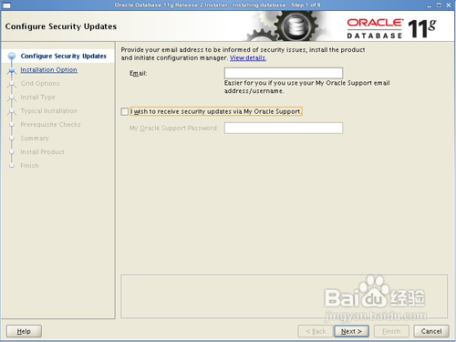](http://jingyan.baidu.com/album/22a299b57870f29e19376adf.html?picindex=2)

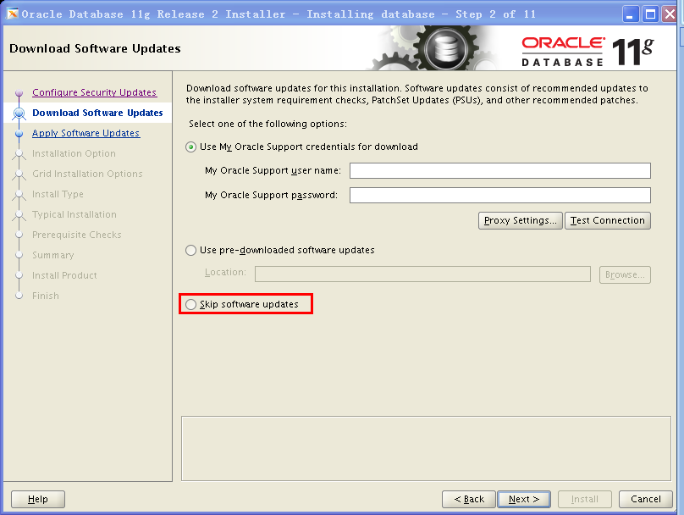

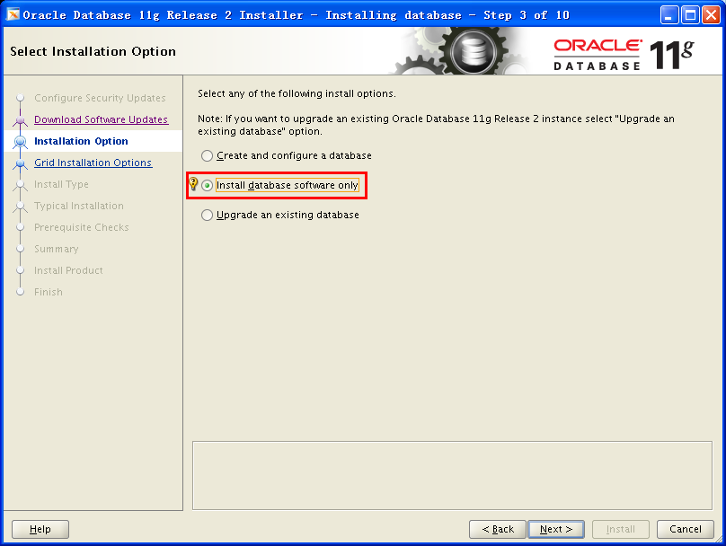

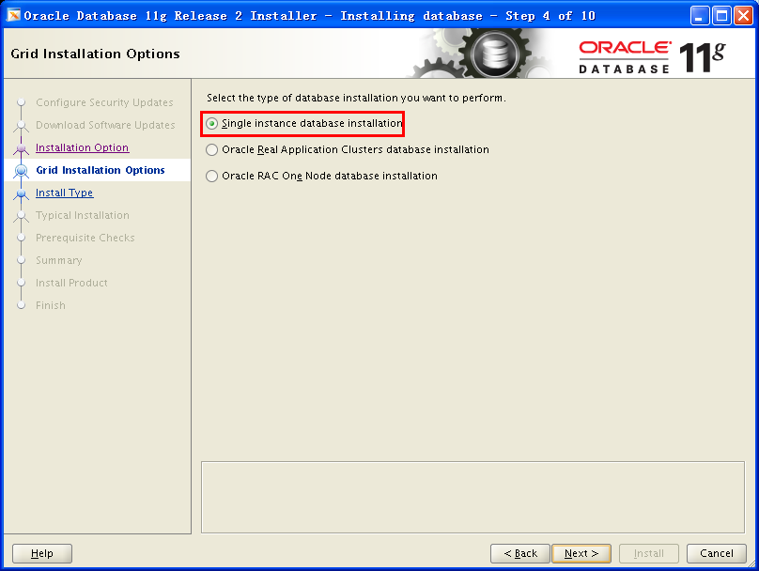

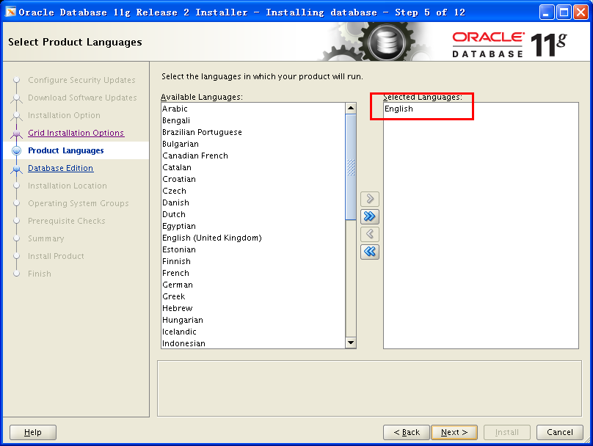

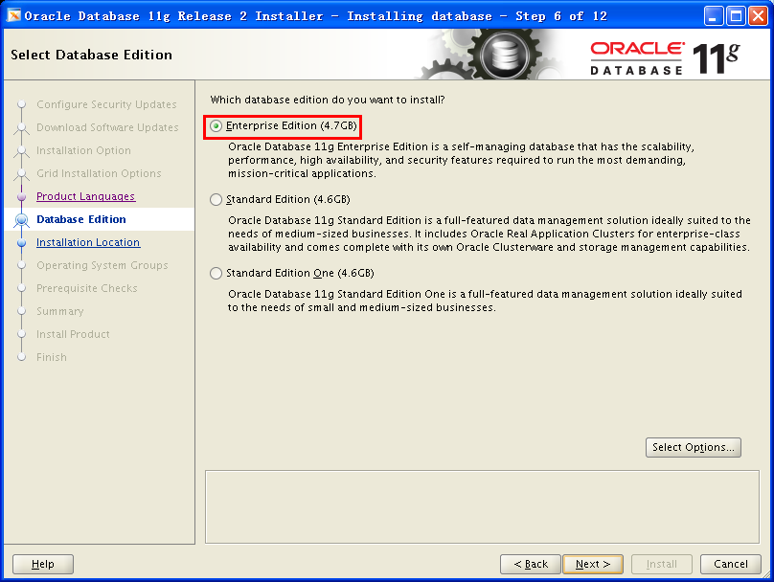

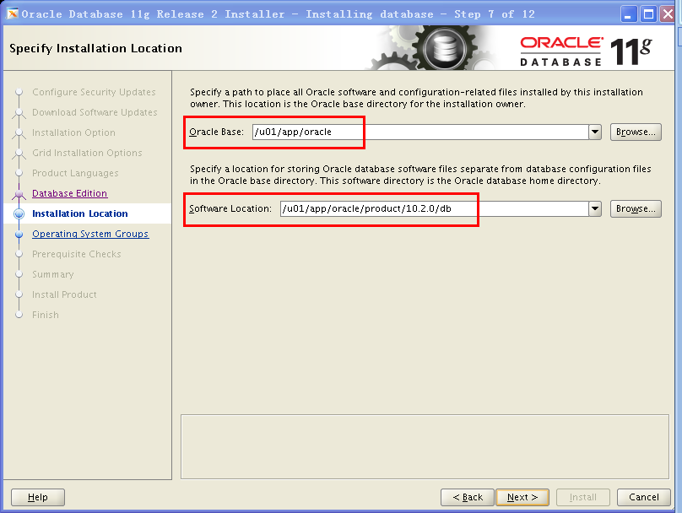

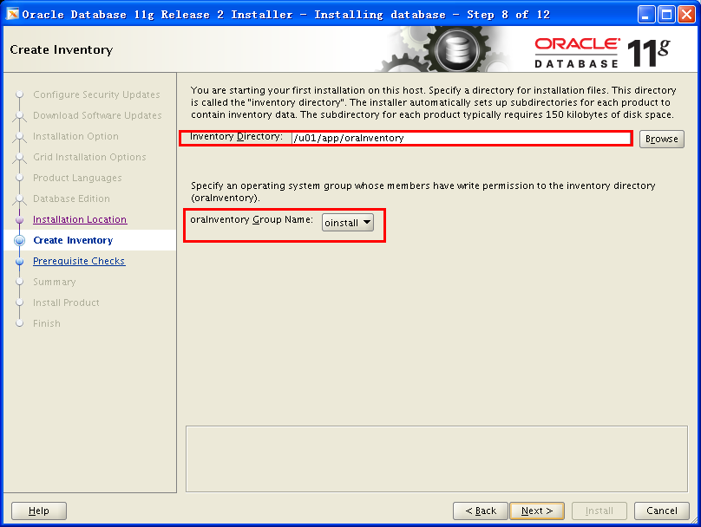

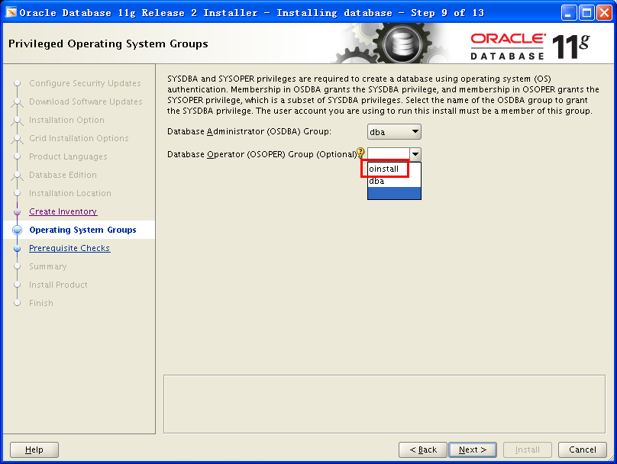

**下图中点Fix&Check Again来修复OS Kernel Parameter 的参数设置，pdksh包可以忽略**

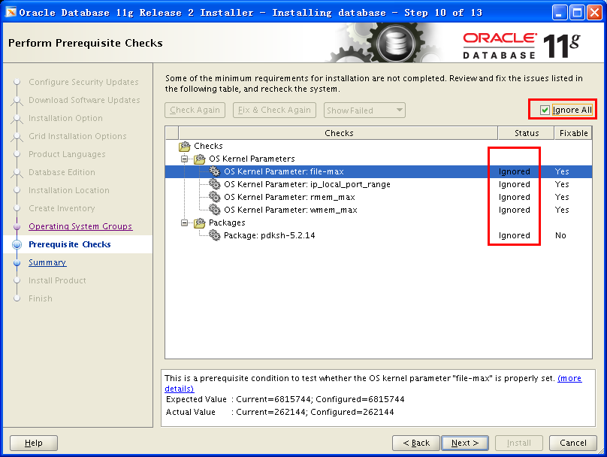

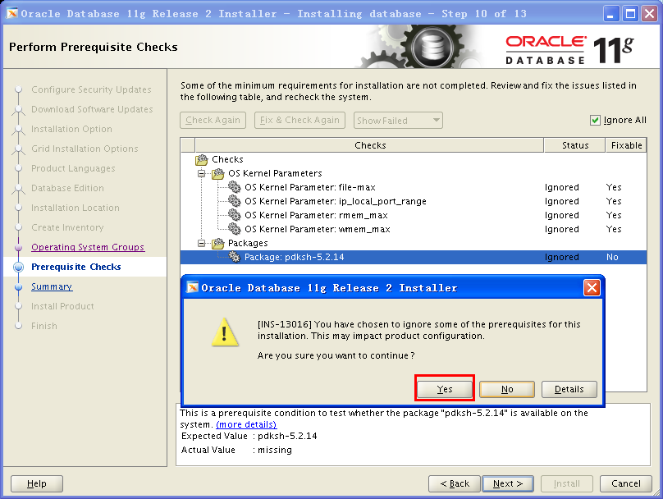

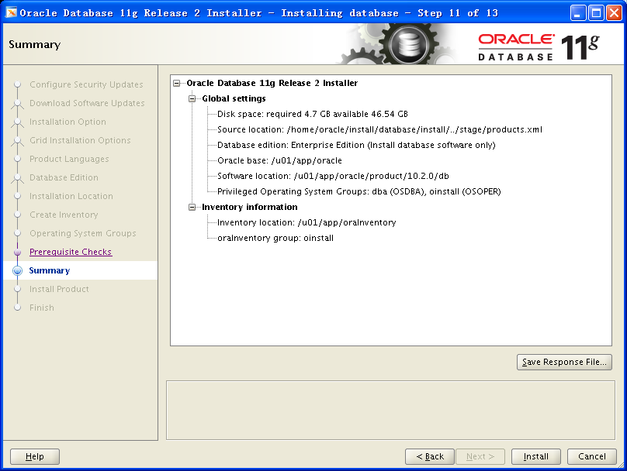

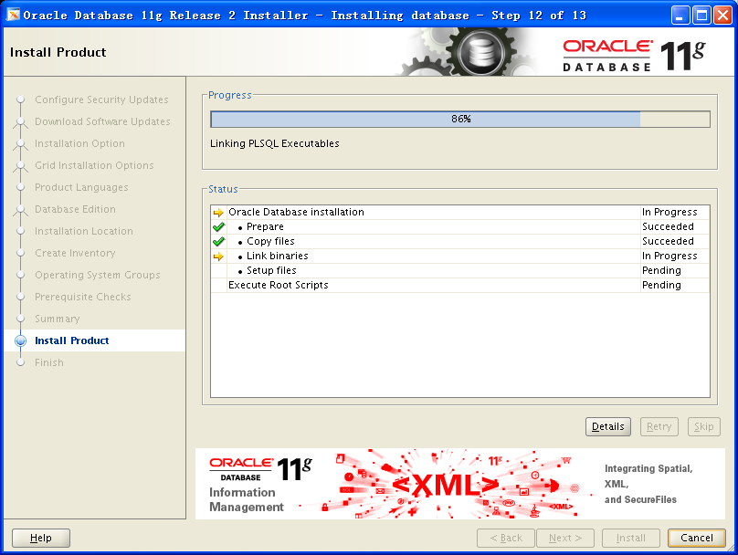

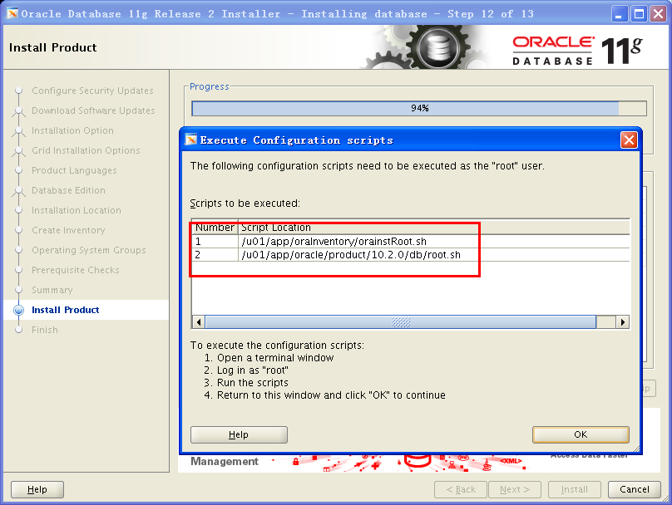

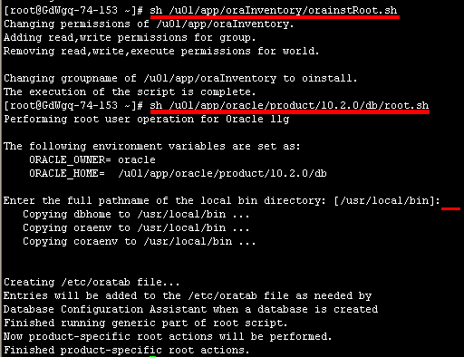

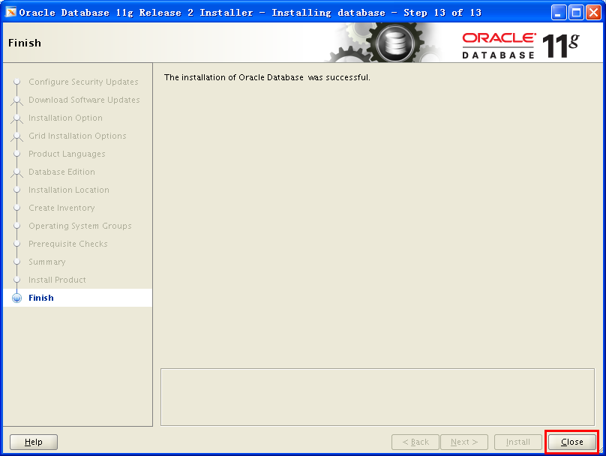

12、dbca创建数据库

$ id

uid=502(oracle) gid=501(oinstall) groups=501(oinstall),502(dba),504(asmdba)

$ dbca

以oracle用户身份通过Xshell登录Linux，执行命令：dbca后，出现如下界面，点击Next继续

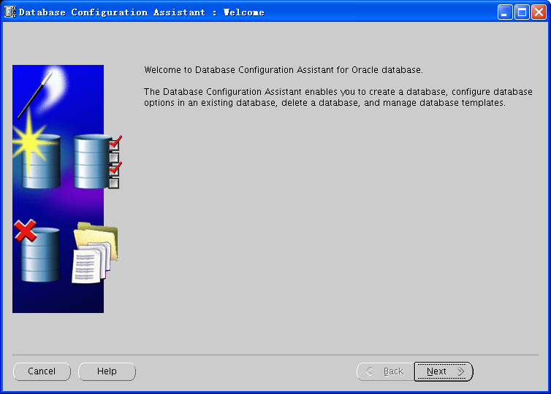

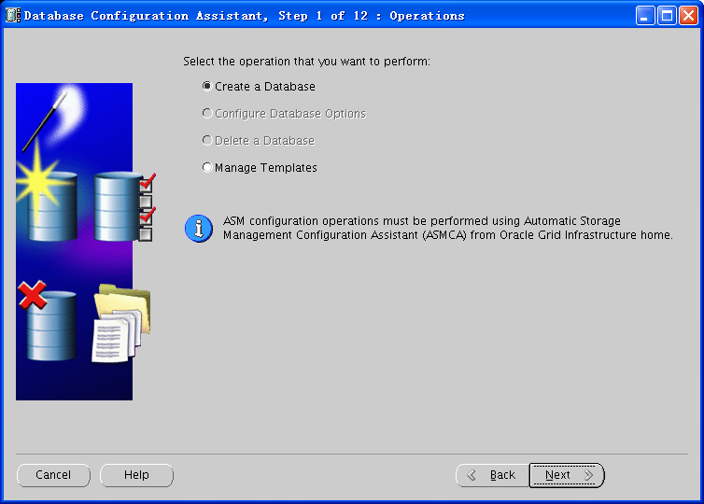

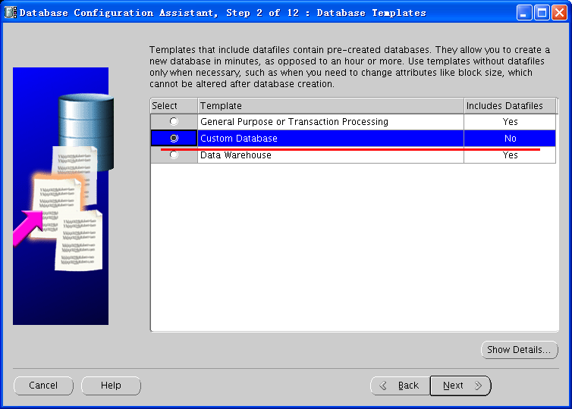

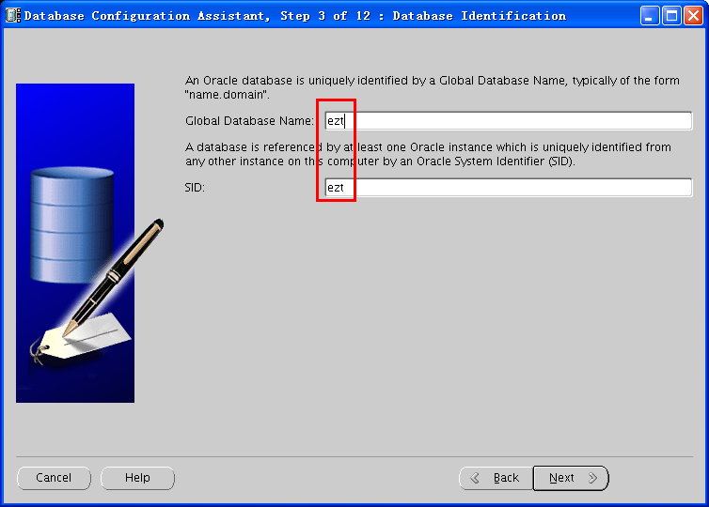

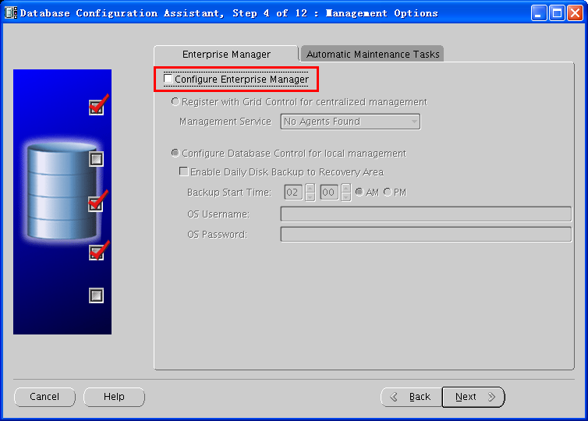

**去掉勾选 Enable automatic maintenance tasks**

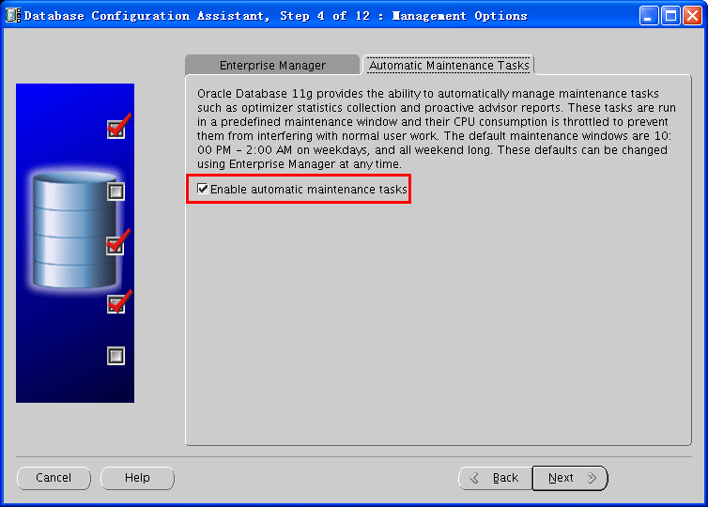

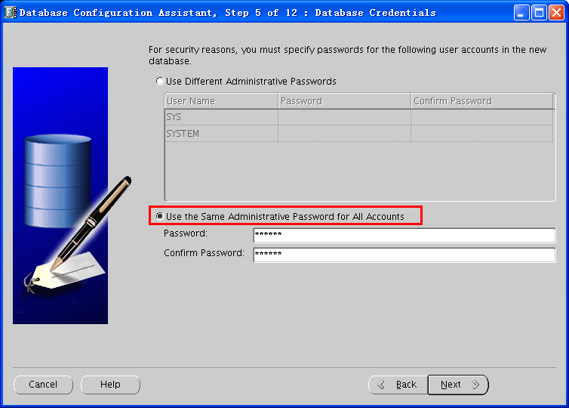

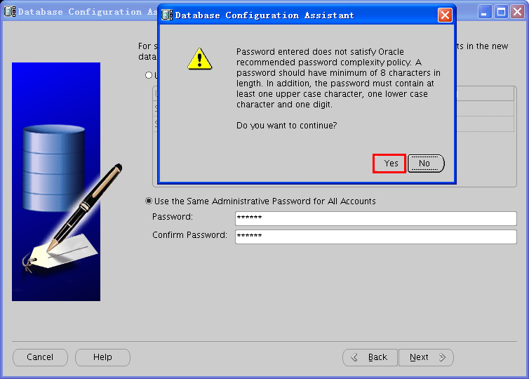



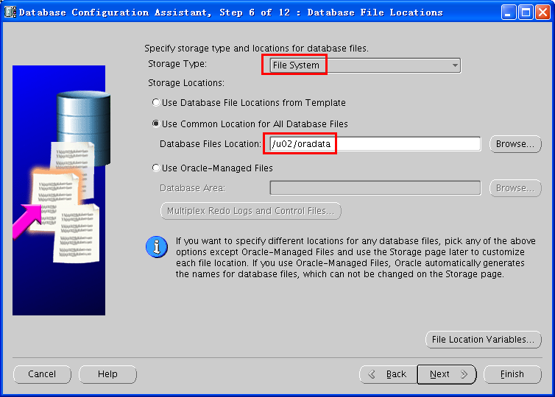

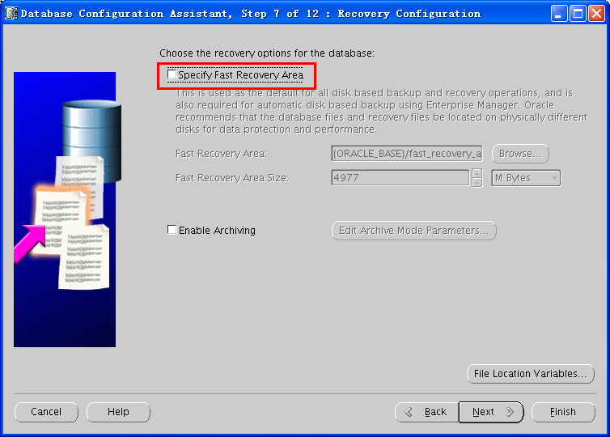

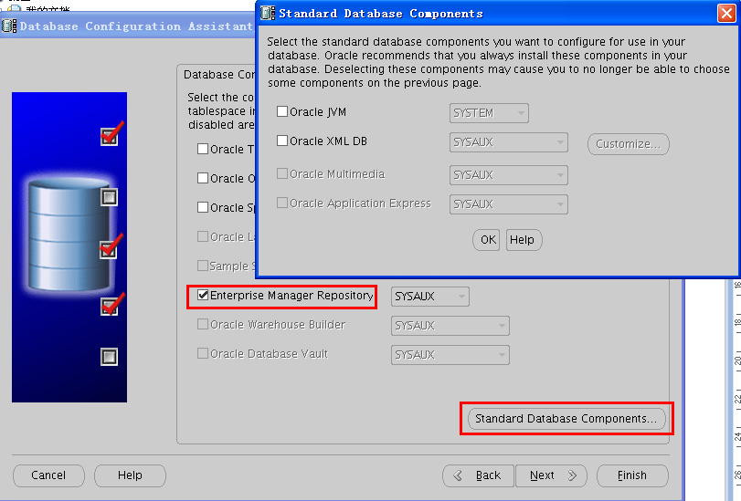

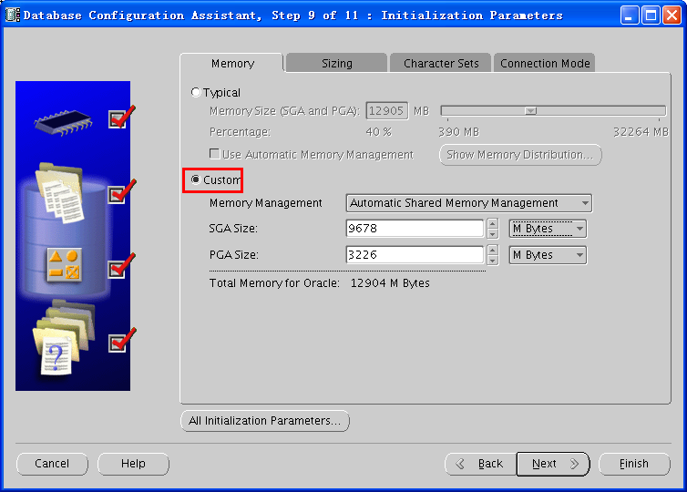

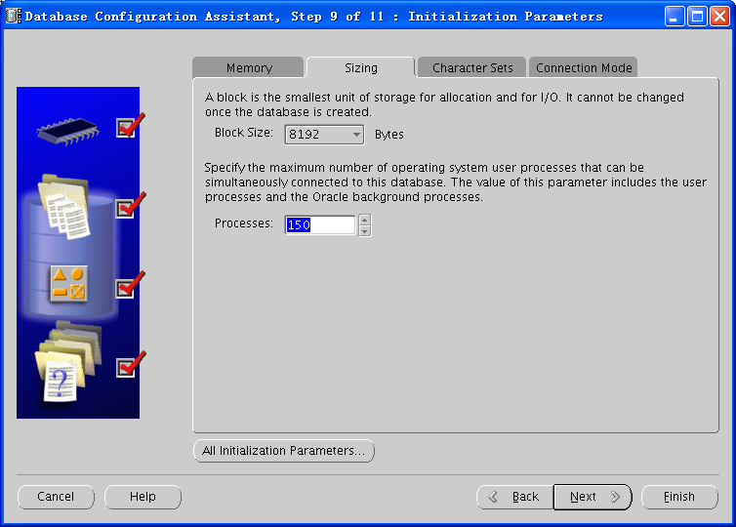

一般使用的字符集是ZHS.16GBK，用这个字符集，请再次与应用人员确认！ 下面的National Character Set 选择默认

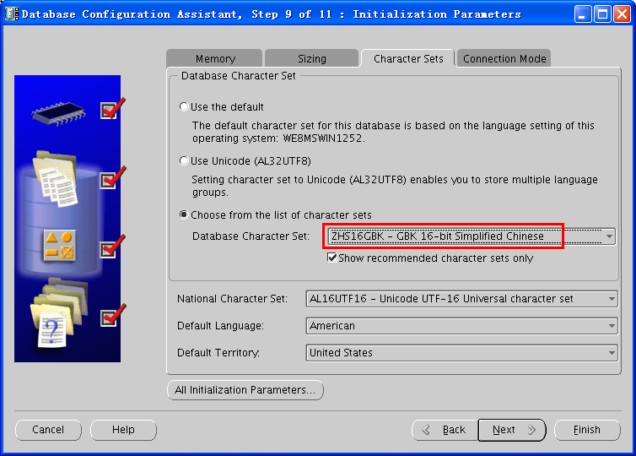

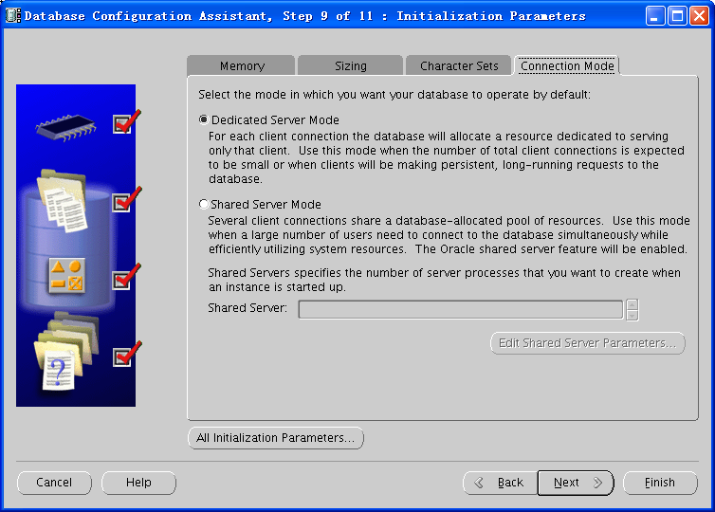

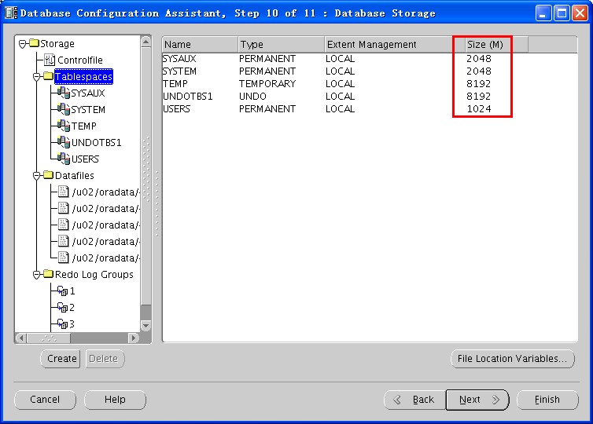

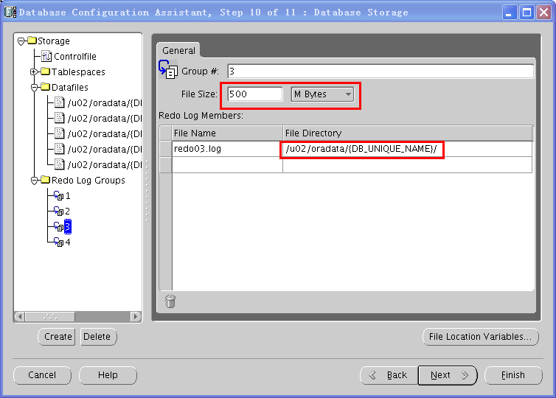

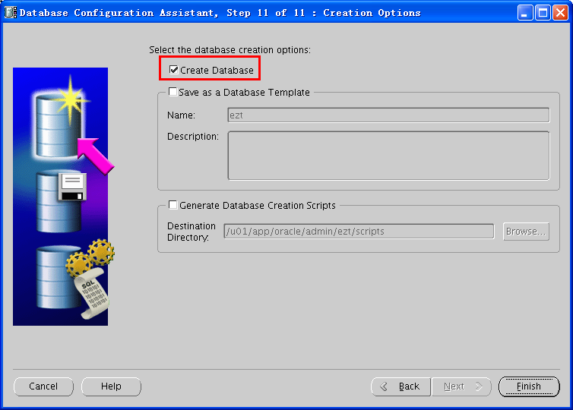

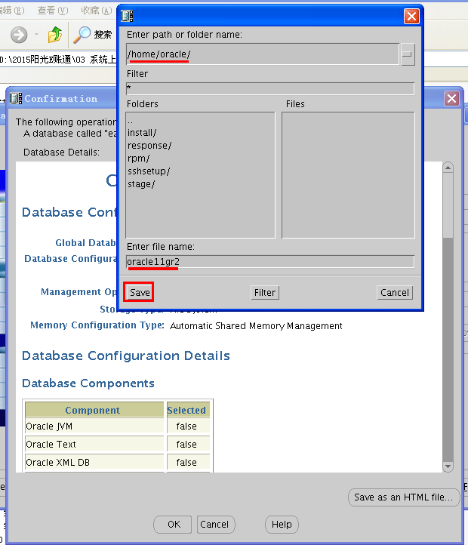

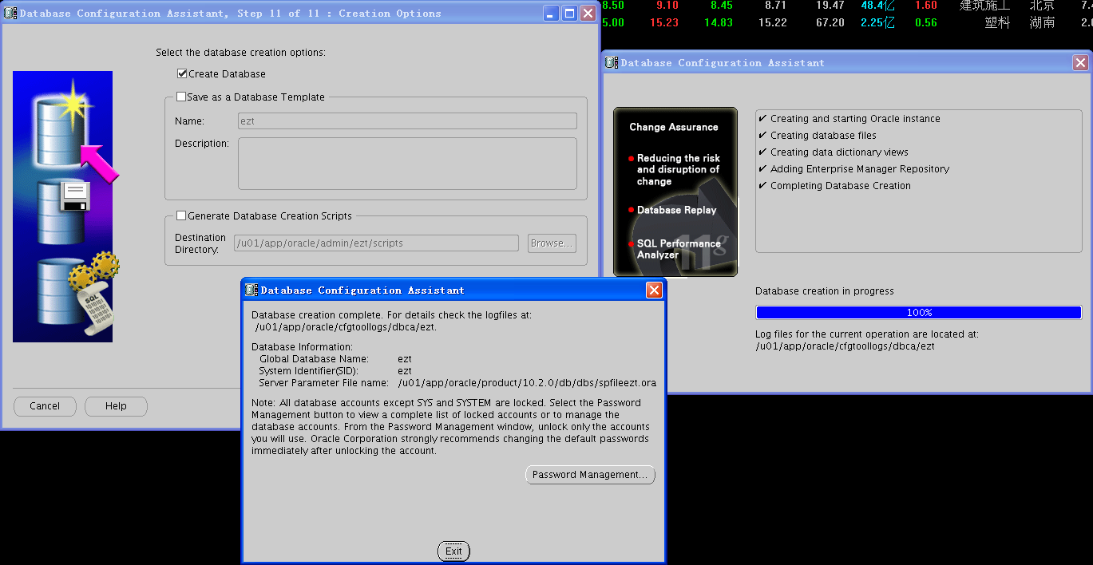

创建监听(oracle 身份)

1. 在创建监听之前先用lsnrctl stop命令将默认的监听停止

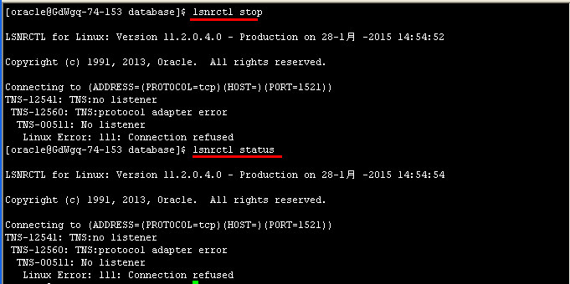

2．然后在ORACLE用户图形界面下运行 netca 命令监听一直按下一步就能完成配置

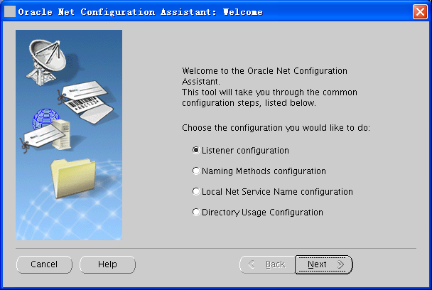

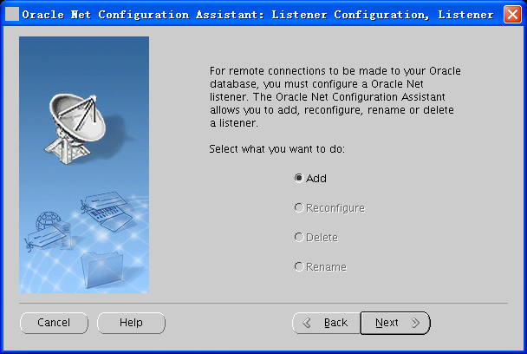

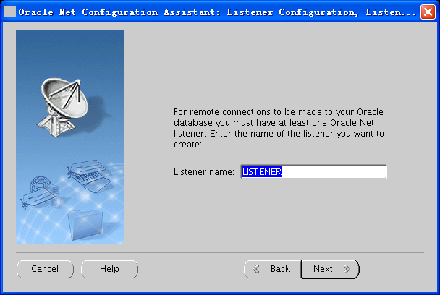

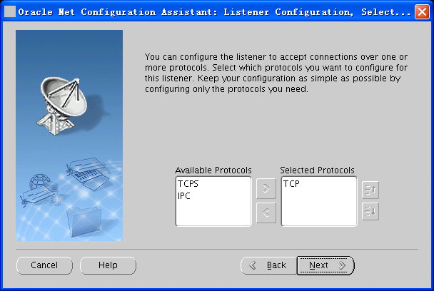

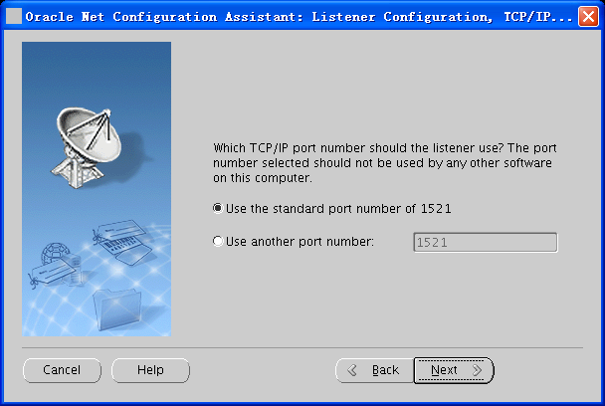

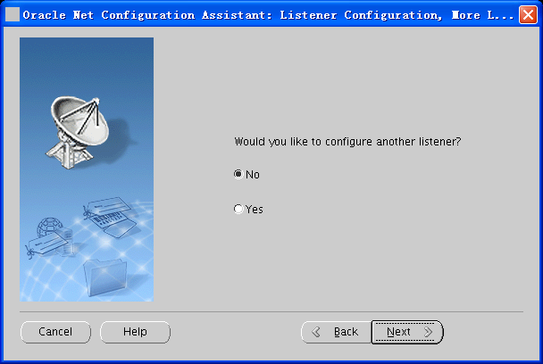

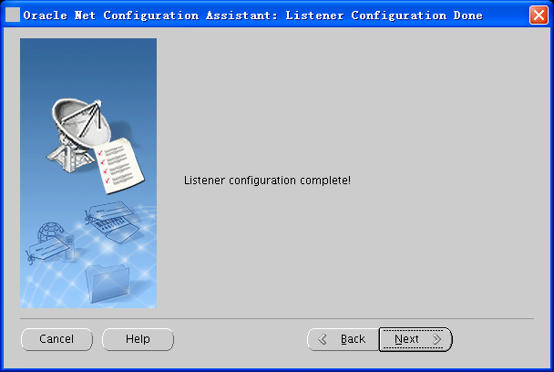

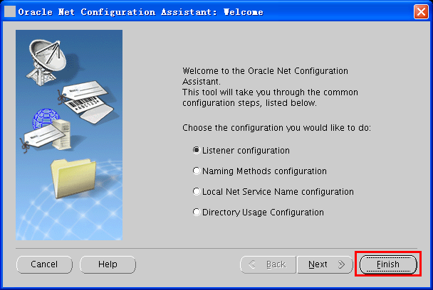

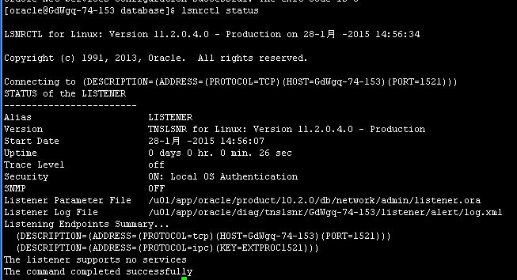

5.2.1. 一般参数

alter system set open_cursors=20000 scope=spfile sid='*';

alter system set session_cached_cursors=300 scope=spfile sid='*';

alter system set OPTIMIZER_INDEX_COST_ADJ=10 scope=spfile sid='*';

alter system set max_dump_file_size ="10G" scope=spfile sid='*';

alter system set deferred_segment_creation=false scope=spfile sid='*';

alter system set SEC_CASE_SENSITIVE_LOGON =FALSE scope=both sid='*';

alter system set parallel_force_local=true scope=spfile sid='*';

alter system set "_use_adaptive_log_file_sync"=false scope=spfile sid='*';

alter system set db_file_multiblock_read_count=16 scope=spfile sid='*';

alter system set optimizer_index_caching=90 scope=spfile sid='*';

alter system set event='28401 trace name context forever, level 1:10949 trace name context forever,level 1' scope=spfile sid='*';

alter system set dispatchers='' scope=spfile sid='*';

alter system set db_file_multiblock_read_count=16 scope=spfile sid='*';

alter system set db_writer_processes=4 scope=spfile sid='*'; (根据系统调整)

alter system set db_files=2048 scope=spfile sid='*'; (根据业务系统调整)

alter system set optimizer_mode=ALL_ROWS scope=spfile sid='*';(根据业务系统调整)

alter system set processes=3000 scope=spfile sid='*'; (根据业务系统调整)

alter system set sga_max_size=12G scope=spfile sid='*'; (根据系统调整)

alter system set sga_target=12G scope=spfile sid='*';

alter system set pga_aggregate_target=4G scope=spfile sid='*';

注：sga_max_size+ pga_aggregate_target=物理内存/2 （可适当放大）

sga_max_size=(物理内存/2) *(2/3)

pga_aggregate_target=(物理内存/2) *(1/3)

sga_target=sga_max_size

以上是物理内存32G示例

5.2.2. 关闭auto space

exec dbms_scheduler.disable('ORACLE_OCM.MGMT_CONFIG_JOB');

exec dbms_scheduler.disable('ORACLE_OCM.MGMT_STATS_CONFIG_JOB');

begin

DBMS_AUTO_TASK_ADMIN.DISABLE(client_name => 'auto optimizer stats collection',

operation => NULL,

window_name => NULL);

end;

/

begin

dbms_auto_task_admin.disable(

client_name => 'auto space advisor',

operation => NULL,

window_name => NULL);

end;

/

begin

dbms_auto_task_admin.disable(

client_name => 'sql tuning advisor',

operation => NULL,

window_name => NULL);

end;

/

5.2.3. 关闭resource_manager_plan

alter system set resource_manager_plan='' scope=both;

execute dbms_scheduler.set_attribute('WEEKNIGHT_WINDOW','RESOURCE_PLAN','');

execute dbms_scheduler.set_attribute('WEEKEND_WINDOW','RESOURCE_PLAN','');

execute dbms_scheduler.set_attribute('SATURDAY_WINDOW','RESOURCE_PLAN','');

execute dbms_scheduler.set_attribute('SUNDAY_WINDOW','RESOURCE_PLAN','');

execute dbms_scheduler.set_attribute('MONDAY_WINDOW','RESOURCE_PLAN','');

execute dbms_scheduler.set_attribute('TUESDAY_WINDOW','RESOURCE_PLAN','');

execute dbms_scheduler.set_attribute('WEDNESDAY_WINDOW','RESOURCE_PLAN','');

execute dbms_scheduler.set_attribute('THURSDAY_WINDOW','RESOURCE_PLAN','');

execute dbms_scheduler.set_attribute('FRIDAY_WINDOW','RESOURCE_PLAN','');

5.2.4. 禁用EMD_MAINTENANCE.EXECUTE_EM_DBMS_JOB_PROCS()

exec sysman.emd_maintenance.remove_em_dbms_jobs;

commit;

5.2.5. 取消profile对用户的相关限制

alter profile default limit FAILED_LOGIN_ATTEMPTS unlimited;

ALTER PROFILE DEFAULT LIMIT PASSWORD_LIFE_TIME UNLIMITED;

5.2.6. 关闭11g默认审计设置

alter system set audit_trail=none scope=spfile sid='*';

5.2.7. 解决11gR2数据库的ALERT文件频繁出现Fatal NI connect error 12170错误

#su - grid

$cd $ORACLE_HOME/network/admin

修改sqlnet.ora，没有则新建，添加： DIAG_ADR_ENABLED = OFF

修改listener.ora，添加： DIAG_ADR_ENABLED_LISTENER = OFF

重启或reload监听。

注意：grid用户下的TNS_ADMIN环境变量要设置正确。