This asset supports muti-platform, but best in Android, iOS, Window Phone 8 platform. Select menu **File** 🡪 **Build Settings**. Check all scenes: **LoadingScene**, **HomeScene**, **MapScene** and **PlayScene** appear or not in **Scenes In Build**. If not, you need add them to **Scenes In Build** in **Build Settings**.

Note: You must index **LoadingScene** in the first with value is 0.

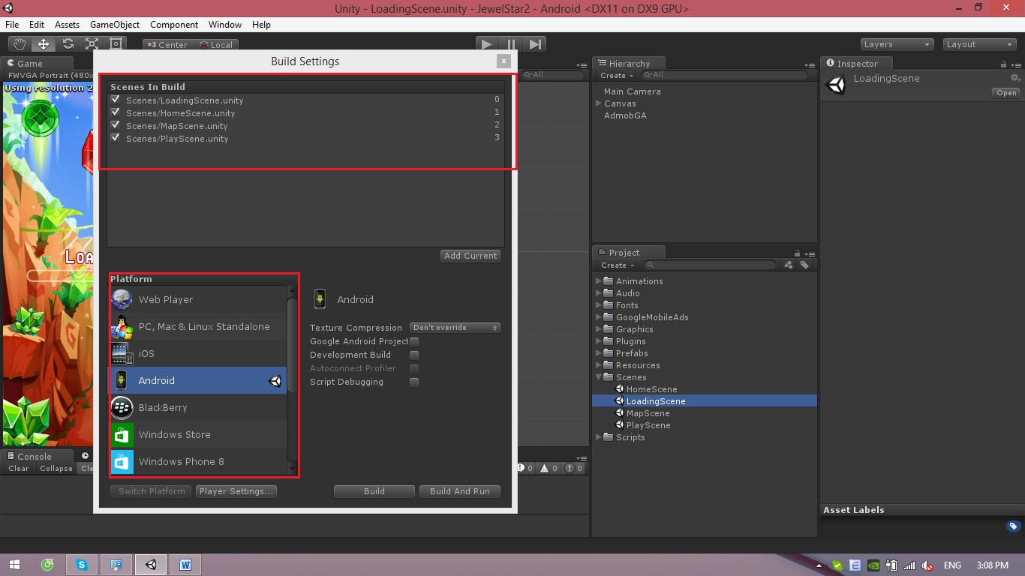

When play game, you must start **LoadingScene** first. If not, will appear bug as in the follow:

