**Match 3 Jewel: Full 298 Levels**

- A complete game is easy to create a new game like the Match-3 type and study Unity. This is very helpful for starters as well as experienced users of unity. You will learn how to be able to start a game: make a loading screen, choose levels, load data, use sound, change the sprites while breaking diamonds, animations,…

- The game with 2 different modes is extremely attractive.

- The game’s GUI is used on unities from above 4.6 one.

- It is supported on Unity 5.

- It can be used on all platform.

- It includes 100% source code. It can run on unity free version, no need to use unity pro one.

- Don’t bug.

- Loading dynamic data in each levels

- It was optimized for the 2d game about images, code and animations,…

- Descriptive documents are easy to customize.

- Appearing a lot of obstacles in the game: soil, rock, ice, chain,…

- Rich sound

- Graphics is extremely beautiful and fascinating.

- You are supported until you get the most satisfaction of this asset.

- Integrated Admob, GA for android and IOS.

- And more others features.

Send all contributive comments to the email: [vietgamestudio@gmail.com](mailto:vietgamestudio@gmail.com). If you have any concerns or questions of this game, you contact us immediately. We will support you right after receiving your comments.

**Types of Jewels :**

|  |  |
| --- | --- |
| D:\PublicAssetStore\JewelsStar2\Project Custome\JewelStar2\Assets\Graphics\Jewels\1.png | 0 |
| D:\PublicAssetStore\JewelsStar2\Project Custome\JewelStar2\Assets\Graphics\Jewels\2.png | 1 |
| D:\PublicAssetStore\JewelsStar2\Project Custome\JewelStar2\Assets\Graphics\Jewels\3.png | 2 |
| D:\PublicAssetStore\JewelsStar2\Project Custome\JewelStar2\Assets\Graphics\Jewels\4.png | 3 |
| D:\PublicAssetStore\JewelsStar2\Project Custome\JewelStar2\Assets\Graphics\Jewels\5.png | 4 |
| D:\PublicAssetStore\JewelsStar2\Project Custome\JewelStar2\Assets\Graphics\Jewels\6.png | 5 |
| D:\PublicAssetStore\JewelsStar2\Project Custome\JewelStar2\Assets\Graphics\Jewels\8.png | 6 |
| D:\PublicAssetStore\JewelsStar2\Project Custome\JewelStar2\Assets\Graphics\Jewels\7.png | 8 : Eat jewels same color |

Type Of Cell :

|  |  |
| --- | --- |
| D:\PublicAssetStore\JewelsStar2\Project Custome\JewelStar2\Assets\Graphics\Play\Cell\cell_tranf.png | 1 |
| D:\PublicAssetStore\JewelsStar2\Project Custome\JewelStar2\Assets\Graphics\Play\Cell\cell_gray.png | 2 |
| D:\PublicAssetStore\JewelsStar2\Project Custome\JewelStar2\Assets\Graphics\Play\Cell\cell_blue.png | 3 |
| D:\PublicAssetStore\JewelsStar2\Project Custome\JewelStar2\Assets\Graphics\Play\Cell\cell_red.png | 4 |

Type of CellEffect :

|  |  |
| --- | --- |
| D:\PublicAssetStore\JewelsStar2\Project Custome\JewelStar2\Assets\Graphics\Effect\Ice\1.png | 5 |
| D:\PublicAssetStore\JewelsStar2\Project Custome\JewelStar2\Assets\Graphics\Effect\Lock\1.png | 4 |

Type of Power:

|  |  |
| --- | --- |
| D:\PublicAssetStore\JewelsStar2\Project Custome\JewelStar2\Assets\Graphics\Effect\Arrow\9.png | Eat horizontal or Vertical |
| D:\PublicAssetStore\JewelsStar2\Project Custome\JewelStar2\Assets\Graphics\Effect\clock.png | Time |
| D:\PublicAssetStore\JewelsStar2\Project Custome\JewelStar2\Assets\Graphics\Effect\enchant.png | Boom |

When change platform build. If play on editor error : FormatException : Value is not equivalent to either TrueString or FalseString.

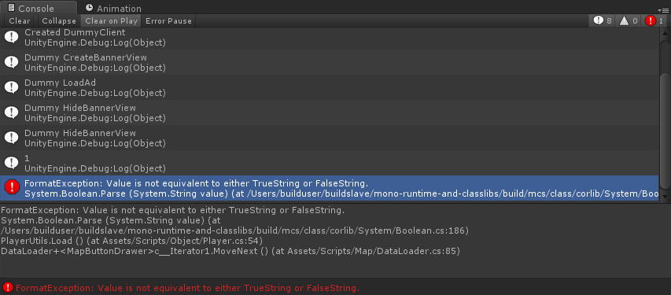

Fix : Open DataLoader.cs and uncomment the line : //PlayerPrefs.DeleteKey(KEY\_FRISTTIME);

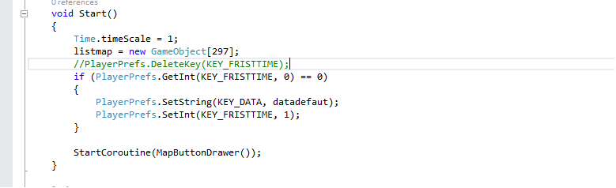

After play not exists error 🡪 comment against. //PlayerPrefs.DeleteKey(KEY\_FRISTTIME);

**Admob + GA**

Current project only support Admob and Google Analytic for Android and IOS.

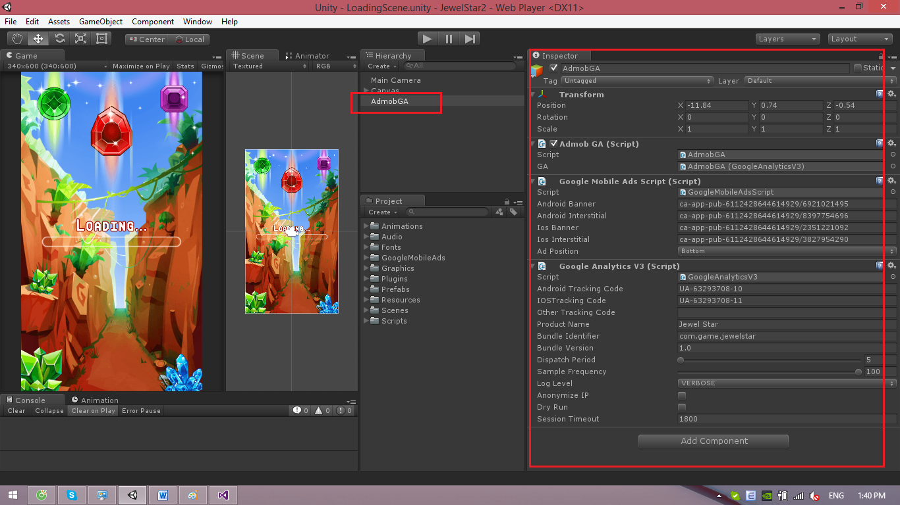

You can change Unit Android Banner, Android Interstitial, IOS banner, IOS Interstitial, Android Tracking Code, IOS Tracking Code, Product Name,…

Link download source and guide for Google Admob, Google Analytic :

* Google Ads Mobile : <https://github.com/googleads/googleads-mobile-plugins>
* Google Analytic : <https://github.com/googleanalytics/google-analytics-plugin-for-unity>

**Custom Map :**

Choose one map by path : Resources\ Maps\XXX.txt

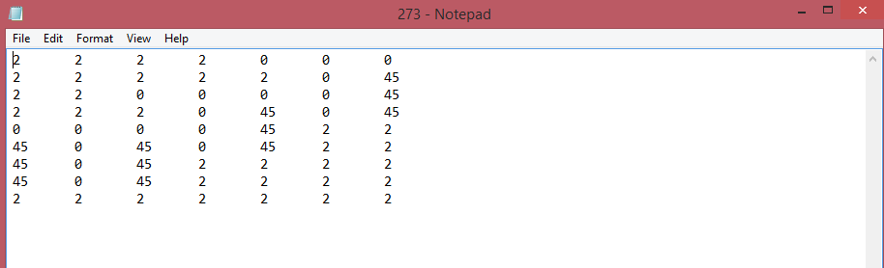

Example : level 273 :

2 : 

0 : Cell Empty

45 : 🡪 4 : 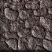 and 5 :  (Type of cell + Type of CellEffect)

Change number to custom map.