软件系统分析与设计
科技专家资源共享平台
部署安装文档

项目组成员信息
小组名称 | 洪洋大小姐不想爆肝
小组联系人 | 杨洪洋、林未
学号 | 姓名 | 本文档中主要承担的工作内容
16211085 | 索宇澄 | 对文档进行修改
16211093 | 林未 | MySQL部署
16211079 | 赵双叶 | 除了MySQL部署之外的其他部署内容
16211088 | 凌国辉 | 对文档进行修改
16211117 | 王嘉星 | 对文档进行修改
16211077 | 王启鹏 | 对文档进行修改
16211125 | 赵昀睿 | 对文档进行修改
16211028 | 杨洪洋 | 对文档进行修改

2019-06
版本变更历史
版本 | 提交日期 | 主要编制人 | 审核人 | 版本说明
01 | 2019-06-05 | 林未、赵双叶 | 杨洪洋 | 完成文档

目 录

1. 项目部署说明 1
1.1 后端部署说明 1
1.2 Apache部署说明 1
1.3 MySQL部署说明 1
1.3.1 数据库简介 1
1.3.2 数据库安装 1
1.4 Solr部署说明 10
1.4.1 部署Tomcat说明 10
1.4.2 配置solr 10
1.5 应用部署说明 12
2. 项目使用说明 13

项目部署说明

后端部署说明
名称 | 版本
操作系统 | CentOS 7.2 64位
Apache | Apache 2.4.33
MySQL | MySQL 5.7
Solr | Solr7.3.1
Tomcat | apache-tomcat-8.5.31
PHP | PHP 5.4.16

Apache部署说明
使用yum命令进行安装。
[root@localhost ~]# yum install -y httpd
开启Apache服务。设为开机自动启动。默认使用80端口。
[root@localhost ~]# systemctl enable httpd
[root@localhost ~]# systemctl start httpd

MySQL部署说明

数据库简介
在本次项目中，我们选择使用了MySQL。MySQL是一个开源的关系型数据库，是最受欢迎的开源软件之一，现在很多网站的数据库都是使用MySQL。

数据库安装
（1）在centos中安装mysql过程如下：
下载mysql的源并安装：
Wget http://repo.mysql.com/mysql57-community-release-el7-8.noarch.rpm
rpm -ivh mysql57-community-release-el7-8.noarch.rpm
yum -y install mysql-server
最终结果如下图1所示：
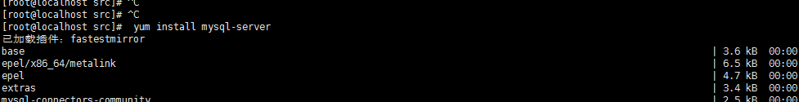
图1 安装mysql

（2）配置/etc/my.cnf：
[mysqld]
#
# Remove leading # and set to the amount of RAM for the most important data
# cache in MySQL. Start at 70% of total RAM for dedicated server, else 10%.
# innodb_buffer_pool_size = 128M
#
# Remove leading # to turn on a very important data integrity option: logging
# changes to the binary log between backups.
# log_bin
#
# Remove leading # to set options mainly useful for reporting servers.
# The server defaults are faster for transactions and fast SELECTs.
# Adjust sizes as needed, experiment to find the optimal values.
# join_buffer_size = 128M
# sort_buffer_size = 2M
# read_rnd_buffer_size = 2M
datadir=/var/lib/mysql
socket=/var/lib/mysql/mysql.sock
server_id = 1
expire_logs_days = 3

# Disabling symbolic-links is recommended to prevent assorted security risks
symbolic-links=0

log-error=/var/log/mysqld.log
pid-file=/var/run/mysqld/mysqld.pid

（3）密码配置
启动mysql服务：service mysqld restart
重置临时密码：grep "password" /var/log/mysqld.log
使用root登录：mysql -u root -p
设置root密码：ALTER USER 'root'@'localhost' IDENTIFIED BY 'password'

至此MySQL安装配置完成

创建数据库
MySQL部署完成后，新建数据库并重命名为resource_sharing，然后运行如下SQL语句建表：
/*
Navicat Premium Data Transfer

Source Server : 123.206.68.192
Source Server Type : MySQL
Source Server Version : 100223
Source Host : 123.206.68.192:3306
Source Schema : resource_sharing

Target Server Type : MySQL
Target Server Version : 100223
File Encoding : 65001

Date: 04/06/2019 15:32:21
*/

SET NAMES utf8mb4;
SET FOREIGN_KEY_CHECKS = 0;

-- ----------------------------
-- Table structure for achievement
-- ----------------------------
DROP TABLE IF EXISTS `achievement`;
CREATE TABLE `achievement` (
`id` int(11) NOT NULL AUTO_INCREMENT,
`title` varchar(255) CHARACTER SET utf8 COLLATE utf8_general_ci NOT NULL DEFAULT '无',
`abstract` varchar(10000) CHARACTER SET utf8 COLLATE utf8_general_ci NOT NULL DEFAULT '无',
`time` datetime(0) NOT NULL,
`price` int(11) NOT NULL DEFAULT 0,
`url` varchar(10000) CHARACTER SET utf8 COLLATE utf8_general_ci NULL DEFAULT NULL,
`type` int(11) NOT NULL,
`author` varchar(255) CHARACTER SET utf8 COLLATE utf8_general_ci NOT NULL,
PRIMARY KEY (`id`) USING BTREE
) ENGINE = InnoDB AUTO_INCREMENT = 130609 CHARACTER SET = latin1 COLLATE = latin1_swedish_ci ROW_FORMAT = Dynamic;

-- ----------------------------
-- Table structure for browse
-- ----------------------------
DROP TABLE IF EXISTS `browse`;
CREATE TABLE `browse` (
`id` int(11) NOT NULL AUTO_INCREMENT,
`viewer` int(11) NOT NULL,
`resource` int(11) NOT NULL,
`time` datetime(0) NOT NULL,
PRIMARY KEY (`id`) USING BTREE,
INDEX `viewer`(`viewer`) USING BTREE,
INDEX `resource`(`resource`) USING BTREE,
CONSTRAINT `browse_ibfk_1` FOREIGN KEY (`viewer`) REFERENCES `user` (`id`) ON DELETE RESTRICT ON UPDATE RESTRICT,
CONSTRAINT `browse_ibfk_2` FOREIGN KEY (`resource`) REFERENCES `achievement` (`id`) ON DELETE RESTRICT ON UPDATE RESTRICT
) ENGINE = InnoDB AUTO_INCREMENT = 430 CHARACTER SET = latin1 COLLATE = latin1_swedish_ci ROW_FORMAT = Dynamic;

-- ----------------------------
-- Table structure for certification
-- ----------------------------
DROP TABLE IF EXISTS `certification`;
CREATE TABLE `certification` (
`id` int(11) NOT NULL AUTO_INCREMENT,
`applicant` int(11) NOT NULL,
`time` datetime(0) NOT NULL ON UPDATE CURRENT_TIMESTAMP(0),
`state` int(11) NOT NULL DEFAULT 0,
PRIMARY KEY (`id`) USING BTREE,
INDEX `applicant`(`applicant`) USING BTREE
) ENGINE = InnoDB AUTO_INCREMENT = 18 CHARACTER SET = latin1 COLLATE = latin1_swedish_ci ROW_FORMAT = Dynamic;

-- ----------------------------
-- Table structure for collection
-- ----------------------------
DROP TABLE IF EXISTS `collection`;
CREATE TABLE `collection` (
`id` int(11) NOT NULL AUTO_INCREMENT,
`uid` int(11) NULL DEFAULT NULL,
`pid` int(11) NULL DEFAULT NULL,
PRIMARY KEY (`id`) USING BTREE,
INDEX `uid`(`uid`) USING BTREE,
INDEX `pid`(`pid`) USING BTREE,
CONSTRAINT `pid` FOREIGN KEY (`pid`) REFERENCES `achievement` (`id`) ON DELETE RESTRICT ON UPDATE RESTRICT,
CONSTRAINT `uid` FOREIGN KEY (`uid`) REFERENCES `user` (`id`) ON DELETE RESTRICT ON UPDATE RESTRICT
) ENGINE = InnoDB AUTO_INCREMENT = 18 CHARACTER SET = latin1 COLLATE = latin1_swedish_ci ROW_FORMAT = Dynamic;

-- ----------------------------
-- Table structure for comment
-- ----------------------------
DROP TABLE IF EXISTS `comment`;
CREATE TABLE `comment` (
`id` int(11) NOT NULL AUTO_INCREMENT,
`resource` int(11) NOT NULL,
`commentator` int(11) NOT NULL,
`content` varchar(255) CHARACTER SET utf8 COLLATE utf8_general_ci NOT NULL,
`time` datetime(0) NOT NULL,
PRIMARY KEY (`id`) USING BTREE,
INDEX `resource`(`resource`) USING BTREE,
INDEX `commentator`(`commentator`) USING BTREE,
CONSTRAINT `comment_ibfk_1` FOREIGN KEY (`resource`) REFERENCES `achievement` (`id`) ON DELETE RESTRICT ON UPDATE RESTRICT,
CONSTRAINT `comment_ibfk_2` FOREIGN KEY (`commentator`) REFERENCES `user` (`id`) ON DELETE RESTRICT ON UPDATE RESTRICT
) ENGINE = InnoDB AUTO_INCREMENT = 18 CHARACTER SET = latin1 COLLATE = latin1_swedish_ci ROW_FORMAT = Dynamic;

-- ----------------------------
-- Table structure for download
-- ----------------------------
DROP TABLE IF EXISTS `download`;
CREATE TABLE `download` (
`id` int(11) NOT NULL AUTO_INCREMENT,
`downloader` int(11) NOT NULL,
`resource` int(11) NOT NULL,
`time` datetime(0) NOT NULL,
PRIMARY KEY (`id`) USING BTREE,
INDEX `downloader`(`downloader`) USING BTREE,
INDEX `resource`(`resource`) USING BTREE,
CONSTRAINT `download_ibfk_1` FOREIGN KEY (`downloader`) REFERENCES `user` (`id`) ON DELETE RESTRICT ON UPDATE RESTRICT,
CONSTRAINT `download_ibfk_2` FOREIGN KEY (`resource`) REFERENCES `achievement` (`id`) ON DELETE RESTRICT ON UPDATE RESTRICT
) ENGINE = InnoDB AUTO_INCREMENT = 4 CHARACTER SET = latin1 COLLATE = latin1_swedish_ci ROW_FORMAT = Dynamic;

-- ----------------------------
-- Table structure for paper
-- ----------------------------
DROP TABLE IF EXISTS `paper`;
CREATE TABLE `paper` (
`id` int(11) NOT NULL,
`date` varchar(255) CHARACTER SET utf8 COLLATE utf8_general_ci NULL DEFAULT NULL,
`database` varchar(255) CHARACTER SET utf8 COLLATE utf8_general_ci NULL DEFAULT NULL,
`cited` varchar(255) CHARACTER SET utf8 COLLATE utf8_general_ci NULL DEFAULT '0',
`fund` varchar(255) CHARACTER SET utf8 COLLATE utf8_general_ci NULL DEFAULT NULL,
`keyword` varchar(255) CHARACTER SET utf8 COLLATE utf8_general_ci NULL DEFAULT NULL,
`doi` varchar(255) CHARACTER SET utf8 COLLATE utf8_general_ci NULL DEFAULT NULL,
`classification` varchar(255) CHARACTER SET utf8 COLLATE utf8_general_ci NULL DEFAULT NULL,
`source1` varchar(1000) CHARACTER SET utf8 COLLATE utf8_general_ci NULL DEFAULT NULL,
`source2` varchar(1000) CHARACTER SET utf8 COLLATE utf8_general_ci NULL DEFAULT NULL,
`source3` varchar(1000) CHARACTER SET utf8 COLLATE utf8_general_ci NULL DEFAULT NULL,
`source4` varchar(1000) CHARACTER SET utf8 COLLATE utf8_general_ci NULL DEFAULT NULL,
PRIMARY KEY (`id`) USING BTREE,
CONSTRAINT `paper_ibfk_1` FOREIGN KEY (`id`) REFERENCES `achievement` (`id`) ON DELETE RESTRICT ON UPDATE RESTRICT
) ENGINE = InnoDB CHARACTER SET = latin1 COLLATE = latin1_swedish_ci ROW_FORMAT = Dynamic;

-- ----------------------------
-- Table structure for patent
-- ----------------------------
DROP TABLE IF EXISTS `patent`;
CREATE TABLE `patent` (
`id` int(11) NOT NULL AUTO_INCREMENT,
`application` varchar(255) CHARACTER SET utf8 COLLATE utf8_general_ci NOT NULL,
`date` date NOT NULL,
`applicant` varchar(255) CHARACTER SET utf8 COLLATE utf8_general_ci NOT NULL,
`address` varchar(255) CHARACTER SET utf8 COLLATE utf8_general_ci NOT NULL,
`inventor` varchar(255) CHARACTER SET utf8 COLLATE utf8_general_ci NOT NULL,
`main_classification` varchar(255) CHARACTER SET utf8 COLLATE utf8_general_ci NOT NULL,
`classification` varchar(255) CHARACTER SET utf8 COLLATE utf8_general_ci NOT NULL,
PRIMARY KEY (`id`) USING BTREE,
CONSTRAINT `patent_ibfk_1` FOREIGN KEY (`id`) REFERENCES `achievement` (`id`) ON DELETE RESTRICT ON UPDATE RESTRICT
) ENGINE = InnoDB AUTO_INCREMENT = 1 CHARACTER SET = latin1 COLLATE = latin1_swedish_ci ROW_FORMAT = Dynamic;

-- ----------------------------
-- Table structure for project
-- ----------------------------
DROP TABLE IF EXISTS `project`;
CREATE TABLE `project` (
`id` int(11) NOT NULL AUTO_INCREMENT,
`hoster` varchar(255) CHARACTER SET utf8 COLLATE utf8_general_ci NOT NULL,
`email` varchar(255) CHARACTER SET utf8 COLLATE utf8_general_ci NOT NULL,
`budget` int(11) NOT NULL,
`department` varchar(255) CHARACTER SET utf8 COLLATE utf8_general_ci NOT NULL,
`number` varchar(255) CHARACTER SET utf8 COLLATE utf8_general_ci NOT NULL,
`tender` date NULL DEFAULT NULL,
`due` date NULL DEFAULT NULL,
PRIMARY KEY (`id`) USING BTREE,
CONSTRAINT `project_ibfk_1` FOREIGN KEY (`id`) REFERENCES `achievement` (`id`) ON DELETE RESTRICT ON UPDATE RESTRICT
) ENGINE = InnoDB AUTO_INCREMENT = 1 CHARACTER SET = latin1 COLLATE = latin1_swedish_ci ROW_FORMAT = Dynamic;

-- ----------------------------
-- Table structure for purchase
-- ----------------------------
DROP TABLE IF EXISTS `purchase`;
CREATE TABLE `purchase` (
`id` int(11) NOT NULL AUTO_INCREMENT,
`purchaser` int(11) NOT NULL,
`resource` int(11) NOT NULL,
`time` datetime(0) NOT NULL,
PRIMARY KEY (`id`) USING BTREE,
INDEX `purchaser`(`purchaser`) USING BTREE,
INDEX `resource`(`resource`) USING BTREE,
CONSTRAINT `purchase_ibfk_1` FOREIGN KEY (`purchaser`) REFERENCES `user` (`id`) ON DELETE RESTRICT ON UPDATE RESTRICT
) ENGINE = InnoDB AUTO_INCREMENT = 1 CHARACTER SET = latin1 COLLATE = latin1_swedish_ci ROW_FORMAT = Dynamic;

-- ----------------------------
-- Table structure for recharge
-- ----------------------------
DROP TABLE IF EXISTS `recharge`;
CREATE TABLE `recharge` (
`id` int(11) NOT NULL AUTO_INCREMENT,
`recharger` int(11) NOT NULL,
`amount` int(11) NOT NULL,
`time` datetime(0) NOT NULL,
`kind` int(11) NOT NULL,
PRIMARY KEY (`id`) USING BTREE,
INDEX `recharger`(`recharger`) USING BTREE,
CONSTRAINT `recharge_ibfk_1` FOREIGN KEY (`recharger`) REFERENCES `user` (`id`) ON DELETE RESTRICT ON UPDATE RESTRICT
) ENGINE = InnoDB AUTO_INCREMENT = 1 CHARACTER SET = latin1 COLLATE = latin1_swedish_ci ROW_FORMAT = Dynamic;

-- ----------------------------
-- Table structure for search
-- ----------------------------
DROP TABLE IF EXISTS `search`;
CREATE TABLE `search` (
`id` int(11) NOT NULL AUTO_INCREMENT,
`searcher` int(11) NOT NULL,
`term` varchar(255) CHARACTER SET utf8 COLLATE utf8_general_ci NOT NULL,
`time` datetime(0) NOT NULL,
PRIMARY KEY (`id`) USING BTREE,
INDEX `searcher`(`searcher`) USING BTREE,
CONSTRAINT `search_ibfk_1` FOREIGN KEY (`searcher`) REFERENCES `user` (`id`) ON DELETE RESTRICT ON UPDATE RESTRICT
) ENGINE = InnoDB AUTO_INCREMENT = 6 CHARACTER SET = latin1 COLLATE = latin1_swedish_ci ROW_FORMAT = Dynamic;

-- ----------------------------
-- Table structure for specialist
-- ----------------------------
DROP TABLE IF EXISTS `specialist`;
CREATE TABLE `specialist` (
`id` int(11) NOT NULL AUTO_INCREMENT,
`name` varchar(255) CHARACTER SET utf8 COLLATE utf8_general_ci NOT NULL,
`affiliation` varchar(255) CHARACTER SET utf8 COLLATE utf8_general_ci NULL DEFAULT NULL,
PRIMARY KEY (`id`) USING BTREE
) ENGINE = InnoDB AUTO_INCREMENT = 354276 CHARACTER SET = latin1 COLLATE = latin1_swedish_ci ROW_FORMAT = Dynamic;

-- ----------------------------
-- Table structure for specialist_achievement
-- ----------------------------
DROP TABLE IF EXISTS `specialist_achievement`;
CREATE TABLE `specialist_achievement` (
`aid` int(11) NOT NULL,
`sid` int(11) NOT NULL,
`order` int(11) NOT NULL,
PRIMARY KEY (`aid`, `sid`) USING BTREE
) ENGINE = InnoDB CHARACTER SET = latin1 COLLATE = latin1_swedish_ci ROW_FORMAT = Dynamic;

-- ----------------------------
-- Table structure for transfer
-- ----------------------------
DROP TABLE IF EXISTS `transfer`;
CREATE TABLE `transfer` (
`id` int(11) NOT NULL AUTO_INCREMENT,
`old_ouwner` int(11) NOT NULL,
`new_owner` int(11) NOT NULL,
`time` datetime(0) NOT NULL,
`money` int(11) NOT NULL,
PRIMARY KEY (`id`) USING BTREE,
INDEX `old_ouwner`(`old_ouwner`) USING BTREE,
INDEX `new_owner`(`new_owner`) USING BTREE,
CONSTRAINT `transfer_ibfk_1` FOREIGN KEY (`old_ouwner`) REFERENCES `specialist` (`id`) ON DELETE RESTRICT ON UPDATE RESTRICT,
CONSTRAINT `transfer_ibfk_2` FOREIGN KEY (`new_owner`) REFERENCES `specialist` (`id`) ON DELETE RESTRICT ON UPDATE RESTRICT
) ENGINE = InnoDB AUTO_INCREMENT = 1 CHARACTER SET = latin1 COLLATE = latin1_swedish_ci ROW_FORMAT = Dynamic;

-- ----------------------------
-- Table structure for user
-- ----------------------------
DROP TABLE IF EXISTS `user`;
CREATE TABLE `user` (
`id` int(11) NOT NULL AUTO_INCREMENT,
`nickname` varchar(255) CHARACTER SET utf8 COLLATE utf8_general_ci NOT NULL,
`profile` varchar(255) CHARACTER SET utf8 COLLATE utf8_general_ci NULL DEFAULT NULL,
`email` varchar(255) CHARACTER SET utf8 COLLATE utf8_general_ci NULL DEFAULT NULL,
`islogin` int(11) NOT NULL DEFAULT 0,
`balance` int(11) NOT NULL DEFAULT 0,
`password` varchar(255) CHARACTER SET utf8 COLLATE utf8_general_ci NOT NULL,
`avator` varchar(255) CHARACTER SET utf8 COLLATE utf8_general_ci NULL DEFAULT 'http://123.206.68.192/avator/default.jpg',
`type` int(11) NOT NULL,
`expert` int(11) NULL DEFAULT NULL,
`identityCard` varchar(255) CHARACTER SET latin1 COLLATE latin1_swedish_ci NULL DEFAULT NULL,
`identity1` varchar(255) CHARACTER SET latin1 COLLATE latin1_swedish_ci NULL DEFAULT NULL,
`identity2` varchar(255) CHARACTER SET latin1 COLLATE latin1_swedish_ci NULL DEFAULT NULL,
PRIMARY KEY (`id`) USING BTREE,
INDEX `expert`(`expert`) USING BTREE,
CONSTRAINT `user_ibfk_1` FOREIGN KEY (`expert`) REFERENCES `specialist` (`id`) ON DELETE RESTRICT ON UPDATE RESTRICT
) ENGINE = InnoDB AUTO_INCREMENT = 23 CHARACTER SET = latin1 COLLATE = latin1_swedish_ci ROW_FORMAT = Dynamic;

SET FOREIGN_KEY_CHECKS = 1;
建完表后的数据库结构如下图所示。之后将爬取到的科技专家与成果信息等数据导入到数据库resource_sharing中，确保论文数量>10万，专家数量>1万。至此MySQL部署完毕。
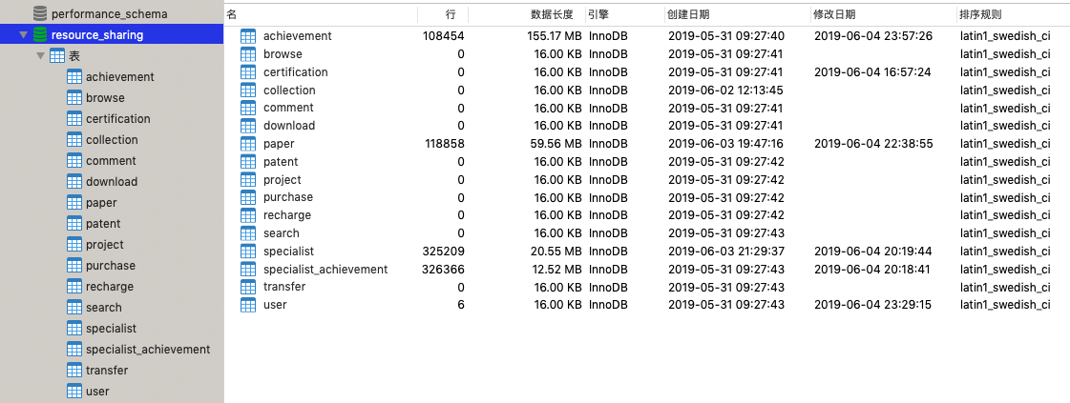

Solr部署说明
部署Solr分为部署Tomcat和Solr和配置Solr两个部分。

部署Tomcat说明
解压Tomcat文件到文件夹。
[root@localhost ~]# tar -xvf apache-tomcat-8.5.31.tar.gz –C /data/soft
解压Solr文件到文件夹。
[root@localhost ~]# tar -xvf solr-7.3.1.tgz -C /data/soft
然后把solr-7.3.1/server/solr-webapp 下的 webapp 文件夹拷贝到 tomcat 的 webapps 下。之后拷贝配置文件
[root@solr1 solr-webapp]# cp -r webapp/ /data/soft/solr/apache-tomcat-8.5.31/webapps/
拷贝 solr-7.3.1/server/lib/ 目录下的 gmetric4j-1.0.7.jar ，以及 metrics 开头的 jar 包拷贝到 apache-tomcat-8.5.31/webapps/solr7/WEB-INF/lib/ 下.
[root@solr1 lib]# cp gmetric4j-1.0.7.jar solr/apache-tomcat-8.5.31/webapps/solr7/WEB-INF/lib/
[root@solr1 lib]# cp metrics-*.* solr/apache-tomcat-8.5.31/webapps/solr7/WEB-INF/lib/
拷贝 solr-7.3.1/server/ 下的 solr 文件夹到 /usr/local/solr目录下，重命名为solrhome.
[root@solr1 dist]# cd /usr/local/solr/solr-7.3.1/server/
[root@solr1 server]# ls
contexts etc lib modules README.txt resources scripts solr solr-webapp start.jar
[root@solr1 server]# cp -r solr /usr/local/solr
之后关联solr 和 solrhome，修改/WEB-INF/web.xml。

配置solr
在配置好的solrhome下创建两个核。new_core核new_core2
[root@VM_0_14_centos apache-tomcat-8.5.40]# cd solrhome
[root@VM_0_14_centos solrhome]# ls
configsets new_core new_core2 README.txt solr.xml zoo.cfg
修改new_core/conf下的配置文件，对于字段进行设计、对于数据库进行连接。
[root@VM_0_14_centos solrhome]# ls
configsets new_core new_core2 README.txt solr.xml zoo.cfg
[root@VM_0_14_centos solrhome]# cd new_core
[root@VM_0_14_centos new_core]# ls
conf core.properties data
[root@VM_0_14_centos new_core]# cd conf
[root@VM_0_14_centos conf]# ls
clustering _rest_managed.json
currency.xml _schema_analysis_stopwords_english.json
data-config.xml _schema_analysis_synonyms_english.json
dataImport.properties solrconfig.xml
elevate.xml spellings.txt
lang stopwords.txt
managed-schema synonyms.txt
mapping-FoldToASCII.txt update-script.js
mapping-ISOLatin1Accent.txt velocity
params.json xslt
protwords.txt
成功部署之后，对于分词器进行测试。
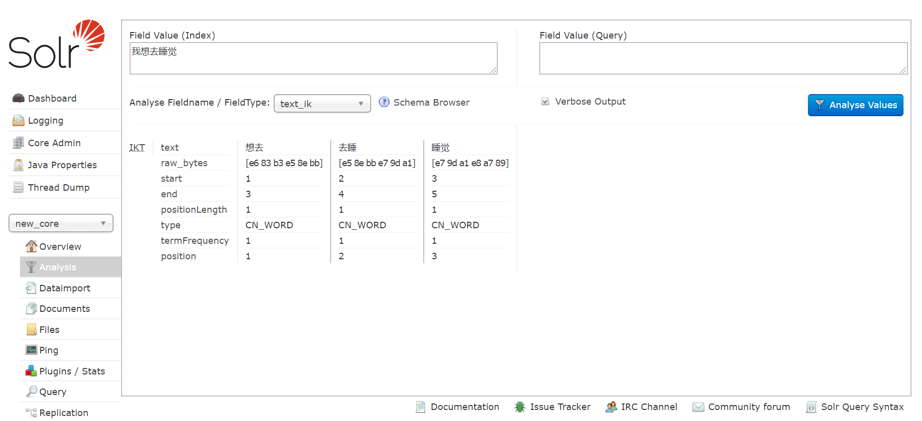
测试成功。然后在solr Admin界面选择一个核选择dataimport建立索引文件。
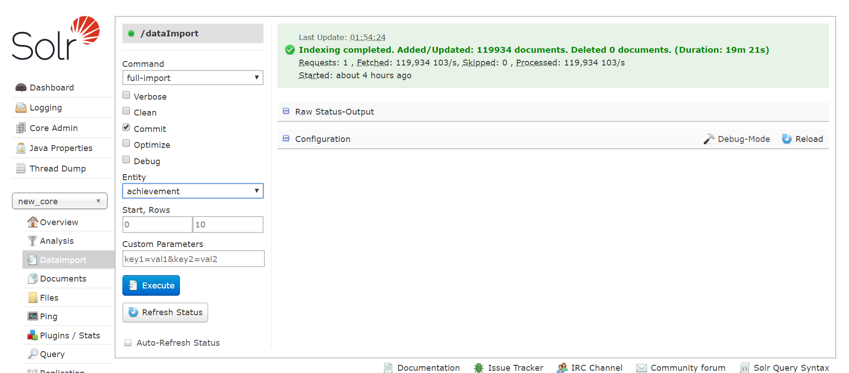
可以测试solr是否搜索成功。
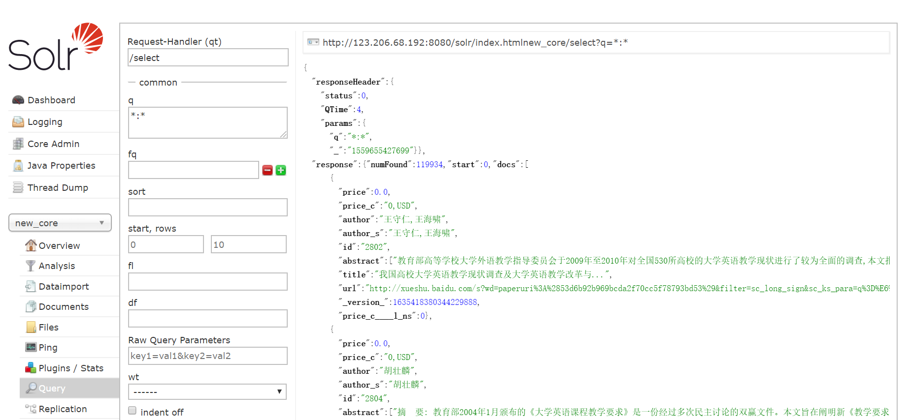
搜索成功。

应用部署说明
搭建ftp服务，使用ftp软件进行连接。
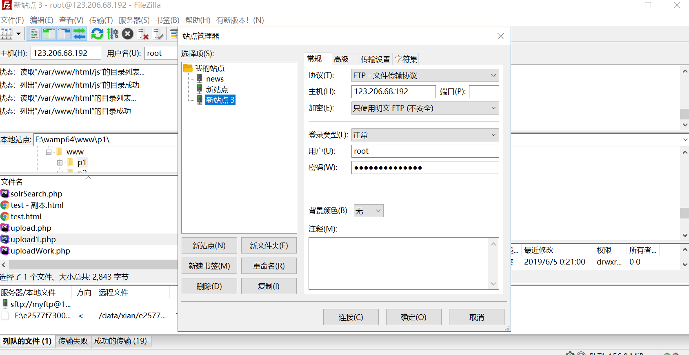
连接成功之后，将项目包上传到Apache的网页文件夹。
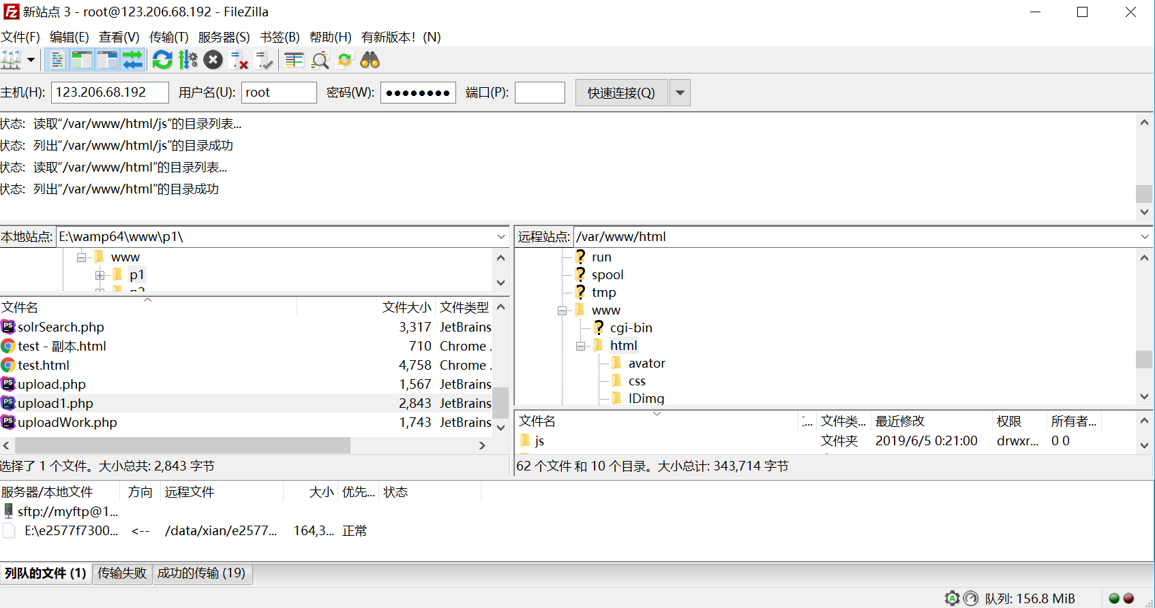

项目使用说明
项目部署在服务器的80端口，可以使用域名http://www.zdoubleleaves.cn/进行访问。
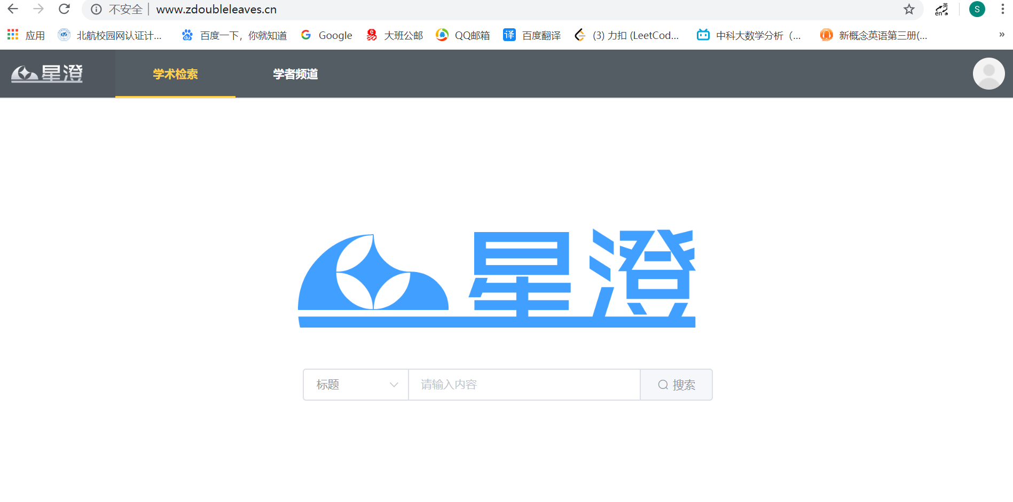
主页的中间是我们的logo和搜索框，搜索可以选择全文、标题和摘要检索。
主页的上方的检索的类型，可以选择学术检索和学者频道。
在搜索框输入内容对于科技成果进行检索。也可以选择上端栏目中的学者频道，对于专家进行检索。
检索科技成果的结果中对于检索的关键词进行了标红处理，方便用户查看内容。检索专家的结果支持模糊检索。
检索的结果最多返回100条。
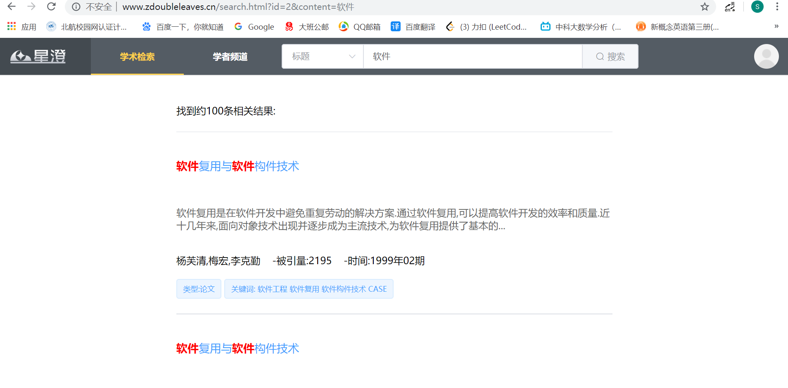
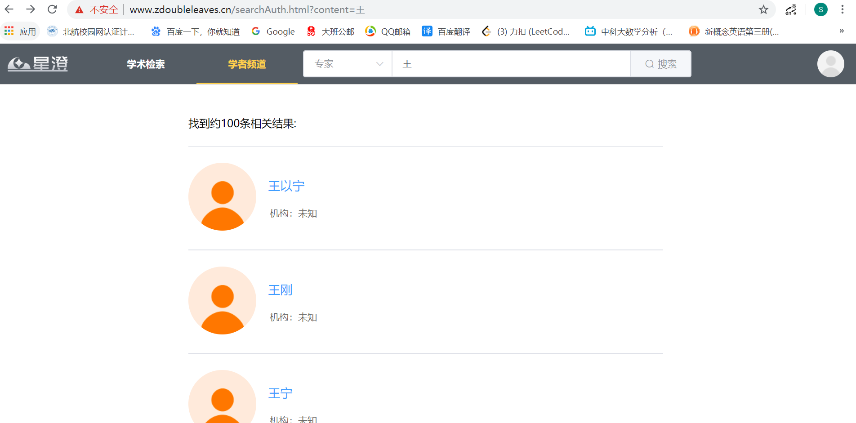
点击专家进入专家主页，专家主页提供了专家的被引次数和成果，以及期刊的类型等。在专家的下方提供相似的文献推荐，专家的右侧提供了该专家的合作学者。
在专家头像的下方提供了我要认证的按钮，方便用户认证。
