Table 1. Effect of Anti-Vaping Laws on Lung-Related Hospitalizations

Dependent Variable: Lung-Related Hospitalizations
 | Pre-2021 (Parallel Trends) | DiD (State + Year FE)
 | b/se | b/se
Treated State (Adopted Ban) | -2515.126***
 | (257.870)
Post × Treated State (After Ban in Effect) |  | -4030.462***
 |  | (68.031)
Observations | 550 | 1050
R-squared | 0.658 | 0.963
Standard errors in parentheses. Model (1): Parallel-trends test using pre-2021 sample (State FE: No, Year FE: Yes). Model (2): Difference-in-Differences estimate with state and year fixed effects (State FE: Yes, Year FE: Yes). Standard errors clustered at the state level. * p<0.10, ** p<0.05, *** p<0.01.

Note. Table 1 reports regression estimates examining the impact of state-level anti-vaping laws on lung-related hospitalizations. Model (1) uses data from 2010–2020 to test the parallel trends assumption, ensuring that hospitalization rates in treated and untreated states evolved similarly before 2021. Model (2) estimates the Difference-in-Differences (DiD) treatment effect after including both state and year fixed effects.

The coefficient for Treated State (Adopted Ban) is –2515.126, which indicates that, before 2021, states that would later adopt vaping bans already had about 2,515 fewer lung-related hospitalizations on average compared to untreated states. The key coefficient, Post × Treated State (After Ban in Effect) is –4030.462, representing that after 2021, treated states experienced roughly 4,030 fewer lung-related hospitalizations per year than untreated states, suggesting that the vaping bans significantly reduced lung-related health incidents.

Figure 1. Difference-in-Differences: Lung Hospitalizations Over Time

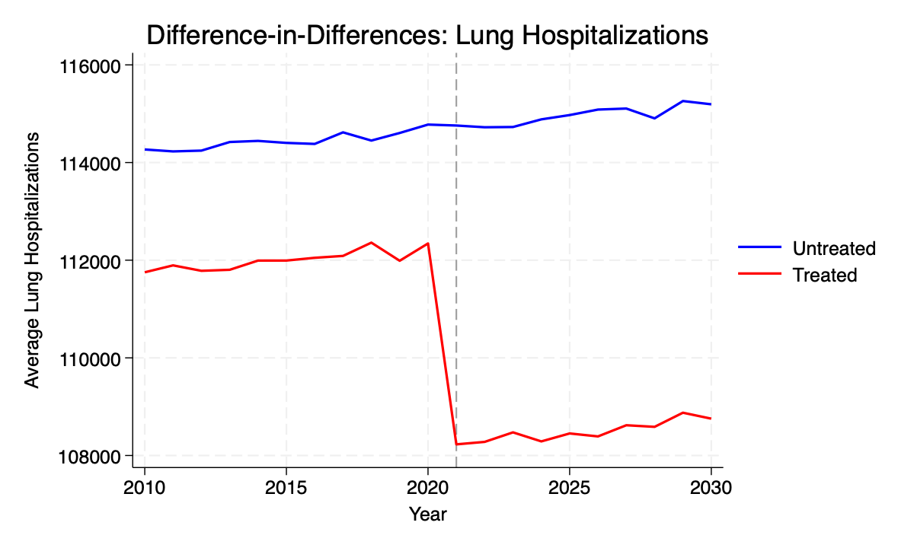
Note. Figure 1 plots average lung-related hospitalizations by year for treated (red line) and untreated (blue line) states. The vertical dashed line marks 2021, the year anti-vaping laws were enacted in 23 states. Before 2021, the two lines follow parallel paths, consistent with the parallel trends assumption. After 2021, the treated group’s hospitalization rate declines sharply relative to the untreated group.

