RR

2023-03-17

## R Markdown

This is an R Markdown document. Markdown is a simple formatting syntax for authoring HTML, PDF, and MS Word documents. For more details on using R Markdown see <http://rmarkdown.rstudio.com>.

When you click the **Knit** button a document will be generated that includes both content as well as the output of any embedded R code chunks within the document. You can embed an R code chunk like this:

## Warning: package 'dplyr' was built under R version 4.1.3

##   
## Attaching package: 'dplyr'

## The following objects are masked from 'package:stats':  
##   
## filter, lag

## The following objects are masked from 'package:base':  
##   
## intersect, setdiff, setequal, union

## Warning: package 'ggplot2' was built under R version 4.1.3

## Warning: package 'ipred' was built under R version 4.1.3

## Warning: package 'tree' was built under R version 4.1.3

## Warning: package 'randomForest' was built under R version 4.1.3

## randomForest 4.7-1.1

## Type rfNews() to see new features/changes/bug fixes.

##   
## Attaching package: 'randomForest'

## The following object is masked from 'package:ggplot2':  
##   
## margin

## The following object is masked from 'package:dplyr':  
##   
## combine

## Warning: package 'ggsci' was built under R version 4.1.3

## Warning: package 'flextable' was built under R version 4.1.3

##   
## average good poor   
## 1130 299 31

## # weights: 99 (64 variable)  
## initial value 1603.973941   
## iter 10 value 818.689672  
## iter 20 value 742.519592  
## iter 30 value 656.433535  
## iter 40 value 624.117643  
## iter 50 value 620.475347  
## iter 60 value 620.247015  
## iter 70 value 619.717132  
## final value 619.716567   
## converged

## Warning in tree(OverallCondCat ~ ., data = dplyr::select(house_data,  
## HouseStyle, : NAs introduced by coercion

## Warning in tree(OverallCondCat ~ ., data = dplyr::select(house_data, LotArea, :  
## NAs introduced by coercion

##   
## Classification tree:  
## tree(formula = OverallCondCat ~ ., data = dplyr::select(house_data,   
## LotArea, LotConfig, Condition1, BldgType, HouseStyle, OverallQual,   
## YearBuilt, X1stFlrSF, KitchenQual, SalePrice, OverallCondCat))  
## Variables actually used in tree construction:  
## [1] "YearBuilt" "SalePrice" "X1stFlrSF"  
## Number of terminal nodes: 9   
## Residual mean deviance: 0.8558 = 1242 / 1451   
## Misclassification error rate: 0.189 = 276 / 1460

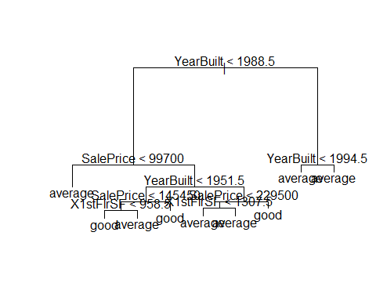

| names | good | poor |
| --- | --- | --- |
| (Intercept) | 111.0189 | 30.8321 |
| LotArea | 0.0000 | -0.0001 |
| LotConfigCulDSac | 0.5278 | 1.0283 |
| LotConfigFR2 | 0.1371 | 0.0650 |
| LotConfigFR3 | 1.3317 | -2.1166 |
| LotConfigInside | -0.1463 | -0.9298 |
| Condition1Feedr | 0.9157 | -0.5521 |
| Condition1Norm | 0.5435 | 0.9317 |
| Condition1PosA | 2.8747 | -3.6666 |
| Condition1PosN | 1.8813 | 3.7066 |
| Condition1RRAe | 1.4038 | -7.2394 |
| Condition1RRAn | -0.0395 | -4.9728 |
| Condition1RRNe | 2.8415 | -0.0925 |
| Condition1RRNn | 0.3294 | -1.7255 |
| BldgType2fmCon | -0.2772 | -13.2204 |
| BldgTypeDuplex | -2.0383 | -2.0528 |
| BldgTypeTwnhs | 0.5583 | -7.5659 |
| BldgTypeTwnhsE | -1.5992 | 1.6545 |
| HouseStyle1.5Unf | -0.3293 | 0.7851 |
| HouseStyle1Story | 0.7603 | -0.6873 |
| HouseStyle2.5Fin | 0.2686 | 2.3323 |
| HouseStyle2.5Unf | -2.2321 | -7.1449 |
| HouseStyle2Story | -0.7563 | -0.8638 |
| HouseStyleSFoyer | 1.4584 | -11.9564 |
| HouseStyleSLvl | 1.3432 | -10.5353 |
| OverallQual | -0.0326 | -0.7547 |
| YearBuilt | -0.0571 | -0.0140 |
| X1stFlrSF | -0.0025 | 0.0036 |
| KitchenQualFa | -0.5979 | -0.5615 |
| KitchenQualGd | 0.6649 | -2.3378 |
| KitchenQualTA | -0.4593 | -1.2969 |
| SalePrice | 0.0000 | 0.0000 |

## Including Plots

You can also embed plots, for example:



Note that the echo = FALSE parameter was added to the code chunk to prevent printing of the R code that generated the plot.