**Create Root Folder:**

* $ mkdir <folder_name>
* $ cd < folder_name >

**Set up a virtual environment:**

* $ pip3 install pipenv --user
* $ pipenv shell
* $ pipenv install django

**Create Project:**

* $ django-admin startproject <project_name>
* $ cd <project_name>

**Apply Migrations**

* $ python3 manage.py migrate

**Create Admin**

* $ python3 manage.py createsuperuser

**Run Server:**

* $ python3 manage.py runserver

**Create an App:**

* $ python3 manage.py startapp <app_name>

**Register the App:**

* Go to <project_name>/settings.py
* Set templates dir

**Save all requirments:**

* $ pip freeze > requirements.txt

* Set static dir

* Add ‘<app_name>.apps.<AppName>Config’ under “INSTALLED_APPS” dictionary

**Create “templates” folder under the root folder**

**Create “base.html” under “templates” folder**

**Create “static” folder under the root folder**

**Create “urls.py” under <app_name> folder**

**Add home view:**

* Go to <app_name>/views.py

* Go to <app_name>/urls.py

* Go to <project_name>/ urls.py

* Try http://127.0.0.1:8000/

**Create “Search” model:**

* Go to <app_name>/models.py

* Go to <app_name>/admin.py

* $ python3 manage.py makemigrations
* $ python3 manage.py runserver

**Setup base html template:**

* Create “css” folder under “static” folder
* Create “style.css” under static/css

* Add code to templates/base.html

**Create <project_name> git repo:**

* Generate .gitignore File
* Create <project_name> repo in GitHub
* $ git init
* $ git add .
* $ git commit -m "<comment>"
* $ git remote add origin <git_url>
* $ git remote -v
* $ git pull origin master --allow-unrelated-histories
  + i
  + :wq
* $ git push origin master

echo "# codedaddies_list" >> README.md

git init

git add README.md

git commit -m "first commit"

git branch -M main

git remote add origin https://github.com/yangjialin94/codedaddies_list.git

git push -u origin main

**Create new_search view:**

* Create <app_name> folder under templates
* Create new_search.py under templates/<app_name>
* Add new_search view in <app_name>/views.py

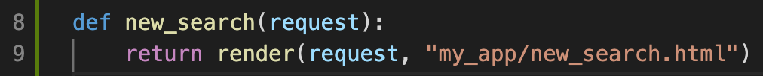

* Add new_search path in <app_name>/urls.py

* Add code to templates/<app_name>/new_search.html

**Create web scraping functionaility:**

* Edit <app_name>/views.py
* Edit new_search function
* Edit templates/<app_name>/new_search.html

**Push to git:**

* $ git add .
* $ git commit -m "<comment>"
* $ git push origin master