**Hardware:**

|  |  |  |  |  |
| --- | --- | --- | --- | --- |
| **System:** | MD1_CTM [DS] |  | **Vehicle identity number:** | LETEDEE11MH052641 |
| **ECU variant:** | MD1CS089 |  | **Type of vehicle:** | JIE |
| **Fuel Type:** | Diesel |  | **Mileage:** | 22923 |
| **Software project and version:** | P2266_MD1CS089_RT99_CN6b_V400T9_D507 |  | **Gearbox:** | MT |
| **Accelerator:** |  |  | **Emission standard:** | CN6 |
|  |  |  | **ECU identification:** | 1200053257 |

**Software:**

|  |  |
| --- | --- |
| **A2L-File:** | P2266_MD1CS089_RT99_CN6b_V400T9_D507.a2l |
| **Hex- File:** | P2266_MD1CS089_RT99_CN6b_V400T9_debug**.hex** |

Responsible for correctness of data and measurement process:

|  |  |  |  |
| --- | --- | --- | --- |
| Tested By: | Youchenghao | Dept.: | WABT |
| Date: | 2023.03.17 | Signature: | <signature of analyser> |

**Tested functions within the scope of test scale:**

|  |  |  |  |  |
| --- | --- | --- | --- | --- |
| **Function** | **o.k.** | **Delta ECU MST** | **Complete ECU MST** | **EMRT** |
| BOA |  |  |  |  |
| APP_PlausBrk |  |  |  |  |
| BrkNpl_04 |  |  |  |  |
| BrkNpl_05 |  |  |  |  |
| NGS_06 |  |  |  |  |
| Clth_05 |  |  |  |  |

*-> Project specific test cases. May need adaptation for other projects

**1.Preparation before execution of tests**

1. Use ETK ECU to execute the test cases
2. Make sure to get the series intended dataset from EAP(MoniCa Calculated)
3. Change the below values in the hex before flashing the software (with hex-post-treatment). The below values are only for ECUMST execution [excluding MoCMeM_Co]

MoCMem_noMEMChkRst_CW = 85

MoCMem_noMEMChkRstCpl_CW = 170

1. Before executing each test case please make sure that you are clearing the Reset History buffer and DFES number. So that all existing errors can be removed before executing test case.

**Clearing the Reset History buffer: Clearing the DFEC number buffer:**

rba_Reset_rstHistBuf_C = 255 DSMAUX_xClearTrg_C = 255

rba_Reset_rstHistBuf_C = 0 DSMAUX_xClearTrg_C=0

**4. Test Requirements**

Before the execution of the tests, following points needs to be checked with the ECU at the test system:

• APP-sensor signals are detected correctly.

• No limitations are active (the following FIds are not active and set to 1 respectively: FId_CoVehPrpLimErr,FId_EngDemTrqLimErr1,FId_EngDemTrqLimErr2,FId_EngPrtNLimErr).

• Emergency Stop switch installed on the vehicle.

• No error set (error which are not relevant for the execution of the ECU-MST might be calibrated to inactive and could be assigned to the error class 0 with the deactivation of the corresponding inhibit matrix respectively).

• Only INCA.7.0.0 or above version is used for measurements.

• Hex-post treatment (HPT) is performed on the dataset used for testing

• Additional delta MST test cases has to be tested based upon label changed compared to full MST completed dataset. Use impact analysis sheet to decide delta MST testcases.

• Test case repetition is eliminated in new ECU-MST test cases. PA should ensure VAT or EMRT are measured correclty and consistence with single measurement. We recommend to test VAT test cases 2 or 3 times in order to avoid travel to customer site again.

Note: ECU-MST is preferably to be carried out using a C-sample emulation probe (ETK) ECU.

**5. Abbreviations used in this document**

WP -> Working page

RP -> Reference page

VAT -> Vehicle Acceleration Test

HPT -> Hex-Post Treatment

MT -> Manual Transmission

AT -> Automatic Transmission

EMRT -> ECU Monitoring Error Reaction

# APP_PL_BR_1 – Brake Override Accelerator

|  |  |  |
| --- | --- | --- |
| ***Name of the measuring template*** ***Version-Nr.*** 001 ***from***       ECU-MST | | |
| ***Execution:***   1. Clear error memory through **DSMAUX_xClearTrg_C (0 🡪 255 🡪 0)** 2. Start recording 3. Enter initial state 4. Press brake simultaneously (APP still pressed), until Brk_st=3 and hold it for some time (10sec) 5. Check whether DFC_APPPlausBrk is set | | ***Initial state:***   * 1st gear, * Vehicle speed VehV_v > = 12 km/h (APP_vLim_C) * APP_r >=20% * Engine speed Epm_nEng > 1200rpm (APP_nLim_C) * Warm engine > 25℃ |
| ***Data changes:***  None | | ***Hardware changes:***  none |
| ***Fault detection:***   * Brk_stMn=1, Brk_stRed = 1 * Brk_st=3 * APP_bPlaBrk = 1 * APP_rUnFlt > 0% * APP_r = 0% | | |
| ***Result:***  DFC_APPPlausBrk is set | | ***Criterion:***  EMRT <= 1000ms |
| ***Comments:***  EMRT = T1 – T2  T1 = APP_r = 20% and Brake pressed Brk_st=3  T2 = APP_bPlaBrk = 1 and APP_r = 0% | |
| ***Error time:*** | 454.78ms | ***Evaluation:*** Pass  Fail |
| ***Name of the measuring file:*** 1APP_PL_BR_1 – Brake Override Accelerator | | |
| ***Note :*** | | |

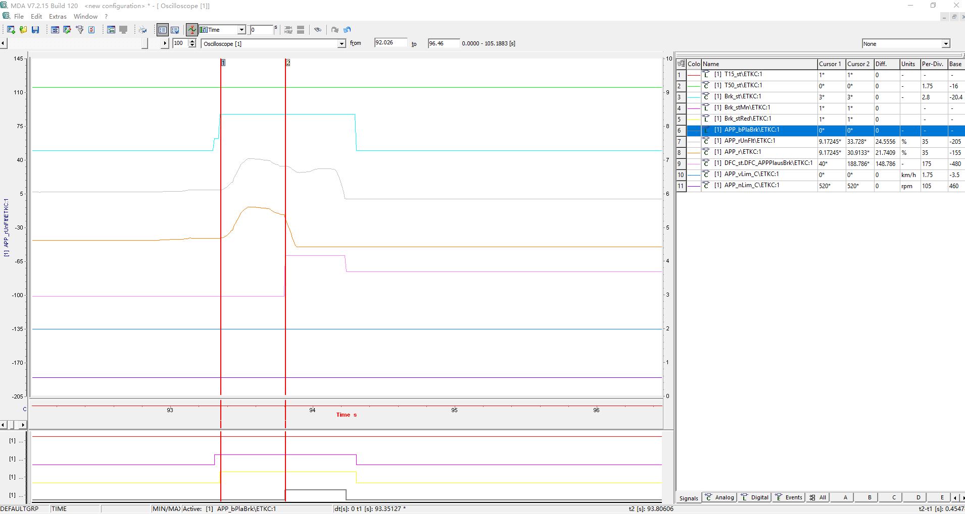

# Brk_04 – Main Brake Plausibility Check (DIO)

|  |  |  |
| --- | --- | --- |
| ***Name of the measuring template:***       ***Version-Nr.*** 001 ***from***       ECU-MST | | |
| ***Execution:***   1. Clear error memory through **DSMAUX_xClearTrg_C (0 🡪 255 🡪 0)** 2. Set vehicle to initial state 3. Start recording 4. Press brake then trigger error by data changes 5. Release brake | | ***Initial state:***  0th gear,  Idle Engine speed (Epm_nEng 600-800) Tra_numGear = 0 |
| ***Data changes:***  ***Make Hi to Lo debounce time MAX:***  Brk_tiMaiSwtDebHiLo_C=MAX (could be different for projects) | | ***Hardware changes:*** |
| ***Fault detection:***   * Brk_stMn=1, Brk_stRed = 0 * DFC_BrkPlausChk will indicate error after debounce time DDRC_DurDeb.Brk_tiPlausChkDebDef_C 取整(或最大值)单位毫秒 * Brk_st will be 1. * Error reactions can be seen (Lamp indication to driver) – Need to check by tester manually | | |
| ***Result:***  DFC_BrkPlausChk is set  DFC_BrkNpl* will not be set | | ***Criterion:***  Detection of error via diagnosis within same driving cycle (latest after 2-3 driving cycles);  Indication to driver via lamp |
| ***Comments:*** | |
| ***Error time:*** | NA | ***Evaluation:*** Pass  Fail |
| ***Name of the measuring file:*** 2Brk_04 – Main Brake Plausibility Check (DIO) | | |
| ***Note :*** | | |

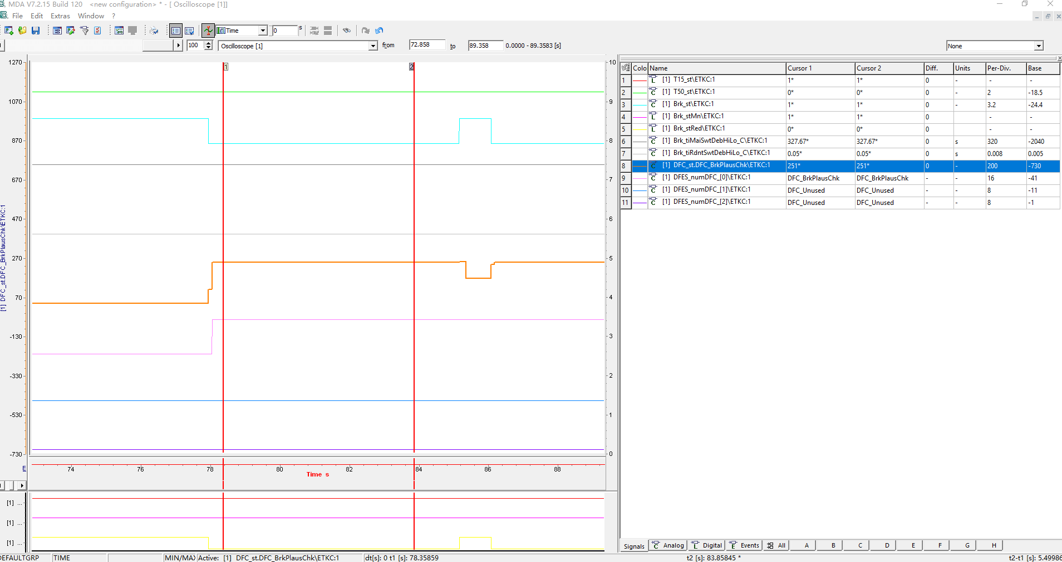

# Brk_05 – Redundant Brake Plausibility Check (DIO)

|  |  |  |
| --- | --- | --- |
| ***Name of the measuring template:***       ***Version-Nr.*** 001 ***from***       ECU-MST | | |
| ***Execution:***   1. Clear error memory through **DSMAUX_xClearTrg_C (0 🡪 255 🡪 0)** 2. Set vehicle to initial state 3. Start recording 4. Press brake then trigger error by data changes 5. Release brake | | ***Initial state:***  0th gear,  Idle Engine speed |
| ***Data changes:***  ***Make Hi to Lo debounce time MAX:***  Brk_tiRdntSwtDebHiLo_C=MAX (could be different for projects) | | ***Hardware changes:*** |
| ***Fault detection:***   * Brk_stMn=0, Brk_stRed = 1 * DFC_BrkPlausChk will indicate error after debounce time DDRC_DurDeb.Brk_tiPlausChkDebDef_C * Brk_st will be 1. * Error reactions can be seen (Lamp indication to driver) – Need to check by tester manually | | |
| ***Result:***  DFC_BrkPlausChk is set  DFC_BrkNpl* will not be set | | ***Criterion:***  Detection of error via diagnosis within same driving cycle (latest after 2-3 driving cycles);  Indication to driver via lamp |
| ***Comments:*** | |
| ***Error time:*** | NA | ***Evaluation:*** Pass  Fail |
| ***Name of the measuring file:*** 3Brk_05 – Redundant Brake Plausibility Check (DIO) | | |
| ***Note :*** | | |

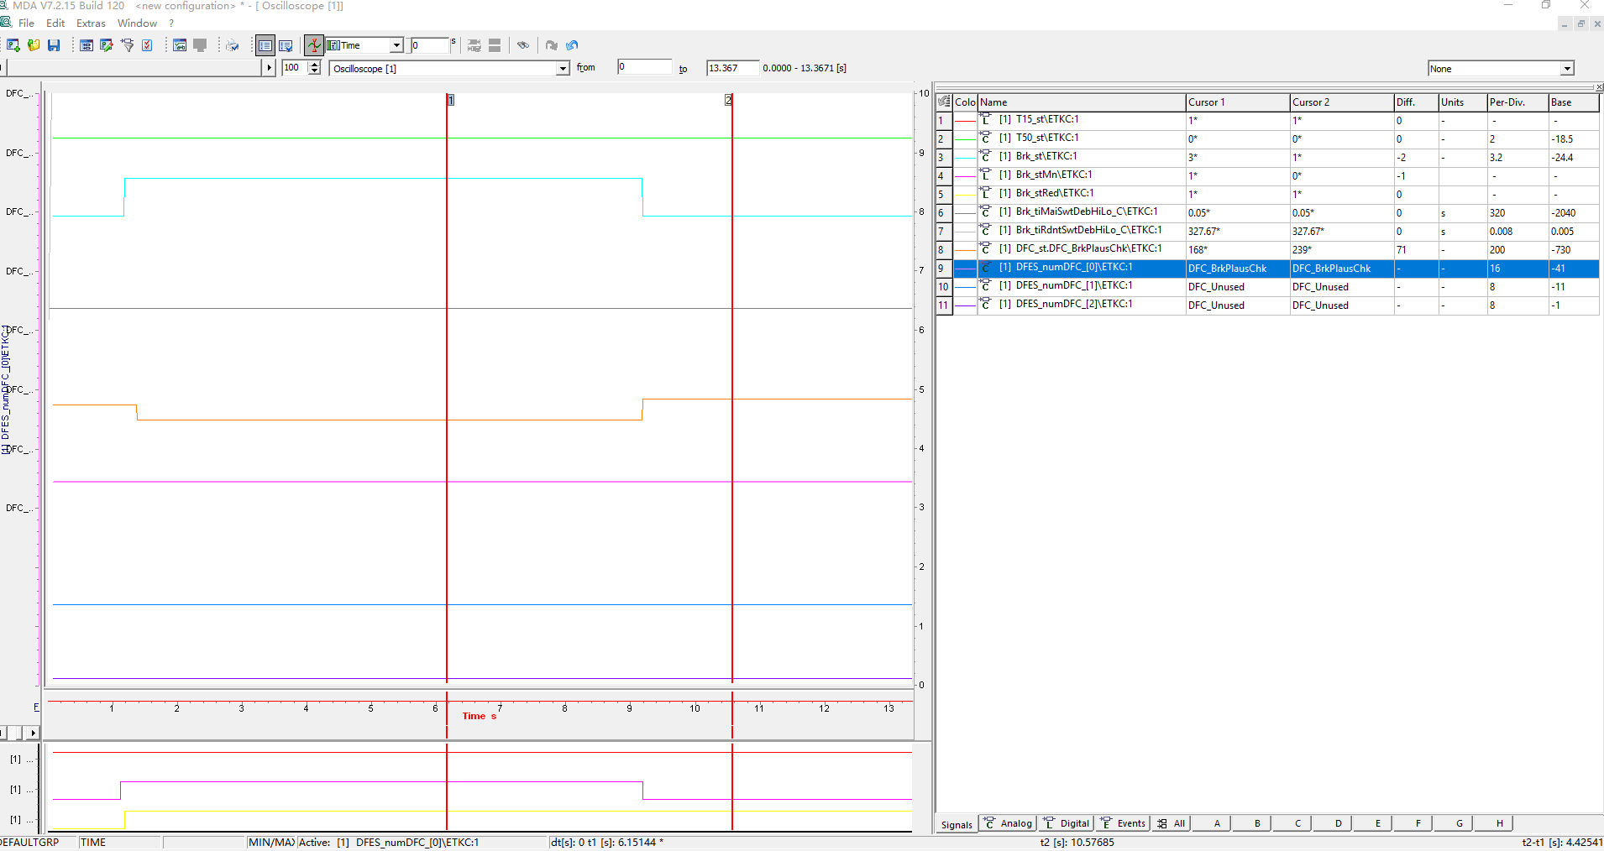

# NGS_06 – Neutral Gear Sensor Plausibility Check (Digital Sensor)

|  |  |  |
| --- | --- | --- |
| ***Name of the measuring template:***       ***Version-Nr.*** 001 ***from***       ECU-MST | | |
| ***Execution:***   1. Clear error memory through **DSMAUX_xClearTrg_C (0 🡪 255 🡪 0)** 2. Change labels on working page and be in Working page 3. Set vehicle to initial state 4. Start recording 5. Press clutch and change the Gear while driving | | ***Initial state:***  Engine Running(CoEng_st)  Vehicle normal driving VehV_v\ETKC > 0 |
| ***Data changes:***  Gbx_NPosDeb.tiLoHi_C = MAX | | ***Hardware changes:***  none |
| ***Fault detection:***   * Gbx_stNPos = 0 and Tra_numGear changes * Gbx_stGearShftDet = 1 * Error reactions can be seen (Lamp indication to driver) – Need to check by tester manually | | |
| ***Result:***  DFC_GbxNPosNpl is SET? | | ***Criterion:***  DFC_GbxNPosNpl is SET and error reaction is seen (Lamp indication to driver) |
| ***Comments:***  Confirmed with customer DFC_GbxNPosNpl is disabled in latest dataset, no need to enable. | |
| ***Error time:*** | NA | ***Evaluation:*** Pass  Fail |
| ***Name of the measuring file:*** 4NGS_06 – Neutral Gear Sensor Plausibility Check (Digital Sensor) | | |
| ***Note :*** | | |

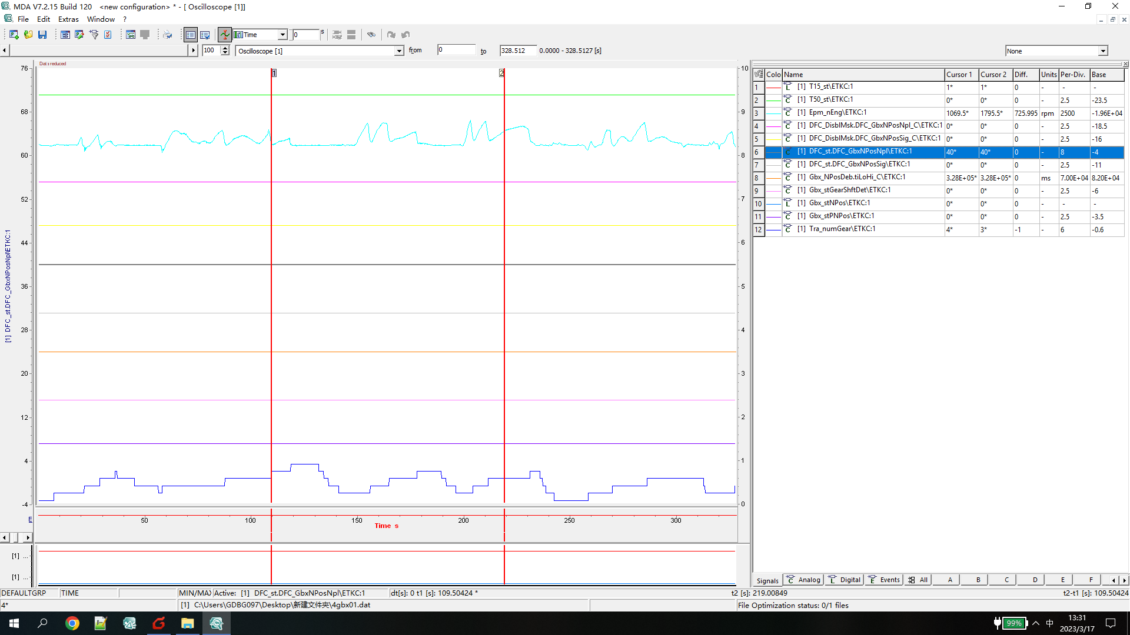

# Clth_05 – Plausibility check of CLTH-stuck (Digital Sensor-Top Clutch)

|  |  |  |
| --- | --- | --- |
| ***Name of the measuring template:***       ***Version-Nr.*** 001 ***from***       ECU-MST | | |
| ***Execution:***   1. Clear error memory through **DSMAUX_xClearTrg_C (0 🡪 255 🡪 0)** 2. Change labels on working page and be in Working page 3. Start recording 4. Enter initial state 5. Shift gear from current to higher by pressing clutch 6. Do the step 5 again and wait for error reported | | ***Initial state:***  (i) Engine Running(CoEng_st)  (ii) vehicle moving |
| ***Data changes:***  Clth_Deb.TimeHighLow_C = MAX  Check for Clth_st.0=1 | | ***Hardware changes:*** |
| ***Fault detection:***   * Clth_st.0=0 * Tra_numGear != Clth_numLastVldGear * Error reactions can be seen (Lamp indication to driver) – Need to check by tester manually | | |
| ***Result:***  DFC_ClthNplOpn is SET  Error reaction is seen.(Lamp indication to driver) | | ***Criterion:*** |
| ***Comments:*** | |
| ***Error time:*** | NA | ***Evaluation:*** Pass  Fail |
| ***Name of the measuring file:*** 5Clth_05 – Plausibility check of CLTH-stuck (Digital Sensor-Top Clutch) | | |
| ***Note :*** | | |

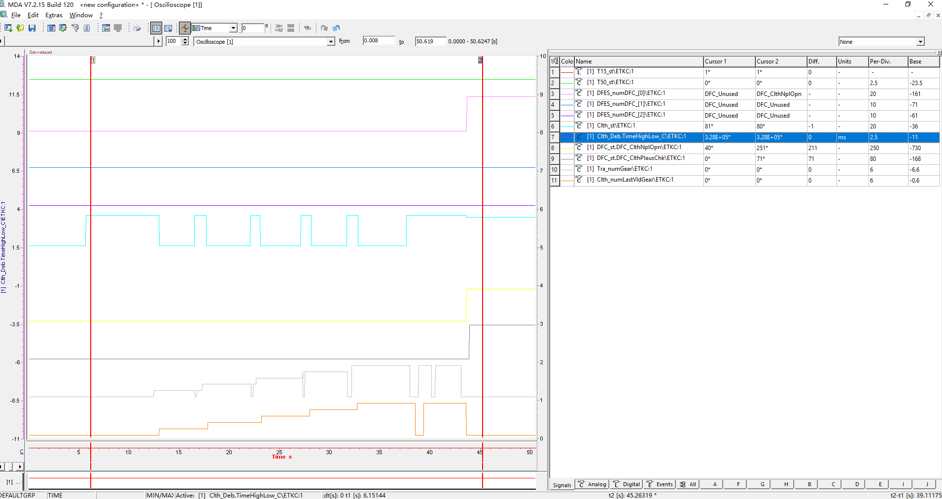

# Clth_06 – Plausibility check of CLTH-stuck (Digital Sensor-Bottom Clutch)

|  |  |  |
| --- | --- | --- |
| ***Name of the measuring template:***       ***Version-Nr.*** 001 ***from***       ECU-MST | | |
| ***Execution:***   1. Clear error memory through **DSMAUX_xClearTrg_C (0 🡪 255 🡪 0)** 2. Change labels on working page and be in Working page 3. Start recording 4. Enter initial state 5. Shift gear from current to higher by pressing clutch 6. Do the step 5 again and wait for error reported | | ***Initial state:***  (i) Engine Running(CoEng_st)  (ii) vehicle moving |
| ***Data changes:***  Clth_AutoStrt.TimeHighLow_C = MAX  Check for Clth_st.0=0 | | ***Hardware changes:*** |
| ***Fault detection:***   * Clth_st.0=0 * Clth_bAutoStrtEnaCond=1 * Tra_numGear != Clth_numLastVldGear * Clth_bClthPlausErr=1 * Error reactions can be seen (Lamp indication to driver) – Need to check by tester manually | | |
| ***Result:***  DFC_ClthPlausChk is SET  Error reaction is seen.(Lamp indication to driver) | | ***Criterion:***  DFC_ClthPlausChk is SET.  Error reaction is seen.(Lamp indication to driver) |
| ***Comments:*** | |
| ***Error time:*** | NA | ***Evaluation:*** Pass  Fail |
| ***Name of the measuring file:*** 6Clth_06 – Plausibility check of CLTH-stuck (Digital Sensor-Bottom Clutch) | | |
| ***Note :*** | | |

