Yang Jiao
82222745
Math 131B

1.
- n = 20
> pbinom(10, 20, 0.75)
[1] 0.01386442
> pbinom(11, 20, 0.75)
[1] 0.04092517
> pbinom(12, 20, 0.75)
[1] 0.1018119

Thus, c= 11 is our best estimate.

b)
> n = 20
> c = 11
> pbinom(c, n, 0.7)
[1] 0.1133315
> pbinom(c, n, 0.65)
[1] 0.2376224
> pbinom(c, n, 0.5)
[1] 0.7482777
> pbinom(c, n, 0.25)
[1] 0.9990646
> pbinom(c, n, 0.1)
[1] 0.9999999

Thus, with the success probability p decreases, the power of my test increases. It makes sense. Because given the null hypothesis is actually true, the probability of rejecting the null hypothesis, increased when null hypothesis increases. And the power p approaches to 1.

c)

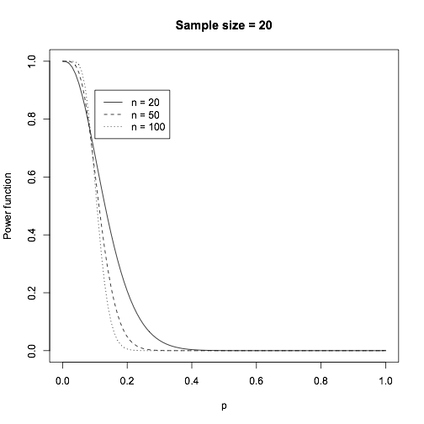

At region where 0 < c < 0.75, as sample size increases, the power increases.

2.
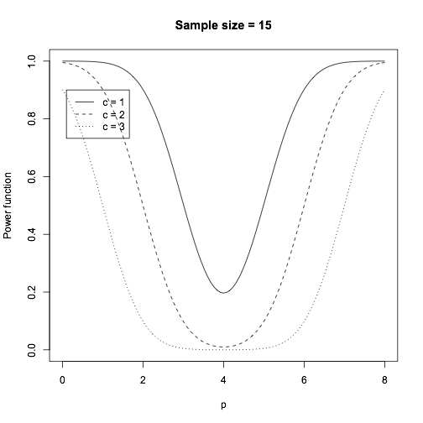

3.
a)
> t.test(ht2~sex, var.equal = TRUE, mu = 0, alternative = "two.sided")

Two Sample t-test

data: ht2 by sex
t = -1.0709, df = 56, p-value = 0.2888
alternative hypothesis: true difference in means is not equal to 0
95 percent confidence interval:
-2.6822985 0.8135485
sample estimates:
mean in group Female mean in group Male
87.46563 88.40000

> Male = var(ht2[sex == "Male"])
> Female = var(ht2[sex == "Female"])
> Male
[1] 9.2168
> Female
[1] 12.29588

Since p-value = 0.2888, we fail to reject the null hypothesis. We conclude there is no significant evidence that the mean height at age 2 differs from males and females.

b)
> sqrt(var(ht2))
[1] 3.308988
>
> power.t.test(n=NULL, delta=1, sd=3.3, sig.level=0.05, power=0.5)

Two-sample t test power calculation

n = 84.63654
delta = 1
sd = 3.3
sig.level = 0.05
power = 0.5
alternative = two.sided

NOTE: n is number in *each* group

We make assumptions that standard deviation of heights at age 2 is 3.3. Then we come to our conclusion that the n should be 85.

c)

> power.t.test(n=NULL, delta=1, sd=3.3, sig.level=0.05, power=0.8)

Two-sample t test power calculation

n = 171.9143
delta = 1
sd = 3.3
sig.level = 0.05
power = 0.8
alternative = two.sided

NOTE: n is number in *each* group

> power.t.test(n=NULL, delta=1, sd=3.3, sig.level=0.05, power=0.95)

Two-sample t test power calculation

n = 283.9888
delta = 1
sd = 3.3
sig.level = 0.05
power = 0.95
alternative = two.sided

NOTE: n is number in *each* group

For n = 0.8 and 0.95, assuming a true difference of 1cm. The required sample size gets larger and larger as desired power increases.

d)
> power.t.test(n=NULL, delta=2, sd=3.3, sig.level=0.05, power=0.5)

Two-sample t test power calculation

n = 21.91338
delta = 2
sd = 3.3
sig.level = 0.05
power = 0.5
alternative = two.sided

NOTE: n is number in *each* group

> power.t.test(n=NULL, delta=2, sd=3.3, sig.level=0.05, power=0.8)

Two-sample t test power calculation

n = 43.71858
delta = 2
sd = 3.3
sig.level = 0.05
power = 0.8
alternative = two.sided

NOTE: n is number in *each* group

> power.t.test(n=NULL, delta=2, sd=3.3, sig.level=0.05, power=0.95)

Two-sample t test power calculation

n = 71.7311
delta = 2
sd = 3.3
sig.level = 0.05
power = 0.95
alternative = two.sided

NOTE: n is number in *each* group

Compared to b) and c), where the true difference was 1cm, the required sample size decrease.

