Yang Jiao
82222745
Math 105B
HW #7

This homework require us to Implement the Householder’s method and the QR method using Matlab for a given matrix A and test the code for 2(a, d) in 9.4 and 4(c, d) in 9.5.
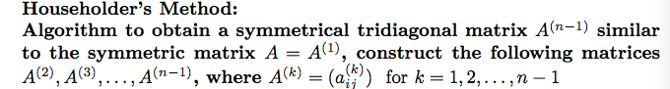
By applying the Householder’s method, we got 2(a)’s tridiagnal matrix to be this Tri1:
Tri1 =

4.0000 1.4142 0 0
1.4142 4.0000 1.0000 0
0 1.0000 2.0000 1.4142
0 0 1.4142 3.0000

By applying the Householder’s method, we got 2(d)’s tridiagnal matrix to be this Tri1:

Tri2 =

2.0000 1.4142 0 0 0
1.4142 3.5000 0.4523 0 0
0 0.4523 2.1364 3.2746 0
0 0 3.2746 7.0295 0.1733
0 0 0 0.1733 5.8540



By applying the QR method, we got 4(c)’s tridiagnal matrix to be this result3:
result3 =

4.4142 3.0000 1.5858

message3 =

''
Then we can check this by finding the eigenvalue of 4(c)’s tridiagnal matrix A3:
>> eig(A3)

ans =

1.5858
3.0000
4.4142

By applying the QR method, we got 4(c)’s tridiagnal matrix to be this result4:
result4 =

4.0274 3.7276 2.0707 5.7840 0.8903

message3 =

''

Then we can check this result by finding the eigenvalue of 4(c)’s tridiagnal matrix A4:
>> eig(A4)

ans =

0.8903
2.0707
3.7276
4.0274
5.7840

