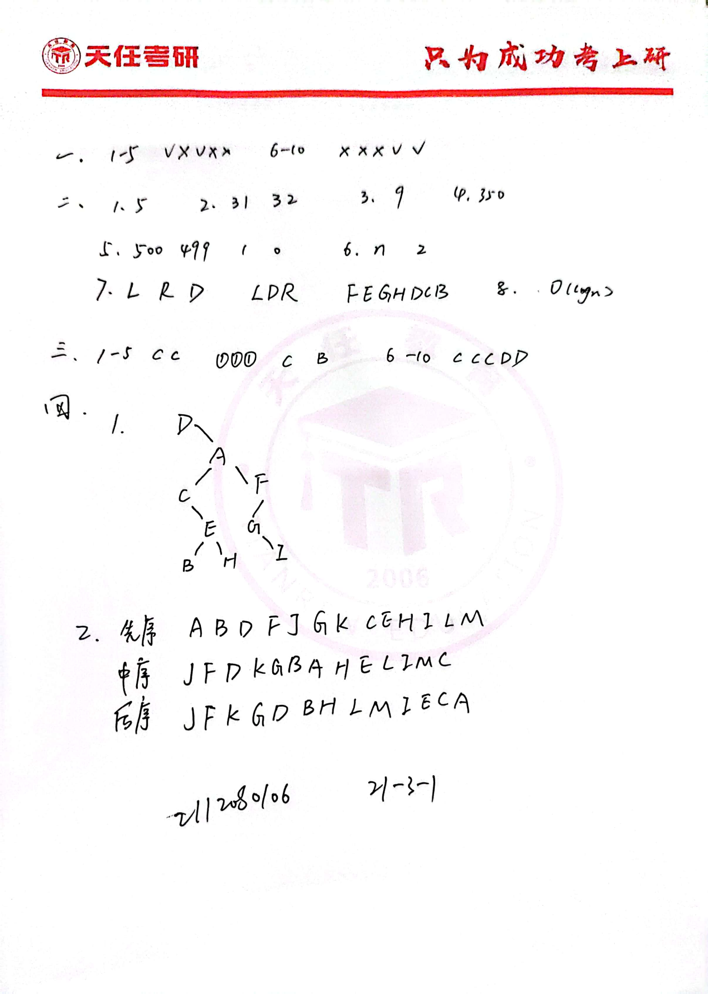

五

1、编写递归算法，计算二叉树中叶子结点的个数

int countLeaves(Node* root) {

if (root == nullptr) {

return 0;

} else if (root->left == nullptr && root->right == nullptr) {

return 1;

} else {

return countLeaves(root->left) + countLeaves(root->right);

}

}

2、写出求二叉树深度的算法

int maxDepth(Node* root) {

if (root == nullptr) {

return 0;

}

else {

int left_height = maxDepth(root->left);

int right_height = maxDepth(root->right);

return max(left_height, right_height) + 1;

}

}