# 打包资源（Res Package）

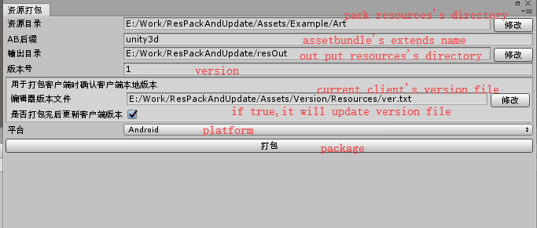

1.资源目录：点击修改按钮，打开你需要打包的资源文件夹

资源目录：Click the 修改 button to open the resource folder you need to package

1. AB后缀：打包后的资源后缀名

AB后缀：Packaged resource suffix name

1. 输出目录：打包后的assetbundle的目标文件夹

输出目录：Target folder of packaged AssetBundle

1. 版本号：打包的资源对应的资源版本号

版本号：The resource version number corresponding to the packaged resource

1. 编辑器版本文件：当前客户端的版本号文件，用以确认当前客户端的版本号

编辑器版本文件：The version file of the current client to confirm the version number of the current client

1. 是否打包完后更新客户端版本：如果版本文件不为空，则自动更新unity项目的版本文件

是否打包完后更新客户端版本：If the version file is not empty, the version file of the unit project is automatically updated

1. 平台：打包对应的运行平台，仅支持Android和iOS

平台：Packing the corresponding platform, only supporting Android and iOS

1. 打包：package

# 资源放到资源服务器（Submit Resource Server）

1. 假如你是开发阶段且没有自己的服务器，那么你可以下载Nginx(http://nginx.org/en/download.html)最新版本的Nginx,然后解压到你喜欢的目录，如：

1.If you are in the development stage and don't have your own server, you can download the latest version of Nginx (http://nginx.org/en/download.html) and extract it to your favorite directory, such as:

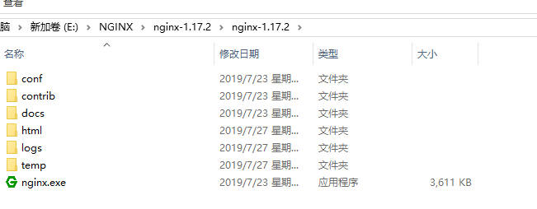

之后执行nginx.exe，那么本地的资源服务器就搭建完成了。Nginx的资源需要上传到html目录。

After executing nginx.exe, the local resource server is set up. Nginx resources need to be uploaded to the HTML directory.

1. 找到刚刚打包的资源压缩包以及ver.txt上传到资源服务器

2.Find the newly packaged resource compression package and upload ver.txt to the resource server

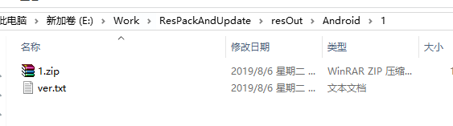

1. 注意：提交的资源需要区分平台目录，如

Note: Submitted resources need to differentiate platform directories，such

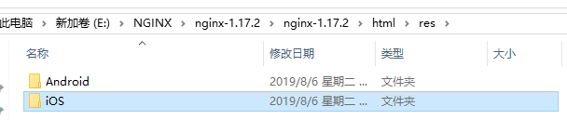

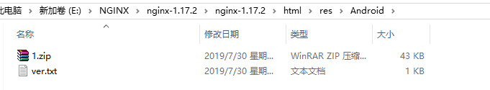

# 3.资源更新（Res Update）

1.VersionMananger.inst.Init(url);

初始化时就会自动执行更新逻辑

Update logic is automatically executed at initialization

2.API



OnVersionPhaseChange:阶段切换回调

OnVersionError：更新出错回调



GetDownLoadProgress:获取下载进度

更多详情可以查看例子：Assets/Test/Test.cs

For more details, see the example: Assets/Test/Test.cs