**INFO 6205**

**Program Structures & Algorithms**

**Summer Full 2018**

**Assignment 4**

1. **Conclusion**

For this assignment, I set the Array_size from 2000000 to 500000, set cutoff/Array_size from 0 to 1. Then for each cutoff of each array, running the program for ten times. Then we will acquire the average running time of those. According to the running result, for my machine, when cutoff/Array_Size is roughly between 0.25~0.5, the parallel sorting will have better performance, and will run less time.

Environment: 2.5 GHZ Intel Core i7, java version 8

1. **Graph of various ordering situations is given below:**

**ArraySize: 2000000**

From picture above, the cutoff/Arraysize is between 0.25~0.5, the running time has better performance.

**Arraysize: 1500000**

From the picture above, the cutoff/array_size is between 0.1 and 0.5, the running time has better performance.

**ArraySize: 1000000**

From the picture, the cutoff/array_size is between 0.25 and 0.5, the running time has better permance.

**ArraySize 500000**

From the picture above, when the cutoff/array_size is between 0.25 and 0.5, the running time has better performance.

1. **Running results**

**Arraysize:2000000**

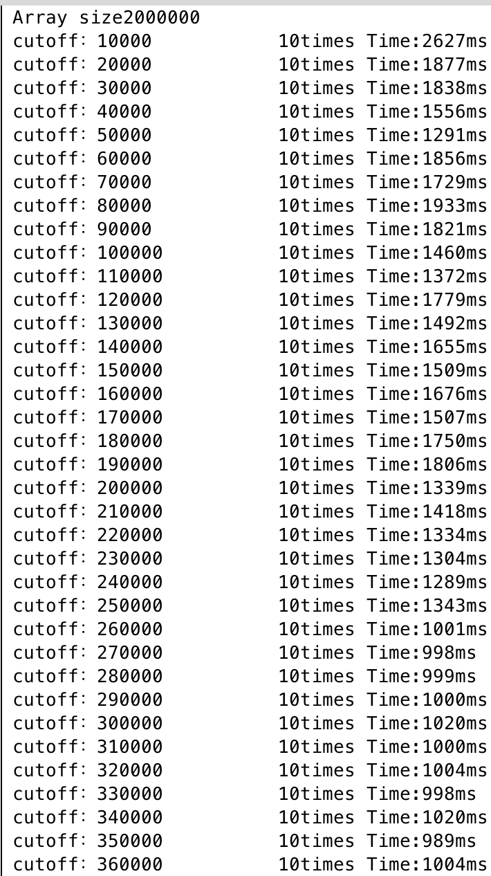 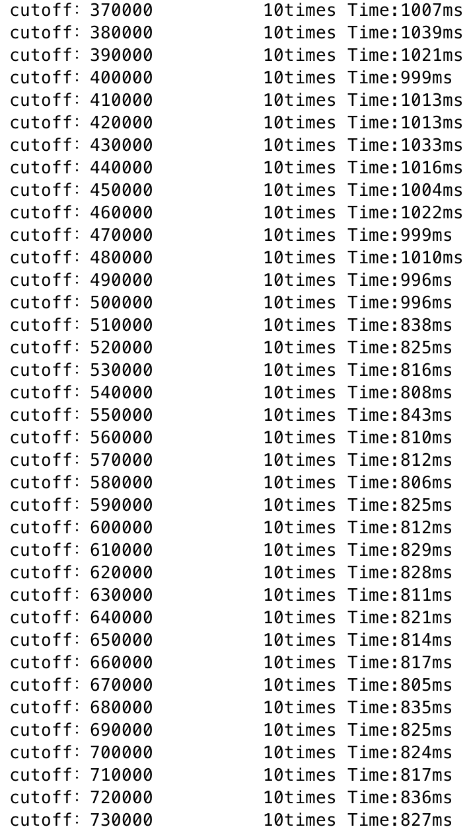 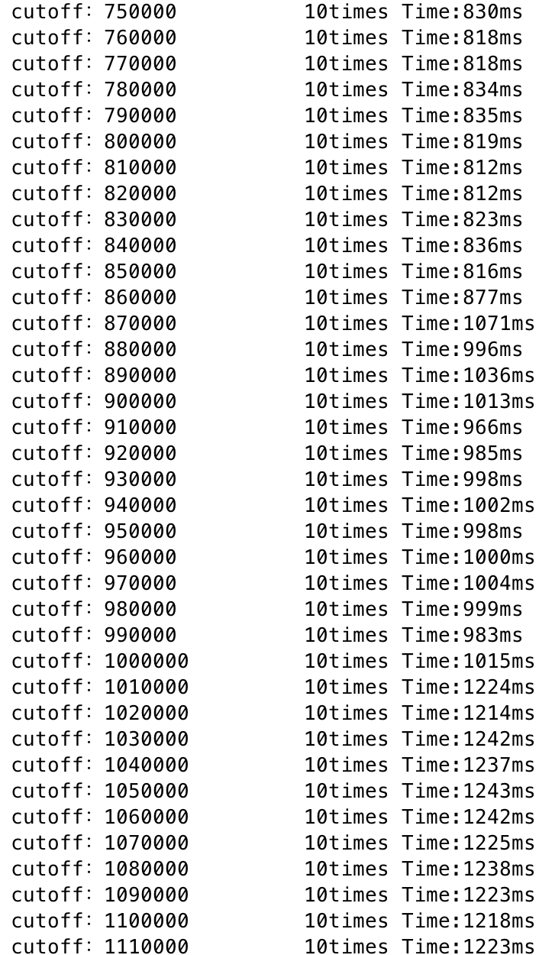

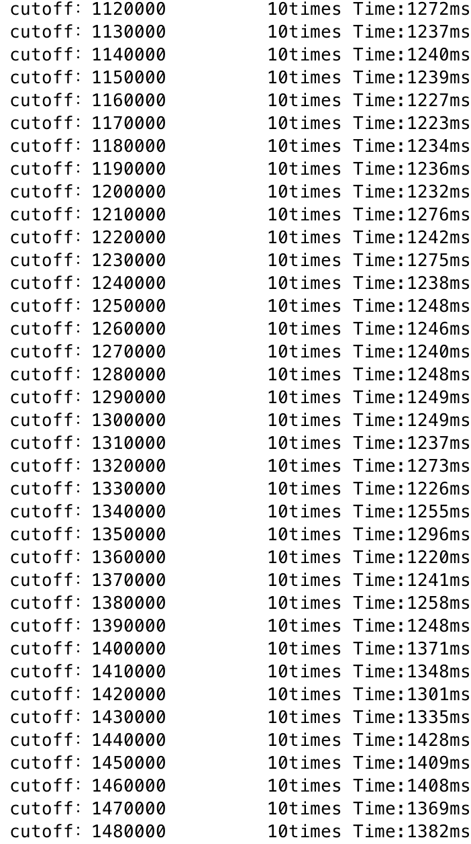 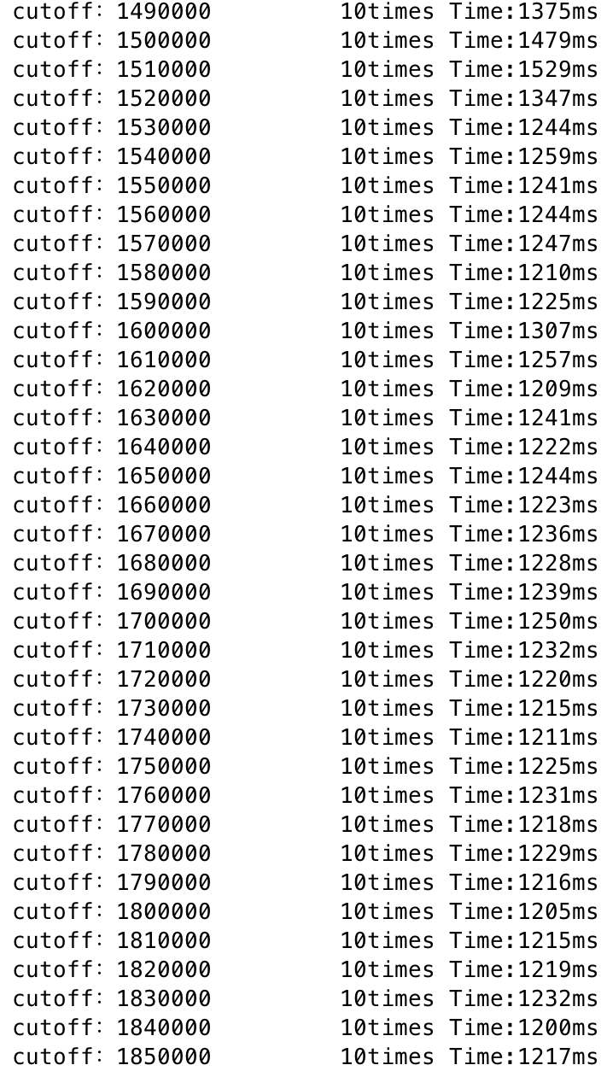 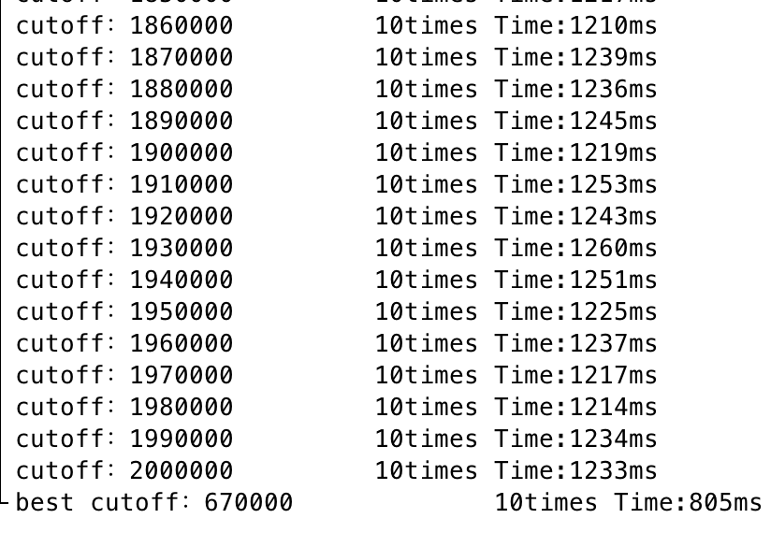

**Arraysize:1500000**

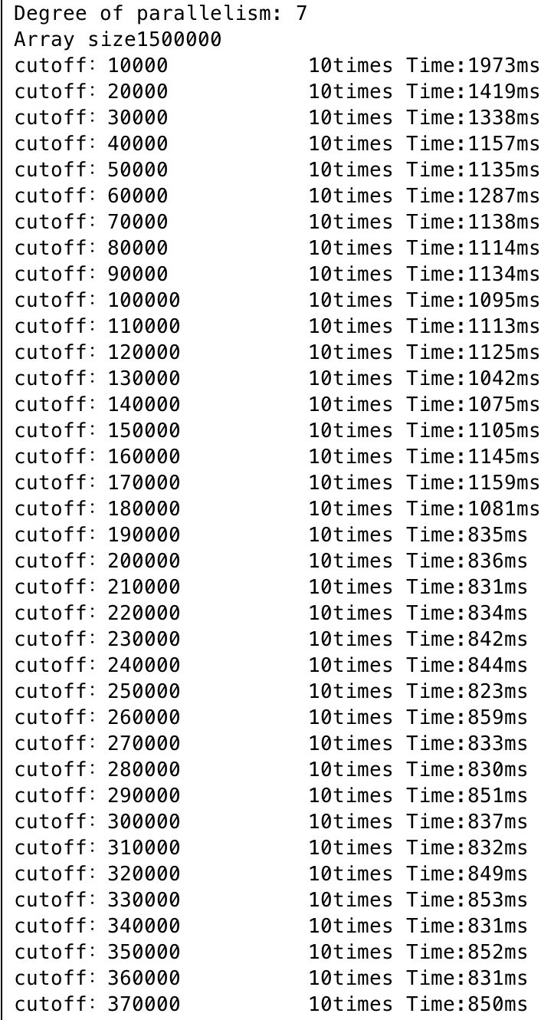 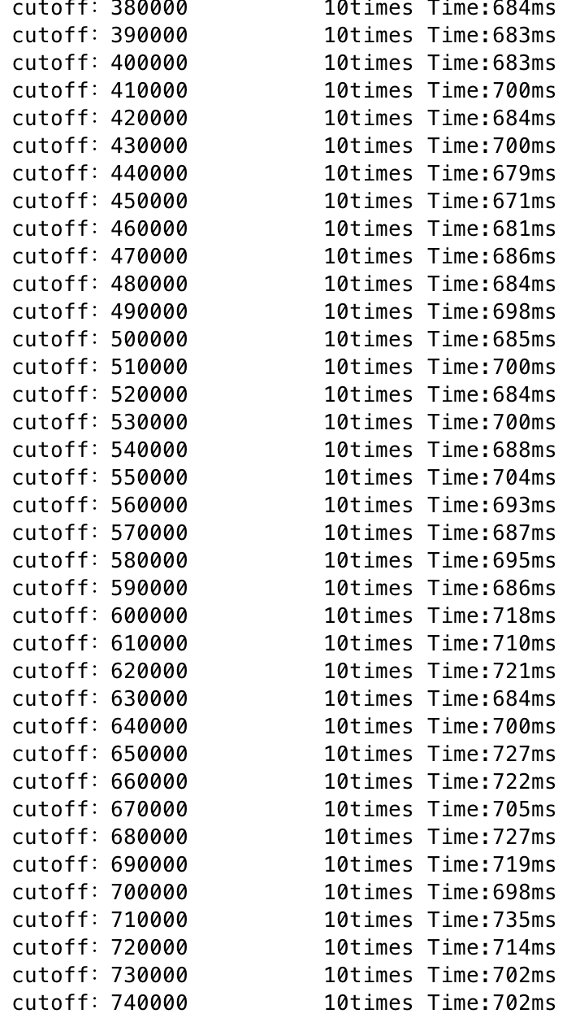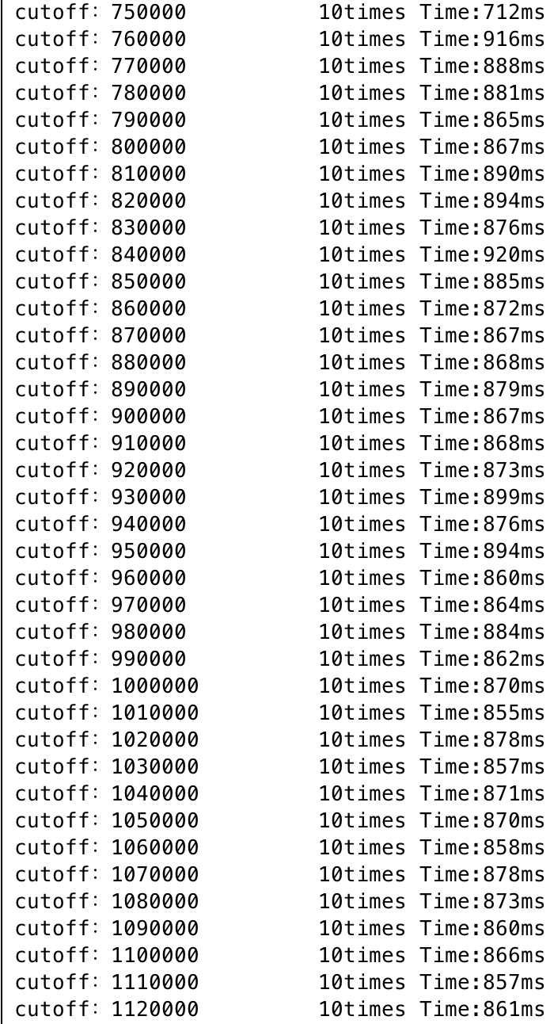 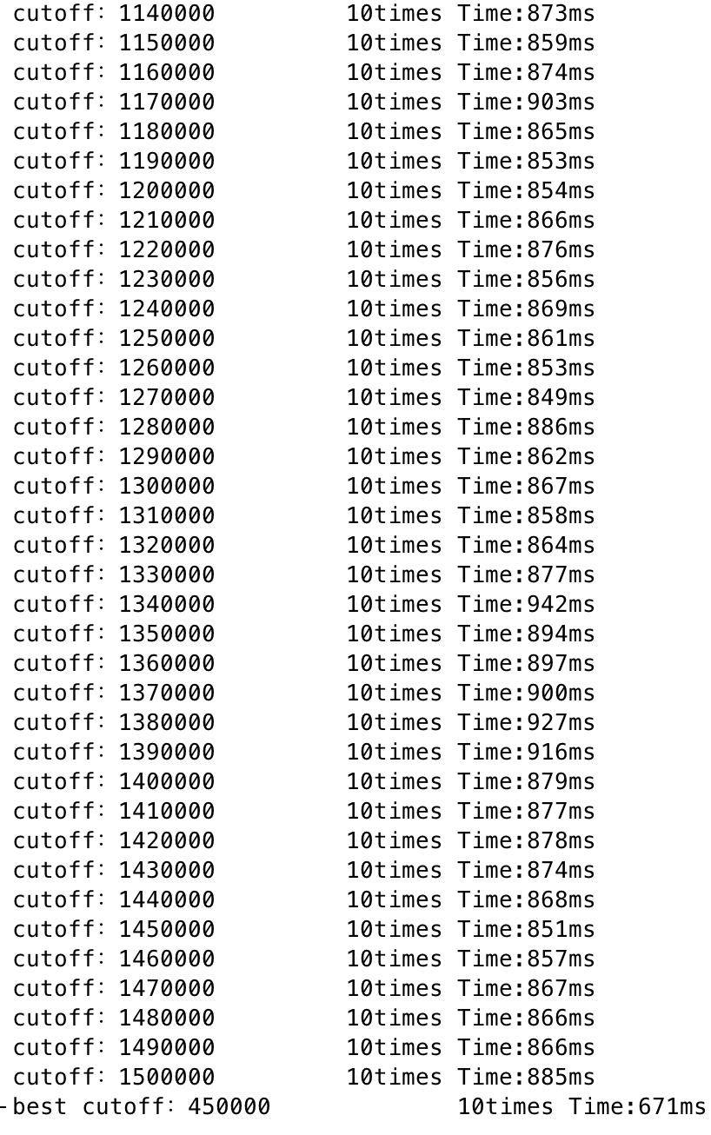

**Arraysize:1000000**

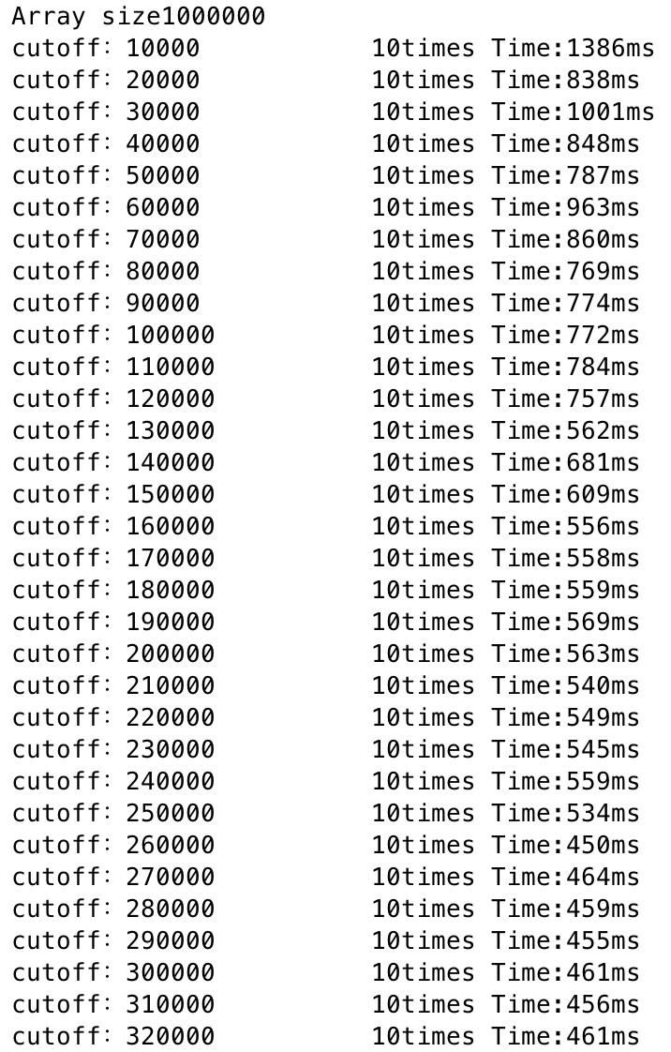 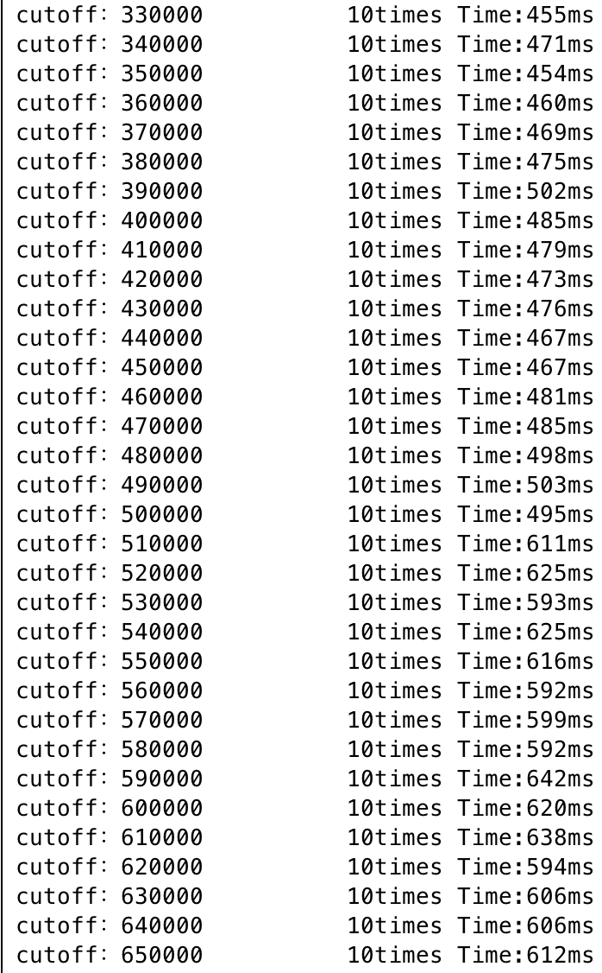 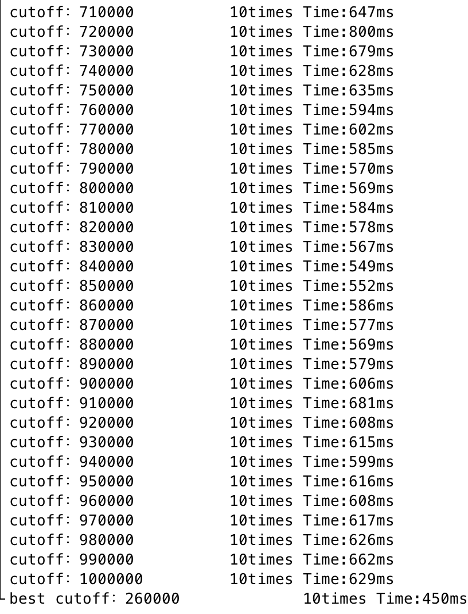

**Arraysize:500000**

