XIQSE Automation Framework Design

# Three main components

## Defs – these are the definitions for specific UI elements (e.g., XPATH, CSS)

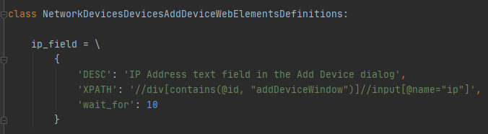

## Elements – these are the “getters” for the UI element definitions

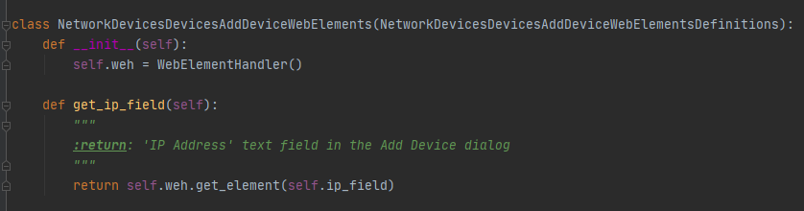

## Flows – these are the keywords which act upon the UI elements

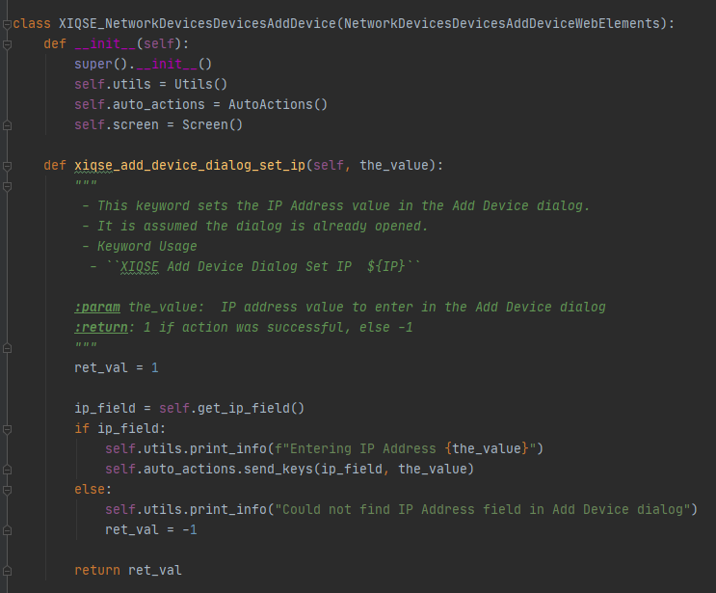

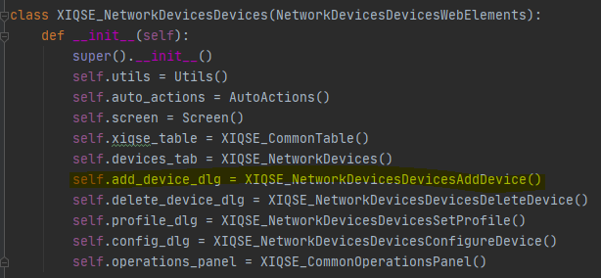

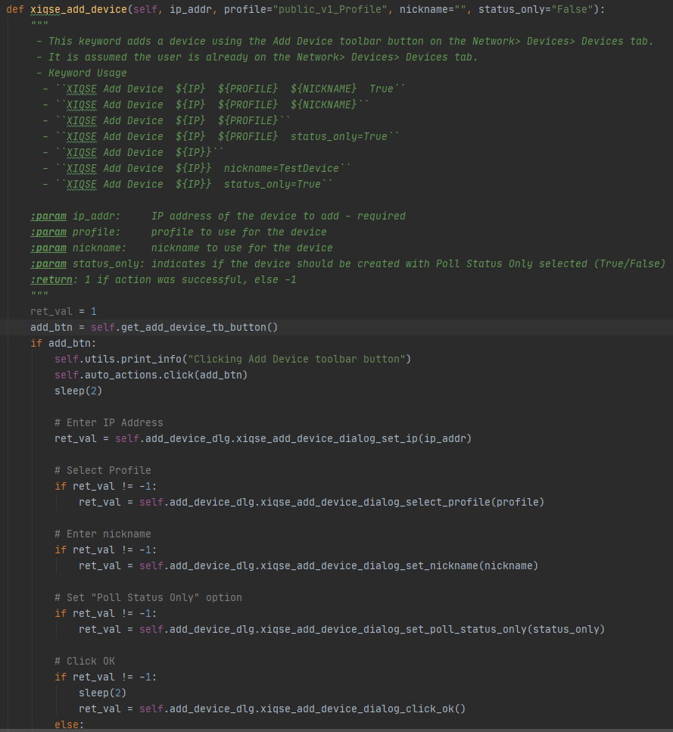

# Design

## Create a separate set of classes (defs/elements/flows) for **each view**

## Place each class in a folder which shows where it lives within the UI, based on tab/view structure

## Dialog classes should simply consist of keywords for setting each individual field and clicking each button – the main view class which brings up that dialog should have the larger keyword(s) for populating the dialog as a whole and clicking the OK button

## Generic example:

* + Tab B is a sub tab of Tab A
  + Tab B contains two toolbar buttons (T1 and T2) and a table
  + Toolbar button T1 brings up a dialog, say T1Action
  + Toolbar button T2 just performs an action without bringing up another view/dialog
  + We want to automate Tab B - clicking the two toolbar buttons, populating the T1Action dialog, and interacting with the table

This would require two sets of files (defs/elements/flows): one set of files for Tab B and another set of files for the T1Action dialog:

* TabA
  + TabB
    - defs
      * TabATabBWebElementsDefinitions
      * TabATabBT1ActionWebElementsDefinitions
    - elements
      * TabATabBWebElements
      * TabATabBT1ActionWebElements
    - flows
      * XIQSE_TabATabB
      * XIQSE_TabATabBT1Action

In this example, clicking the T1 or T2 toolbar buttons, or interacting with the table, would require keywords within XIQSE_TabATabB:

* xiqse_tabb_click_t1()
* xiqse_tabb_click_t2()
* xiqse_tabb_select_row()

The keywords within XIQSE_TabATabBT1Action would simply set the individual fields of the dialog and click the action buttons.

* xiqse_t1action_dialog_set_field_1()
* xiqse_t1action_dialog_set_field_2()
* xiqse_t1action_dialog_set_field_3()
* xiqse_t1action_dialog_click_ok()
* xiqse_t1action_dialog_click_cancel()

XIQSE_TabATabB would create a variable for XIQSE_TabATabBT1Action in its __init__() function and use it to call the keywords to set the fields of the dialog and click OK when the T1 toolbar button is clicked.

* in init:

self.t1action_dlg = XIQSE_TabATabBT1Action()

* in keywords:

self.t1action_dlg.xiqse_t1action_dialog_set_field_1()

self.t1action_dlg.xiqse_t1action_dialog_click_ok()

**This keeps each view separated from the others, allowing smaller, more manageable files.**

## References to specific code examples

### Network>Devices>Devices - Add Device, Set Profile, Configure Devices, etc.

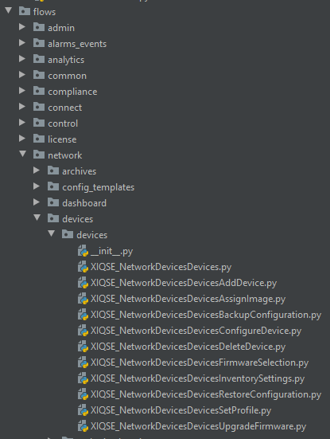

### Admin> Profiles - Add Profile, Delete Profile, Edit Profile, etc.

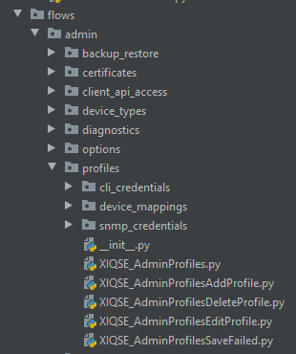

### Admin> Profiles> SNMP Credentials – Add Cred, Delete Cred, etc.

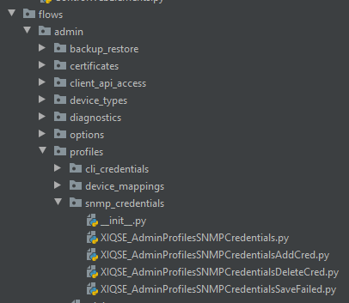

## **Remember**: if a new view is opened, it should have a new class; even if it is a new dialog opened from an existing dialog, just **create a new class for every view**