Phenotype_Data

DavidO

2/23/2017

## R Markdown

"1_QTL_AllFamilies_NoOutlier"

This is QTL phenotypic data for all field plots, before averaging reps. Factors for BLUP: Longitude = plot column. Latitude = plot row. TFamily = F1/inbred/control grouping. Line is alternative name for Genotype. Rep (1 vs 2)

Phenotype Key: SC = stand count, DT = days to tassel, DPS = days to pollen shed, 15NT1 = 15N sample time-point 1, 15NT2 = 15N time-point 2, 15NT3 = 15N time-point 3, AR = aerial root nodes, PDM = plant dry mass, PTN = plant total nitrogen, GDM = grain dry mass, GTN = grain total nitrogen. 15NT_R values can be ignored.

This is an R Markdown document. Markdown is a simple formatting syntax for authoring HTML, PDF, and MS Word documents. For more details on using R Markdown see <http://rmarkdown.rstudio.com>.

When you click the **Knit** button a document will be generated that includes both content as well as the output of any embedded R code chunks within the document. You can embed an R code chunk like this:

summary(cars)

## speed dist   
## Min. : 4.0 Min. : 2.00   
## 1st Qu.:12.0 1st Qu.: 26.00   
## Median :15.0 Median : 36.00   
## Mean :15.4 Mean : 42.98   
## 3rd Qu.:19.0 3rd Qu.: 56.00   
## Max. :25.0 Max. :120.00

## Including Plots

You can also embed plots, for example:

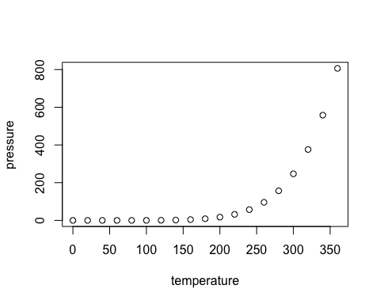

Note that the echo = FALSE parameter was added to the code chunk to prevent printing of the R code that generated the plot.