2019 ICML note

Ju Yang

06/10/2019 - 06/15/2019

Long Beach, CA

Table of Contents

Tutorial: Never-Ending Learning 3

Tutorial: Meta-Learning: from Few-Shot Learning to Rapid Reinforcement Learning 4

Tutorial: Algorithm configuration: learning in the space of algorithm designs 5

Workshop: Automated Machine Learning 6

Grey-box Bayesian Optimization for AutoML @Uber 6

Lessons Learned from Helping 200,000 non-ML experts use ML @fast.ai 7

A Boosting Tree Based AutoML System for Lifelong Machine Learning 8

An Overview of Google's Work on AutoML and Future Directions @Google 8

Towards Semi-Automated Machine Learning @ Google research 10

Panel discussion 10

Workshop: Machine Learning for Music Discovery 11

From Listening to Watching, A Recommender Systems Perspective @Netflix 11

Characterizing Musical Correlates of Large-Scale Discovery Behavior @ Stanford 15

NPR: Neural Personalised Ranking for Song Selection @Apple 15

Personalization at Amazon Music @Amazon 17

A Model-Driven Exploration of Accent Within the Amateur Singing Voice 19

What’s Broken in Music Informatics Research? Three Uncomfortable Statements @Adobe 19

Workshop: Learning and Reasoning with Graph-Structured Representations 19

RL with graph: chemistry and beyond @ Benevolent AI 19

Geometric processing 20

Workshop: Self-supervised learning workshop 21

Supervised learning 21

Data Shapley: Equitable Valuation of Data for Machine Learning 22

Feature Grouping as a Stochastic Regularizer for High-Dimensional Structured Data 22

Metrics optimized example weights 22

Improving Model Selection by Employing the Test Data 22

Clustering 23

Scalable fair clustering @IBM 23

DBSCAN++: Towards fast and scalable density clustering 23

concrete autoencoder 24

Spectral clustering of signed graph 24

Fair k-Center Clustering for Data Summarization 24

Better k-means ++ @Google research 24

Spectral clustering for fairness constraints 25

Supervised hierarchical clustering 25

Learn to route in similarity graph @Yandex 25

Power k-means clustering 25

The Wasserstein Transform 25

Sequential Facility Location: Approximate Submodularity and Greedy Algorithm 26

Neural collaborative subspace clustering 26

Unsupervised deep learning by neighborhood discovery 26

Autoregressive energy machine ARNN @deepmind 26

Noise2Self: Blind Denoising by Self-Supervision 27

Learning Dependency Structures for Weak Supervision Models 27

Applications 27

Exploiting Worker Correlation for Label Aggregation in Crowdsourcing @facebook 27

Efficient Amortised Bayesian Inference for Hierarchical and Nonlinear Dynamical Systems 28

A Multitask Multiple Kernel Learning Algorithm for Survival Analysis with Application to Cancer Biology 28

Fast and Flexible Inference of Joint Distributions from their Marginals 28

Cognitive Model Priors for Predicting Human Decisions 28

Conditioning by adaptive sampling for robust design 28

Direct Uncertainty Prediction for Medical Second Opinions @google brain 29

Dynamic Measurement Scheduling for Event Forecasting Using Deep RL 29

DeepNose: Using artificial neural networks to represent the space of odorants @ cold spring harbor 29

Doubly Robust Joint Learning for Recommendation on Data Missing Not at Random 30

Linear-Complexity Data-Parallel Earth Mover’s Distance Approximations @IBM 30

Model Comparison for Semantic Grouping 30

Rank aware factorization machines @Tencent 30

CAB: Continuous Adaptive Blending Estimator for Policy Evaluation and Learning 31

Time series 31

Generative Adversarial User Model for Reinforcement Learning Based Recommendation System 31

Deep Factors with Gaussian Processes for Forecasting @Amazon AWS 31

Weakly-Supervised Temporal Localization via Occurrence Count Learning 32

Imputing missing events in continuous time event series 32

ML System 32

Fault tolerance in iterative convergent ML @Petuum 32

Static automatic batching in tensorflow @ Google brain 33

Reinforcement learning 33

Control Regularization for Reduced Variance Reinforcement Learning 33

On the Generalization Gap in Reinforcement Learning Reparameterizable @salesforce research 33

RL in internet congestion control 34

model based active exploration MAX @ NNAISENSE 34

inverse RL with ranking 34

Adversarially Learned Representations for Information Obfuscation and Inference 34

adaptive neural tree @microsoft 35

Invited talk 35

Learning @ cognitive science 35

Best paper: challenge assumption in unsupervised learning representation 35

Expo 36

Criteo AI Lab 36

SigOpt 36

Yandex 36

# Tutorial: Never-Ending Learning

* Organization: <http://lifelongml.org/>
* Website: <https://sites.google.com/site/neltutorialicml19/>
* Slides: <https://docs.google.com/viewer?a=v&pid=sites&srcid=ZGVmYXVsdGRvbWFpbnxuZWx0dXRvcmlhbGljbWwxOXxneDo1ZTRhMGQ3OGM5NzI0NjFm>

Content

* Reinforcement learning
* Transfer learning
* Representation learning
* Multi-task learning
* Curriculum learning
* Catastrophic Forgetting

Function learning X -> y

Agent learning: sensor => action, collections of functions

Set of functions, set of reflection

Tuple of sensor, effector, memory, Fns, Graph, L

* Learn to learn
* Unlabeled data
* Initial structure of agent

NELL: never ending learning learner

Structure for agent with unlabeled data

* NLP ontology knowledge graph
* Use deduction for unlabeled data
* Learn concept by its context

Continue to learn, First order constraints

Self-reflection

RL, SOAR：search space

Continue / sequential learning (CL）

* Sequence of tasks, T1, T2,... Tn
* Multi-task from original model (check paper)
  + Fine tuning
  + Feature
  + Joint training
* Without forgetting
* Constraint regularization
  + L2 too rigid
  + Elastic weight consolidation EWC

External knowledge (use and update)

* Memory + knowledge graph
* Memory network
  + End2end
* KG
  + Dense representation in vector space
  + KG embedding of triplet
  + KG for doc classification [NAACL 2018]
  + Use external knowledge for NLP learning

Representation learning in NLP

* States, and sequence
* Word embedding
* Word2vec, self-attention BERT ⇒ check it out

Learning to learn by gradient descent by gradient descent

<https://arxiv.org/abs/1606.04474>

curriculum -driven learning Bengio

* What is curriculum: sequence of tasks

Curiosity-driven Learning

* Predict reward of action

# Tutorial: Meta-Learning: from Few-Shot Learning to Rapid Reinforcement Learning

* Slides: <https://drive.google.com/file/d/1DuHyotdwEAEhmuHQWwRosdiVBVGm8uYx/view?usp=sharing>
* Additional reading:
  + <https://towardsdatascience.com/advances-in-few-shot-learning-a-guided-tour-36bc10a68b77>
  + <https://zhuanlan.zhihu.com/p/61215293>

Definition:

Meta-learning application in supervised learning ⇒ few shot learning

No large dataset, few samples for each class

Black-box adaption

* Output some parameters of the network

Meta learning v.s. Learn to learn

Infer all parameters (without training it) in a scalable way?

* Fine tune
* Optimization-based inference
* Meta-parameter???
  + Second order optimization problem
* Optimization v.s. Black-box adaption
* Bayesian graph task-specific parameters

meta-RL challenge

* Meta overfitting
  + Define task distribution
  + Too few tasks
* Memorization
  + Learn single classifier that doesn’t adapt
  + Generalize and learn fast about new objects
  + Initiate NN architecture, and generalize fast

Online meta-learning ICML 19’

<https://arxiv.org/abs/1902.08438>

# Tutorial: Algorithm configuration: learning in the space of algorithm designs

* Slides: <http://ml.informatik.uni-freiburg.de/~hutter/ICML19_AC.pdf>

Design Algo as ML problem

* View TSP/combinatory etc algo as ML
* Build problem solver (local search algo)
* Meta-algo: take other algos as input
* Objective
  + Run time
  + Black-box opto
  + Hyperparameter opto
* Uncertainty estimate from the regression model
* High variation run-time across algo
* SMAC (bayesian opto)

# Workshop: Automated Machine Learning

* Website: <https://sites.google.com/view/automl2019icml/>
* Book: <https://www.springer.com/gp/book/9783030053178>
* Organization: <https://www.automl.org/events/>

## Grey-box Bayesian Optimization for AutoML @Uber

Peter Frazier

[https://icml.cc/Conferences/2019/AcceptedWorkshopFAQ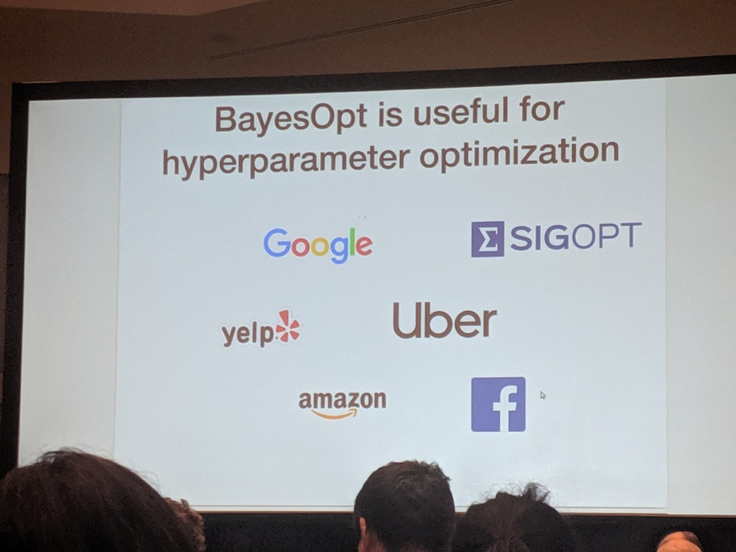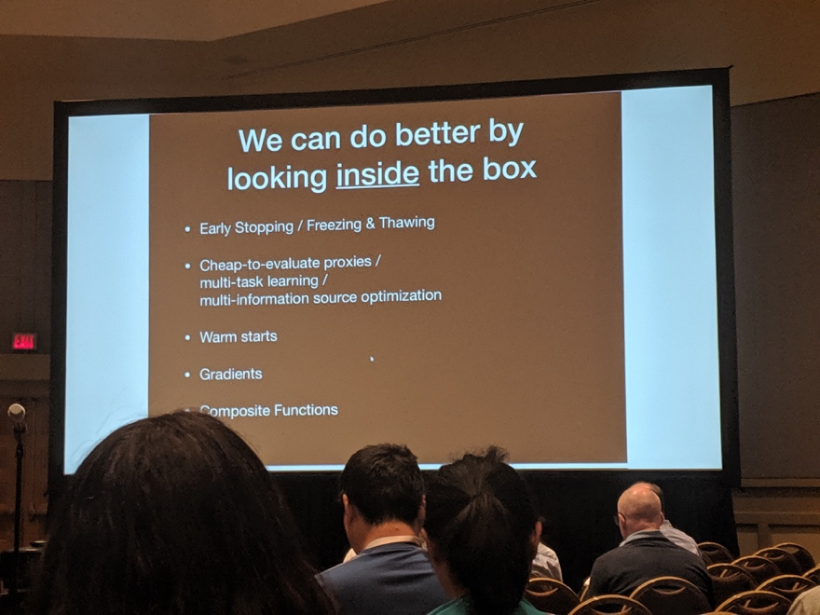](https://icml.cc/Conferences/2019/AcceptedWorkshopFAQ)

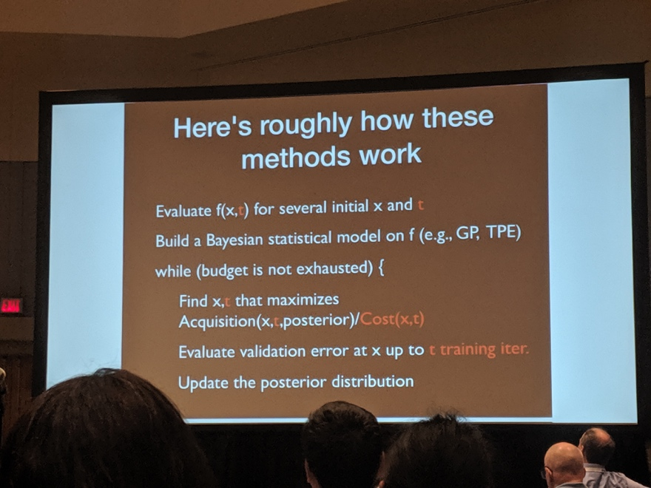

* BayesOpt in blackbox
* Classical bayesian opto: EGO
* Points evaluated
* 2012 use BO for hyperparameter tuning
  + In NN hyperparemter
  + NN architecture
  + Widely used
* Blackbox ⇒ greybox
  + Better by looking inside the box
  + Early stopping / freezing, thawing
  + Multi-task learning
  + Warm starts
  + Gradients (leverage)
* Epochs and learning curve from training
  + Model the learning curve directly
  + Such that not to perform whole evaluation
* Hyperband
  + Stop poor evaluations
* Combine BO with early stopping: active research
  + Based on training???
  + BO means Bayesian optimal stopping 2019 ICML
* Cheap eval proxies
  + Multi-task BO
  + GP bandit
* GREY BOX
  + f(x,t)
  + t: training iteration
  + Search in both acquisition of x, and t, and cost
* Inference based on learning curve
  + Tweak EI acq function
* Look into the blackbox to improve BO performance

## Lessons Learned from Helping 200,000 non-ML experts use ML @fast.ai

Rachel Thomas

* Making nn uncool again
* Fastai libracy -> pytorch
* Use DL in application
* Productionalize / monitor the work
* ML: the high interest credit card of technical debt
  + <https://ai.google/research/pubs/pub43146>
  + <https://storage.googleapis.com/pub-tools-public-publication-data/pdf/43146.pdf>
* Learning rate finder
* Transfer learning ⇒ applied to NLP tasks / image
  + With smaller dataset
* Courses
  + <https://course.fast.ai/>
  + Test applications for my own side projects
* Start with problem and people, and then search for solutions

## A Boosting Tree Based AutoML System for Lifelong Machine Learning

* Neurips 2018 automl challenge
* High cardinality features
  + Streaming encoder
  + TF: Frequency encoding (probability)
  + Ordinal representation
* High order feature combo
* Feature selection
  + Expansion-reduction
* Concept drift
* Hyper-Opto
  + Portfolio search + BO in local search space
  + Search with warm start

## An Overview of Google's Work on AutoML and Future Directions @Google

Jeff Dean

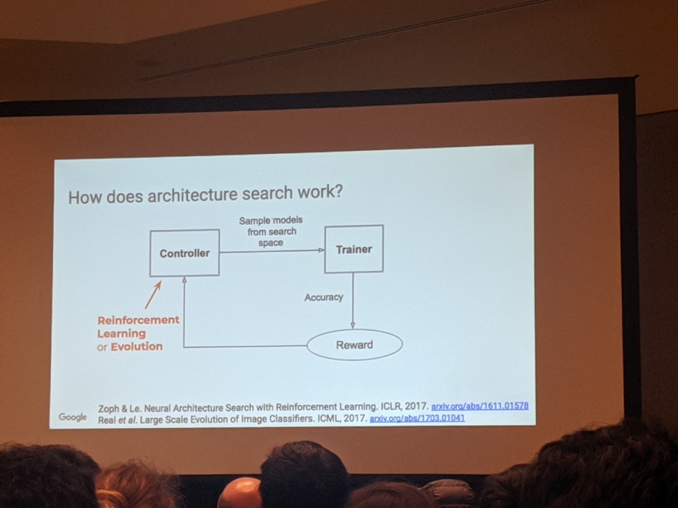

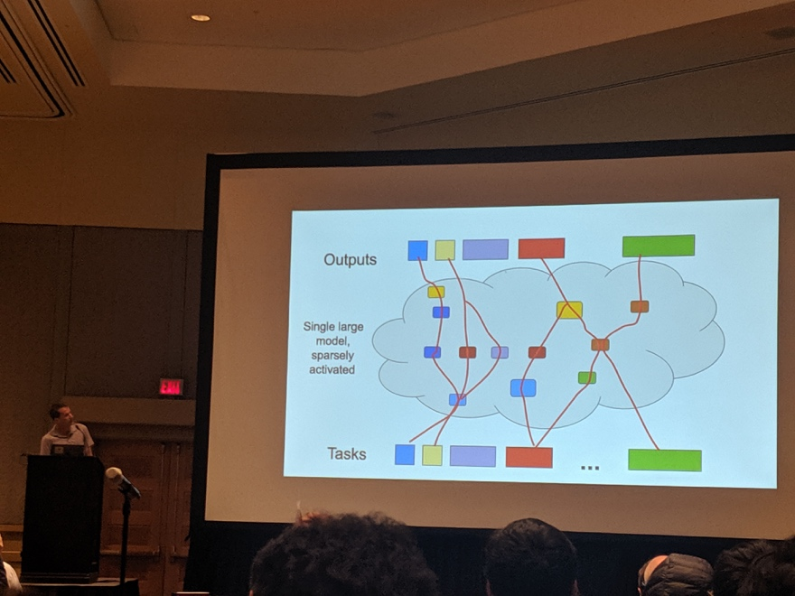

* 20 yrs in google, mapreduce, tensorflow
* Design choices ⇒ fully automated
* autoML on tabular data at Google
* Architecture search
* Activation function search
* autoRL
* Current autoML
  + Data + compute
  + Cons: cold start, no prior knowledge
  + Solutions: transfer learning / meta-learning / multi-task learning
* Future
  + Bigger model, sparsely activated
    - Per-example routing
    - MoE layer
  + Single model to solve multiple tasks
    - Generalize
  + Dynamically learn / grow pathways
    - Pathway search
  + Model architecture adapt
  + New tasks use existing skills
* Problems
  + Catastrophic forgetting
  + Balance obj across tasks
  + Dynamic routing of experts
  + large-scale/dynamic modeling ← software / hardware
  + Meta-level capacity control

## Towards Semi-Automated Machine Learning @ Google research

Charles Sutton

* Automl is more than just models
  + At the system level, only a very small piece is ML
* Semi-AutoML
  + AI assistant
  + Design issues
* Data base/data mining/programming
* AIDA
  + AI for data analytics
  + Transformation / integration
    - Parse csv

## Panel discussion

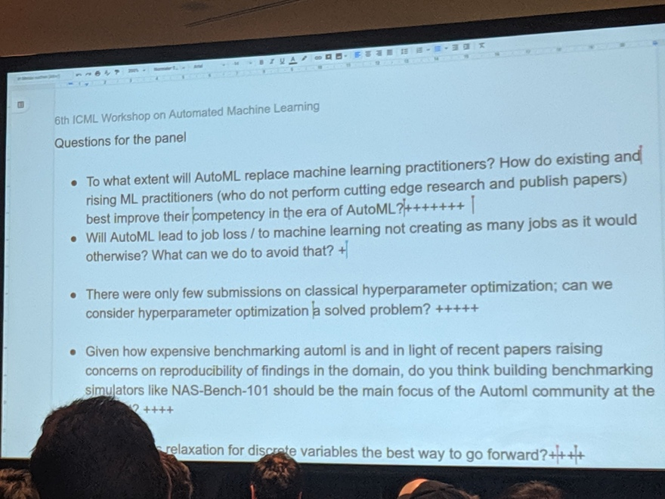

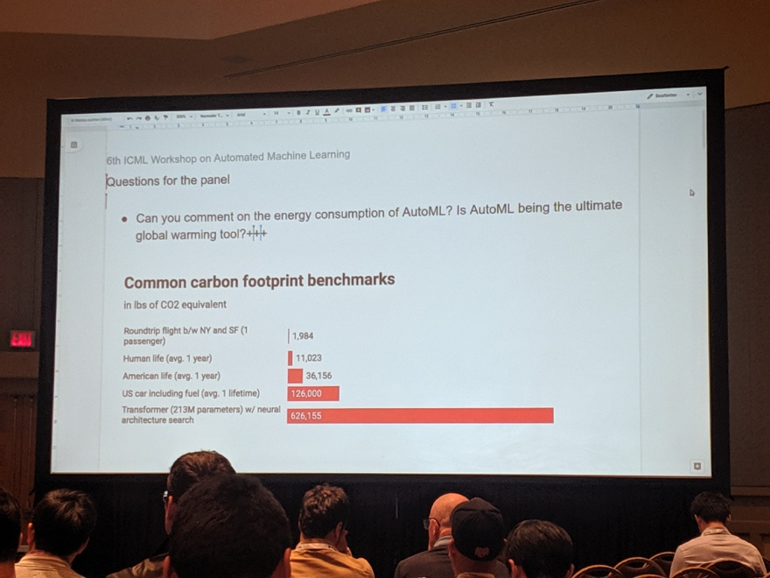

* AutoML, machine learning practitioner, and job at risk
* Deep AutoML and energy consumption
* Classical hyperperamter search (grid, random, etc) v.s. Bayesian-based approach

# Workshop: Machine Learning for Music Discovery

Schedule <https://icml.cc/Conferences/2019/Schedule?showEvent=3517>

## From Listening to Watching, A Recommender Systems Perspective @Netflix

Yves Raimond, director of research

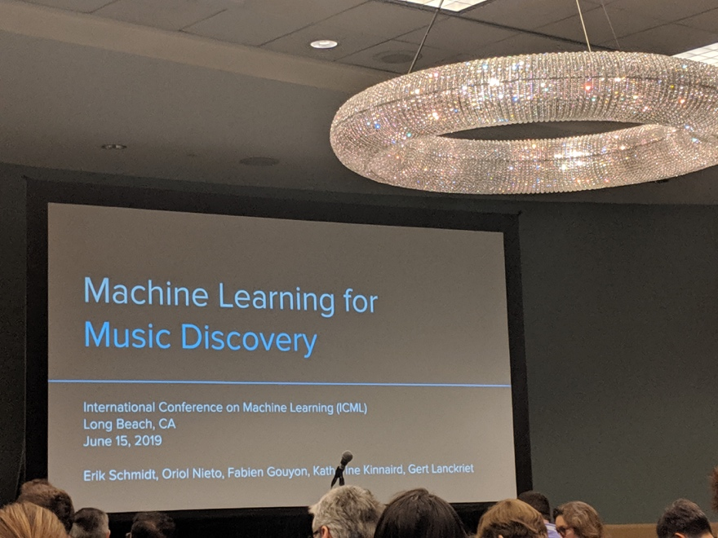

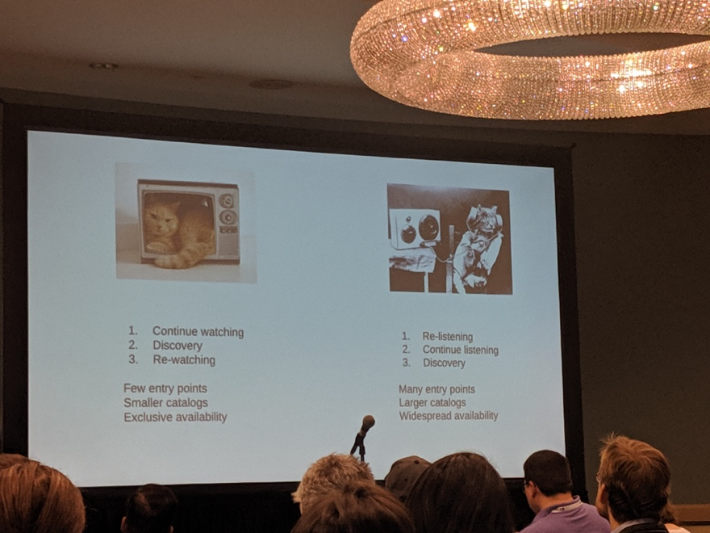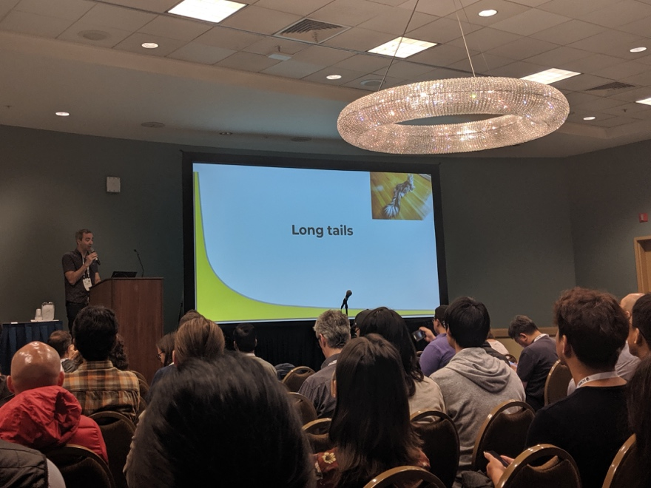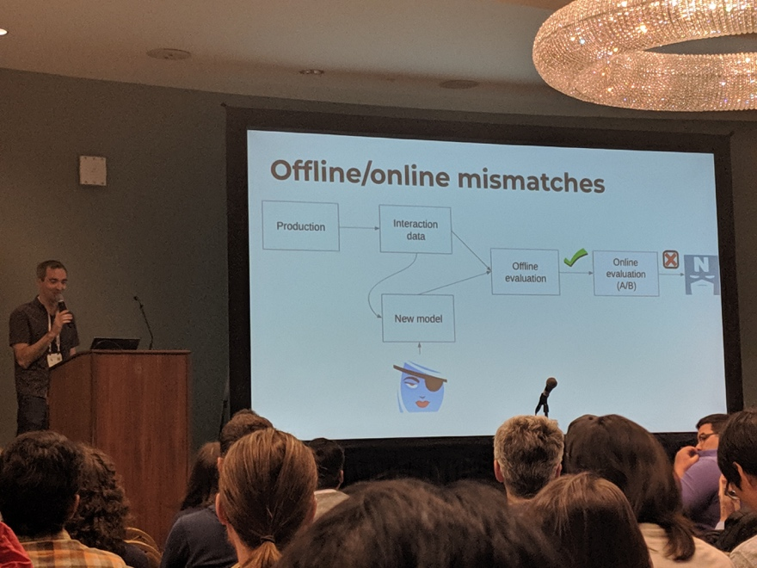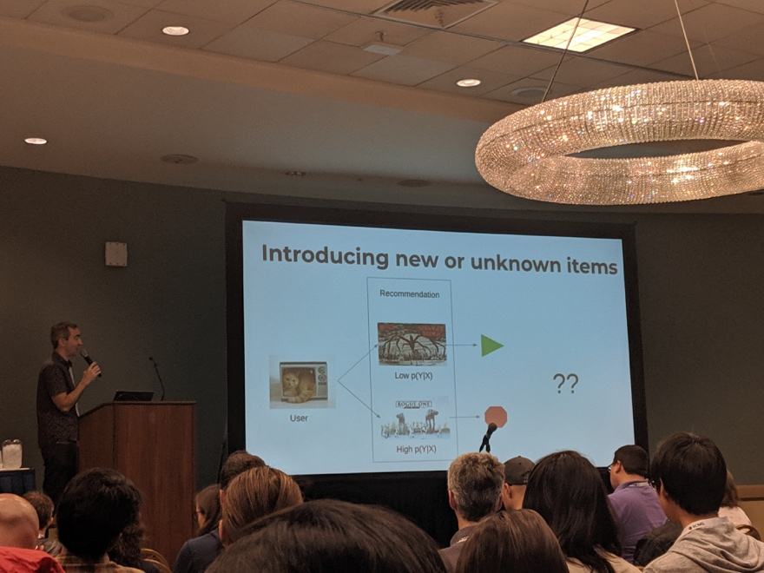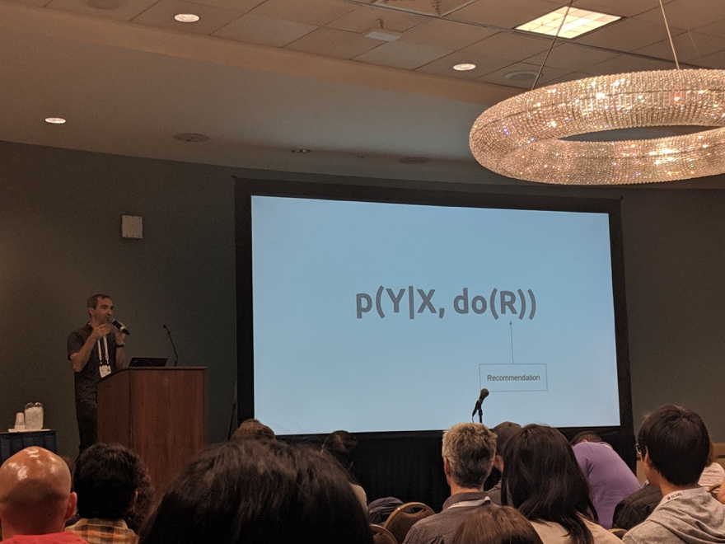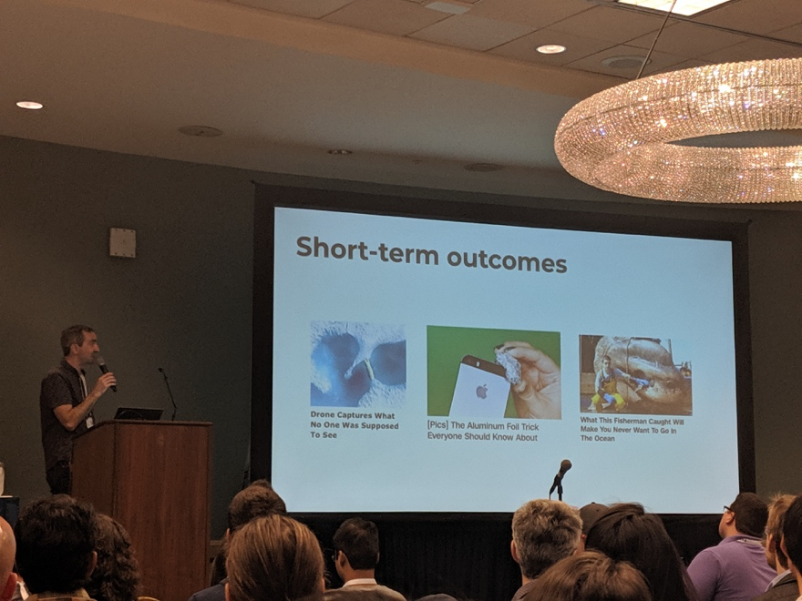

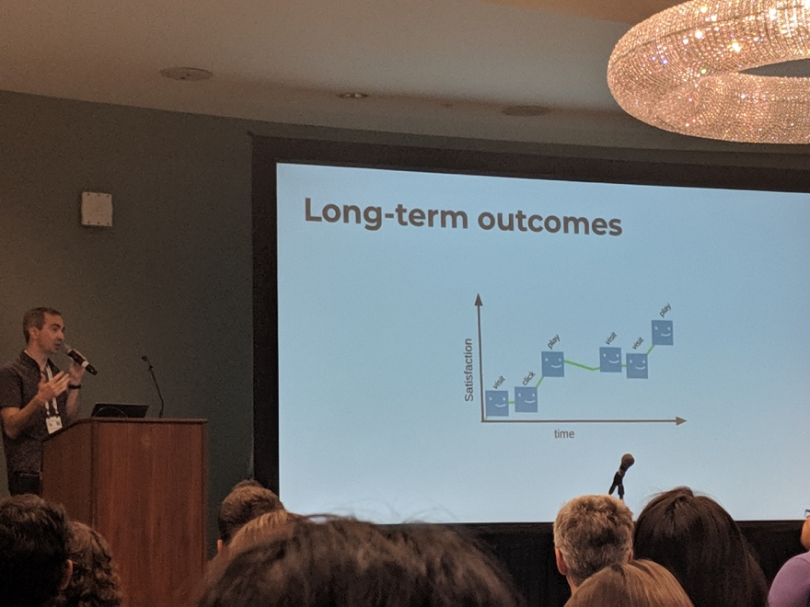

* TV v.s. Music
  + Listen
    - * Old favorites
      * New albums by favorite artists
      * Discover new tracks (among ~27M tracks, challenging)
  + Watch
    - * New episodes of favorite show
      * Discover new shows (~1M, smaller space)
      * Old favorites
* Recommend completely new things
  + Rewarding ⇒ personalize for all subscribers
  + Home page, rank
* Diagram
  + Training data -> rec algo -> rec -> feedback -> another iter of training data
  + Feedback = f(recommend)
    - * Good or bad recommendation
      * Explicit / implicit
      * Implicit
        + Engagement
        + Play minutes
      * Explicit
        + Survey
        + Thumb up and down
  + Reward = f(feedback)
    - * From feedback to long term success
* Music: large catalog + weaker feedback
  + Long tail <https://www.springer.com/us/book/9783642132865>
  + Music data graphs circa 2007 <http://musicontology.com>
* From graph to recommendations
  + Knowledge graph ⇒ recommender
* TV: smaller catalog + strong feedback
  + Short tail
  + Past engagement is most predictive of future engagement
  + Collaborative filtering (CF) is the KING
  + Matrix factorization
  + Challenge
* Differential engagement across items
* New items with no engagement
  + CF?
* Dealing with tail
  + Correlation way
    - * p(Y|X): feature predicts outcome, content-based
      * Wavenet
      * <https://scholar.google.com/citations?user=yNNIKJsAAAAJ&hl=en>
  + Back to MF
    - * Feed-forward view
      * U x V => inner product
      * Deeper
  + Add extra info to the matrix
    - * Sequence of past engagement
      * Feature space
      * Baseline sequence + continuous time context
* offline/online mismatch???
* Introduce new or unknown items
  + High or low p(Y|X)
* p(Y|X, do(R))
  + Epsilon-greedy: simple but expensive
  + IPS?: probability weighting, high variance
  + IV?: instrumental va?? hard to scale
  + Others
* Design rewards
  + E[Y|X, do (R)]
  + Maximize expected reward, given recommendation
  + Focus on long term reward
    - * Sequence of actions
      * RL ⇒ delayed reward
  + Optimize for long term

## Characterizing Musical Correlates of Large-Scale Discovery Behavior @ Stanford

Blair Kaneshiro <https://ccrma.stanford.edu/~blairbo/>

* EEG
* audio content recognition services such as Shazam
* Shazam query features
  + Shazam offset study
    - Billboard hit
* <https://www.frontiersin.org/articles/10.3389/fpsyg.2017.00416/full>
* we investigate whether the timing of audio identification queries within a song can be related back to specific musical events.
* We aggregate and analyze a large collection of Shazam query offsets—that moment in a song when a user initiates a query—over a set of massively popular songs
* Histogram of song: number of queries at each time of a song
  + When do people start to query in a song
  + chorus

## NPR: Neural Personalised Ranking for Song Selection @Apple

Mark Levy

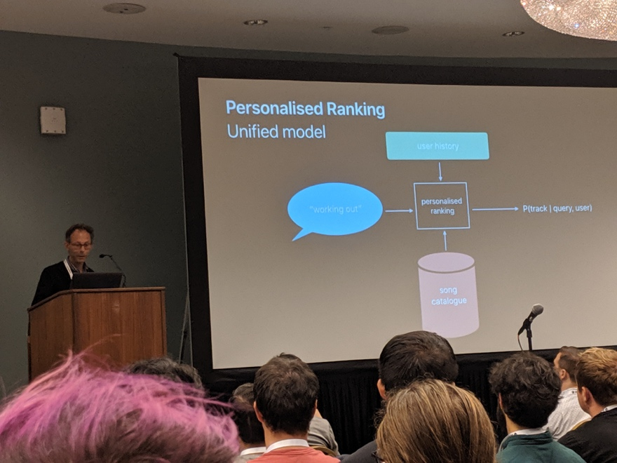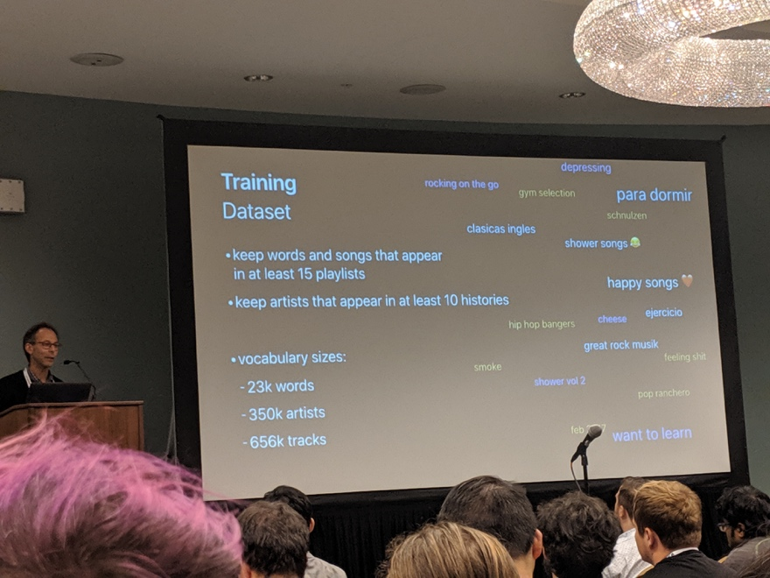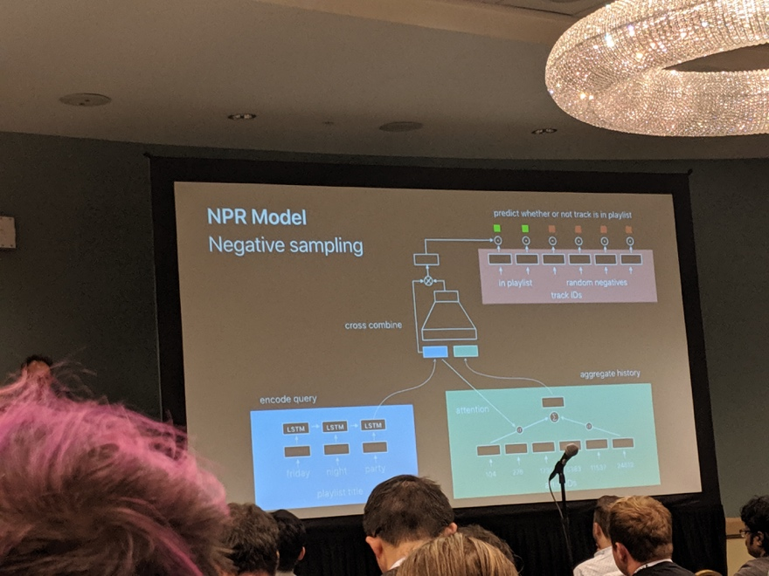

* Apple music science team
* Personalized ranking
  + Board search => ranking
  + Create a playlist with a title => recommend song list
  + “Play music, alexa”
* Workflow
  + Query => database match + user history taste => rank
* Approach 1: tagging
  + Tagging first
  + Personalization later
* Tagger is not sufficient for ranking
  + Not just display correctly, but also induce listening
* Re-ranking from thousands of songs from ~M songs
  + Users hate all genre in this candidates
  + Language specific
* Use unified model
  + With a lot of data
  + 4.5 million use playlists with titles
  + Basic quality filter
    - Limit playlist per user
  + Use history
    - ~top 200 artists per user
  + Training data
    - Vocabulary
  + Title + query => NPR
    - Softmax
    - Encoded query (word embedding LSTM)
    - Artist id embedding (song pooling??)
    - Embed songs as tensors
  + NPR model with attention
    - How to aggregate over history
    - Weighted sum over time
    - Latent cross
    - Negative sampling (not for all softmax)
  + Optimization
    - Sampled softmax loss
    - Vanilla hyperparameters
      * Gradient descent with fixed learning rate
      * Embedding size 100
  + Setting
    - Attention with 1 or 4 heads
* Demo
  + Music recommendation by search

## Personalization at Amazon Music @Amazon

Kat Ellis

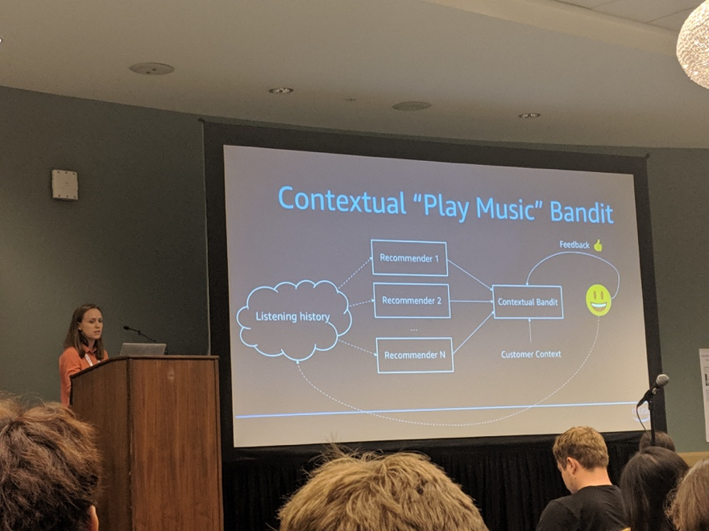

* Alexa, play summer time
  + Training
    - Pairwise ranking model
      * query
      * Maximize prob of ranking positive over negative
* Alexa, play music
  + Popular?
  + Recommendation?
  + Playlist?
* Strategy
  + Listening history ⇒ station recommender
* Understand intent
  + Contextual bandit
  + Customer context
* Embedding models for personalized recommendations
  + Songs for YOU
  + Matrix factorization
    - Minimize Euclidean distance
  + User interest
    - No explicit rating
      * Very sparse
    - Implicit feedback
      * Softmax: user-item interaction
      * Confidence term C(ij)
* Offline evaluation
  + Within-batch sampling
* A/B test
  + Engagement 93%+
* Song embedding
  + t-sNE
* Cold-start
  + Content-based CF ⇒ learn behavioral similarity
  + Large margin ranking loss
* Future work
  + Stability of embedding
  + Presentation bias
  + contextualization

## A Model-Driven Exploration of Accent Within the Amateur Singing Voice

Camille Noufi

* MERI
* Characteristic of voices
  + Fixed: demographic
  + Fleeting: perceived levels, likeability, expressivity
  + Accent: origin
* Timbre / intonation : capture accent
* Kareoke dataset: DAMP by smule
  + <https://ccrma.stanford.edu/damp/>

## What’s Broken in Music Informatics Research? Three Uncomfortable Statements @Adobe

Justin Salamon

* MIR in pitch tracking
  + <http://www.justinsalamon.com/>
  + Track instrument/voice in track
* Applications
  + Query by humming
  + Convert song recog
  + Classify singing style
  + Pattern detection
* 1: melody extraction
  + What is genre, what is melody, what is MUSIC?
  + Arbitrary definition of music related concepts
  + What exactly to extract?
    - ???
  + Definition is determined by the annotation of the dataset
* 2: evaluate algo performance
  + Dataset too small/homogenous
  + Metrics not good
* 3: lean start up
  + <https://medium.com/@blacktar/customer-development-resources-for-startups-7dc2272c94ec>

# Workshop: Learning and Reasoning with Graph-Structured Representations

Schedule <https://graphreason.github.io/schedule.html>

## RL with graph: chemistry and beyond @ Benevolent AI

Marwin Segler

* Graph everywhere
  + chemistry the study of small graphs
  + design->make->test->design
  + ML based design and make
* Generate drugs from data
  + Drug discovery with goal-directed optimization
  + K-L divergence of distribution
* Planning in graph-based environment
  + M = (S,A,T,R)
  + State, action, transition, reward
* How to target a molecule
  + Usually require knowledge, experience, and creativity (similar to chess)
  + Not every molecule is synthesizable YET
* How to make a molecule

## Geometric processing

Yaron Lipman

Weizmann Institute of Science

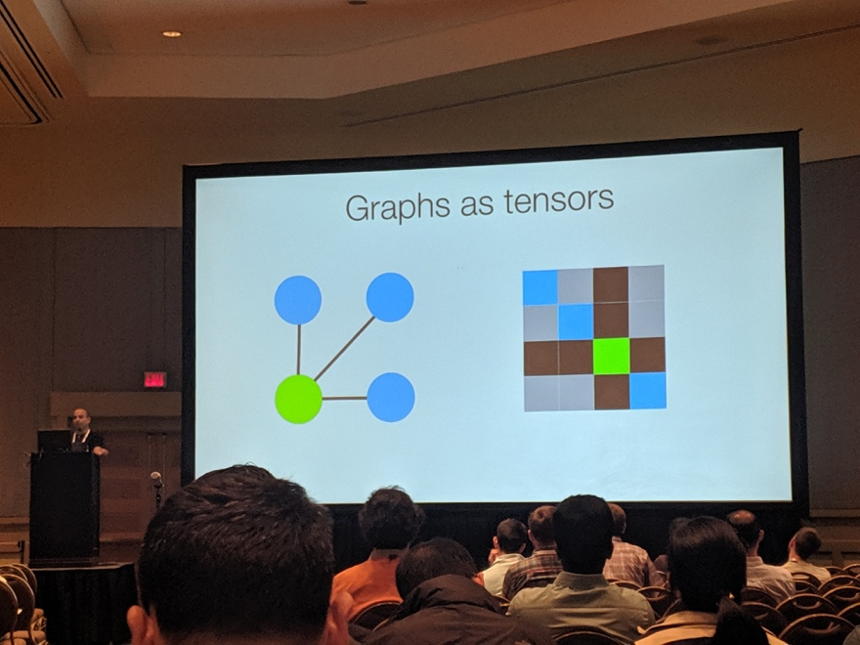

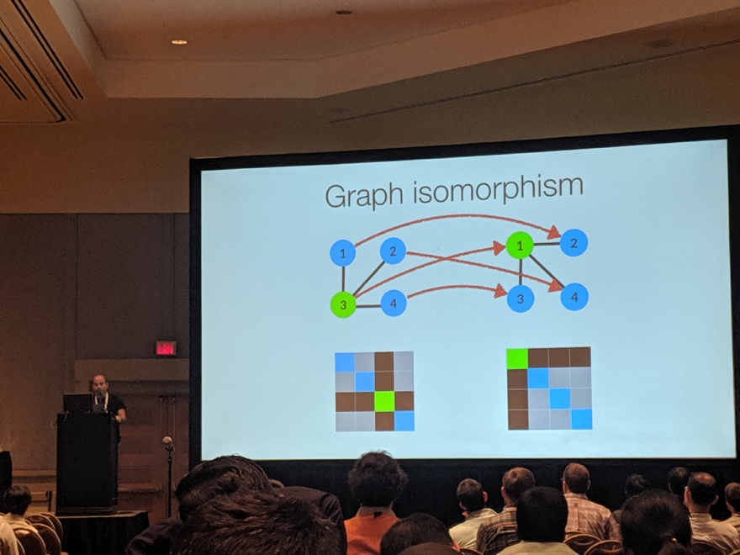

* Geometric processing
* Graph classification/regression
  + f(GRAPH) => label
* Efficiency of neural net / power
  + Characterize graph geometry with features (HOW)
* Invariant graph networks
  + Graphs not as graph, but as tensors (matrix), adjacency matrix
  + Graph isomorphism (equivalent graph)
    - Matrix => permutation P (dot) A = B
    - Permutation also applies to higher dimension tensor
    - Re-order each dimension
  + Function
    - f(p X) = f(X)
    - Function is the same on X and permuted X
* Graph learning
  + f(MATRIX) => label
  + Linear and point-wise non-linear activation Y = sigma(L(X))
  + Equivariant graph
    - f(pX) = pf(X)
* Invariant graph network (IGN)
  + Implement

# Workshop: Self-supervised learning workshop

Schedule <https://sites.google.com/view/self-supervised-icml2019>

Self-supervised learning is a promising alternative where proxy tasks are developed that allow models and agents to learn without explicit supervision in a way that helps with downstream performance on tasks of interest. One of the major benefits of self-supervised learning is increasing data efficiency: achieving comparable or better performance with less labeled data or fewer environment steps (in Reinforcement learning / Robotics).

# Supervised learning

## Data Shapley: Equitable Valuation of Data for Machine Learning

<https://arxiv.org/abs/1904.02868>

Training + learner + performance

* quantify the value of data in algorithmic predictions and decisions.
  + For example, in healthcare and consumer markets, it has been suggested that individuals **should be compensated for the data that they generate**, but it is not clear what is an equitable valuation for individual data.
  + In this work, we develop a **principled framework to address data valuation in the context of supervised machine learning**.
  + Given a learning algorithm trained on n data points to produce a predictor, we propose **data Shapley** as a metric to quantify the value of each training datum to the predictor performance.

## Feature Grouping as a Stochastic Regularizer for High-Dimensional Structured Data

<https://arxiv.org/abs/1807.11718>

* High dimension + small sample + noise
* Regularization
  + Early stopping
  + L1, l2
  + Group LASSO
  + Stochasticity
  + ReNA: feature grouping Hoyos 2016
    - Fast clustering
    - Signal approximation

## Metrics optimized example weights

<https://arxiv.org/abs/1805.10582>

Slides <https://icml.cc/media/Slides/icml/2019/seasideball(11-11-00)-11-11-25-4392-metric-optimize.pdf>

* Ranking model
  + Train and test are not paired: hinge loss
  + Global and local metrics don’t match
  + precision@3
* MOEW
  + Maximize test metrics
  + <https://openreview.net/pdf?id=SklgHoRqt7>
  + Weighted space

## Improving Model Selection by Employing the Test Data

<http://proceedings.mlr.press/v97/westphal19a.html>

Slides: <https://icml.cc/media/Slides/icml/2019/seasideball(11-11-00)-11-11-30-4393-improving_model.pdf>

* Model selection: we investigate the properties of novel evaluation strategies, namely when the final model is selected based on empirical performances on the test data.
* When in doubt, delay the final model choice to the test data

# Clustering

## Scalable fair clustering @IBM

<https://arxiv.org/abs/1902.03519>

Slides: <https://icml.cc/media/Slides/icml/2019/grandball(11-16-00)-11-16-30-5049-scalable_fair_c.pdf>

* Fair clustering:
* Algo fairness
* Common unsupervised tasks
* Feature engineering
* Balanced cluster (for features)

## DBSCAN++: Towards fast and scalable density clustering

<https://arxiv.org/pdf/1810.13105.pdf>

a simple modification of DBSCAN which only requires computing the **densities for a chosen subset** of points.

* Scalable clustering
* Parametric
  + Minimize loss function with k
* Non-parametric
  + Density
  + Arbitrary shape
  + Groups
    - Density
    - Mode-seeking: meanshift
* DENSITY
  + High concentration data points
  + Euclidean distance
  + **Compare using sk-learn functions**
* DBSCAN
  + Neighbor
  + Radius, core points
  + How it works
* Sampling ⇒ to make it faster
* Greedy k-center
  + NP hard
  + Gradient descent
* Run faster by sampling

## concrete autoencoder

paper: <http://proceedings.mlr.press/v97/balin19a.html>

slides: <https://icml.cc/media/Slides/icml/2019/103(13-11-00)-13-11-20-4961-concrete_autoen.pdf>

* Unsupervised Feature Selection (UFS) is Widely Used in Machine Learning
* Mostly based on L1 L2 regularization
* Identify important features to measure, and then reconstruct other features
* Concrete random variables
  + In: all features
  + Out: top features
* Implementation is just a few lines of code from a standard autoencoder

## Spectral clustering of signed graph

Paper: <https://arxiv.org/abs/1905.06230>

Slides:<https://icml.cc/media/Slides/icml/2019/103(13-11-00)-13-11-30-4963-spectral_cluste.pdf>

* In-cluster: only pos edges
* Out-cluster: only neg edges
* Metrics ⇒ power mean Laplacian
* Use signed graph for clustering

Coreset for Ordered Weighted Clustering

paper: <https://arxiv.org/abs/1903.04351>

slides: <https://icml.cc/media/Slides/icml/2019/103(13-11-00)-13-11-35-4964-coresets_for_or.pdf>

* K-median

## Fair k-Center Clustering for Data Summarization

Paper: <https://arxiv.org/abs/1901.08628>

* K-center problem
* NP hard

## Better k-means ++ @Google research

Paper: <http://proceedings.mlr.press/v97/lattanzi19a.html>

Slides: <https://icml.cc/media/Slides/icml/2019/103(13-11-00)-13-12-00-4966-a_better_k-mean.pdf>

* Local search
  + slow
* K-means
  + Seeding + Lloyd’s algorithm
    - Probably the most celebrated heuristic for k-means is the wellknown Lloyd’s algorithm (Lloyd, 2006). The algorithm is also often called the k-means algorithm. The algorithm usually performs very well in practice, but it does not provide a theoretical approximation guarantee
* Combine both
  + K-means++ seeding with local search
* Experiment with benchmark

## Spectral clustering for fairness constraints

Paper: <https://arxiv.org/pdf/1901.08668.pdf>

Slides: <https://icml.cc/media/Slides/icml/2019/103(13-11-00)-13-12-10-4968-guarantees_for_.pdf>

* Fair clustering (Chierichetti et al. 2017): in every cluster, **each group Vs should be represented with (approximately) the same fraction** as in the whole data set V
* Use fair clustering in our clustering
* NP hard
* Balanced results

## Supervised hierarchical clustering

Paper: <http://proceedings.mlr.press/v97/yadav19a.html>

Slides: <https://icml.cc/media/Slides/icml/2019/103(13-11-00)-13-12-15-4969-supervised_hier.pdf>

* Linkage function (distance)
  + Unknown which one is the best
* Exponential linkage
  + Learnable linkage function
* Weighted edge
* Use errors of hierarchical clustering results to get gradient descent

Training Objective & Algorithm: Jointly Optimizing Dissimilarity & Linkage Function

## Learn to route in similarity graph @Yandex

paper: <https://arxiv.org/abs/1905.10987>

slides: <https://icml.cc/media/Slides/icml/2019/grandball(12-16-00)-12-16-35-4493-learning_to_rou.pdf>

* In KNN search space
* • Recall@1 — a rate of queries for which the actual nearest neighbor is successfully found
* Similarity graph: Edges connect (mostly) nearest neighbors
  + Local search
  + Graph Convolutional Network

## Power k-means clustering

Paper: <http://proceedings.mlr.press/v97/xu19a.html>

Slides: <https://icml.cc/media/Slides/icml/2019/104(13-09-00)-13-09-40-4768-power_k-means_c.pdf>

* lloyd algo
* K-harmonic mean as the criteria, rather than arithmetic mean

## The Wasserstein Transform

paper: <http://proceedings.mlr.press/v97/memoli19a/memoli19a.pdf>

slides: <https://icml.cc/media/Slides/icml/2019/104(13-16-00)-13-16-20-4424-the_wasserstein.pdf>

* Metric space + scale parameter
* for enhancing and denoising datasets defined on general metric spaces
* mean shift also inherits stability under perturbations

## Sequential Facility Location: Approximate Submodularity and Greedy Algorithm

Paper: <http://proceedings.mlr.press/v97/elhamifar19a.html>

Slides: <https://icml.cc/media/Slides/icml/2019/104(13-16-00)-13-16-25-4425-sequential_faci.pdf>

* Subset selection to represent large ground set
* Sequential subset selection ⇒ fast greedy algorithm
* X: source -> y: target
* Procedure learning

## Neural collaborative subspace clustering

paper: <https://arxiv.org/abs/1904.10596>

slides: <https://icml.nips.cc/media/Slides/icml/2019/104(13-16-00)-13-16-30-4426-neural_collabor.pdf>

* Subspace: dimension reduction
* STOA methods
  + Affinity matrix
  + Normalized cut or spectral clustering
* New
  + affinity matrix in batch
  + Train classifier using affinity matrix
* Affinity from classification
* Encoder-decoder for clustering
* Collaborative learning for clustering = classification affinity

## Unsupervised deep learning by neighborhood discovery

paper: <https://arxiv.org/abs/1904.11567>

slides: <https://icml.cc/media/Slides/icml/2019/104(13-16-00)-13-16-35-4427-unsupervised_de.pdf>

* Clustering analysis
* Consistent neighborhood, similarity
* Use entropy to learn class consistency

## Autoregressive energy machine ARNN @deepmind

Paper: <https://arxiv.org/abs/1904.05626>

* Model joint distribution of random variables at high dimension
* Deep generative model
* Importance sampling not work well for high dimension
* Auto-regressive nn
  + Output depends on independent

## Noise2Self: Blind Denoising by Self-Supervision

Paper: <https://arxiv.org/abs/1901.11365>

Slides: <https://icml.cc/media/Slides/icml/2019/104(13-16-00)-13-17-05-4430-noise2self_bli.pdf>

* Biomedical data (noisy)
* Protein imaging (s/n: 1:10)
* Noise removal with supervision
* Self-supervision
  + f(x)-x?
  + expected
* Conditional expectation of noise pixels
* With CNN training
* De-noise image

## Learning Dependency Structures for Weak Supervision Models

Paper: <https://arxiv.org/abs/1903.05844>

Slides: <https://icml.cc/media/Slides/icml/2019/104(13-16-00)-13-17-10-4431-learning_depend.pdf>

* Snorkel: widely used in industry
  + Deal with noisily labeled data
  + Model the label functions’ behavior to denoise
  + Probabilistic labels
* Probabilistic generative training data
* <https://dawn.cs.stanford.edu/2017/12/01/snorkel-programming/>

# Applications

## Exploiting Worker Correlation for Label Aggregation in Crowdsourcing @facebook

Paper: <http://proceedings.mlr.press/v97/li19i.html>

* inferring consensus aggregation of collected annotations is a core crowdsourcing task, with the simplest technique being majority voting.
* **Numerous probabilistic models** have emerged that parameterise worker reliability to improve consensus accuracy (David & Skene, 1979; Whitehill et al., 2009; Kim & Ghahramani, 2012).
* Multiple label for the same item, and aggregate labels on the same item, to infer true label
  + Based on the observed label
* Also with missing values
* Bayesian classifier
  + Joint distribution of worker labels + true labels ⇒ marginal prob
  + **True label is first generated, and then item labels are generated (generative model)**
* Worker labels are independent iBCC / dependent BCC
  + Conditional prob
* Tensor rank decomposition

## Efficient Amortised Bayesian Inference for Hierarchical and Nonlinear Dynamical Systems

Paper: <https://arxiv.org/abs/1905.12090>

Slides: <https://icml.cc/media/Slides/icml/2019/201(12-11-00)-12-11-20-4906-efficient_amort.pdf>

* Synthetic biology / generating pattern
* **Genetic circuit in** biological function E-coli molecular engineering
* Simulate differential behaviors

## A Multitask Multiple Kernel Learning Algorithm for Survival Analysis with Application to Cancer Biology

Paper: <http://proceedings.mlr.press/v97/dereli19a/dereli19a.pdf>

Slides: <https://icml.cc/media/Slides/icml/2019/201(12-11-00)-12-11-25-4907-a_multitask_mul.pdf>

* A multitask multiple kernel learning algorithm
* Use chip sequencing info to identify cancer types
* Kernel learning, survival kernel
* Design new algo with some theoretical

## Fast and Flexible Inference of Joint Distributions from their Marginals

Paper: <http://proceedings.mlr.press/v97/frogner19a/frogner19a.pdf>

Slides: <https://icml.cc/media/Slides/icml/2019/201(12-11-00)-12-11-30-4908-fast_and_flexib.pdf>

* Learning: infer 2 random variables with joint dist
* conditional dist
* From known to infer unknown

## Cognitive Model Priors for Predicting Human Decisions

Paper <https://arxiv.org/abs/1905.09397>

Slides <https://icml.cc/media/Slides/icml/2019/201(12-11-00)-12-11-35-4909-cognitive_model.pdf>

* Behavioral science
* ML
  + Flexibility
  + Hard to generalize
* Cognitive model prior ⇒ better generalization
  + Input ⇒ behavior
  + Synthetic data
* Train NN
* BEAST
  + Black box model
* Training size ⇒ variation

## Conditioning by adaptive sampling for robust design

Paper: <https://arxiv.org/abs/1901.10060>

Slides: <https://icml.cc/media/Slides/icml/2019/201(12-11-00)-12-11-40-4910-conditioning_by.pdf>

* Design protein seq for function
* Existing
  + Known sequence ⇒ function (ML)
* New
  + From function, design sequence
* **Model-based optimization**
  + Adaptive sampling
  + MC sampling and anneal
  + Timestamps sample sequence
* Pathological oracles
* Deal with small training size
* Minimize KL divergence
* Testing is different
  + Ground truth design: GP mean function
    - How to train a GP
    - And then sample from GP
  + No good set of hold-out
* Compare with bayesian opto

## Direct Uncertainty Prediction for Medical Second Opinions @google brain

Paper: <https://arxiv.org/abs/1807.01771>

Slides: <https://icml.cc/media/Slides/icml/2019/201(12-11-00)-12-12-00-4911-direct_uncertai.pdf>

* Second opinion among doctors
  + Source of disagreement from patient’s profile
* **Flag patients with 2nd opinions**
* Approach
  + Uncertainty via classification
  + Direct uncertainty prediction DUP
* Hidden features seen by doc, not by photos

## Dynamic Measurement Scheduling for Event Forecasting Using Deep RL

Paper: <https://arxiv.org/abs/1901.09699>

Slides: <https://icml.cc/media/Slides/icml/2019/201(12-11-00)-12-12-05-4912-dynamic_measure.pdf>

Dynamic treatment scheduling

Patients outcome -- measurement

Uniform policy from

DQN-RL, a lot of action space

* RL framework for cost-sensitive scheduling of measurements in time-series
* Scalable to large number of measurements
* Promising results in a real-world ICU dataset (MIMIC3)

## DeepNose: Using artificial neural networks to represent the space of odorants @ cold spring harbor

Paper: <http://proceedings.mlr.press/v97/tran19b/tran19b.pdf>

<https://icml.cc/media/Slides/icml/2019/201(12-11-00)-12-12-15-4914-deepnose_using.pdf>

* Odorant receptor combination
  + 3D molecular filter
  + Train with neural net
* Autoencoder
* Classifier using encoder’s features
* Dimension reduction for odor cloud

## Doubly Robust Joint Learning for Recommendation on Data Missing Not at Random

Paper: <http://proceedings.mlr.press/v97/wang19n/wang19n.pdf>

Slides: <https://icml.cc/media/Slides/icml/2019/201(13-09-00)-13-09-00-4916-doubly_robust_j.pdf>

* Missing Ratings: Missing Not at Random
* Producer / user
* Error imputation

## Linear-Complexity Data-Parallel Earth Mover’s Distance Approximations @IBM

Paper: <https://arxiv.org/abs/1812.02091>

Slides: <https://icml.cc/media/Slides/icml/2019/201(13-09-00)-13-09-20-4917-linear-complexi.pdf>

* Network problem
* Search accuracy/complexity
  + GPU friendly/optimality
* Introduce some new Relaxed in-flow constraints

## Model Comparison for Semantic Grouping

Paper: <https://arxiv.org/abs/1904.13323>

Slides: <https://icml.cc/media/Slides/icml/2019/201(13-09-00)-13-09-25-4918-model_compariso.pdf>

* Semantic group
* Bag of words embedding
* Hypothesis testing: whether 2 sentences come from the same semantic group
  + Bayes Factor - Integrates out Parameters

## Rank aware factorization machines @Tencent

Paper: <https://arxiv.org/abs/1905.07570>

Slides: <https://icml.cc/media/Slides/icml/2019/201(13-09-00)-13-09-30-4919-rafm_rank-awar.pdf>

* Embedding with weight
* FM: inner product

## CAB: Continuous Adaptive Blending Estimator for Policy Evaluation and Learning

Paper: <https://arxiv.org/abs/1811.02672>

Slides: <https://icml.cc/media/Slides/icml/2019/201(13-09-00)-13-09-35-4920-cab_continuous.pdf>

* Online policy learning and evaluation
* Online A/B testing
* Interpolated Counterfactual Estimator Family

# Time series

## Generative Adversarial User Model for Reinforcement Learning Based Recommendation System

Paper <https://arxiv.org/abs/1812.10613>

Slides <https://icml.cc/media/Slides/icml/2019/201(11-14-00)-11-14-25-4831-generative_adve.pdf>

* Generative for RL and RS
* In RS, experience is updated from historical observation
* Challenges
  + User is the environment, not a lot of interactions
  + Reward function is unknown
* Generative simulator
* **Use GAN**
* Sequential information: LSTM / position weight (attention)
* Cascading Q network
* CTR

## Deep Factors with Gaussian Processes for Forecasting @Amazon AWS

<https://arxiv.org/pdf/1812.00098.pdf>

Slides: <https://icml.cc/media/Slides/icml/2019/201(11-14-00)-11-14-35-4833-deep_factors_fo.pdf>

* Classical time series models fail to fit data well and to scale to large problems, but succeed at providing uncertainty estimates. The converse is true for deep neural networks.
  + Classical time series methods, such as **Autoregressive Integrated Moving Average (ARIMA) [3], exponential smoothing [4] and general Bayesian time series [5]**, excel at modeling the complex dynamics of individual time series of sufficiently long history.
  + These methods are **local, that is, they learn one model per time series**. As a consequence, they cannot effectively extract information across multiple time series. These classical methods also have challenges with **cold-start problems**, where more time series are added or removed over time.
* Deep neural networks (DNNs), in particular, r**ecurrent neural networks (RNNs), such as LSTMs** [6] have been successful in time series forecasting [7, 8]. DNNs are generally effective at extracting patterns across multiple time series. Without a combination with probabilistic methods, such as variational dropout [9] and deep Kalman filters [10], DNNs can be prone to overfitting and have challenges in modeling uncertainty [11].
* we propose a hybrid model that incorporates the benefits of both approaches. Our new method is data-driven and scalable via a latent, global, deep component. It also **handles uncertainty through a local classical Gaussian Process model**. Our experiments demonstrate that our method obtains higher accuracy than state-of-the-art methods.
* Model all time series jointly and globally (works better, complex model, impossible to add more) global/local model

## Weakly-Supervised Temporal Localization via Occurrence Count Learning

Paper <http://users.cs.cf.ac.uk/SchroeterJ1/docs/Weakly-Supervised%20Temporal%20Localization%20via%20Occurrence%20Count%20Learning.pdf>

Github

<https://github.com/SchroeterJulien/ICML-2019-Weakly-Supervised-Temporal-Localization-via-Occurrence-Count-Learning>

Slides: <https://icml.cc/media/Slides/icml/2019/201(11-14-00)-11-14-40-4834-weakly-supervis.pdf>

Obj

* Weakening the annotation requirement
* **Occurrence count**
* Training / inference
* Weakly-supervised
* Counting model
  + Localization
* Loss
  + Compare loss by K-L divergence of the count
* Sound signal ⇒ fourier transform ⇒ CNN  convolution representation ⇒ LSTM

## Imputing missing events in continuous time event series

Paper: <https://arxiv.org/abs/1612.09328>

Slides: <https://icml.cc/media/Slides/icml/2019/201(11-14-00)-11-15-05-4836-imputing_missin.pdf>

* Incomplete data
* when/where ?
* Impute the missing event
  + neural hawkes process
* Game logs retrospective
* Sequential monte carlo

# ML System

## Fault tolerance in iterative convergent ML @Petuum

<https://arxiv.org/abs/1810.07354>

* Distributed ML for model training
* Parameter server architecture (worker and namenode)
  + Unreliable environment at challenge
  + Node failure
  + Slow network
* Tradition: strict consistency model ⇒ inefficient for ML
* Better for ML: Relaxed consistency model
  + Bad: designed for SGD specific algo
* ML training is **self-correcting** in general
  + Unreliable env ⇒ parameter perturbation ⇒ convergence with cost
* Assumption
  + Iterative algo
  + Faults as perturbations
  + Convergence
* Fault-tolerance from priority checkpoints
* System fault can be captured as perturbation

## Static automatic batching in tensorflow @ Google brain

Paper <http://proceedings.mlr.press/v97/agarwal19a/agarwal19a.pdf>

Slides <https://icml.cc/media/Slides/icml/2019/grandball(11-16-00)-11-17-00-5052-static_automati.pdf>

* Tf nodes graph (pytorch though)
* Vectorization challenges

# Reinforcement learning

## Control Regularization for Reduced Variance Reinforcement Learning

Paper: <https://arxiv.org/abs/1905.05380>

Slides: <https://icml.cc/media/Slides/icml/2019/hallb(12-14-00)-12-14-20-4610-control_regular.pdf>

* Optimal policy, distribution of state/action
* High variance for RL during learning
  + Use some control prior for policy
* Control Regularization helps by providing:
  + Reduced variance
  + Higher rewards
  + Faster learning
  + Potential safety guarantees

## On the Generalization Gap in Reinforcement Learning Reparameterizable @salesforce research

Paper: <http://proceedings.mlr.press/v97/wang19o.html>

Slides: <https://icml.cc/media/Slides/icml/2019/hallb(12-14-00)-12-14-25-4611-on_the_generali.pdf>

* Intrinsic gap: RL classic learning theory
* Extrinsic gap: train/test diff

## RL in internet congestion control

Paper: <https://arxiv.org/pdf/1810.03259.pdf>

Slides: <https://icml.cc/media/Slides/icml/2019/hallb(12-14-00)-12-14-35-4613-a_deep_reinforc.pdf>

* Latency measurement
* New congestion control timeline
  + Reward-based architecture: PCC
* Replace gradient descent with RL network

## model based active exploration MAX @ NNAISENSE

paper: <https://arxiv.org/abs/1810.12162>

* E-e tradeoff
* Pure exploration without reward
* task-agnostic  ⇒ similar to unsupervised pre-training followed by fine-tuning
* Bayesian perspective of the exploration
  + Experience changes information gain (posterior info)
* Active.reactive exploration
  + Reactive: provoked by env
  + Active: not provoked by env, science test hypothesis
* Explored area v.s. Unexplored area (model disagree)
* Model-based ⇒ prediction of policy distribution (s,a) => r
* Convert exploration to BO

## inverse RL with ranking

paper: <https://arxiv.org/abs/1904.06387>

slides: <https://icml.cc/media/Slides/icml/2019/hallb(12-14-00)-12-15-00-4615-extrapolating_b.pdf>

Good policy from bad demonstrations

* Use ranked demonstration, allow for extrapolation
* T-REX
* Used to study swarm and multi-agent learning

## Adversarially Learned Representations for Information Obfuscation and Inference

paper: <http://proceedings.mlr.press/v97/bertran19a.html>

slides: <https://icml.cc/media/Slides/icml/2019/grandball(12-16-00)-12-16-00-4489-adversarially_l.pdf>

* Why user decides to share data
* Learn space-preserving representations that obfuscate sensitive information while preserving utility
* Filter image to obscure sensitive information
  + Gender
  + Emotion
* KL divergence

## adaptive neural tree @microsoft

paper: <https://arxiv.org/abs/1807.06699>

slides: <https://icml.cc/media/Slides/icml/2019/grandball(12-16-00)-12-16-20-4490-adaptive_neural.pdf>

* Deep neural net + decision tree
  + DNN: feature learning, scalable, architecture hand designed
  + DT: hand designed features, architecture learned
* ANT:
  + DTs which uses NNs in every path and routing decisions.
  + DT-like architecture growth using SGD
* Growth by SGD
* Unsupervised hierachrical clustering with ANT??!!!

Invited talk

## Learning @ cognitive science

* AI learning v.s. kid learning
* <https://icml.cc/Conferences/2019/Schedule?showEvent=4334>
* Generalization with little data
* MESS: model-building exploratory, social learning system
  + for DARPA grant
  + Abstract causal model from stats evidence
  + Active learning through exploratory play
  + Social learning by imitation
  + Development => e-e trade-off

Child development cognitive psychology

* Psychological Bulletin 2012 gopnik and wellman
* <https://www.ncbi.nlm.nih.gov/pubmed/22582739>

## Best paper: challenge assumption in unsupervised learning representation

**Francesco Locatello, Stefan Bauer, Mario Lucic, Gunnar Rätsch, Sylvain Gelly, Bernhard Schölkopf, Olivier Bachem**

Paper: <https://arxiv.org/abs/1811.12359>

Google blog <https://ai.googleblog.com/2019/04/evaluating-unsupervised-learning-of.html>

* Unsupervised representation learning
  + understand high-dimensional data, and to distill that knowledge into useful representations in an unsupervised manner, remains a key challenge in deep learning.
  + One approach is disentangled representations: capture the independent features of a given scene in such a way that **if one feature changes, the others remain unaffected**
  + We do not find any empirical evidence that the **considered models can be used to reliably learn disentangled representations in an unsupervised way,**

# Expo

## Criteo AI Lab

* Ad research
* DSP
* <https://ailab.criteo.com/hyper-parameter-optimization-algorithms-a-short-review/>

## SigOpt

* Bayesian Opto API
* ~ 6 month trial, ~ 10k per month
* Two Sigma Blog: [Why Two Sigma is Using SigOpt for Automated Parameter Tuning](https://www.twosigma.com/news/article/why-two-sigma-is-using-sigopt-for-automated-parameter-tuning/)
* NVIDIA Blog: [Deep Learning Hyperparameter Optimization with Competing Objectives](https://devblogs.nvidia.com/sigopt-deep-learning-hyperparameter-optimization/)
* NVIDIA Blog: [Optimizing End-to-End Memory Networks Using SigOpt and GPUs](https://devblogs.nvidia.com/optimizing-end-to-end-memory-networks-using-sigopt-gpus/)
* AWS Blog: [Fast CNN Tuning with AWS GPU Instances and SigOpt](https://aws.amazon.com/blogs/machine-learning/fast-cnn-tuning-with-aws-gpu-instances-and-sigopt/)
* ICML Paper: [Evaluation System for a Bayesian Optimization Service](https://arxiv.org/abs/1605.06170)
* ICML Paper: [A Stratified Analysis of Bayesian Optimization Methods](https://arxiv.org/abs/1603.09441)

## Yandex

CatBoost

<https://tech.yandex.com/catboost/>

* Python API
* Compatible with Java
* Internal categorical feature transformation