1. 定时任务不执行

解决方案：

1、 启动命令 celery -A <mymodule> beat -l info --scheduler django_celery_beat.schedulers:DatabaseScheduler

2、添加配置文件 'CELERY_ENABLE_UTC': False,  
'DJANGO_CELERY_BEAT_TZ_AWARE': False,

2、celery work 执行失败

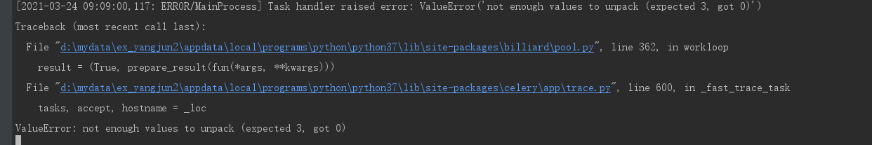

ValueError: not enough values to unpack (expected 3, got 0)

解决方案：

1. 安装依赖pip install eventlet
2. 启动命令 celery -A <mymodule> worker -l info -P eventlet
   1. 执行 celery -A <mymodule> worker -l info -P eventlet 报错：django.db.utils.DatabaseError: DatabaseWrapper objects created in a thread can only be used in that same thread. The object with alias 'default' was created in thread id 2068603070080 and this is thread id 2069065236128.
   2. 用celery -A xxx  worker -l info  --pool=solo启动work