**389. Valid Sudoku**

中文

English

Determine whether a Sudoku is valid.

The Sudoku board could be partially filled, where empty cells are filled with the character ..

**Example**

**Example 1:**

Input:

["53..7....","6..195...",".98....6.","8...6...3","4..8.3..1","7...2...6",".6....28.","...419..5","....8..79"]

Output: true

Explanation:

The sudoku is look like this. It's vaild.

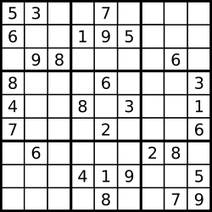

**Example 2:**

Input:

["53..7j...","6..195...",".98....6.","8...6...3","4..8.3..1","7...2...6",".6....28.","...419..5","....8..79"]

Output: false

Explanation:

The sudoku is look like this. It's invaild because there are two '5' in the first row and the sixth line.

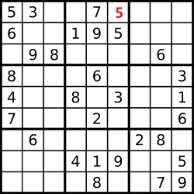

**Clarification**

What is Sudoku?

* <http://sudoku.com.au/TheRules.aspx>
* [https://zh.wikipedia.org/wiki/數獨](https://zh.wikipedia.org/wiki/%E6%95%B8%E7%8D%A8)
* <https://en.wikipedia.org/wiki/Sudoku>
* <http://baike.baidu.com/subview/961/10842669.htm>

**Notice**

A valid Sudoku board (partially filled) is not necessarily solvable. Only the filled cells need to be validated.