LogisticRegression:

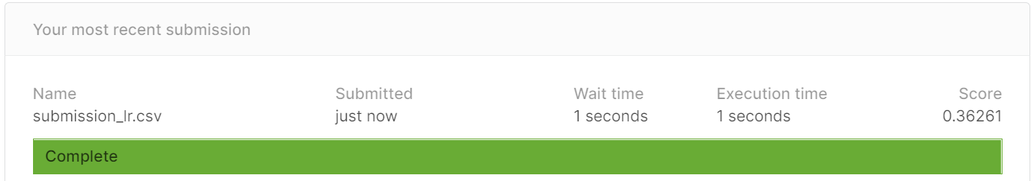

XGBoost

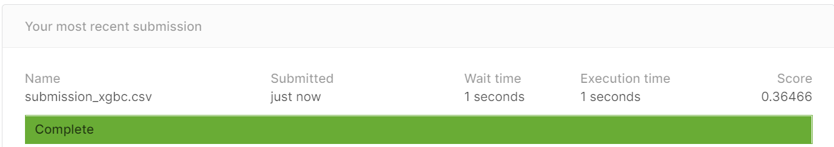

Lightgbm

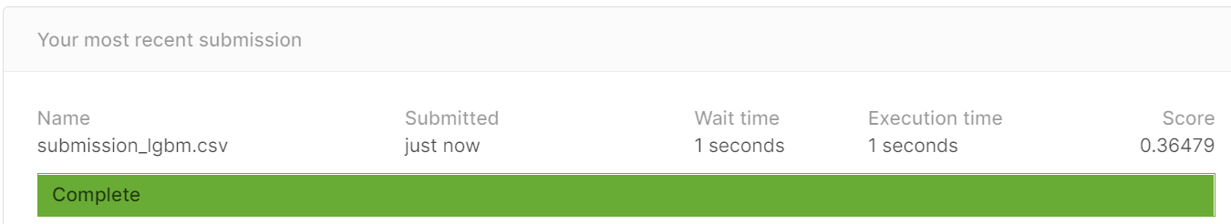

Random Forest

