W205 Project 2

# Submission 1 and 2

I tried to create DB named Tcount, but for some reason I cannot access it from sparse, so I just used default DB named postgres, and also used default folder tweetwordcount.

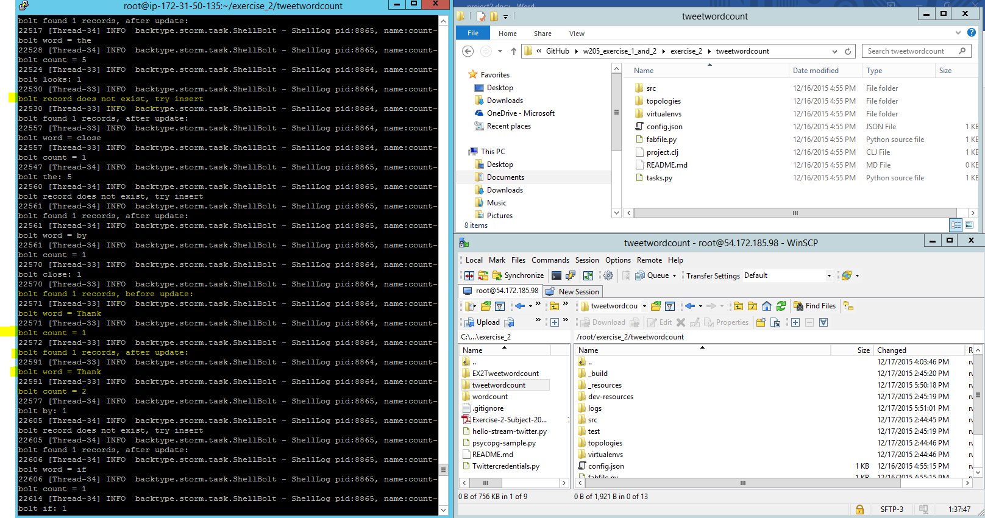

# Submission 3

When word count bolt counts words from twitter feed, it also reads from postgres DB. If this word already existed, it will read the existing count and increment using the local word count value. If the word does not exist, it will insert a key using current word and count.

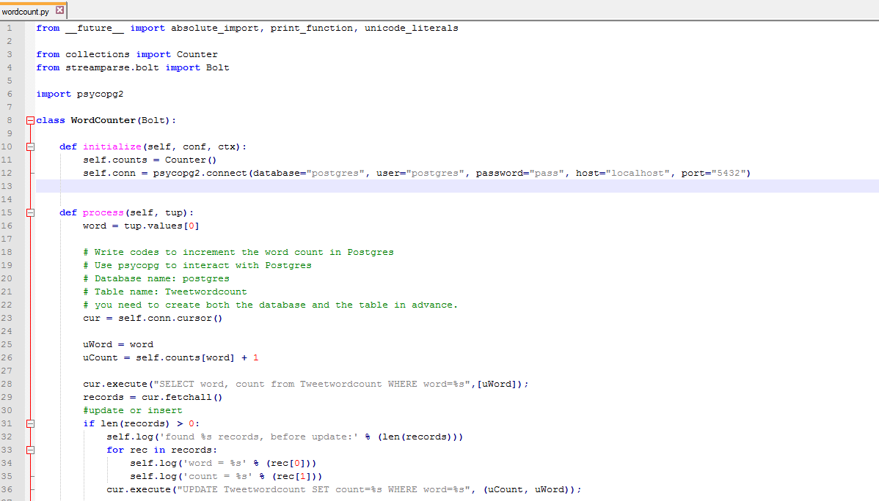

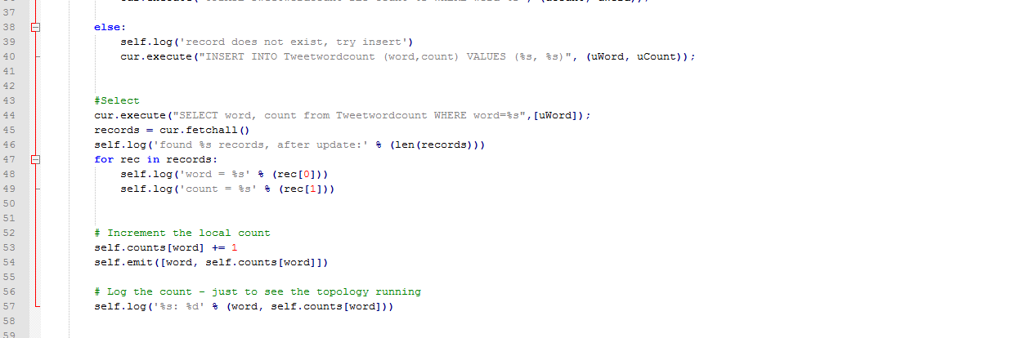

After running for a few minutes, the table tweetwordcount got updated

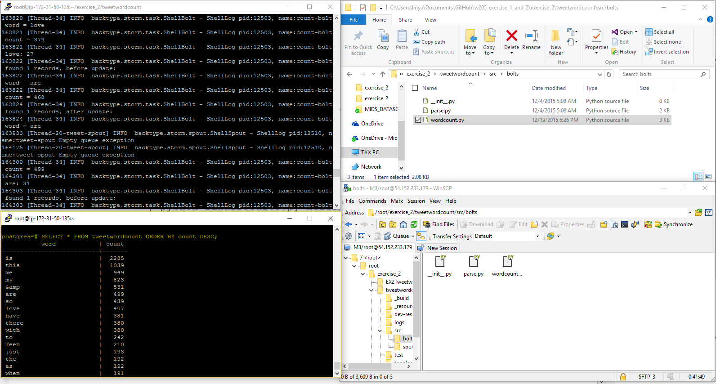

# Submission 4

Sample query result for word hello.

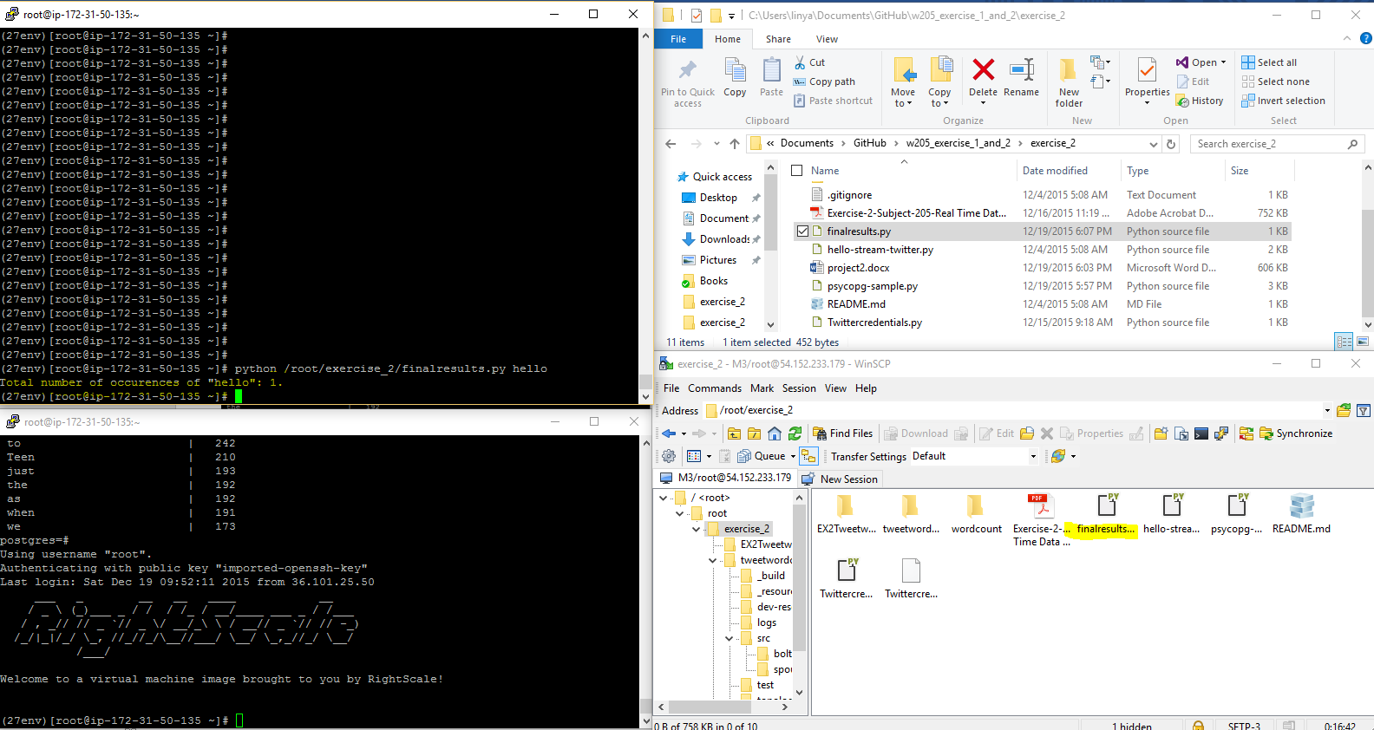

Sample query without supplying arg, it will return all word counts, sorted by word in alphabetical ascending order.

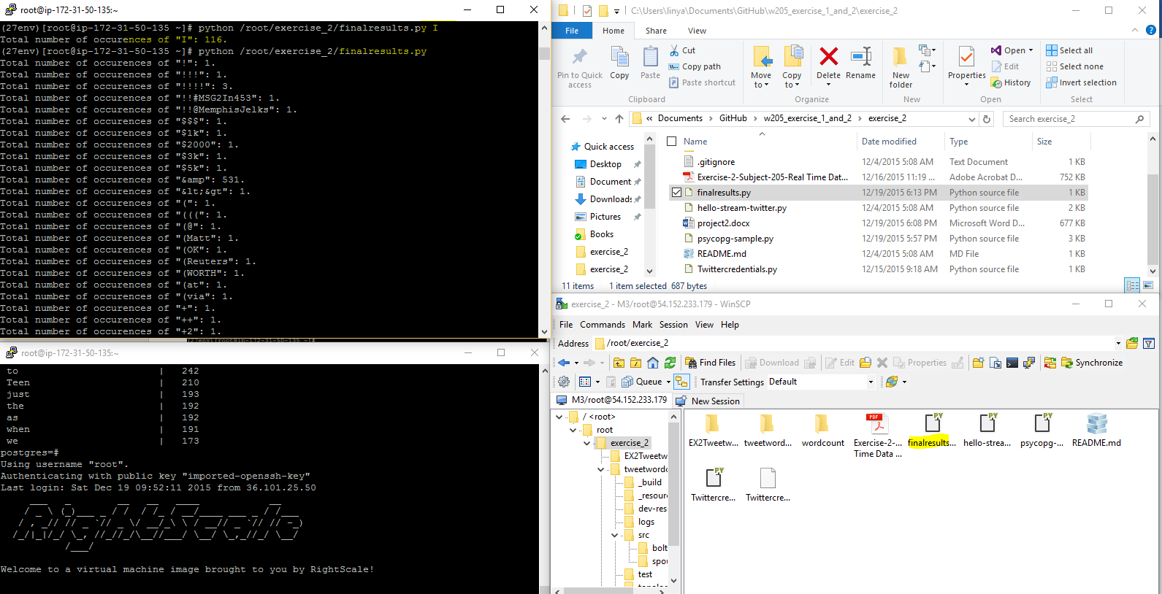

Query histogram, using lower limit and upper limit, inclusive on both sides. Parameter format is: lower,upper, such as 3,8

