**Overview**

In this project, you will make use of Python to explore data related to **bikeshare systems** for **3** major bikeshare systems in the United States.

You will perform data wrangling to **unify the format** of data from the three systems and write code to compute **descriptive statistics**. You will also make use of a package that is not part of the standard Python library to help you visualize the data.

If you are not familiar with the data analysis process, this project will be your first exposure to the kinds of steps that a data analyst takes when they approach a dataset. The steps of the process that you go through here will be covered in more depth as you continue on with the Nanodegree program. For now, all you need is the general programming skills you've learned from the "Introduction to Python Programming" course and a desire to learn about the data analysis process! Note that you may not have seen some of the packages used in the project prior to this point, so you should be comfortable with following documentation links and experimenting with code to build your intuition for how to use the packages to solve the problems posed.

# Getting Started

To complete this project, you will use Jupyter Notebooks through a workspace in the classroom. Jupyter Notebooks are a great way to work with your code interactively while also being able to include descriptive and informative text to build a report. The next few concepts in this lesson will help you get started with understanding notebooks. If you would like to learn more about these tools, or you need some additional help to get started, you can check out Anaconda and Jupyter Notebooks in the "Intro to Data Analysis" Core Concept of this course.

# Completing This Project

The **Jupyter** Notebook in the "Project Notebook" concept has all the information required to submit this project. Click on the Bike\_Share\_Analysis.ipynb file to start up the notebook kernel. Read through the notebook, answering questions and running blocks of code when prompted. Remember that if you get stuck or if you have any questions along the way, you can reach out for help using support resources like live help and the Slack community. If you feel comfortable with it, you can also **download** all of the necessary files, either from the Resources tab on this page or from the "Project Notebook" page, and work on the project using a **local installation** of **Anaconda and Jupyter** Notebook.

When you’ve worked through the entire notebook, you will download your work and submit it in the last concept in the lesson. You will submit two files: the **original file** and **a more portable format**.

* For the former, if you go to the **front menu** of the notebook page (where you can see the project files) and click on the **checkbox** to the left of the file name, you should see **a set of buttons** appear at the top of the page. You can click on the "**Download**" button to download your completed notebook to your local computer.
* For the latter, you can **save a copy** of the report as a .html or .pdf document by accessing the "File > Download as..." menu in the Notebook app. This way, someone who wants to just read your completed work can view it without needing to start up the Notebook app themselves.

# Notebook interface

When you create a new notebook, you should see something like this:

**[[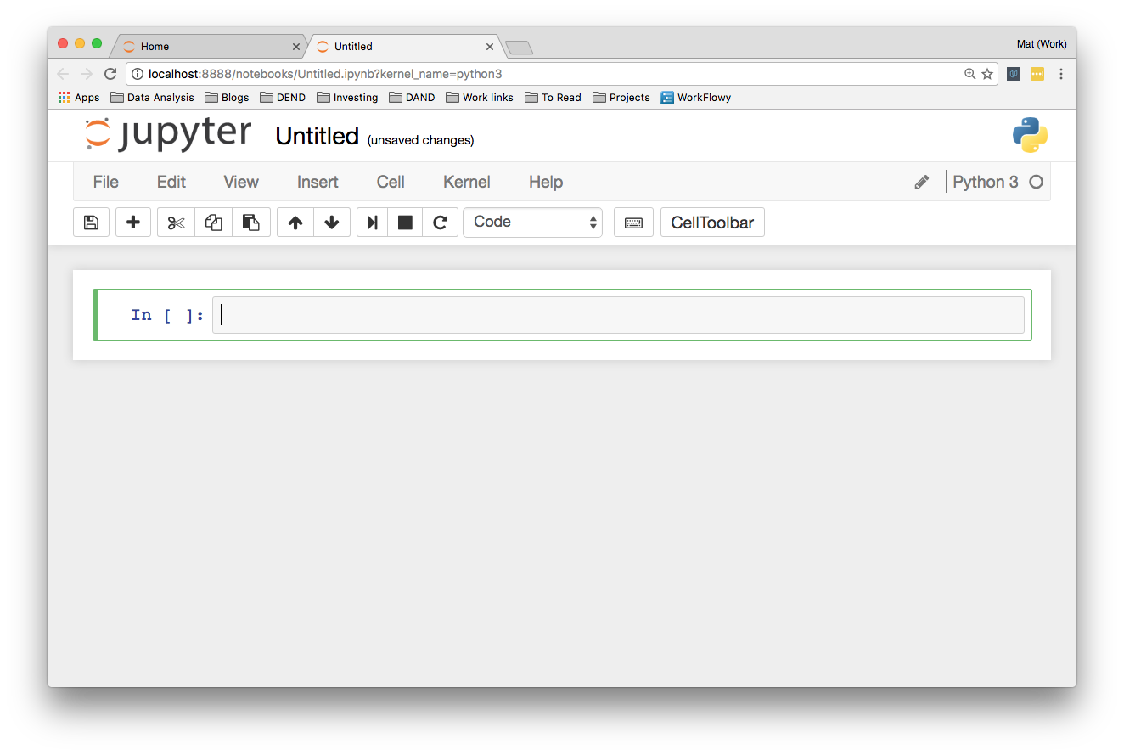](https://classroom.udacity.com/nanodegrees/nd002-ent/parts/8ba0d7fa-a87e-431a-9ff0-1e6090b7a6e5/modules/c89c8727-97d9-41ee-b57b-e7add630381a/lessons/ef631031-1887-4bd0-8e85-84ba793885f8/concepts/0d3b93d8-fd93-4dde-92f2-55594d6d458e)](https://classroom.udacity.com/nanodegrees/nd002-ent/parts/8ba0d7fa-a87e-431a-9ff0-1e6090b7a6e5/modules/c89c8727-97d9-41ee-b57b-e7add630381a/lessons/ef631031-1887-4bd0-8e85-84ba793885f8/concepts/0d3b93d8-fd93-4dde-92f2-55594d6d458e)**

Feel free to try this yourself and poke around a bit.

You’ll see a little box **outlined in green**. This is called a cell. Cells are where you write and run your code. You can also change it to render Markdown, a popular formatting syntax for writing web content. I'll cover Markdown in more detail later. In the toolbar, click “Code” to change it to **Markdown** and back. The little play button runs the cell, and the up and down arrows move cells up and down.

When you run a code cell, the **output** is displayed **below** the cell. The cell also gets numbered, you see In [1]: on the left. This lets you know the code was run and the order if you run multiple cells. Running the cell in Markdown mode renders the Markdown as text.

## The tool bar

Elsewhere on the tool bar, starting from the left:

* The anachronistic symbol for "save," the floppy disk. Saves the notebook!
* The + button creates a new cell
* Then, buttons to cut, copy, and paste cells.
* Run, stop, restart the kernel
* Cell type: code, Markdown, raw text, and header
* Command palette (see next)
* Cell toolbar, gives various options for cells such as using them as slides

### Command palette

The little keyboard is the command palette. This will bring up a panel with a search bar where you can search for various commands. This is really helpful for speeding up your workflow as you don't need to search around in the menus with your mouse. Just open the command palette and type in what you want to do. For instance, if you want to merge two cells:

## More things

At the top you see the title. Click on this to rename the notebook.

Over on the right is the kernel type (Python 3 in my case) and next to it, a little circle. When the kernel is running a cell, it'll fill in. For most operations which run quickly, it won't fill in. It's a little indicator to let you know longer running code is actually running.

Along with the save button in the toolbar, notebooks are automatically saved periodically. The most recent save is noted to the right of the title. You can save manually with the save button, or by pressing escape then s on your keyboard. The escape key changes to command mode and s is the shortcut for "save." I'll cover command mode and keyboard shortcuts later.

In the "File" menu, you can download the notebook in multiple formats. You'll often want to download it as an HTML file to share with others who aren't using Jupyter. Also, you can download the notebook as a normal Python file where all the code will run like normal. The [**Markdown**](https://daringfireball.net/projects/markdown/) and **[reST](http://docutils.sourceforge.net/rst.html" \t "_blank)** formats are great for using notebooks in blogs or documentation.

**[[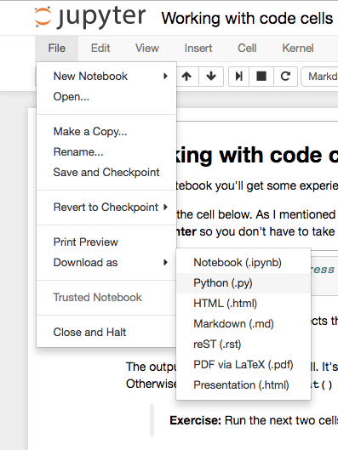](https://classroom.udacity.com/nanodegrees/nd002-ent/parts/8ba0d7fa-a87e-431a-9ff0-1e6090b7a6e5/modules/c89c8727-97d9-41ee-b57b-e7add630381a/lessons/ef631031-1887-4bd0-8e85-84ba793885f8/concepts/0d3b93d8-fd93-4dde-92f2-55594d6d458e)](https://classroom.udacity.com/nanodegrees/nd002-ent/parts/8ba0d7fa-a87e-431a-9ff0-1e6090b7a6e5/modules/c89c8727-97d9-41ee-b57b-e7add630381a/lessons/ef631031-1887-4bd0-8e85-84ba793885f8/concepts/0d3b93d8-fd93-4dde-92f2-55594d6d458e)**

"run cell" button above. However, it's easier to run it by pressing **Shift + Enter**

Shift + Enter runs the cell then selects the next cell or creates a new one if necessary. You can run a cell without changing the selected cell by pressing **Control + Enter**.

code completion. That is, you only need to type part of the name, then press **tab**.

find some function, but you need more information. You can show more information by pressing **shift + tab** twice

## Timing code

At some point, you'll probably spend some effort optimizing code to run faster. Timing how quickly your code runs is essential for this optimization. You can use the %timeit magic command to time how long it takes for **a function** to run, like so:

**[[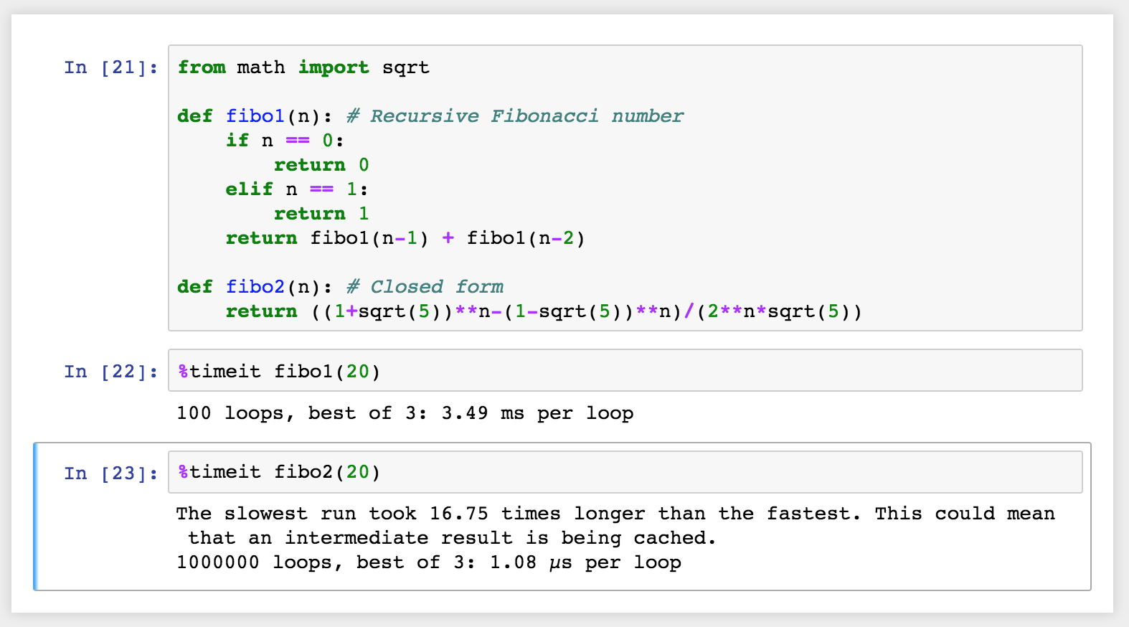](https://classroom.udacity.com/nanodegrees/nd002-ent/parts/8ba0d7fa-a87e-431a-9ff0-1e6090b7a6e5/modules/c89c8727-97d9-41ee-b57b-e7add630381a/lessons/ef631031-1887-4bd0-8e85-84ba793885f8/concepts/256cdd36-17d4-442a-a033-7c64ce83f7f8)](https://classroom.udacity.com/nanodegrees/nd002-ent/parts/8ba0d7fa-a87e-431a-9ff0-1e6090b7a6e5/modules/c89c8727-97d9-41ee-b57b-e7add630381a/lessons/ef631031-1887-4bd0-8e85-84ba793885f8/concepts/256cdd36-17d4-442a-a033-7c64ce83f7f8)**

If you want to time how long it takes for **a whole cell** to run, you’d use %%timeit like so:

**[[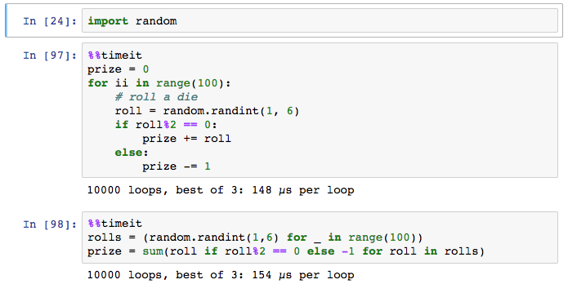](https://classroom.udacity.com/nanodegrees/nd002-ent/parts/8ba0d7fa-a87e-431a-9ff0-1e6090b7a6e5/modules/c89c8727-97d9-41ee-b57b-e7add630381a/lessons/ef631031-1887-4bd0-8e85-84ba793885f8/concepts/256cdd36-17d4-442a-a033-7c64ce83f7f8)](https://classroom.udacity.com/nanodegrees/nd002-ent/parts/8ba0d7fa-a87e-431a-9ff0-1e6090b7a6e5/modules/c89c8727-97d9-41ee-b57b-e7add630381a/lessons/ef631031-1887-4bd0-8e85-84ba793885f8/concepts/256cdd36-17d4-442a-a033-7c64ce83f7f8)**

## Embedding visualizations in notebooks

As mentioned before, notebooks let you embed images along with text and code. This is most useful when you’re using matplotlib or other plotting packages to create **visualizations**.

You can use %matplotlib to set up matplotlib for **interactive** use in the notebook. By default figures will render in their own window. However, you can pass arguments to the command to select a specific [**"backend"**](http://matplotlib.org/faq/usage_faq.html#what-is-a-backend), the software that renders the image. To render figures directly in the notebook, you should use the inline backend with the command %matplotlib inline.

**Tip:** On **higher resolution screens** such as Retina displays, the default images in notebooks can **look blurry**. Use %config InlineBackend.figure\_format = 'retina' after %matplotlib inline to render **higher resolution images**.

**[[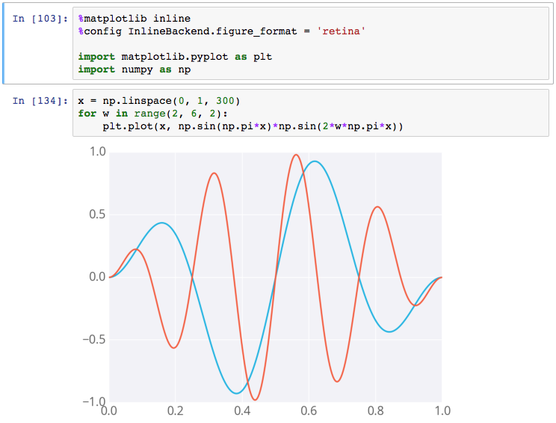](https://classroom.udacity.com/nanodegrees/nd002-ent/parts/8ba0d7fa-a87e-431a-9ff0-1e6090b7a6e5/modules/c89c8727-97d9-41ee-b57b-e7add630381a/lessons/ef631031-1887-4bd0-8e85-84ba793885f8/concepts/256cdd36-17d4-442a-a033-7c64ce83f7f8)](https://classroom.udacity.com/nanodegrees/nd002-ent/parts/8ba0d7fa-a87e-431a-9ff0-1e6090b7a6e5/modules/c89c8727-97d9-41ee-b57b-e7add630381a/lessons/ef631031-1887-4bd0-8e85-84ba793885f8/concepts/256cdd36-17d4-442a-a033-7c64ce83f7f8)**

**[Example figure in a notebook](https://classroom.udacity.com/nanodegrees/nd002-ent/parts/8ba0d7fa-a87e-431a-9ff0-1e6090b7a6e5/modules/c89c8727-97d9-41ee-b57b-e7add630381a/lessons/ef631031-1887-4bd0-8e85-84ba793885f8/concepts/256cdd36-17d4-442a-a033-7c64ce83f7f8)**

## Debugging in the Notebook

With the Python kernel, you can turn on the interactive debugger using the magic command %pdb. When you cause an error, you'll be able to inspect the variables in the current namespace.

**[[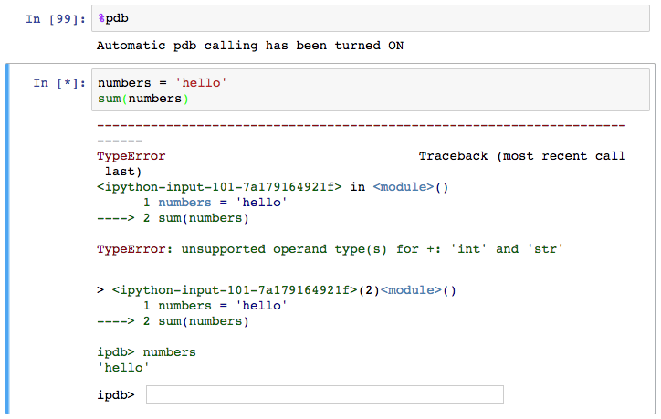](https://classroom.udacity.com/nanodegrees/nd002-ent/parts/8ba0d7fa-a87e-431a-9ff0-1e6090b7a6e5/modules/c89c8727-97d9-41ee-b57b-e7add630381a/lessons/ef631031-1887-4bd0-8e85-84ba793885f8/concepts/256cdd36-17d4-442a-a033-7c64ce83f7f8)](https://classroom.udacity.com/nanodegrees/nd002-ent/parts/8ba0d7fa-a87e-431a-9ff0-1e6090b7a6e5/modules/c89c8727-97d9-41ee-b57b-e7add630381a/lessons/ef631031-1887-4bd0-8e85-84ba793885f8/concepts/256cdd36-17d4-442a-a033-7c64ce83f7f8)**

**[Debugging in a notebook](https://classroom.udacity.com/nanodegrees/nd002-ent/parts/8ba0d7fa-a87e-431a-9ff0-1e6090b7a6e5/modules/c89c8727-97d9-41ee-b57b-e7add630381a/lessons/ef631031-1887-4bd0-8e85-84ba793885f8/concepts/256cdd36-17d4-442a-a033-7c64ce83f7f8)**

Above you can see I tried to sum up a string which gives an error. The debugger raises the error and provides a prompt for inspecting your code.

Read more about pdb in [**the documentation**](https://docs.python.org/3/library/pdb.html). To quit the debugger, simply enter q in the prompt.