Analysis Report - WeRateDogs Twitter

BY YANG, Linjing

2019/02/10

## **1. Dog Ratings**

Since there are various rating denominators (although most of them are 10), the rating of dogs is calculated by dividing the numerator by the denominator.

The outliers have been deleted in Data Cleaning section.

It shows that the ratings of dogs are left-skewed distributed, with the mean of 1.06 and the median of 1.10. Besides, 25% of the dogs are rated equal to or more than 100%. Thus, it can be found that most dogs are considered to be better than perfect.

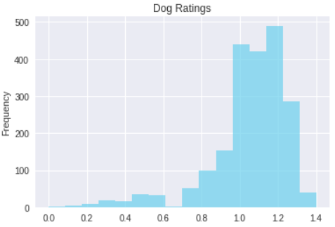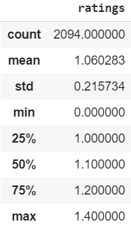

## **2. Source of Tweet**

From the pie chart, it presents that the dominate source is from iPhone, which is 93.7%. Only a few people use Vine (4.3%), Website (1.5%) and TweetDect (0.5%) to browse WeRateDogs Tweet.

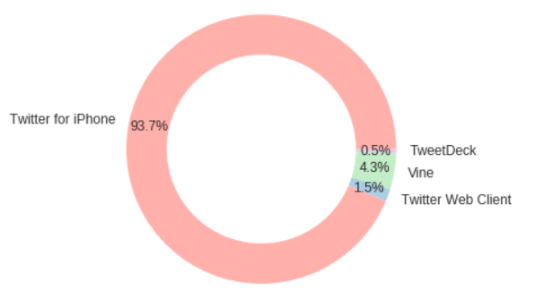

## **3. Relationship between Retweet and Favourite**

The count of retweet and favourite are highly positively correlated ( *r* = 0.927). Thus, we could say that the more people like a tweet, the more they retweet it.

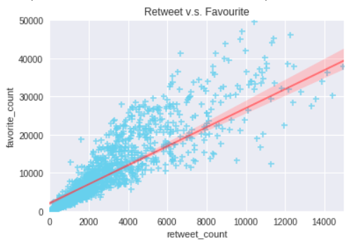

## **4. Breeds**

The top 15 predicted dogs are shown in the plot.

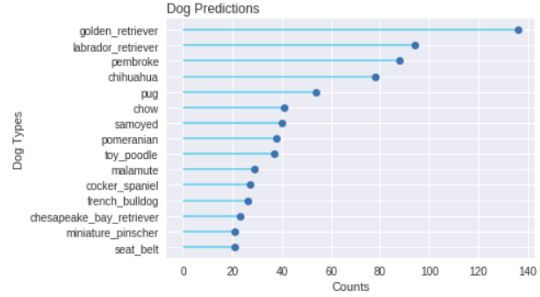

It can be seen that **Golden Retriever** is the No.1 predicted dog, which has been predicted 150 times with high confidence. The confidence of predicting it is left skewed, with the median of 0.78 and mean of 0.72.

The second most predicted dog is **Labrador Retriever** (100 times), the high confidence of which is also left skewed with the median of 0.71 and mean of 0.67.

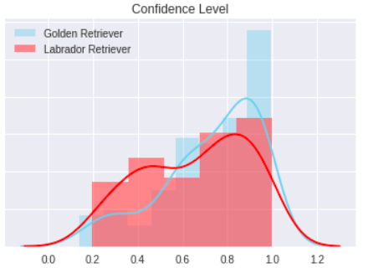

## **5. Dog Stages**

Only 336 out of 2094 dogs have their stages presented in the dataset. The most common stage is pupper (230), followed by doggo (83) among the dogs whose stage has been presented.

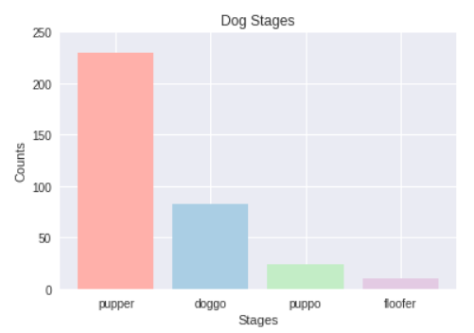

The explanation of dog stages is shown as follows.

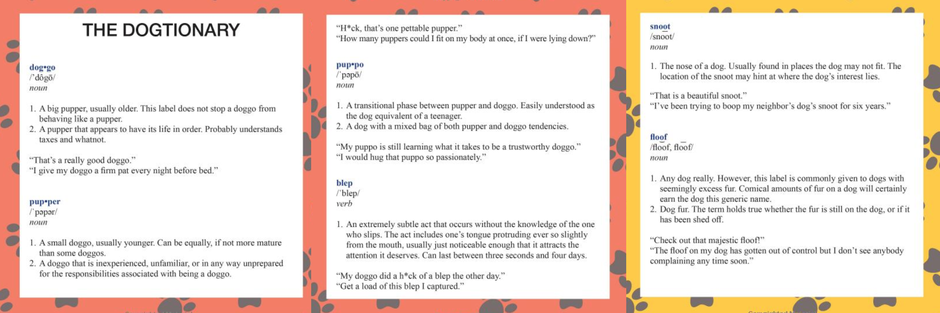

## **6. Post Tweet Day**

From Monday to Sunday, the number of posted tweet decreases. WeRateDogs followers may expect to see more new tweets on Monday.

