- 素材查询接口，在rows里加入参数material_level字段，对应字段返回正确。
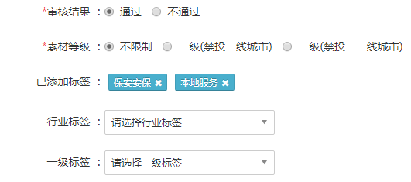
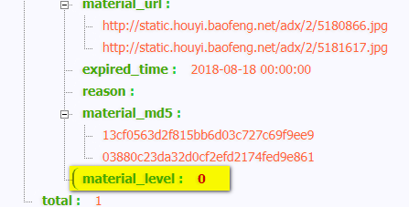
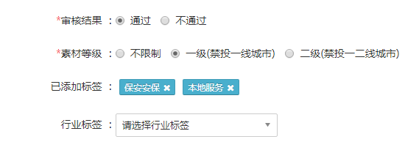
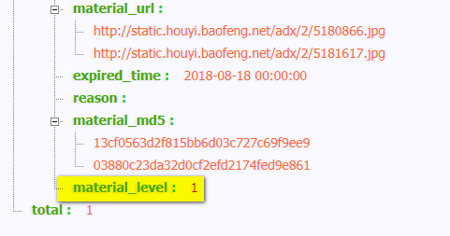
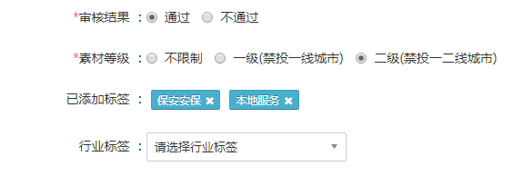
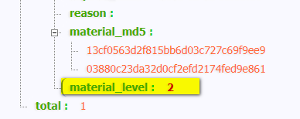
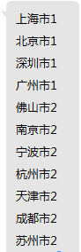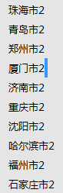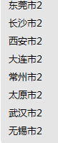
2.bid response的校验，在交易市场的广告内容设置、底价设置、DSP设置上，允许一线城市二线城市和其他城市的投放，并屏蔽了其他DSP的竞价，确保素材mat071703的一定会被使用，在素材审核阶段分别选择不限制、禁投一线、禁投一二线，测试用例如下。

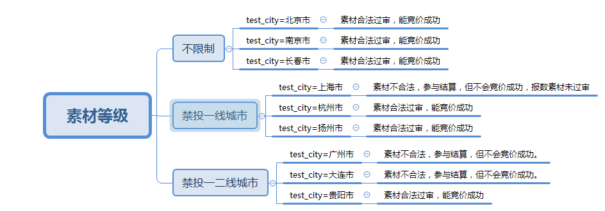
http://rtb.baofeng.com/index.php?adp=15746518&debug=open&test_city=广州市
报数如下：广州市 禁投一二线城市 无竞价字段dealprice，ecode报6301 素材未过审
Material Error: 74391163=>material level error: 2

No Win DSP: 15746518

DT Log: bf.ad.adx.server.adxxs::appkey=ad&ltype=adxxs&enc=0&log={"itime":"2018-07-20 15:36:24","value":{"adposition":"15746518","bidtype":0,"dvc":4,"stage":1,"status":1,"ecode":1100,"requestid":"d10e8f72473700f005e67292f28c9bff"}}

DT Log: bf.ad.adx.server.adxdsp::appkey=ad&ltype=adxdsp&enc=0&log={"itime":"2018-07-20 15:36:24","value":{"adposition":"15746518","bidtype":0,"dvc":4,"stage":2,"status":1,"ecode":2100,"requestid":"d10e8f72473700f005e67292f28c9bff"}}

DT Log: bf.ad.adx.server.adxdsp::appkey=ad&ltype=adxdsp&enc=0&log={"itime":"2018-07-20 15:36:24","value":{"adposition":"15746518","bidtype":0,"dvc":4,"stage":2,"status":2,"ecode":2201,"requestid":"d10e8f72473700f005e67292f28c9bff","dspid":[74391163]}}

DT Log: bf.ad.adx.server.adxrtb::appkey=ad&ltype=adxrtb&enc=0&log={"itime":"2018-07-20 15:36:24","value":{"adposition":"15746518","bidtype":0,"dvc":4,"stage":3,"status":1,"ecode":3100,"requestid":"d10e8f72473700f005e67292f28c9bff","biddingid":"6eea2b1f41a9ae378cade869747601a8","dspid":[74391163],"rtime":{"74391163":0}}}

DT Log: bf.ad.adx.server.adxrtb::appkey=ad&ltype=adxrtb&enc=0&log={"itime":"2018-07-20 15:36:24","value":{"adposition":"15746518","bidtype":0,"dvc":4,"stage":3,"status":2,"ecode":3201,"requestid":"d10e8f72473700f005e67292f28c9bff","biddingid":"6eea2b1f41a9ae378cade869747601a8","dspid":[74391163],"rtime":{"74391163":9}}}

DT Log: bf.ad.adx.server.adxmat::appkey=ad&ltype=adxmat&enc=0&log={"itime":"2018-07-20 15:36:24","value":{"adposition":"15746518","dvc":4,"stage":6,"status":3,"ecode":6301,"requestid":"d10e8f72473700f005e67292f28c9bff","biddingid":"6eea2b1f41a9ae378cade869747601a8","dspid":[74391163],"crid":"mat071703","dealid":""}}

DT Log: bf.ad.adx.server.adxprice::appkey=ad&ltype=adxprice&enc=0&log={"itime":"2018-07-20 15:36:24","value":{"adposition":"15746518","bidtype":0,"dvc":4,"stage":4,"status":2,"ecode":4201,"requestid":"d10e8f72473700f005e67292f28c9bff","biddingid":"6eea2b1f41a9ae378cade869747601a8","dspprice":{"74391163":30}}}

DT Log: bf.ad.adx.server.adxxs::appkey=ad&ltype=adxxs&enc=0&log={"itime":"2018-07-20 15:36:24","value":{"adposition":"15746518","bidtype":0,"dvc":4,"stage":1,"status":2,"ecode":1202,"requestid":"d10e8f72473700f005e67292f28c9bff","biddingid":"6eea2b1f41a9ae378cade869747601a8"}}
http://rtb.baofeng.com/index.php?adp=15746518&debug=open&test_city=贵阳市
三线城市贵阳市 禁投一二线城市 有dealprice字段，竞价成功可显示。
Material Redis Key: mat_74391163_mat071703

Dsp Bid Datas: {"dspid":74391163,"bidfloor":"25","price":30,"type":"rtb","material_valid":true}

Win Dsp Data: dspid=>74391163 bidfloor=>25 price=>30 type=>rtb winPrice=>25.01

DT Log: bf.ad.adx.server.adxxs::appkey=ad&ltype=adxxs&enc=0&log={"itime":"2018-07-20 15:46:49","value":{"adposition":"15746518","bidtype":0,"dvc":4,"stage":1,"status":1,"ecode":1100,"requestid":"7860c407a1d86a2ee654e56661949cdf"}}

DT Log: bf.ad.adx.server.adxdsp::appkey=ad&ltype=adxdsp&enc=0&log={"itime":"2018-07-20 15:46:49","value":{"adposition":"15746518","bidtype":0,"dvc":4,"stage":2,"status":1,"ecode":2100,"requestid":"7860c407a1d86a2ee654e56661949cdf"}}

DT Log: bf.ad.adx.server.adxdsp::appkey=ad&ltype=adxdsp&enc=0&log={"itime":"2018-07-20 15:46:49","value":{"adposition":"15746518","bidtype":0,"dvc":4,"stage":2,"status":2,"ecode":2201,"requestid":"7860c407a1d86a2ee654e56661949cdf","dspid":[74391163]}}

DT Log: bf.ad.adx.server.adxrtb::appkey=ad&ltype=adxrtb&enc=0&log={"itime":"2018-07-20 15:46:49","value":{"adposition":"15746518","bidtype":0,"dvc":4,"stage":3,"status":1,"ecode":3100,"requestid":"7860c407a1d86a2ee654e56661949cdf","biddingid":"511bba30d34c74ea94960e29466217a0","dspid":[74391163],"rtime":{"74391163":0}}}

DT Log: bf.ad.adx.server.adxrtb::appkey=ad&ltype=adxrtb&enc=0&log={"itime":"2018-07-20 15:46:49","value":{"adposition":"15746518","bidtype":0,"dvc":4,"stage":3,"status":2,"ecode":3201,"requestid":"7860c407a1d86a2ee654e56661949cdf","biddingid":"511bba30d34c74ea94960e29466217a0","dspid":[74391163],"rtime":{"74391163":7}}}

DT Log: bf.ad.adx.server.adxprice::appkey=ad&ltype=adxprice&enc=0&log={"itime":"2018-07-20 15:46:49","value":{"adposition":"15746518","bidtype":0,"dvc":4,"stage":4,"status":2,"ecode":4201,"requestid":"7860c407a1d86a2ee654e56661949cdf","biddingid":"511bba30d34c74ea94960e29466217a0","dspprice":{"74391163":30}}}

DT Log: bf.ad.adx.server.adxwin::appkey=ad&ltype=adxwin&enc=0&log={"itime":"2018-07-20 15:46:49","value":{"adposition":"15746518","bidtype":0,"dvc":4,"stage":5,"status":2,"ecode":5200,"requestid":"7860c407a1d86a2ee654e56661949cdf","biddingid":"511bba30d34c74ea94960e29466217a0","dspid":[74391163],"preprice":"25","offerprice":"30","dealprice":"25.01"}}

DT Log: bf.ad.adx.server.adxxs::appkey=ad&ltype=adxxs&enc=0&log={"itime":"2018-07-20 15:46:49","value":{"adposition":"15746518","bidtype":0,"dvc":4,"stage":1,"status":2,"ecode":1201,"requestid":"7860c407a1d86a2ee654e56661949cdf","biddingid":"511bba30d34c74ea94960e29466217a0","dspid":[74391163],"crid":"mat071703","is_dadi":0,"adnid":"","tempid":0,"dealid":""}}

