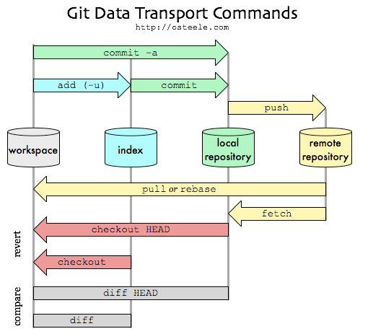

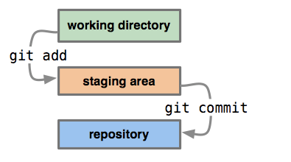

**HEAD** points to currently checked out branch, which tip points to last commit in the "git directory (repository)"

The **index** is a staging area where the new commit is prepared. Essentially, the contents of the index are what will go into the new commit (though if you do git commit -a, this will automatically add all changes to files that Git knows about to the index before committing, so it will commit the current contents of your working tree). git add will add or update files from the working tree into your index.

**working tree** is what is actually in the files that you are currently working on.

Reset VS Checkout

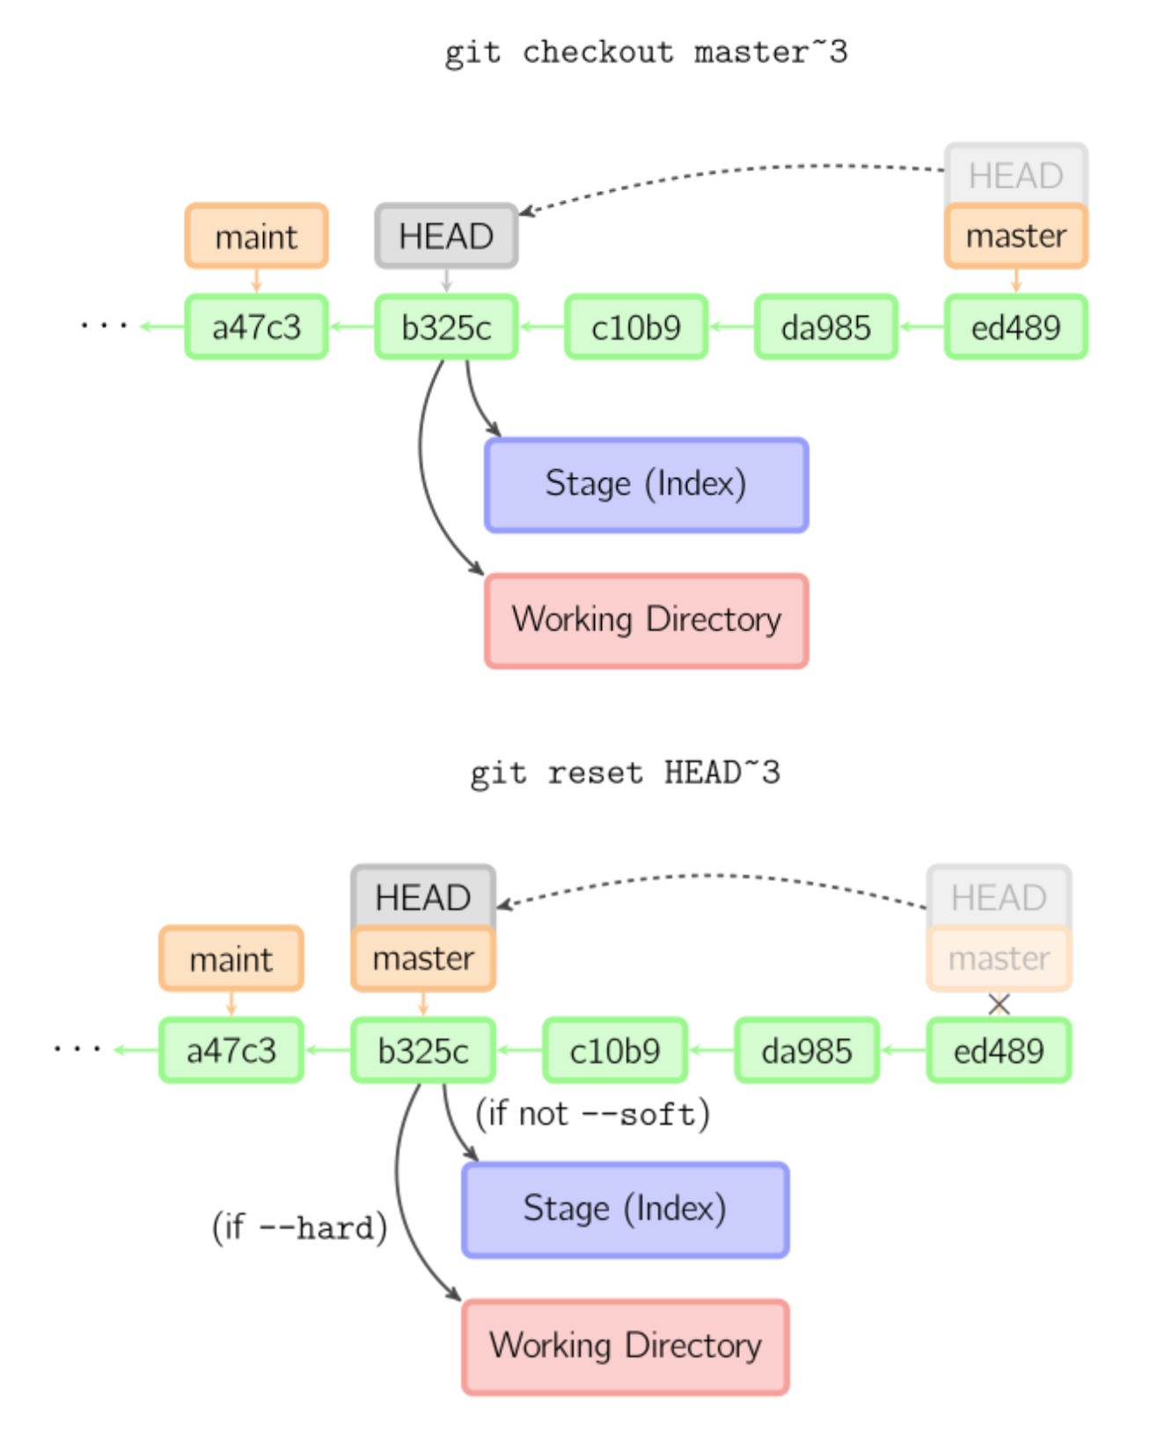

Reset:

* --soft – The staged snapshot and working directory are not altered in any way.
* --mixed – The staged snapshot is updated to match the specified commit, but the working directory is not affected. This is the default option.
* --hard – The staged snapshot and the working directory are both updated to match the specified commit.

Checkout: move HEAD to a different branch and update the working directory to match.