**Name: Mao YANG**

**Email:my4n20@soton.ac.uk**

What do you observe for the last command above (i.e. print(np.dot(U[:,0], U[:,1])))? Can you formally prove that this is the result you would expect for the specific structure in the matrix B ?

Because B is a symmetric matrices, and

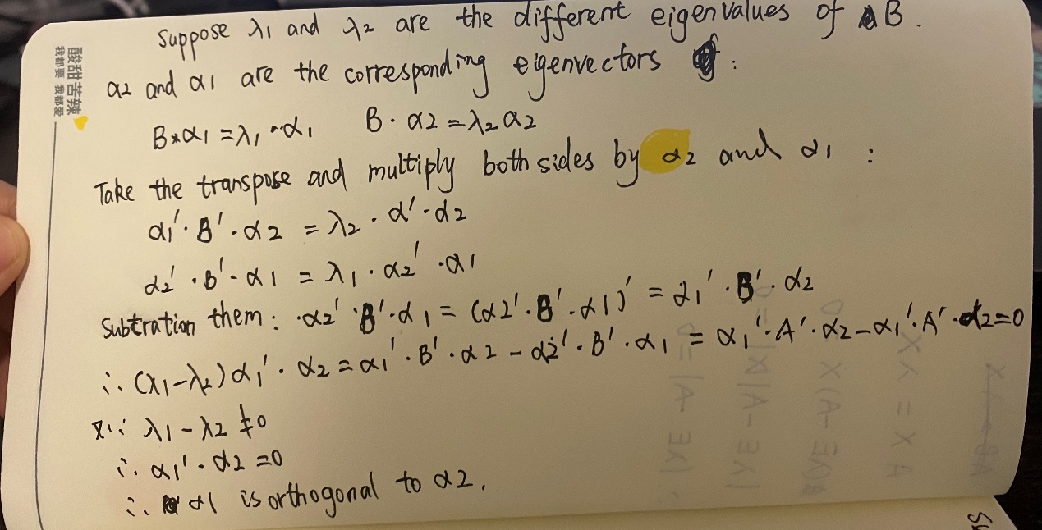

As shown in the result of the code:

-2.220446049250313e-16

[[ 1.00000000e+00 -1.11022302e-16 -8.32667268e-17]

[-1.11022302e-16 1.00000000e+00 0.00000000e+00]

[-8.32667268e-17 0.00000000e+00 1.00000000e+00]]

The number: -2.220446049250313e-16 is almost equal to 0.

So it is correctly proved.

**1 Random Numbers and Uni-variate Densities**

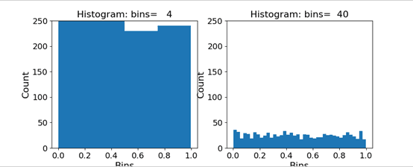 • Though the data is from a uniform distribution, the histogram does not appear flat. Why?

Because the y-coordinate is a randomly generated number, so it has little possibility to produce exactly the same number.

• Every time you run it, the histogram looks slightly different? Why?

Because these numbers are randomly generated numbers, so it could change every time.

• How do the above observations change (if so how) if you had started with more data?

We're going to see all the Numbers that are in the set range.

**When add and subtract some uniform random numbers:**

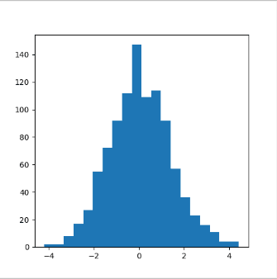

**What do you observe? How does the resulting histogram change when you change the number of uniform random numbers you add and subtract?**

The bar graph is like Gaussian distribution.

**Is there a theory that explains your observation?**

central limit theorem:

The subtraction of two uniform distributions is a Gaussian

**2 Uncertainty in Estimation**

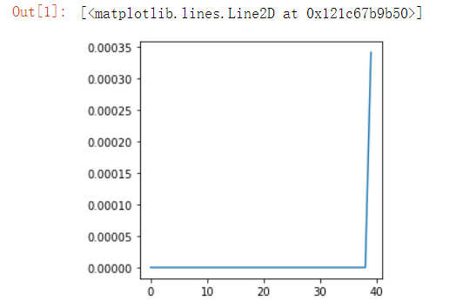

**3 Bi-variate Gaussian Distribution**

The original one:

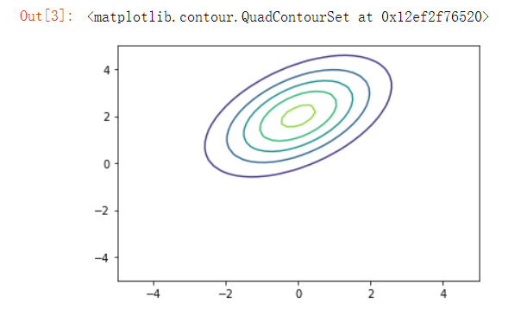

while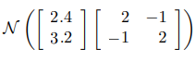:

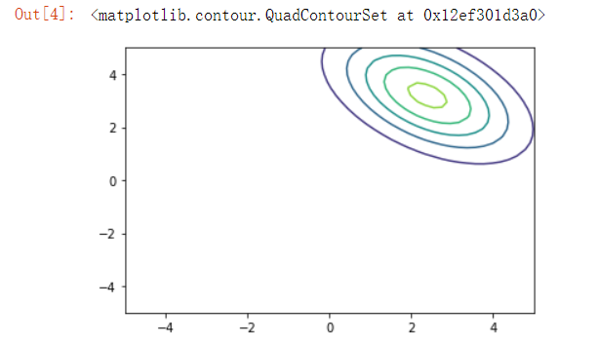

while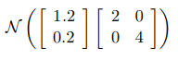:

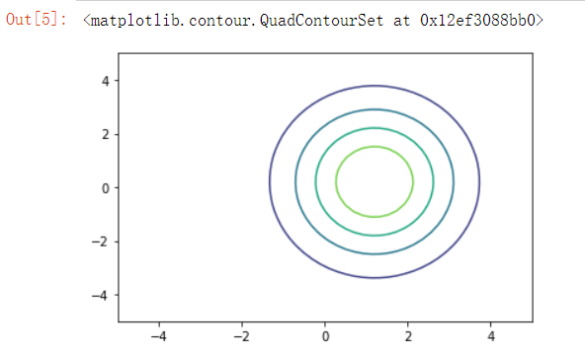

while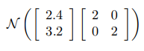:

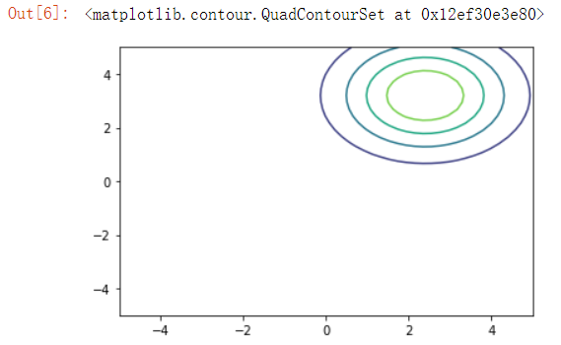

**4 Sampling from a multi-variate Gaussian**

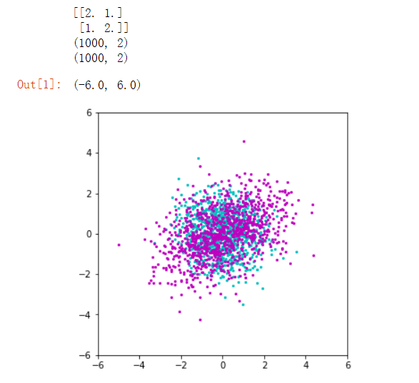

**5 Distribution of Projections**

**The picture of the result:**

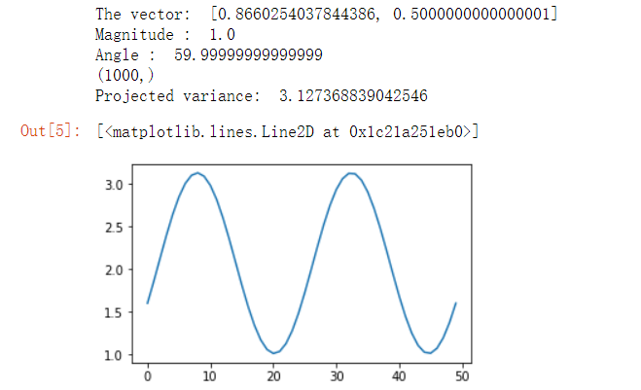

**What are the maxima and minima of the resulting plot?**

The different results of the code:

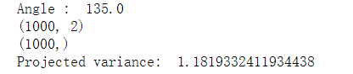

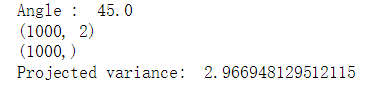

Maxima= 2.96 when theta=45°

Minima=1.18 when theta=135°

**• Compute the eigenvalues an eigenvectors of the covariance matrix C**

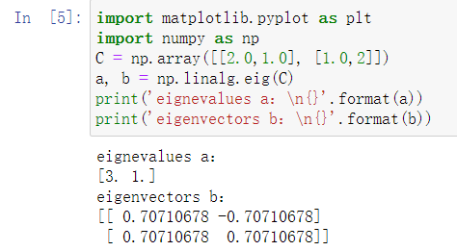

**• Can you see a relationship between the eignevalues and eigenvectors and the maxima and minima of the way the projected variance changes?**

As can be seen from the answers to the two questions above, the minimum eigenvector and the maximum eigenvector correspond to the maxima and minima.

**• The shape of the graph might have looked sinusoidal for this two dimensional problem.**

**Can you analytically confirm if this might be true?**

**As the results shows:**

**Shape(Y)=(1000,2) shape(u)=(2, ) shape(Yp)=(1000, )**

**u=[sinθ cosθ]T**

**Yp=u@Y=N(uY,uCuT)**