**输出结果1：模型参数**

|  |  |
| --- | --- |
| 参数名 | 参数值 |
| 数据切分 | 0.7 |
| 数据洗牌 | 是 |
| 交叉验证 | 5 |
| 迭代次数 | 100 |
| 学习率 | 0.1 |
| L2正则项 | 1 |
| 树的最大深度 | 10 |
| 达成优化以后继续迭代的次数 | 20 |

**输出结果2：特征重要性**

| 特征名称 | 特征重要性 |
| --- | --- |
| Gender | 4.20% |
| Height | 2.10% |
| Weight | 9.70% |
| CALC | 0.90% |
| FAVC | 0.40% |
| FCVC | 1.60% |
| NCP | 0.50% |
| SCC | 0.10% |
| SMOKE | 0.00% |
| CH2O | 1.10% |
| family_history_with_overweight | 0.10% |
| FAF | 0.90% |
| TUE | 1.40% |
| CAEC | 0.60% |
| MTRANS | 1.80% |
| BMI | 65.20% |
| Meals_Per_Day | 6.40% |
| Total_Activity_Score | 1.10% |
| Water_Intake_Per_Kg | 1.60% |
| Age_Group | 0.30% |

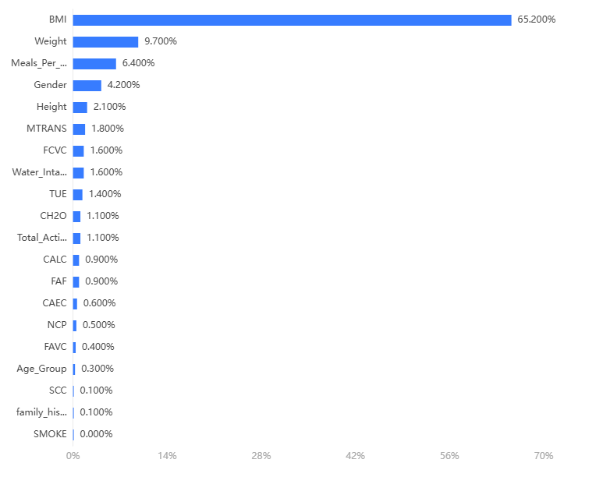

**输出结果3：混淆矩阵热力图**

**训练集：**

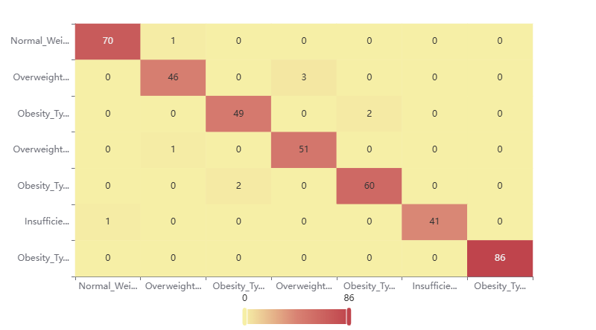

**输出结果4：模型评估结果**

|  |  |  |  |  |
| --- | --- | --- | --- | --- |
|  | 准确率 | 召回率 | 精确率 | F1 |
| 训练集 | 1 | 1 | 1 | 1 |
| 交叉验证集 | 0.987 | 0.987 | 0.987 | 0.986 |
| 测试集 | 0.976 | 0.976 | 0.976 | 0.976 |